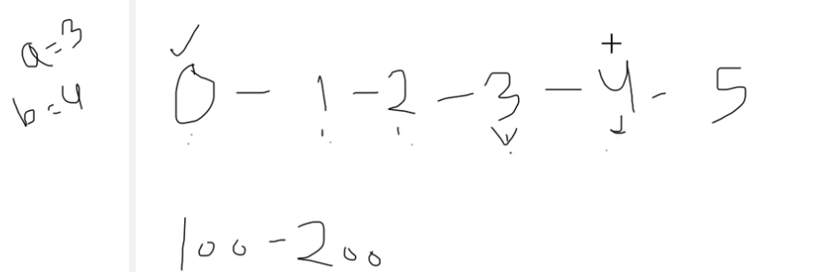

Here number start from 0.hence a=3 is at 3 node and b=4 is at 4 node.

Code:

