There is 2 methods here.

1st:

Here we can just do with count: if we encounter odd node leave them. We encounter even node we segregate to the right.

If odd number of node number of times we need to do this is c-1/2 and in even c/2+1 time->

It will run for:

My code:

ListNode\* oddEvenList(ListNode\* head)

{

int count=0;

if(head==NULL || head->next==NULL || head->next->next==NULL)

return head;

//first get count and to the end

ListNode\* end=head;

while(end->next!=NULL)

{

count++;

end=end->next;

}

int run=(count%2==0)?count/2:(count/2)+1;

ListNode\* temp=head;

while(run>0)

{

end->next=temp->next;

temp->next=temp->next->next;

run--;

end->next->next=NULL;

temp=temp->next;

end=end->next;

}

return head;

}

Now 2nd approach:it says we will have 2 linked list 1 will contain odd and 2nd will contain even.

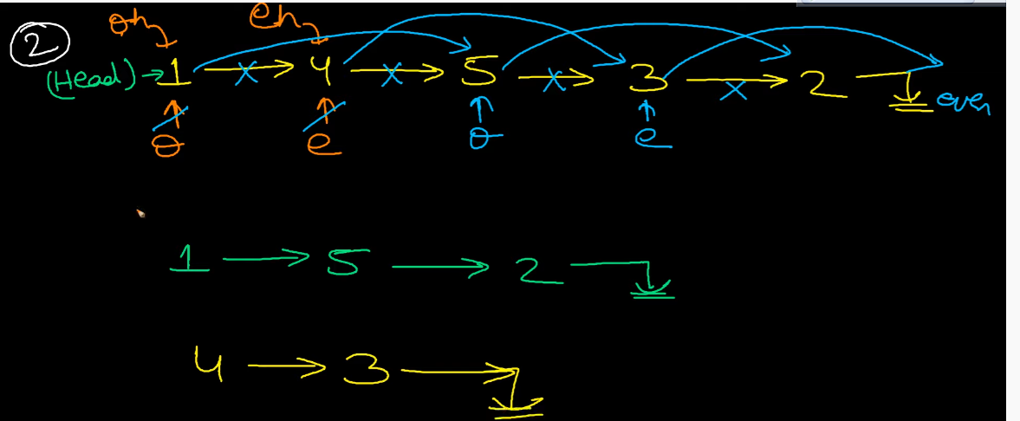

ListNode\* oddEvenList(ListNode\* head)

{

if(head==NULL||head->next==NULL||head->next->next==NULL)

return head;

ListNode\* odd=head;

ListNode\* even=head->next;

ListNode\* odd1=head;;

ListNode\* even1=head->next;

while(even && even->next)

{

odd=odd->next->next;

even=even->next->next;

odd->next=odd;

even->next=even;

}

odd->next=even1;

return odd1;

}

};