This analysis is about the situation of the rapidly spreading delta variant corona virus across the world especially in UK, India, Russia and Germany and the main reasons behind it.

About dataset.

File "covid19data.csv" contains info about the total corona cases ,positive cases and death cases as well the other dataset 'delta_variant' contains "num_sequences" columns which holds the data for total test done for all variant from the received total positive corona cases and "per_sequences" columns contains the percentage of the all the variant, Similarly in " num_sequences_total" the total count of the variant is also included. Below, you can see a sample of this information.

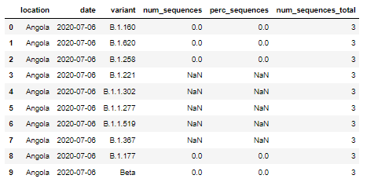

As we know UK is the hardest hit country with delta variant of corona virus with 216,249 affected until the month of July with India in the second. There may be different reasons for the increase in cases like Holiday/vacation, Festivals.

So after knowing the dates where the festivals were held and the holidays happened we plotted few diagrams for the worst hit country UK and comparatively the country with fewer cases like Germany.

First we, from the dataset covid-19 we had the given confirmed cases then we calculated the daily cases for UK, India and Germany.

First for the country UK, we searched the dates which were mostly holiday or summer break which was from 19th April to June 23.

We plotted a bar graph with respect to date and daily cases from covid dataset and selected few dates with respect to dates having high number of cases.

Then from delta variant dataset we took the "perc_sequence" of the same following dates to calculate the confirmed delta variant cases of those following dates. We got the following results.

Similar steps were involved while doing for the country India with Kumbha Mela being the festival which was held from 1 April to 30th of Apri.l