CHAPTER 9- Generative Adversarial Networks (GAN) for image generation

9.1 Introduction to GANs: GAN architecture (generator and discriminator)
9.2 Training GANs:Code
9.3 Applications of GANs

9.1 Introduction to GANs
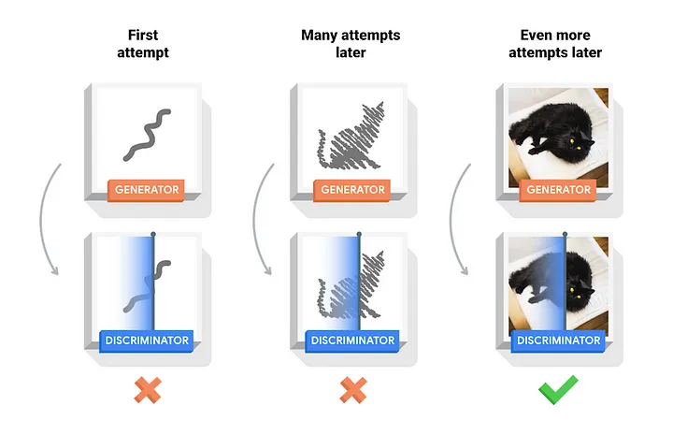
- Generative Adversarial Networks, or GANs, are a deep-learning-based generative model.
- GANs are a model architecture for training a generative model,which uses CNN.
- GANs (Generative Adversarial Networks) work like a game between two players:
  - Generator: Think of this as a creative artist trying to make fake images that look real.
  - Discriminator: This is like a detective trying to figure out if an image is real (from the actual dataset) or fake (made by the generator).
- The generator keeps improving its "fake" images to fool the discriminator, and the discriminator keeps getting better at spotting fakes. Over time, the generator gets so good that its images are almost indistinguishable from real ones. This back-and-forth helps create highly realistic images or data.
- Training GANs is very different from training “normal” neural networks, where the goal is usually to minimize a single loss function until the model converges to an optimal solution. Instead, GANs involve a dynamic and competitive process:
- The generator tries to minimize its loss by making realistic fakes to fool the discriminator.
- The discriminator tries to minimize its own loss by correctly identifying real and fake examples.
- This creates a constant tug-of-war between the two models. Unlike traditional training, there’s no fixed point of convergence because both models are learning and adapting simultaneously, which makes GAN training more challenging and unstable.

9.1.1 GAN Architecture

Components of Generative Adversarial Networks (GANs)
- Generator Network
  - Purpose: Generates new data samples resembling the training data.
  - Input: Random noise (e.g., a vector of random values).
  - Output: Data samples like images, text, or audio.
  - Objective: Fool the discriminator by creating realistic data samples.
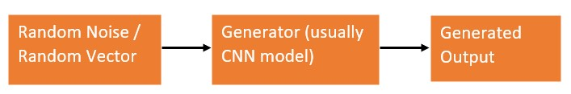
- Discriminator Network
  - Purpose: Distinguishes between real and generated (fake) data.
  - Input: Both real data (from the training set) and fake data (from the generator).
  - Output: A probability indicating whether the input is real or fake.
  - Objective: Correctly classify real and fake data.
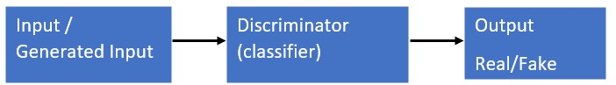
- Adversarial Training Process
- There are many different variations and modifications to GANs training. However, if we follow the original paper [1], the vanilla GAN training loop is the following:(IN DETAIL IN 9.2)
for number of training iterations do:
  - Generate m examples (images, audio…) from the sample distribution (i.e. random noise z) that we will denote: G(z)
  - Take m examples from the training dataset: x
  - Mix all the examples (generated and training dataset) and feed them to the Discriminator D. The output of D will be between 0 and 1, meaning 0 the example is fake and 1 the example is real
  - Measure the Discriminator Loss functions and adjust parameters
  - Generate new m examples G’(z)
  - Feed G’(z) to the Discriminator. Measure the Generator Loss function and adjust the parameters.
end for
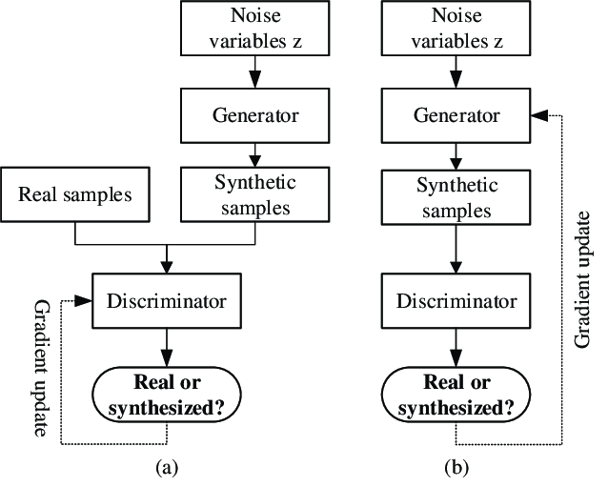

- Loss Functions
https://www.baeldung.com/cs/gan-loss
  - Generator Loss: This measures how well the generated data points fool the discriminator into believing they are real. A low Generator Loss signifies that the Generator is successfully creating realistic data.
  - Discriminator Loss: This measures how well the Discriminator can distinguish the real data from generated data. A low Discriminator Loss indicates that Discriminator is effectively identifying forgeries.

9.1.2 The Original GAN Loss (Min-Max Loss)
https://towardsdatascience.com/how-gans-learn-creativity-478fc1e4cc79#5ca5
The Min-Max loss function is central to the training of GANs, encapsulating the competitive dynamic between the Generator (G) and the Discriminator (D).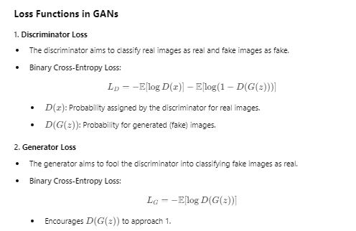

Breakdown of the Components:
- E:
  - The expectation operator calculates the average over the respective distributions.
    - Ex∼pdata(x)​: Expectation over the real data distribution.
    - Ez∼pz(z): Expectation over the random noise distribution.
- log⁡D(x):
  - The Discriminator’s loss for real data.
  - D(x) is the probability that x is real. Ideally, D(x)→1 for real samples, resulting in log⁡D(x)→0, which minimizes the Discriminator's loss for real data.
- log⁡(1−D(G(z))):
  - The loss for the Generator.
  - D(G(z)) is the probability that the fake data G(z) is real. The Generator wants D(G(z))→1, minimizing log⁡(1−D(G(z))).
- Random Noise Input
  - Purpose: Provides diverse inputs to the generator for creating varied data samples.
  - Description: A vector of random values, typically sampled from a uniform or normal distribution.
- Training Data
  - Real Data: Genuine data samples from the target domain (e.g., images from a dataset).
  - Fake Data: Generated by the generator during training to mimic real data.

9.1.3 Challenges in GAN Training and How to Mitigate Them (Simple Explanation)

1. Mode Collapse
- What is it?
The generator keeps creating the same type of output, even though the real data has a lot of variety.
- Why does it happen?
The generator learns only one part of the real data distribution that the discriminator finds hard to differentiate.
- How to fix it?
  - Mini-batch Discrimination: Make the generator learn to create varied outputs by comparing a batch of generated samples.
  - Unrolled GANs: Let the generator adjust its updates based on how the discriminator might respond in the future.

2. Vanishing Gradients
- What is it?
The discriminator gets too good, making it difficult for the generator to learn because the feedback (gradient) it gets is too small.
- Why does it happen?
When the discriminator perfectly classifies real and fake data, it stops providing useful feedback to the generator.
- How to fix it?
  - Use Wasserstein GAN (WGAN): Changes the loss function to measure the "distance" between real and fake distributions, providing stable gradients.
  - Batch Normalization: Normalize the input of each layer to keep training stable.
  - Use alternative GAN architectures like Relativistic GANs, which compare the realness of real and fake samples relatively.

3. Training Instability
- What is it?
GAN training can become unstable, causing the generator and discriminator to oscillate or fail to converge.
- Why does it happen?
The adversarial nature of GANs can cause one network to overpower the other.
- How to fix it?
  - Use gradient clipping: Limit how much the weights can change in one update.
  - Apply learning rate decay: Gradually reduce the learning rate during training.
  - Use regularized GANs: Introduce penalties like R1 regularization to stabilize training.

4. Overfitting
- What is it?
The discriminator memorizes the real data instead of learning general features, making it less effective.
- Why does it happen?
The discriminator becomes too powerful and stops generalizing.
- How to fix it?
  - Add dropout layers to the discriminator to prevent memorization.
  - Use data augmentation: Increase the diversity of real data by applying transformations like flipping, rotation, etc.
9.1.4 NUMERICALs:
Here N is number of sample(images):
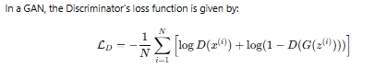
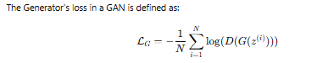

PB::Calculate Combined Loss for Discriminator and Generator for given data:D(x)=0.85 for real data, D(G(z))=0.25 for generated data ,also Compute the Discriminator’s loss and Generator’s loss.
USE LOG BASE 10 ONLY FOR COMPUTING NUMERICAL
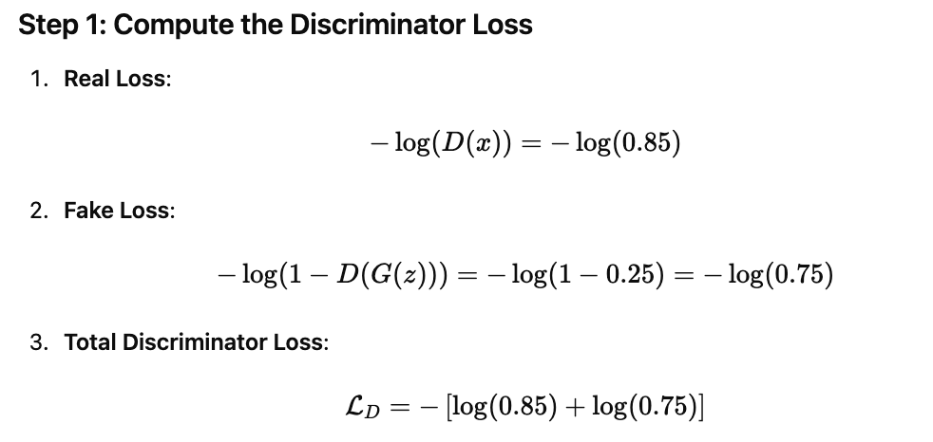
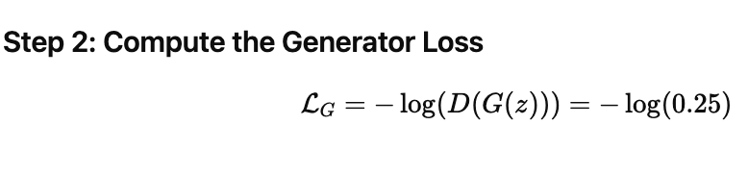
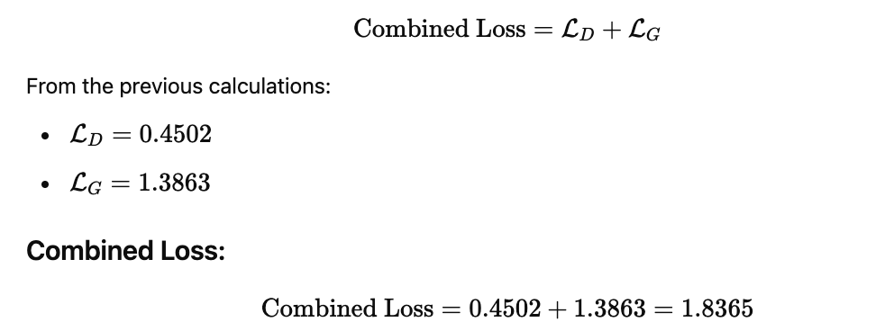
PB::::In a GAN, the Discriminator’s loss function is defined as given below.Given that D(x)=0.9 for real data samples and D(G(z))=0.2 for fake samples, and N=100, compute the Discriminator's loss.
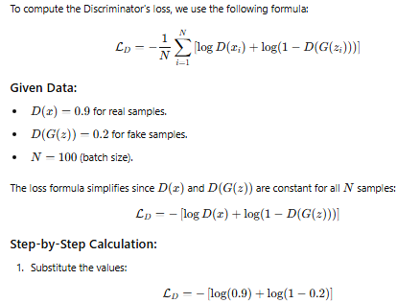
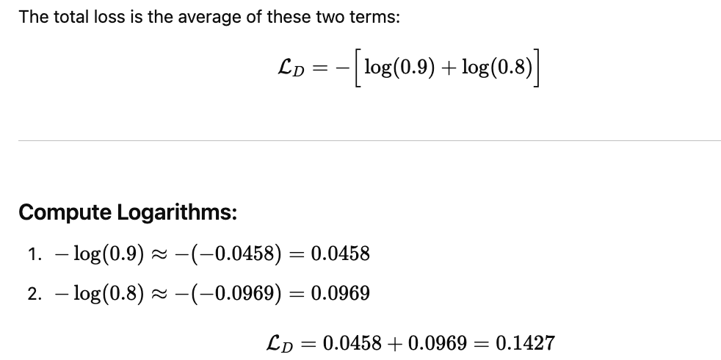

Q:::::In a GAN, compute the Discriminator’s loss for 5 real samples and 5 fake samples. The Discriminator's prediction values for real samples are D(x)={0.9,0.8,0.85,0.87,0.92}, and for fake samples are D(G(z))={0.2,0.15,0.18,0.25,0.22}. Calculate the individual losses for each sample, and then determine the average Discriminator loss.
USE LOG BASE 10 ONLY FOR COMPUTING NUMERICAL

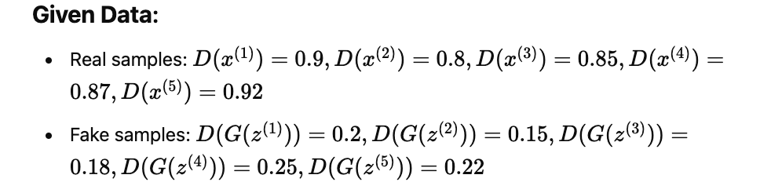
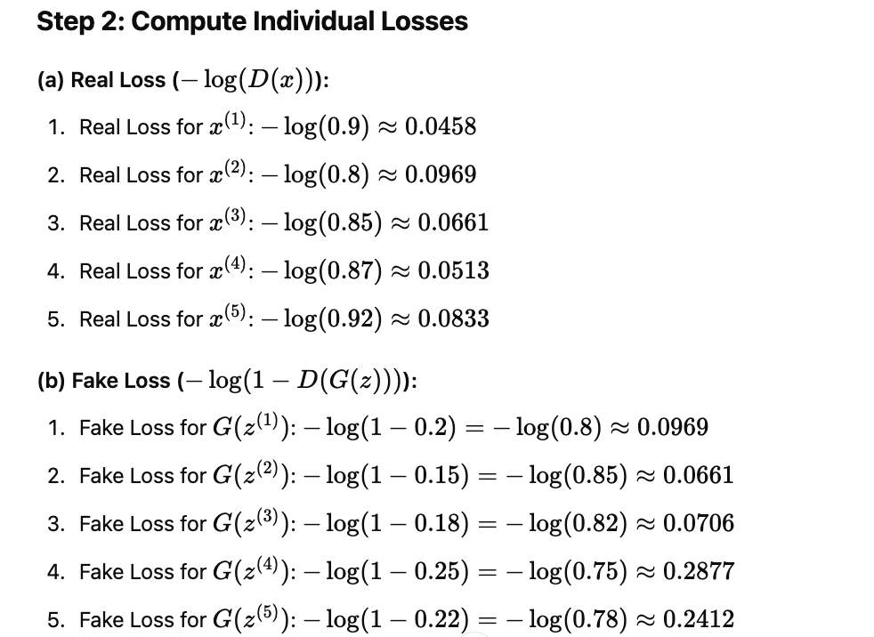
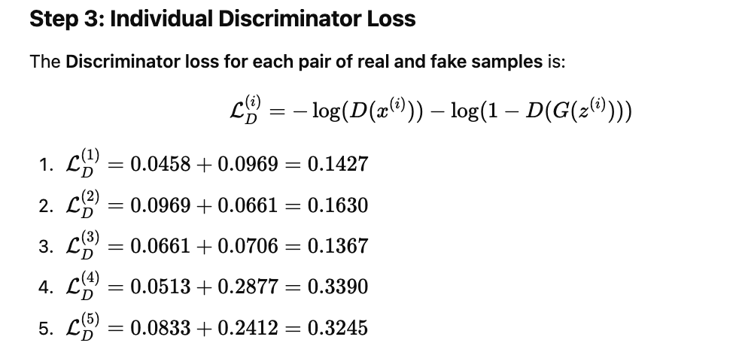
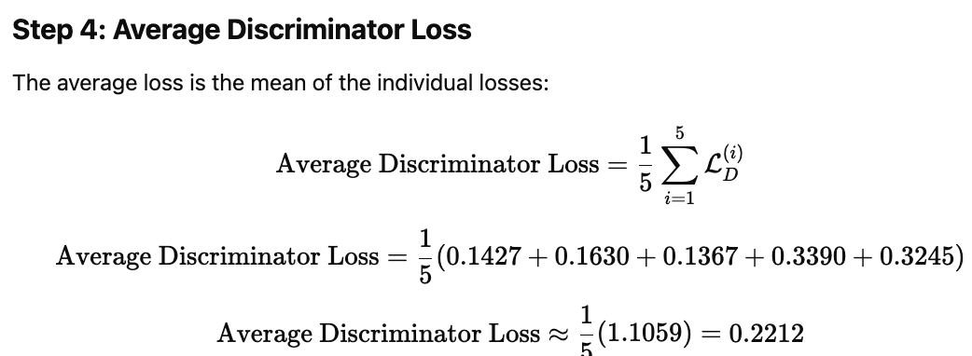

9.2 Train GAN Model

9.2.1 Basic Terminology of GAN Training

Before diving into the process, let’s understand some fundamental concepts and terms involved in GAN training:

1. Latent Space
- A vector of random noise (e.g., Gaussian distribution) fed into the generator to create diverse outputs.
- Represents compressed and abstract data features.

2. Loss Functions
- Generator Loss: Encourages the generator to create data that the discriminator classifies as real.
- Discriminator Loss: Measures how well the discriminator distinguishes between real and fake data.

3. Training Loop
- Alternates between training the generator and discriminator.
- Aims to reach a Nash equilibrium where the generator creates realistic outputs, and the discriminator struggles to differentiate real from fake.

9.2.2 Detailed GAN Training Process

Stage 1: Initialize the GAN
- Build the generator and discriminator models with appropriate architectures (e.g., fully connected layers, convolutional layers).
- Initialize model weights randomly.
- Define optimizers (e.g., Adam) and hyperparameters like learning rate and batch size.

Stage 2: Prepare the Dataset
- Load the dataset (e.g., MNIST, CIFAR-10).
- Normalize the data to a range of [-1, 1] for stability with the generator’s tanh output.
- Shuffle and batch the dataset for training.

Stage 3: Define Loss Functions
- Generator Loss:
  - Measures how well the generator fools the discriminator.
  - Example: Binary Cross-Entropy Loss with real labels (1) for fake data.
- Discriminator Loss:
  - Measures how well the discriminator distinguishes real from fake data.
  - Combines two Binary Cross-Entropy Losses:
    - For real data: Discriminator predicts 1.
    - For fake data: Discriminator predicts 0.

Stage 4: Train the GAN
The GAN training alternates between training the discriminator and the generator.

Step 4.1: Train the Discriminator
- Input Real Data:
  - Select a batch of real images from the dataset.
  - Pass them to the discriminator.
  - Compute the loss between discriminator predictions and real labels (1).
- Input Fake Data:
  - Generate fake images using the generator with random noise as input.
  - Pass the fake images to the discriminator.
  - Compute the loss between discriminator predictions and fake labels (0).
- Update the Discriminator:
  - Combine the real and fake losses.
  - Backpropagate the total loss and update discriminator weights.

Step 4.2: Train the Generator
- Generate Fake Data:
  - Use random noise as input to the generator to create fake images.
- Fool the Discriminator:
  - Pass the fake images to the discriminator.
  - Compute the loss between discriminator predictions and real labels (1).
  - This step teaches the generator to produce realistic data.
- Update the Generator:
  - Backpropagate the generator loss and update its weights.

Stage 5: Repeat for Multiple Epochs
- Iterate through the dataset for multiple epochs.
- In each epoch:
  - Train the discriminator several times to improve its classification accuracy.
  - Train the generator to produce more realistic data.

Stage 6: Monitor Progress
- After every few epochs:
  - Save or visualize generated images to assess their quality.
  - Track generator and discriminator losses to monitor convergence.
- If the generator loss decreases and discriminator loss stabilizes, the GAN is improving.

Practical Implementation of Generative Adversarial Networks (GANs) on MNIST Dataset
# example of training a gan on mnist
from numpy import expand_dims
from numpy import zeros
from numpy import ones
from numpy import vstack
from numpy.random import randn
from numpy.random import randint
from keras.datasets.mnist import load_data
from keras.optimizers import Adam
from keras.models import Sequential
from keras.layers import Dense
from keras.layers import Reshape
from keras.layers import Flatten
from keras.layers import Conv2D
from keras.layers import Conv2DTranspose
from keras.layers import LeakyReLU
from keras.layers import Dropout
from matplotlib import pyplot

# define the standalone discriminator model
def define_discriminator(in_shape=(28,28,1)):
model = Sequential()
model.add(Conv2D(64, (3,3), strides=(2, 2), padding='same', input_shape=in_shape))
model.add(LeakyReLU(alpha=0.2))
model.add(Dropout(0.4))
model.add(Conv2D(64, (3,3), strides=(2, 2), padding='same'))
model.add(LeakyReLU(alpha=0.2))
model.add(Dropout(0.4))
model.add(Flatten())
model.add(Dense(1, activation='sigmoid'))
# compile model
opt = Adam(lr=0.0002, beta_1=0.5)
model.compile(loss='binary_crossentropy', optimizer=opt, metrics=['accuracy'])
return model

# define the standalone generator model
def define_generator(latent_dim):
model = Sequential()
# foundation for 7x7 image
n_nodes = 128 * 7 * 7
model.add(Dense(n_nodes, input_dim=latent_dim))
model.add(LeakyReLU(alpha=0.2))
model.add(Reshape((7, 7, 128)))
# upsample to 14x14
model.add(Conv2DTranspose(128, (4,4), strides=(2,2), padding='same'))
model.add(LeakyReLU(alpha=0.2))
# upsample to 28x28
model.add(Conv2DTranspose(128, (4,4), strides=(2,2), padding='same'))
model.add(LeakyReLU(alpha=0.2))
model.add(Conv2D(1, (7,7), activation='sigmoid', padding='same'))
return model

# define the combined generator and discriminator model, for updating the generator
def define_gan(g_model, d_model):
# make weights in the discriminator not trainable
d_model.trainable = False
# connect them
model = Sequential()
# add generator
model.add(g_model)
# add the discriminator
model.add(d_model)
# compile model
opt = Adam(lr=0.0002, beta_1=0.5)
model.compile(loss='binary_crossentropy', optimizer=opt)
return model

# load and prepare mnist training images
def load_real_samples():
# load mnist dataset
(trainX, _), (_, _) = load_data()
# expand to 3d, e.g. add channels dimension
X = expand_dims(trainX, axis=-1)
# convert from unsigned ints to floats
X = X.astype('float32')
# scale from [0,255] to [0,1]
X = X / 255.0
return X

# select real samples
def generate_real_samples(dataset, n_samples):
# choose random instances
ix = randint(0, dataset.shape[0], n_samples)
# retrieve selected images
X = dataset[ix]
# generate 'real' class labels (1)
y = ones((n_samples, 1))
return X, y

# generate points in latent space as input for the generator
def generate_latent_points(latent_dim, n_samples):
# generate points in the latent space
x_input = randn(latent_dim * n_samples)
# reshape into a batch of inputs for the network
x_input = x_input.reshape(n_samples, latent_dim)
return x_input

# use the generator to generate n fake examples, with class labels
def generate_fake_samples(g_model, latent_dim, n_samples):
# generate points in latent space
x_input = generate_latent_points(latent_dim, n_samples)
# predict outputs
X = g_model.predict(x_input)
# create 'fake' class labels (0)
y = zeros((n_samples, 1))
return X, y

# create and save a plot of generated images (reversed grayscale)
def save_plot(examples, epoch, n=10):
# plot images
for i in range(n * n):
# define subplot
pyplot.subplot(n, n, 1 + i)
# turn off axis
pyplot.axis('off')
# plot raw pixel data
pyplot.imshow(examples[i, :, :, 0], cmap='gray_r')
# save plot to file
filename = 'generated_plot_e%03d.png' % (epoch+1)
pyplot.savefig(filename)
pyplot.close()

# evaluate the discriminator, plot generated images, save generator model
def summarize_performance(epoch, g_model, d_model, dataset, latent_dim, n_samples=100):
# prepare real samples
X_real, y_real = generate_real_samples(dataset, n_samples)
# evaluate discriminator on real examples
_, acc_real = d_model.evaluate(X_real, y_real, verbose=0)
# prepare fake examples
x_fake, y_fake = generate_fake_samples(g_model, latent_dim, n_samples)
# evaluate discriminator on fake examples
_, acc_fake = d_model.evaluate(x_fake, y_fake, verbose=0)
# summarize discriminator performance
print('>Accuracy real: %.0f%%, fake: %.0f%%' % (acc_real*100, acc_fake*100))
# save plot
save_plot(x_fake, epoch)
# save the generator model tile file
filename = 'generator_model_%03d.h5' % (epoch + 1)
g_model.save(filename)

# train the generator and discriminator
def train(g_model, d_model, gan_model, dataset, latent_dim, n_epochs=100, n_batch=256):
bat_per_epo = int(dataset.shape[0] / n_batch)
half_batch = int(n_batch / 2)
# manually enumerate epochs
for i in range(n_epochs):
# enumerate batches over the training set
for j in range(bat_per_epo):
# get randomly selected 'real' samples
X_real, y_real = generate_real_samples(dataset, half_batch)
# generate 'fake' examples
X_fake, y_fake = generate_fake_samples(g_model, latent_dim, half_batch)
# create training set for the discriminator
X, y = vstack((X_real, X_fake)), vstack((y_real, y_fake))
# update discriminator model weights
d_loss, _ = d_model.train_on_batch(X, y)
# prepare points in latent space as input for the generator
X_gan = generate_latent_points(latent_dim, n_batch)
# create inverted labels for the fake samples
y_gan = ones((n_batch, 1))
# update the generator via the discriminator's error
g_loss = gan_model.train_on_batch(X_gan, y_gan)
# summarize loss on this batch
print('>%d, %d/%d, d=%.3f, g=%.3f' % (i+1, j+1, bat_per_epo, d_loss, g_loss))
# evaluate the model performance, sometimes
if (i+1) % 10 == 0:
summarize_performance(i, g_model, d_model, dataset, latent_dim)

# size of the latent space
latent_dim = 100
# create the discriminator
d_model = define_discriminator()
# create the generator
g_model = define_generator(latent_dim)
# create the gan
gan_model = define_gan(g_model, d_model)
# load image data
dataset = load_real_samples()
# train model
train(g_model, d_model, gan_model, dataset, latent_dim)
9.3 GAN Application
Generative Adversarial Networks (GANs) have diverse applications across various fields. Some notable ones include:
- Image Generation and Synthesis: GANs are extensively used in creating high-quality images from random noise. For instance, they can generate realistic faces, landscapes, or art, which have applications in entertainment, design, and fashion.
- Data Augmentation: In fields like medical imaging, GANs can generate synthetic images to augment small datasets, enhancing model training, especially in scenarios where annotated data is scarce. This is particularly useful for conditions like rare diseases or imaging techniques with limited data.
- Super-Resolution: GANs are used to upscale images, making low-resolution images clearer and more detailed. This has applications in satellite imaging, surveillance, and medical imaging.
- Style Transfer: GANs enable transforming the style of one image (like a painting style) while retaining the content of another image. This is widely used in art, entertainment, and media.
- Face Aging and Face Editing: GANs are employed for tasks like aging a face over time or modifying facial features in photos, which is useful in entertainment and security applications.
- Text-to-Image Generation: By conditioning on textual descriptions, GANs can generate images that match specific descriptions, making them valuable in content creation, marketing, and accessibility.
- Video Generation: GANs are also used in video generation and synthesis, where they create realistic sequences of frames, useful for animation and film production.
- Medical Imaging: As you're exploring in your research, GANs can be applied to early detection of multimodal conditions by generating synthetic medical images that help with diagnosis, augmenting rare disease data, and improving medical image segmentation models.
- 3D Object Generation: GANs can generate 3D models from 2D images, aiding in virtual reality, gaming, and robotics.
Their versatility is what makes GANs a powerful tool across so many domains.

