# Chapter 1: Introduction

## 1.1 Background

BIM requires four years of study to acquire undergraduate academic degree. Initiated by Tribhuvan University in 2001, this course is offered only in a few accountable colleges in Nepal. The course structure is a hybrid program with about 60% information technology and 40% management theory courses. The program intends to equip students with the skills and attributes required to be effective and efficient IT professionals.

Information Management is the study of information and communication systems in business and administration, and is becoming increasingly relevant to other fields as well. Information Management includes development and application of theories, ideas, models, methods, and tools in order to analyze, configure, and use information systems.

Business systems rely on many types of information systems that use a variety of information technologies. It is having impact on all industries in services and manufacturing. Computers and Internet are the major resources of IT which are the backbone today’s business. Internet is a public, cooperative, and self-sustaining facility accessible to hundreds of millions of people worldwide. It is a global network connection which provides medium for exchanging information, news and opinions. The number of Internet users represents 32.7 percent of the world's population. Users accessing the Internet can read, download data, send and receive mails from almost everywhere in the world.

The real time online system has come into existence because of the popularity of Internet. Organization are able to distribute information to the clients on real time basis and helps to build real time system by updating the information to the system. Thus, online system had become the most useful part of the business houses and every organization wants to implement online system for marketing and reporting.

Information Management relies on approaches used in business administration, economics, and computer science; it integrates these and supplements them with approaches that are specific to this subject area. The program is interdisciplinary in nature and courses are borrowed from many different disciplines like Management, Economics, Computer Science, Psychology and Sociology.

The Bachelor of Information Management (BIM) is a special purpose program in semester system designed to develop socially responsible, scientifically approached / creative, and result oriented Information Technology (IT) professionals. The program intends to equip students with the skills and attributes required to be effective and efficient IT professionals.

## 1.2 Purpose of Study/Objective

The changing nature of society has brought a growing demand for knowledge and information at work, in education and in leisure. Librarians, archivists, knowledge managers and many other information professionals are meeting that demand by providing effective access to information resources and services. BIM reflects the critical importance of information and knowledge management across a wide range of fields and institutions. The course provides students with an in-depth understanding of the creation, evaluation, collection, organization, utilization and dissemination of information in the contemporary.

The mission of this program is to develop socially responsible, scientifically approached and result oriented information technology (IT) professionals. The specific objectives of the program are to:

* Prepare IT professionals proficient in the use of computers and computational techniques
* Develop students’ skill in object-oriented software design methods and data management systems.
* Develop effective information systems to solve real life problems in the organizational milieu
* Provide professional training to students by combining information technology with managerial skills
* Prepare students to proceed on to post graduate level study in information management within and outside the country

## 1.3 Methodology

### 1.3.1 Organization Selection

Internship program is required to be performed by all the students for the completion of the BIM program. It is a 6 credit hour subject under which student are required to get attached themselves to an organization which provides an opportunity to work in a professional environment. The Selection of the organization is very crucial and important task. There were many alternatives from big to small organization. But before choosing, there always comes the interest and at the same time organizations’ culture and rules also limits the student to choose the organization for internship. Interest area and future opportunities were considered for choosing the right organization and Pagoda Labs was found to be the right organization for internship. Thus, I joined Pagoda Labs for internship program.

### 1.3.2 Placement/ Duration

Information technology has brought a revolutionary change in the present global market. There is no field that is untouched by IT. From the beginning, the organization’s environment and culture was good. The standard internship period fixed by the University is 6 credit hours. The duration of my internship period was of 2 months starting from April 11 th to June 11 th 2014. During this period I have to analyze the requirements, go through the details and design to meet requirement and develop documentation for the system. The work procedure for this project was categorized into eight different phases. Six different phases are:

* Planning and feasibility study
* Observation
* Analysis
* Design
* Coding and Development
* Testing
* Implementation and maintenance

The activities performed during the internship period have been presented graphically below in Gantt chart.

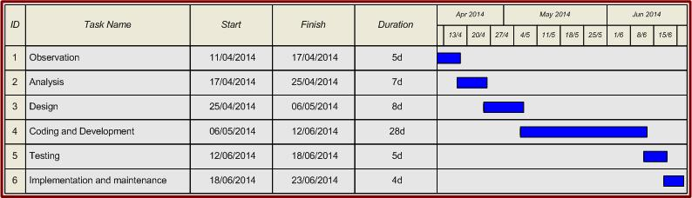

Figure 1: Gantt chart

# Chapter 2: Introduction to Industry

## 2.1 Introduction to Industry

Pagoda Labs is a digital solutions company with the firm belief that effective web design, development and social media strategies need not come with an expensive price tag. Pagoda Labs is a digital creative agency which is one of the popular IT Company in Kathmandu which has been helping the IT sector since 2007.Through this company I got opportunity to work on Online Movie Ticketing system which is design to provide online booking system for all cinema halls under single website.

## 2.2 Introduction to Online Movie Ticketing System

The main purpose of our online Movie ticket booking system is to provide an alternate and convenient way for a customer to buy cinema tickets. It is an automatic system. After the data has been fed into the database, the staff does not need to do anything with the order once it is received through the system. In fact, there is similar system on the internet, but there is no refund method found in the existing system. The goals of our system are:

1. To provide a anytime anyplace service for the customer
2. To minimize the number of staff at the ticket box
3. To promote the film on the internet
4. To increase the profit
5. To obtain statistic information from the booking record.

Our online Movie ticketing is a web-based system. The customers can buy ticket online and cancel the seat at a suitable time (2 days before the show to 1hour before the show). To enhance the refund function, all the customers have to registration become a member before buying ticket.

Staff (admin) can use the system to insert and delete data (e.g. film description, time table) which will update the webpage (webpage are dynamic page, changing according to the data in database). Also, staff can check the statistic information from the system.

Customer needs to register at the site to book tickets to the movie. After selecting the show, the user is presented a seating layout so that he can select seats of his choice. Thereafter the user is redirected to the payment gateway for making a transaction. Generally, a mail is send to the user’s email account. User can take a print out of the ticket and also view booking history. It is measurable, cost effective and user friendly interface. Such system is useful for both customers and promoters equally. Customers can buy movie tickets online at any instance of 24 hours day and can get information about new releases and discounts and give feedback to the owners. These feedbacks would be very important for cinema owners to make new strategy.

The project we are developing is a future project of the Pagoda Labs. However, Pagoda Labs has not named this project yet so we simply call it now Online Movie Ticketing System. This is a fresh new project of Pagoda Labs. This system is design to provide the service of ticket booking system of all cinemas hall under single website. This provides an easiness in moviegoers to view all their favorite movies and make booking. The main purpose of our movie ticketing system is to provide alternate and convenient way for customers to buy cinema tickets. It is an automatic system.

This system basically aims to provide complete information of the movie and schedule to the customer. Admin can use the system to insert and delete data such as movie description, movie schedule which will be update the related webpage and will accessible to the customer. Admin can also view sales reports and analysis and check statistical information from the system. Thus it is also an automated system.

Name of the organization : Pagoda Labs

Contact Person (Name and Position, Personal phone number):

Mr. Dixanta Bahadur Shrestha, CEO, 9849056900

Mr. Shoki Shakya, CEO, 9851043398

Address of the organization : Sanepa, Lalitpur, Nepal

Email : hello@pagodalabs.com

Website : [www.pagodalabs.com](http://www.pagodalabs.com)

Tele Phone : +977-1-5529041

## 2.3 Major Current programs:

1. Web Development Services  
2. Software Development Services  
3. Mobile & iphone Application Development  
4. Multimedia Solutions  
5. Internet Marketing & Search Engine Optimization  
6. Event management and Promotions (K.Garira Marketing and Promotions Pvt Ltd. Kgarira.com)

## 2.4 Mission :

By pulling together global resources, Pagoda Labs are able to provide clients a range of services at an affordable rate. Pagoda Labs serve clients through a number of services, including effective web design, web application development, print design, online marketing and brand development.  
  
 Pagoda Labs are a team of creative and hard working professionals. Pagoda Labs are dedicated to deliver on clients needs. Pagoda Labs are committed to delivering a high level of service and take pride in designs. Pagoda Labs take the time to understand the business and use those information to implement a tailor-made solution. In an environment where the Internet is vital in effective communication, it is important that businesses use all available tools to leverage their market position.

## Objective of the project:

1. To provide a anytime anyplace service for the customer
2. To minimize the number of staff at the ticket box
3. To promote the film on the internet
4. To increase the profit
5. To obtain statistic information from the booking record.

# Chapter 3: Problem Analysis

Modern organization are facing challenges with the problem of management of the information. Appropriate information system is required for enterprises since such information system helps to keep and maintain information and records for long time. So that organization can grab the opportunity and to lead to success. The basic aim of problem analysis is to obtain clear understanding of the needs of the clients and users, what exactly is desired from the software and what the constraints on the solution are. Thus, analysis leads to the actual specification.

## 3.1 Description of the system under study

Online Movie ticketing system is an Internet based application that can be accesses throughout the internet and can be accessed by anyone who has an internet connection. This application will automate the reservation of tickets and enquiries about availability of the tickets. This application includes email confirmation for the tickets. Online Movie ticketing system will be the improved site for booking tickets in cinemas halls. There are websites related to online booking system in Nepal. However, they are limited to some cinema halls only. Our website will allows the users to book the tickets of any cinema halls and get more information about every movies and cinemas halls of Nepal. Site will also notify the customer through emails about different events and facilities. It is important to have a responsive dynamic websites that gives unlimited with up-to-date information for this purpose.

## 3.2 Technical Requirements Analysis

|  |  |
| --- | --- |
| Tools | Details |
| Programming language | PHP based framework - CodeIgniter |
| Database | MYSQL |
| Graphic Design | Adobe Photoshop CS, Twitter Bootstraps |
|  |  |

Table 1: Tools and Platform

|  |  |
| --- | --- |
| Hardware | Specification |
| Processor | Pentium 4 or above |
| RAM | 512 MB or above |
| Visual Display Adapter | 8 MB True Color |
|  |  |

|  |  |
| --- | --- |
| Software | Specification |
| Server | Apache Web Server |
| Operating System | Windows XP or above |
| Application Software | JETBRAINS PHPSTORM |

Table 2: Hardware Requirements

Table 3: Software Requirements

# Chapter 4: Design of Information System

## 4.1. System Development procedure

System Development procedure defines a way of developing the system using various tools and technique such as feasibility analysis, system analysis, system design etc. For the development of Online Move Ticketing System, following a system development procedure which is generally known as system development life cycle (SDLC) is applied. The general steps that has been followed for development of system can be shown below:

Feasibility Analysis

System Analysis

System Design

System Development

System Implementation and Maintenance

Fig 2: System Development Cycle

### 4.1.1. Feasibility Study

First stage is the feasibility analysis where we define and understand what services are required from the system and identify the constraints on the system’s operation and development. .During this phase, a feasibility study was conducted to determine whether the system is feasible solution or not. We have to estimate whether the present systems are satisfying the user’s need or not. System investigation was conducted to determine whether the system produced a feasible solution for the organisation or not. The study considers whether the proposed system will be cost effective from a business point of view and whether it can be developed within existing constraints.Requirement Analysis was done and the necessary components were to be included in the system. A preparation was done and the necessary components to be included in the system were derived

### 4.1.2. System Analysis

The system service, constraints and goals are establish by consultation with system users. They are often define in detail and serve as a system specification.During this phase, the requirements are analysed to meet the user needs. It consists of defining the problem, identifying its causes, specifying the solution and identifying the information requirements.

### 4.1.3. System Design

Third stage is System design. This is the implementation stage of software development where system specification are converted into an executable system. System design is a description of the structure of the system to be implemented. It establishes overall system architecture.The system module that satisfies the functional requirements of the proposed system was developed. In this phase both logical and physical design of the system was done. Design process involves developing several models of the system at different levels of abstraction. As a design is decomposed, errors and omissions in earlier stage are discovered.

### 4.1.4. System Development

Fourth stage is System development where actual development process is performed. Coding, debugging and testing process is applied throughout this stage. Once the different modules are been developed they are integrated the whole system. System validation process is performed to show that system confirms to its specification and that the system meets the expectations of the customers. It involves checking process, such as inspection and reviews at each of the software process form user requirements definition to program development.

### 4.1.5. System Implementation and Maintenance

Final stage is System implementation. This is the longest life cycle phase. The system is install and used in practical. The hardware and software were acquired for implementation of the system and was tested for errors. It involves installing the new system and changeover from the existing system to the new one. Maintenance involves correcting errors which were not discovered earlier stages of the life cycle, improving the implementation of system units and enhancing the system services as new requirements are discovered. The system must be evolved to meet changing customer needs.

## 4.2 General Architecture Overview of the system

Since our system is we based application, we require internet for getting interface of Online Movie Ticketing System. User can access our site through web browsers. Following figure is the general overview of the system.

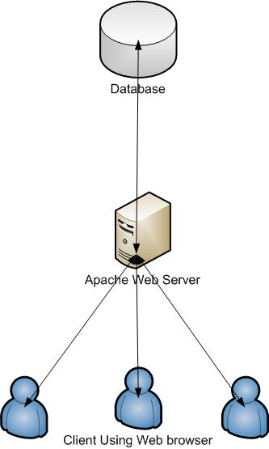

Figure 3: General overview of the system

Users can access our website through network from their web browser. Web browser will request to the server for ours. For now our web server is apache web server that will process the request. Information will be fetch from database and presented to users at their browsers.

## 4.3 Use Case Diagrams

A use case diagram is a type of behavioral diagram which is used to present a graphical overview of the functionality of the system. It shows a set of users and actors and their relationship. Thus, it provides an overview of all or part of the usage requirements for a system in form of an essential models. Use case model uses:

1. Use cases: It describes a sequence of action that can performed by actors and is drawn in horizontal ellipse.
2. Actors: It is a person, organization or external system that plays a role in one more interactions with system.
3. Associations: Associations exists between actors when interactions is involved described by use case diagram and indicated by solid lines.
4. System Boundary Boxes: Rectangle around the use cases indicates the system boundary box to indicate the scope of the system. Anything in the box represents functionality that is in scope and anything outside is not.

We apply use case diagram to illustrate the use view of the system. In Online Movie Ticketing System, there are two system actors.

1. Administrator: They are system actor who perform and provides information, interact with the system and can make changes in the content of the system.
2. Normal User: They are normal actor who interact with the system and gets information and services.

Use case diagram of administrator and client are available in following pages.

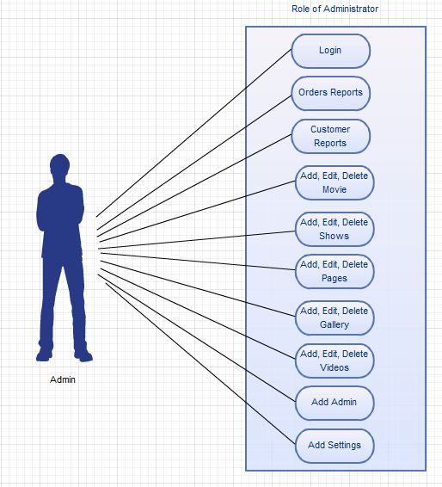

Figure 4: Use case diagram of administrator

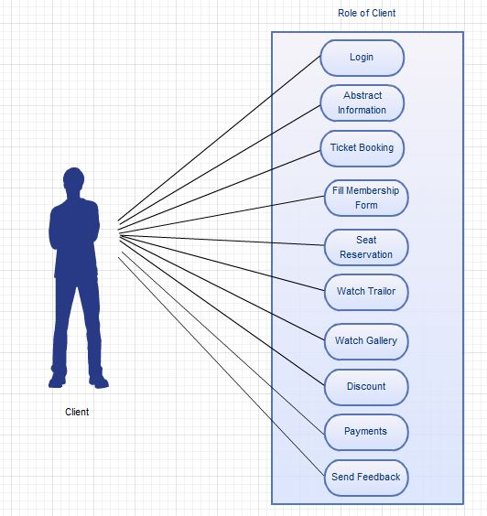

Figure 5: Use Case Diagram of Client

## 4.4 Database Design

### 4.4.1 ER Diagram

ER diagram is the overall design of the database geographically. They are simple and descriptive which defines all the system entities. It represents structure and layout of the database. ERD plays important role to give information about system and relationship with each other.

Such a diagram consists of the following major components.

|  |  |
| --- | --- |
| Entities | Attributes |
| Admin | Admin_id , Admin_name, email, password, created_date, group_id, status |
| admin_group | Group_id, group_name |
| cinema | Cinema_id, name, description, street_name, city, longitude, latitude, contact_no, website |
| halls | Hall_id, hall_name, seat_capacity, cinema_id |
| Movie | Movie_id, name, description, release_date, picture, trailer, starring, rating, type, length, cbfc_rating, status, genre |
| hall_seat | Hall_seat_id, seat_type, price, hall_id |
| shows | Show_id, time, hall_id, movie_id, price, date |
| members | Member_id, name, contact_no, address, email, password |
| booking | Booking_id, hall_seat_id, member_id, show_id, payment_transaction, ticket_id |
| tickets | Ticket_id, show_id, , member_id, seat_id, date |

Table 4: Entities and their corresponding attributes

The different symbols used in ERD are shown below:

ENTITIES:

Entities are objects or concepts that represent important data. They are typically nouns.

**Strong entities** exist independently from other entity types. They always possess one or more attributes that uniquely distinguish each occurrence of the entity.

**Weak entities** depend on some other entity type. They don't possess unique attributes (also known as a primary key) and have no meaning in the diagram without depending on another entity. This other entity is known as the owner.

**Associative entities** are entities that associate the instances of one or more entity types. They also contain attributes that are unique to the relationship between those entity instances.

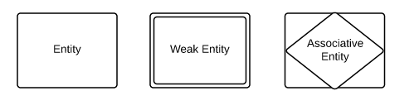

RELATIONSHIPS:

Relationships are meaningful associations between or among entities. They are usually verbs.

Weak relationships, or identifying relationships, are connections that exist between a weak entity type and its owner.

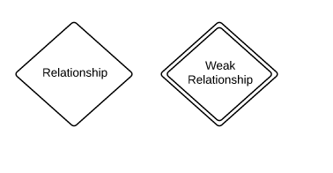

ATTRIBUTES

Attributes are characteristics of either an entity, a many-to-many relationship, or a one-to-one relationship.

Multivalued attributes are those that are capable of taking on more than one value.

Derived attributes are attributes whose value can be calculated from related attribute values.

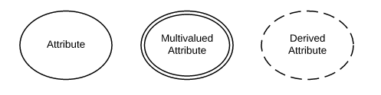

ERD Notation

Relationships illustrate an association between two tables. In the physical data model, relationships are represented by stylized lines.

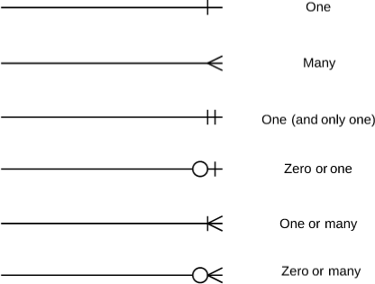

Some of the ER diagram from the schema diagram designed for Online Movie Ticketing System are given in following pages.

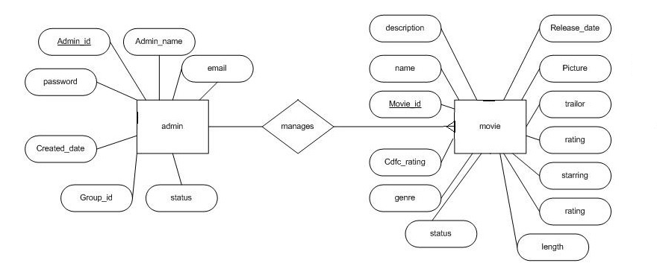

Figure 6: Entity relationship between admin and movie

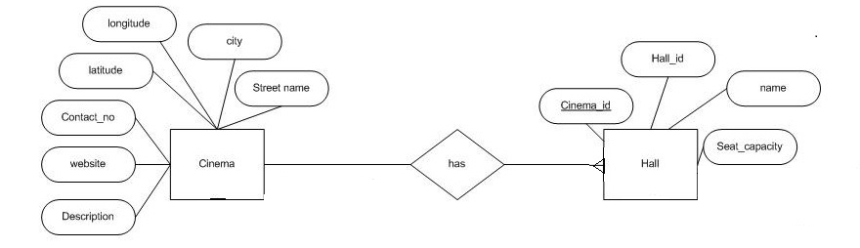

Figure 7: Entity relationship between cinema and hall

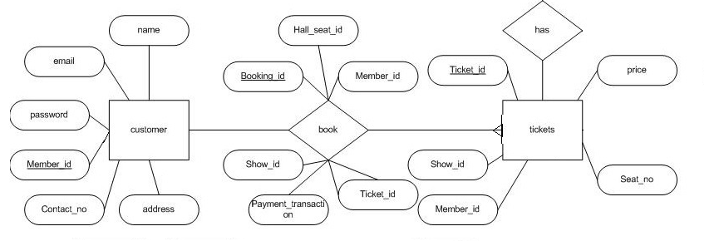

Figure 8: Entity relationship between customer and tickets

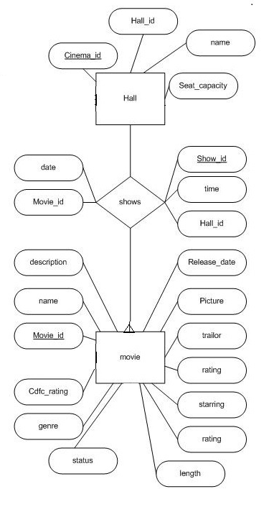

Figure 9: Entity relationship between hall and movie

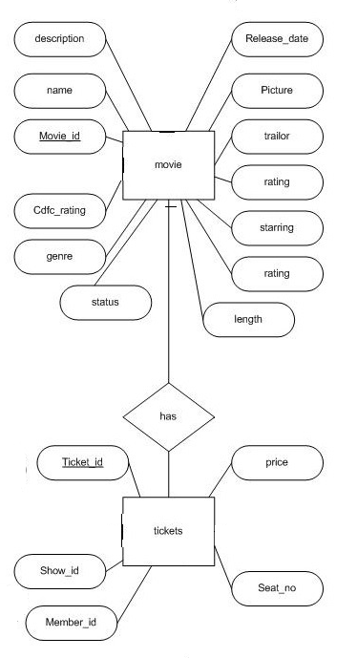

Figure 10: Entity relationship between movie and tickets

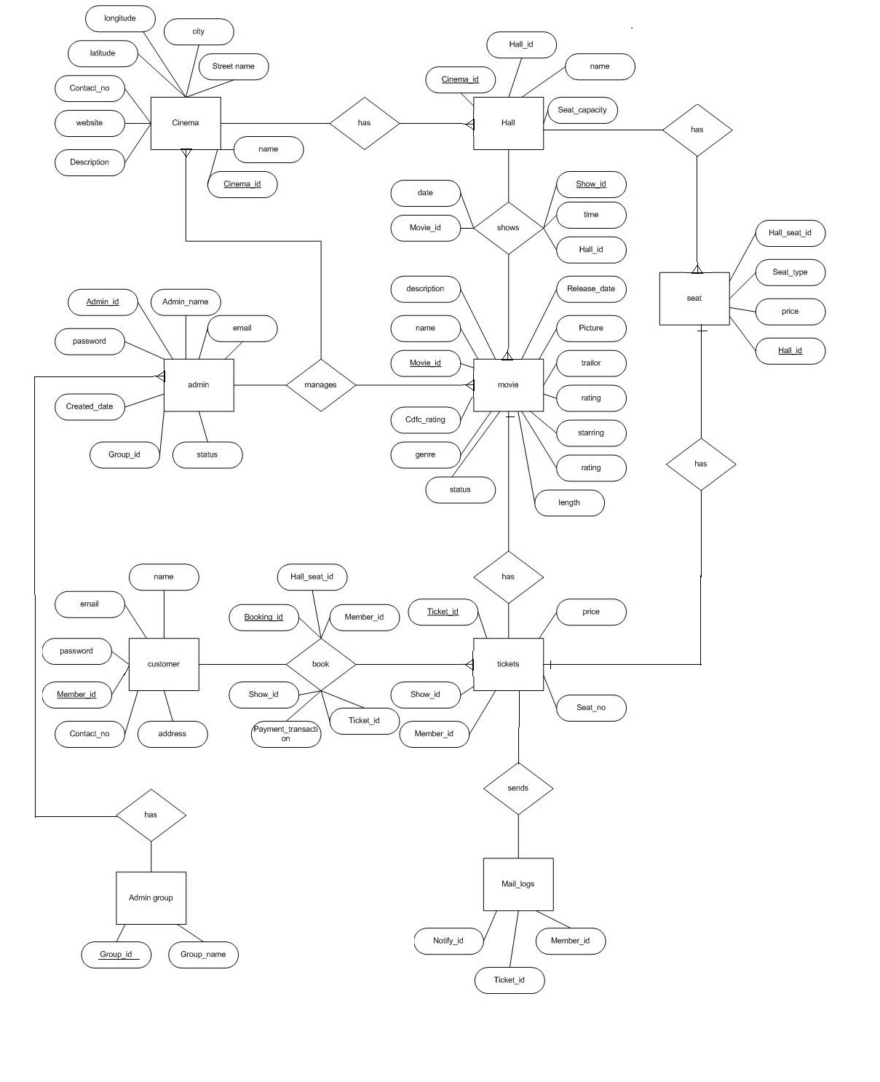

Figure 11: Overall Entity relationship diagram of Online Movie Ticketing system