DevSecOps GitOps Platform
Complete Setup & Learning Guide
AWS · Terraform · GitHub Actions · DevSecOps · Platform Engineering
Steps Completed | Resume From | End Goal
Steps 1–11 completed | Step 12: VPC Module + CI Alignment | Internal Developer Platform
Version 1.1 · Last updated: April 2, 2026

Project Vision
Building a production-grade, multi-environment infrastructure platform on AWS using Terraform and GitHub Actions. The immediate goal is learning DevOps and DevSecOps at production quality. The long-term goal is an Internal Developer Platform where developers self-serve infrastructure through a portal.
Phase | What we are building
Phase 1 — Foundation | AWS security, IAM, Terraform pipeline, self-hosted EC2 runner, multi-environment setup, ephemeral deployments, release tags
Phase 2 — Platform Modules | Reusable Terraform modules: VPC, EC2, ALB, ECS, EKS, Lambda with docs and secure defaults
Phase 3 — IDP | Developer portal, service catalog, self-service workflows, cost visibility, drift detection, visual workflows
Full Project Roadmap
Step | Status | What it covers
Step 1–11 | Done | Security baseline, IAM, runner, bootstrap, CI/CD foundation, promote, destroy
Step 12 | In Progress | Reusable Terraform VPC module wired into dev, stage, and prod
Step 13 | Next | Import the existing runner VPC into Terraform state
Step 14 | Planned | EC2 and ALB reusable modules
Step 15 | Planned | ECS reusable module
Step 16 | Planned | Migrate runner from EC2 to ECS Fargate
Step 17 | Planned | EKS reusable module
Step 18 | Planned | Migrate runner to EKS with ARC
Step 19 | Planned | Internal developer portal
Current State Snapshot
Repository
• Terraform environments exist for dev, stage, and prod.
• GitHub Actions workflows exist for CI, CD, promote, and destroy.
• A reusable VPC module exists in terraform/modules/vpc.
• Self-hosted GitHub Actions runner is running on EC2.
Current Implementation State
• dev, stage, and prod now use a shared VPC module wrapper pattern.
• Environment-specific values are supplied through terraform.tfvars files.
• Outputs are exposed from each environment for later module integration.
• CI is being aligned to map branch intent to the correct Terraform environment.
Locked-In Decisions
• AWS region is ap-south-1.
• Terraform baseline is >= 1.10.0 with S3 native locking.
• No DynamoDB table for state locking.
• No static AWS access keys.
• No NAT Gateway for this learning platform.
• dev stays cost-optimized.
• stage and prod use stronger observability defaults.
• Reusable Terraform modules are the main implementation pattern.
CI/CD Architecture
The pipeline follows a simple GitOps path: feature branches validate first, protected branches map to environment-specific validation, and CD remains limited to dev, stage, and main merges.
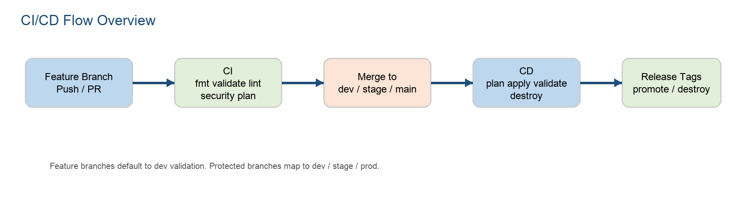
Workflow Notes
Workflow | Current Direction | Best Practice Notes
CI | Run on push to any branch and PR to dev/stage/main | Feature branches default to dev validation; protected branches map to dev, stage, prod
CD | Run only on push to dev, stage, main | Correct for promotion and deploy intent
Promote | Use release tags for stage/prod movement | Manual confirmation for prod remains a good control
Destroy | Manual only with audit trail | Strong safety posture; keep approvals and audit log
Current Step
Step 12: First VPC Module
• Replace old demo resources with a reusable VPC module in dev, stage, and prod.
• Expose environment outputs for future ECS, ALB, and EKS modules.
• Keep dev cheaper, stage/prod more production-like.
Item | Value / Decision
Dev VPC CIDR | 10.0.0.0/16
Stage VPC CIDR | 10.1.0.0/16
Prod VPC CIDR | 10.2.0.0/16
AZ Count | dev=1, stage=2, prod=2
Flow Logs | disabled in dev, enabled in stage and prod
NAT Gateway | not used
Security & Compliance Fixes
Checkov Finding | Why it failed | Fix / Decision
CKV2_AWS_12 | Default security group was unmanaged | Default SG locked down explicitly
CKV_AWS_130 | Public subnets auto-assigned public IPs | map_public_ip_on_launch set to false
CKV_AWS_158 | CloudWatch Log Group not encrypted with KMS | Add customer-managed KMS key for flow logs
CKV_AWS_338 | Retention less than 1 year | Stage and prod flow-log retention should be >= 365 days
CKV_AWS_290 / 355 | IAM policy was too broad | Scope write permissions to the specific log group ARN
Self-Hosted Runner Notes
Disk space pressure on the EC2 runner is expected over time. Common cleanup candidates are old runner tarballs, old versioned bin/externals directories, _diag logs, Docker artifacts, and tool caches.
Runner Item | Can Clean? | Notes
actions-runner-linux-x64-*.tar.gz | Yes | Installer archive is safe to remove
_diag old logs | Yes | Keep only recent logs if needed
bin.older-version | Usually | Remove only after confirming active version
externals.older-version | Usually | Remove only after confirming active version
bin / externals current | No | These are active runner components
Local Verification Practice
• Run terraform fmt -check -recursive terraform before push.
• Run terraform init -backend=false and terraform validate for affected environments.
• Use CI for heavier checks like Checkov, Trivy, Gitleaks, and full backend-backed plan.
• If a shared module changes, validate dev, stage, and prod locally.
Working Notes
Date | Step | Update
2026-04-01 | Step 12 | Replaced demo environment pattern with reusable VPC module wrappers for dev, stage, and prod
2026-04-01 | Step 12 | Added environment-specific tfvars, outputs, and typed variables for all three environments
2026-04-01 | Step 12 | Fixed VPC security findings for default security group and public subnet public-IP behavior
2026-04-02 | CI | CI workflow aligned conceptually to map branch intent to the correct Terraform environment
2026-04-02 | Ops | Reviewed self-hosted runner disk usage and identified safe cleanup candidates
2026-04-02 | Security | New Checkov findings identified around flow-log KMS, retention, and IAM scoping
Next Step
• Finalize ci.yml and .gitignore updates.
• Apply flow-log KMS, retention, and IAM scoping improvements in the VPC module.
• Push changes and observe CI results.
• Move to Step 13: import the existing runner VPC into Terraform state.

