**Algorithmic Trading Product using Machine Learning**

#### A PROJECT REPORT

##### Submitted by

**ADARSH MISHRA**

#### 180130111046

##### In partial fulfilment for the reward of the degree of

**BACHELOR OF ENGINEERING**

### in

**Electronics & Communication Engineering**

**Government Engineering College, Gandhinagar**



**Gujarat Technological University, Ahmedabad April, 2022**

*First Page*

 

**Government Engineering College, Gandhinagar**

**CERTIFICATE**

This is to certify that the project report submitted along with the project entitled **Algorithmic Trading Product using Machine Learning** has been carried out by **Adarsh Mishra** under my guidance in partial fulfilment for the degree of Bachelor of Engineering in **Electronics & Communication**, 8th Semester of Gujarat Technological University, Ahmedabad during the academic year 2021-22.

|  |
| --- |
| **Mr. Kalpesh Kumar Patel Mr. Kishor Kumar Maradia** |
| **Internal Guide Head of Department** |
|  |
|  |

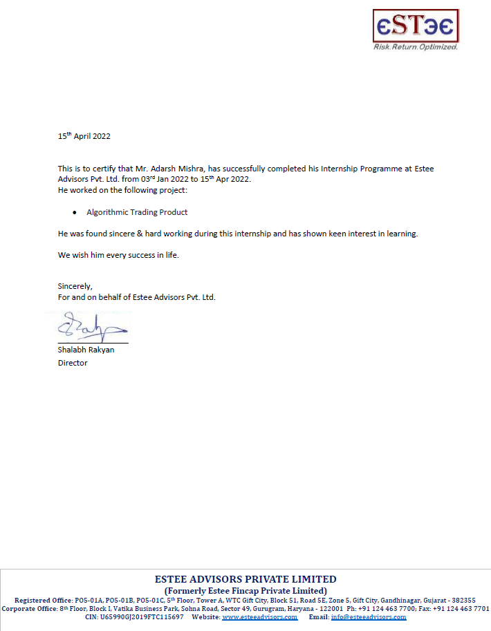

 

**Government Engineering College, Gandhinagar**

**DECLARATION**

I hereby declare that the Internship / Project report submitted along with the Internship / Project entitled **Algorithmic Trading Product using Machine Learning** submitted in partial fulfilment for the degree of Bachelor of Engineering in **Electronics & Communication** to Gujarat Technological University, Ahmedabad, is a bonafide record of original project work carried out by me / us at GEC Gandhinagar under the supervision of **Prof. Kalpesh K Patel** and that no part of this report has been directly copied from any students’ reports or taken from any other source, without providing due reference.

Adarsh Mishra

# ACKNOWLEDGEMENT

First, I would like to thank **Mr. Tushar Shrivastava**, Head, of **Technology Operations in Estee Advisors** for giving me the opportunity to do an internship within the organization.

It is indeed with a great sense of pleasure and immense sense of gratitude that I acknowledge the help of these individuals.

I am highly indebted to my institute guide **Mr. Kalpesh Kumar Patel** and Principal **Dr. Sweta P. Dave**, for the facilities provided to accomplish this internship.

I would like to thank my Head of the Department **Mr. Kishor Kumar Maradia** for his constructive criticism throughout my internship.

I would like to thank College internship coordinator **Mr. Devendra H Patel** internship coordinator Department of Electronics & Communication Department for their support and advices to get and complete internship in above said organization.

I am extremely great full to my department staff members and friends who helped me in successful completion of this internship.

.

Adarsh Mishra

180130111046

# ABSTRACT

We all know about trading; Stock trading involve buying & selling of stocks frequently in order to achieve some profit. Manual trading is almost known to everyone. But for the past few years after research on machine learning and various algorithms were done it was found that we can use this knowledge of ours in machine learning & apply it for trading & thus we came to the term which we now know as **Algo trading**. Algo trading is a form of trading which is done using algorithms which in place of manual decision takes decision on itself to indulge in trading. Estee Advisors is also a quant-based investment management and execution and services provider. I did my internship in Estee Advisors as an Analyst (Technology Operations).

# LIST OF FIGURES

Figure 5.5.1 Model Based on Technical Analysis. 17

Figure 5.6.1 Model Based on Textual Analysis… 18

Figure 5.7.1 Processing data 20

**TABLE OF CONTENTS**

ACKNOWLEDGEMENT i

ABSTRACT ii

LIST OF FIGURES iii

1. INTRODUCTION 1

1.1 Overview Of the Company 1

1.2 What Is Algo Trading? 2

1.3 Features of Algo Trading: 2

1.4 Technical Requirement for Algo Trading 3

2. LEARNING PHASE-I 4

2.1 Learning The Fundamentals 4

2.2 Learning about various Applications 4

2.3 Learning about Services 5

3. LEARNING PHASE-II 6

3.1 What it means to be an Analyst 6

3.2 Role of Analyst 6

3.3 Knowledge Requirement 6

4. MACHINE LEARNING 7

4.1 Introduction 7

4.2 What is Machine Learning 7

4.3 Role of Machine Learning in Algo Trading 7

4.4 High Frequency Trading 8

5. Models for Algo trading 9

5.1 Purpose 9

5.2 Scope 9

5.3 Overview 9

5.4 Models based on Analysis 12

5.4.1 Model Based on Technical Analysis 12

5.5 Block Diagram 13

5.6 Model based on Textual Analysis 14

5.7 Importance of Data 16

6. CONCLUSION 17

REFERENCES 18

**Appendix ……………………………………………………………………………19**

**List of Symbols, Abbreviations and Nomenclature**

**PHP** – Hyper Text Pre-processor

**CSS** – Cascading Style Sheet

**HTML** – Hyper Text Markup Language

* **Diagram Symbol**
* **Usecase Diagram**

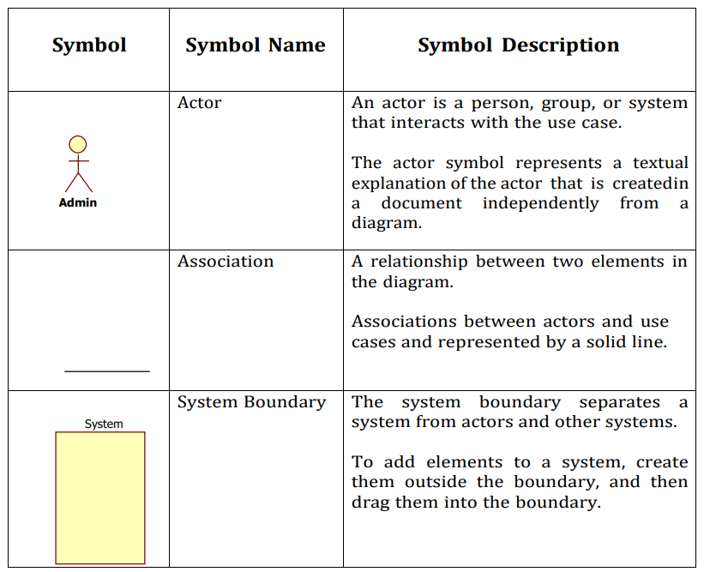

* **Activity Diagram**

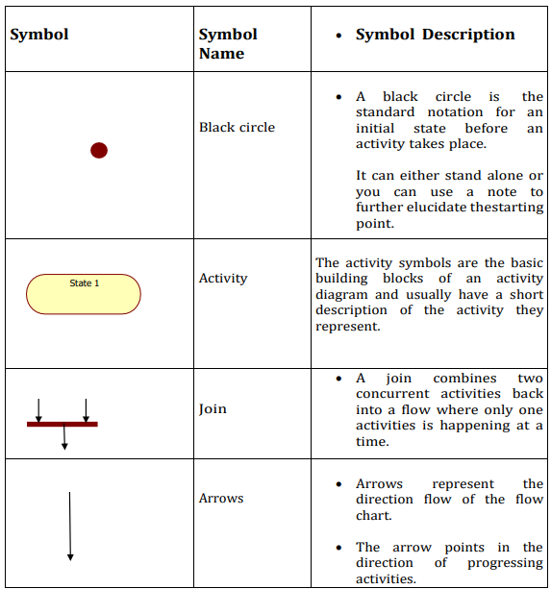

# Chapter 1: INTRODUCTION

## Overview Of the Company

La Net Team is an India based software outsourcing company that offers high quality and cost effective software development service to its clients. We strive for on time delivery of the projects and adhere to stringent quality standards.

We offer flexible and cutting edge solutions that help our clients to operate more efficiently and gain an edge over their competitors. We offer high quality offshore software engineering and programming talent that can be leveraged to gain competitive advantage. We believe in delivering smart business solutions through smart usage of technology and continuously focus on quality of deliverables to our clients.

Our wide range of services include website designing, e-commerce services, Android and IOS Applications, Graphic and Logo design, Website Templates, Website Marketing, Product Development, Software Development etc.

Our local presence guarantees cost advantages specially for the key locations that we are situated in. We strive to upgrade our domain expertise to help us provide not only IT services but valuable business services to our clients. Our primary goal is to help the client to focus on his business and leave the onus upon us to deliver what they need to run their business and make it more competitive through technology.

To ensure that our customers get exactly what they need, we offer a variety of solutions that can be customized, combined, or deployed right out of the box and integrated with existing Enterprise applications.

# Chapter 2: INTRODUCTION

## What Is Screenify?

Screenify is a streaming platform that provides a user experience similar to that of Netflix. It offers a vast library of TV shows and movies, ranging from classic to modern, and covers various genres to cater to different tastes. The app replicates the layout and design of Netflix, providing a familiar and intuitive interface to users.

One of the key features of Screenify is its personalized recommendation engine. The platform uses algorithms to analyze user data and provide recommendations based on their viewing history and preferences. This enables users to discover new content that they are likely to enjoy, making it easy for them to find something to watch quickly.

Another feature that Screenify offers is user profiles. Users can create profiles for themselves and their family members, allowing everyone to have their own watchlist and viewing history. This feature is especially useful for families with children, as it ensures that the content they are exposed to is age-appropriate.

Screenify also offers a robust search function that allows users to search for their favorite shows and movies easily. They can search by title, actor, director, or genre, making it easy to find what they're looking for.

In terms of payment, Screenify provides an easy-to-use payment system that accepts various payment methods, including credit cards, PayPal, and mobile payments. The app also offers a free trial period, giving users the chance to try the app before committing to a subscription.

Overall, Screenify offers a seamless user experience, catering to the modern-day entertainment needs of its audience. It is a great alternative to Netflix for those looking for a similar experience.

## Features of Algo Trading:

screenify consists of various features, few of them are listed below.

1. User-friendly interface: Screenify provides an intuitive and easy-to-use interface, similar to Netflix, making it easy for users to navigate and find content.

2. Personalized recommendations: The app offers a personalized recommendation engine that suggests shows and movies based on users' viewing history and preferences.

3. User profiles: Screenify allows users to create individual profiles for themselves and their family members, providing a tailored viewing experience for everyone.

4. Search function: The app offers a robust search function that allows users to search for shows and movies by title, actor, director, or genre.

5. Multiple device support: Screenify supports multiple devices, allowing users to watch their favorite content on any device, anywhere, and anytime.

6. Offline viewing: Users can download content to watch offline, making it easy to enjoy their favorite shows and movies while on the go.

7. Easy payment system: Screenify provides an easy-to-use payment system that accepts various payment methods, including credit cards, PayPal, and mobile payments.

8. Wide range of content: The app offers a vast library of TV shows and movies covering various genres, providing a diverse range of options for users.

9. Watchlist: Screenify allows users to create a watchlist of shows and movies they want to watch, making it easy to keep track of what they want to see.

10. Ad-free streaming: The app offers ad-free streaming, ensuring that users can enjoy their favorite content without interruptions.

## Technical Requirement for Screenify

here are some of the technical requirements for Screenify:

1. Platform: Screenify can be developed for both iOS and Android platforms, depending on the target audience. It requires a minimum operating system version of iOS 11 or Android 5.0 (Lollipop).

2. Programming Language: The app can be developed using various programming languages such as Swift, Java, or Kotlin, depending on the platform.

3. Backend Development: Screenify requires a robust backend system that can handle user authentication, video streaming, and content management. Backend development can be done using various frameworks such as Ruby on Rails, Node.js, or Django.

4. Video Streaming: The app requires a reliable video streaming service that can handle high-quality video streaming with minimum buffering. This can be achieved by integrating video streaming services such as Amazon Web Services (AWS), Google Cloud Platform, or Microsoft Azure.

5. Database: Screenify requires a scalable and reliable database system that can handle user data, video metadata, and content management. Popular database management systems such as MySQL, MongoDB, or PostgreSQL can be used.

6. Payment Gateway: The app requires a secure and reliable payment gateway that can handle transactions made by users. Payment gateway integration can be done using services such as PayPal, Stripe, or Braintree.

7. Push Notification: Screenify requires push notification services to keep users updated about new content, upcoming releases, and other relevant information. Services such as Firebase Cloud Messaging or Apple Push Notification Service can be used.

8. Security: The app requires robust security features to protect user data, including encryption of sensitive data, secure user authentication, and secure API calls. Security can be ensured by implementing various security standards and protocols, such as SSL/TLS, OAuth, and JWT.

Overall, these technical requirements ensure that Screenify is reliable, secure, and scalable, providing a seamless user experience to its audience.

# LEARNING PHASE-I

Learning phase-I was main focused on learning about the company and its various applications which I would regularly work on.

## 3.1Learning The Fundamentals

I began my internship having an orientation of the company. I went through the process of basic knowledge transfer on a continuous basis throughout my internship. I cleared many concepts in various programming language including JavaScript etc...

Right from setting up the environment to learning the fundamentals of any programming language & also working through databases etc..

## 3.2Learning about various Applications

Web development involves the use of a variety of applications, software tools, and frameworks to design, develop, test, and deploy websites and web applications. Some of the most common applications used in web development include:

1. Code editors: Code editors, such as Visual Studio Code, Sublime Text, and Atom, are used to write and edit code in HTML, CSS, JavaScript, and other programming languages.

2. Integrated Development Environments (IDEs): IDEs, such as Eclipse, NetBeans, and JetBrains IntelliJ IDEA, are used to create and manage web development projects, as well as to write, debug, and deploy code.

3. Version control systems: Version control systems, such as Git, SVN, and Mercurial, are used to manage and track changes to code, collaborate with other developers, and revert changes if necessary.

4. Task runners: Task runners, such as Grunt, Gulp, and npm, automate repetitive tasks in the web development process, such as compiling code, optimizing images, and running tests.

5. Package managers: Package managers, such as npm, Yarn, and Bower, manage dependencies and libraries required for web development projects, making it easier to install and update software.

6. Design tools: Design tools, such as Adobe Photoshop, Sketch, and Figma, are used to create wireframes, mockups, and designs for websites and web applications.

7. Content Management Systems (CMS): CMS, such as WordPress, Drupal, and Joomla, provide an interface to manage the content and functionality of a website or web application.

8. Testing tools: Testing tools, such as Selenium, Jest, and Mocha, automate testing processes, ensuring that websites and web applications are bug-free and function as intended.

9. Web servers: Web servers, such as Apache, Nginx, and IIS, are used to host websites and web applications and deliver content to users.

10. Frameworks: Frameworks, such as React, Angular, Vue, Ruby on Rails, Django, and Laravel, provide pre-built tools and libraries to help developers create more efficient and scalable websites and web applications.

These applications and tools are essential for web developers to create modern, dynamic, and functional websites and web applications that meet the needs of businesses and individuals in the digital age.

## What is JavaScript ?

JavaScript is a programming language that is widely used in web development to add dynamic functionality to websites and web applications. Here are some key concepts in JavaScript:

1. Variables: Variables are used to store data values in JavaScript. They can be declared using the `var`, `let`, or `const` keywords.

2. Data types: JavaScript supports several data types, including strings, numbers, booleans, arrays, and objects.

3. Functions: Functions are reusable blocks of code that perform specific tasks. They can be defined using the `function` keyword and can be passed arguments and return values.

4. Conditionals: Conditionals, such as `if` statements and `switch` statements, are used to execute different blocks of code depending on whether a certain condition is true or false.

5. Loops: Loops, such as `for` loops and `while` loops, are used to repeat blocks of code multiple times.

6. Arrays: Arrays are used to store collections of data values in JavaScript. They can be accessed using index numbers and can be manipulated using various methods.

7. Objects: Objects are used to store collections of properties and values in JavaScript. They can be accessed using dot notation or bracket notation and can be manipulated using various methods.

8. Events: Events, such as mouse clicks and key presses, are used to trigger JavaScript code to execute in response to user actions.

9. DOM manipulation: The Document Object Model (DOM) is a programming interface that allows JavaScript code to interact with HTML and CSS elements on a webpage. JavaScript can be used to add, remove, and modify HTML elements dynamically.

10. Asynchronous programming: Asynchronous programming is used in JavaScript to execute code that does not block the main thread of execution. This is achieved using techniques such as callbacks, promises, and async/await.

These concepts are fundamental to JavaScript and are used extensively in web development to create dynamic and interactive websites and web applications.

# LEARNING PHASE-II

Phase-II of learning is focused on web development technologies such as Node.js, Nest.js, React.js, and Next.js.

Node.js is a runtime environment that allows developers to write server-side applications in JavaScript. It provides a scalable, event-driven architecture that is ideal for building real-time applications, APIs, and microservices.

Nest.js is a progressive Node.js framework for building efficient, scalable, and modular server-side applications. It is built on top of Express.js and provides a robust set of features and architectural patterns to help developers build complex applications.

React.js is a popular front-end library for building user interfaces. It uses a declarative approach to programming, making it easier to build and maintain complex UI components. React.js is used by many large companies, including Facebook, Instagram, and Netflix.

Next.js is a framework for building server-side rendered React.js applications. It provides a variety of features to help developers build high-performance, SEO-friendly web applications.

By learning these technologies, you will gain a better understanding of web development and how to build complex, scalable applications. You will also learn how to work with modern development tools and best practices, which will help you become a more efficient and effective developer.

## 4.1What is NodeJs?

Node.js is a server-side runtime environment for executing JavaScript code. It is built on the V8 JavaScript engine used by the Google Chrome browser and provides an event-driven, non-blocking I/O model that allows applications to handle a large number of connections simultaneously without blocking.

**The key concepts of Node.js include:**

1. Asynchronous programming: Node.js is designed to handle asynchronous I/O operations, meaning it can execute multiple tasks simultaneously without blocking other tasks. This allows Node.js applications to be highly scalable and performant.

2. Modules: Node.js has a built-in module system that allows developers to organize their code into reusable modules. Modules can be shared across applications, making it easy to develop and maintain complex applications.

3. Package manager: Node.js has a package manager called npm that provides access to a vast ecosystem of open-source modules and packages. Developers can easily install and manage dependencies for their projects using npm.

4. Server-side programming: Node.js is designed for server-side programming, allowing developers to build scalable and efficient server-side applications using JavaScript.

5. Event-driven architecture: Node.js uses an event-driven architecture that allows developers to respond to incoming requests and events in a non-blocking way. This allows Node.js applications to be highly responsive and efficient.

Overall, Node.js provides a powerful and flexible platform for building scalable and performant server-side applications using JavaScript. Its event-driven, non-blocking I/O model and vast ecosystem of modules and packages make it a popular choice for web developers around the world.

**MVC architechture in nodeJs:**

MVC (Model-View-Controller) is a software architecture pattern that separates the application into three interconnected components: the model, the view, and the controller.

1. Model: The model represents the application's data and business logic. It is responsible for maintaining the state of the application and handling data-related operations, such as reading and writing data from a database.

2. View: The view represents the user interface of the application. It is responsible for displaying the data to the user and receiving user input, such as mouse clicks and keyboard input.

3. Controller: The controller acts as an intermediary between the model and the view. It receives user input from the view, updates the model accordingly, and then updates the view to reflect the changes in the model.

The key benefits of using the MVC architecture pattern include:

1. Separation of concerns: The MVC architecture pattern separates the application into three distinct components, each with its own responsibility. This makes the code easier to understand, maintain, and modify.

2. Code reusability: The MVC architecture pattern promotes code reusability by separating the application logic from the user interface. This makes it easier to reuse the same code with different user interfaces.

3. Testability: The MVC architecture pattern makes it easier to write unit tests for each component of the application. This helps ensure that each component works correctly and can be tested independently of the others.

4. Flexibility: The MVC architecture pattern is flexible and can be adapted to different types of applications. For example, it can be used to build web applications, desktop applications, and mobile applications.

Overall, the MVC architecture pattern is a powerful and flexible software architecture pattern that can help developers build scalable, maintainable, and testable applications.

## What is ExpresJs?

## Express is a popular open-source framework for building web applications using Node.js. It provides a simple and flexible API for building web servers and handling HTTP requests and responses.

## Some key features of Express include:

## 1. Routing: Express provides a simple and flexible API for defining routes and handling HTTP requests. Developers can define routes based on HTTP methods (GET, POST, PUT, DELETE, etc.) and URL patterns.

## 2. Middleware: Express allows developers to use middleware functions to handle HTTP requests and responses. Middleware functions can be used to perform tasks such as authentication, logging, and error handling.

## 3. Template engines: Express provides support for various template engines, such as EJS and Handlebars, which allow developers to generate dynamic HTML pages.

## 4. Static file serving: Express allows developers to serve static files, such as images and CSS files, using the built-in static middleware.

## 5. Error handling: Express provides a robust error handling mechanism that allows developers to handle errors in a centralized way.

## 6. Built-in support for HTTP cookies: Express provides built-in support for handling HTTP cookies, making it easy to manage user sessions and authentication.

## Overall, Express is a powerful and flexible framework for building web applications using Node.js. Its routing system, middleware support, template engines, static file serving, error handling, and built-in support for HTTP cookies make it a popular choice for building scalable and efficient web servers.

## What is NestJs?

Nest.js is a powerful, progressive Node.js framework for building scalable and efficient server-side applications. It is built on top of the popular Express.js framework and provides a robust set of features and architectural patterns to help developers build complex applications.

**Some key features of Nest.js include:**

1. Modular architecture: Nest.js uses a modular architecture that allows developers to organize their code into reusable modules. Modules can be shared across applications, making it easy to develop and maintain complex applications.

2. Dependency injection: Nest.js supports dependency injection, a design pattern that allows developers to write loosely coupled code. This makes it easier to test and maintain code and improves overall code quality.

3. Built-in support for WebSockets: Nest.js provides built-in support for WebSockets, making it easy to build real-time applications.

4. Type safety: Nest.js is written in TypeScript, a superset of JavaScript that adds type safety to the language. This makes it easier to write bug-free code and catch errors before they occur.

5. Built-in support for microservices: Nest.js provides built-in support for microservices, a popular architectural pattern for building distributed systems.

Overall, Nest.js is a powerful and flexible framework for building scalable and efficient server-side applications using Node.js. Its modular architecture, dependency injection, and built-in support for WebSockets and microservices make it a popular choice for developers around the world.

## What is ReactJs?

React.js is a popular open-source JavaScript library used for building user interfaces (UIs) for web and mobile applications. It was developed by Facebook and is now widely used by many other companies and individual developers.

React.js is based on a component-based architecture, which means that applications are built by creating reusable UI components. Each component represents a part of the UI and can be composed together to create complex interfaces. React.js uses a virtual DOM (Document Object Model) to efficiently update and render changes to the UI.

Some key features of React.js include:

1. Virtual DOM: React.js uses a virtual DOM, which is a lightweight copy of the real DOM, to update and render changes to the UI. This makes React.js very efficient and fast, even when working with large and complex UIs.

2. JSX: React.js uses a syntax called JSX (JavaScript XML) to define UI components. JSX allows developers to write HTML-like code directly in JavaScript, making it easier to create complex UIs.

3. Component-based architecture: React.js is based on a component-based architecture, which makes it easy to create reusable UI components. Each component can be composed together to create complex UIs, making it easy to build scalable and maintainable applications.

4. Unidirectional data flow: React.js uses a unidirectional data flow, which means that data flows in one direction from the parent component to the child components.

5. Large ecosystem: React.js has a large and active ecosystem, with many open-source libraries and tools available for developers. This makes it easy to find and use pre-built components and tools to speed up development.

Overall, React.js is a powerful and flexible JavaScript library for building UIs for web and mobile applications. Its virtual DOM, JSX syntax, component-based architecture, unidirectional data flow, and large ecosystem make it a popular choice for developers around the world.

**Jan-23**

|  |  |  |
| --- | --- | --- |
|  | | |
| **Week-1** | **Backend Technology** | **JavaScript** |

**Feb-23**

|  |  |  |
| --- | --- | --- |
|  | | |
| Week-1 | Backend Technology | JavaScript |
| Week-2 | JavaScript |
| Week-3 | Ad. Js |
| Week-4 | Git |

## Mar-23

|  |  |  |
| --- | --- | --- |
|  | | |
| Week-1 | Backend Technology | Linux |
| Week-2 | NodeJS |
| Week-3 | NodeJS |
| Week-4 | NodeJS |

**April-23**

|  |  |  |
| --- | --- | --- |
|  | | |
| Week-1 | Backend & Frontend Technology | NodeJS |
| Week-2 | MongoDB |
| Week-3 | MongoDB |
| Week-4 | ReactJS |

1. **Chapter 5: System Design**

* **Admin Login Activity Diagram**

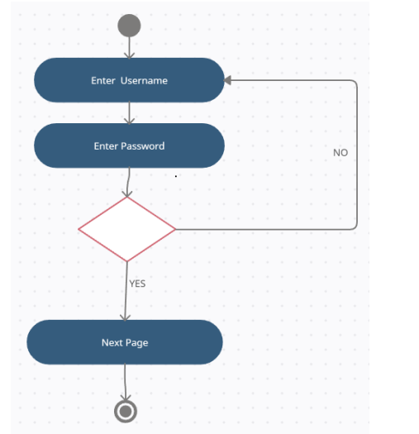

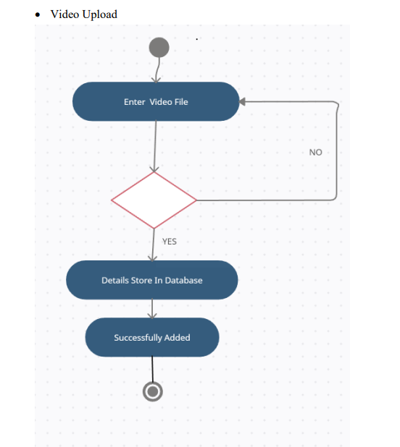

* **User Login Activity Diagram**



**5.2 DATABASE DESIGN / DATA STRUCTURE DESIGN / CIRCUIT DESIGN / PROCESS DESIGN / STRUCTURE DESIGN**

   

* + 1. **MODULES SPECIFICATION(S)**

1. **Admin**
   * + **Login**
     + **Change password**
     + **Logout**
     + **Upload video**
     + **Delete video**
2. **User**

* **Login**
* **Logout**
* **Change password**
* **View video**
* **Create playlist**
* **Like video**

**5.3 INPUT / OUTPUT AND INTERFACE DESIGN (IF APPLICABLE)**



# CONCLUSION

From this internship as an Analyst, I got a hand on experience of work culture. I learnt a lot about Algo Trading.

This report consists of all the new things that I learnt during my internship tenure. Algo trading is a fast-evolving technology with incredible & intelligent functionalities which improves trading performance & speed for market participants. Algo trading has an advantage i.e., the data it has stored & this data helps it to easily identify patterns in an ongoing trend. Machine Learning plays an important role to achieve all these goals.

# REFERENCES

###### Learning references

# <https://nodejs.org/en>

# <https://legacy.reactjs.org/>

# <https://www.w3schools.com/>

# <https://nextjs.org/>

# https://www.npmjs.com/

# 

**Appendix**