### SCREENIFY

##### A PROJECT REPORT

***Submitted by***

**Parmar Dixit**

##### [190130107076]

***In partial fulfillment for the award of the degree Of***

#### BACHELOR OF ENGINEERING

***in***

**Computer Engineering**

**Government Engineering College, Gandhinagar**





#### Gujarat Technological University,

#### Ahmedabad

##### April,2023

 

**Government Engineering College** Sector 28 GIDC, Gandhinagar

Gujarat - 382028, India

### CERTIFICATE

This is to certify that the internship report submitted along with the internship entitled **Screenify** has been carried out by **Parmar Dixit NareshBhai** under my guidance in partial fulfillment for the degree of Bachelor of Engineering in Computer Engineering, 8th Semester of GTU, Ahmedabad during the academic year 2023-24

Prof. Hemani Shah Prof. Dr. Dhaval Parikh

Internal Guide Head of the Department

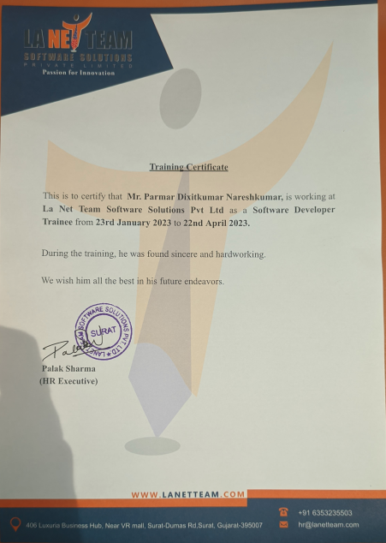

 

**Government Engineering College, Gandhinagar Sector 28 GIDC, Sector 28, Gandhinagar**

382028, Gujarat, India

### DECLARATION

We hereby declare that the Internship report submitted along with the Internship entitled **Screenify** submitted in partial fulfillment for the degree of Bachelor of Engineering in Information Technology to GTU, Ahmedabad, is a bonafide record of original project work carried out by me at **La Net Team Software Solutions Pvt. Ltd.** Under the supervision **Mr. Hitesh Pandya** and that no part of this report has been directly copied from any students report or taken from any other source, without providing due reference.

Name of the Student Sign of Student

Parmar Dixit _____________

### ACKNOWLEDGEMENT

I would like to express my sincere gratitude and appreciation to all those who have supported me during my internship at La Net Team Software Solutions Pvt. Ltd. I am thankful to Mr. Hitesh Pandya, who provided me with constant guidance, encouragement, and support throughout my internship. Their vast knowledge, valuable insights, and expertise in the field of Web Development that helped me develop new skills and broaden my understanding of the industry. I am also grateful to the entire team at La Net Team Software Solutions Pvt. Ltd for providing me with a conducive work environment and giving me the opportunity to work on various projects that have helped me improve my technical skills. I would also like to thank my colleagues for their support and valuable feedback that helped me learn and grow during my internship.

Finally, I am grateful to everyone who contributed to my learning experience at La Net Team Software Solutions Pvt. Ltd. It was an invaluable experience that I will take with me throughout my career.

**Parmar Dixit**

### ABSTRACT

*Screenify is a web application built using React JS and Node.js with MongoDB as the backend database. The website provides a sleek and user-friendly interface where users can browse and stream movies and TV shows. The project leverages the power of MongoDB's document-based structure to store and retrieve movie and TV show information, including availability and recommended content. Users can create and manage their accounts, save their favorite movies and TV shows, and get personalized recommendations based on their viewing history. The site also has an admin portal where administrators can manage content, view user history, and update recommendations. Overall, Screenify is designed to provide a seamless and enjoyable streaming experience for users while providing easy management for administrators.*

#### LIST OF FIGURES

|  |  |  |
| --- | --- | --- |
| **Figure No** | **Figure Description** | **Page No** |
| Figure 4.1.1 | Class Diagram | 15 |
| Figure 4.1.2 | Data Flow Diagram | 16 |
| Figure 4.2.1 | Admin Page | 17 |
| Figure 4.2.2 | Upload New Movie | 17 |
| Figure 4.2.3 | List of Uploaded Movie | 17 |
| Figure 4.2.4 | Delete/Edit Movie Details | 18 |
| Figure 4.2.5 | MongoDB Atlas | 18 |
| Figure 4.2.6 | PostMan API | 19 |

# Content

|  |  |  |  |
| --- | --- | --- | --- |
| Acknowledgement | | | I |
| Abstract | | | II |
| List of Figures | | | III |
| Contents | | | IV |
| **1** |  | **Organization** | 1 |
|  | 1.1 | Overview of Organization | 1 |
|  | 1.2 | Scope of Work | 1 |
|  | 1.3 | Capacity of Organization | 2 |
| **2** |  | **Introduction to Project** | 3 |
|  | 2.1 | Introduction | 3 |
|  | 2.2 | Purpose | 3 |
|  | 2.3 | Scope | 4 |
|  | 2.4 | Objective | 5 |
|  | 2.5 | Technologies used | 6 |
|  | 2.6 | Internship Scheduling |  |
| **3** |  | **Learning Phase** | 7 |
|  | 3.1 | Learning The Fundamentals | 7 |
|  | 3.2 | Learning about various Applications | 7 |
|  | 3.3 | JavaScript | 8 |
|  | 3.4 | NodeJs | 9 |
|  | 3.5 | ExpressJs | 11 |
|  | 3.6 | NestJs | 11 |
| **4** |  | **System Design** | 12 |
|  | 4.1 | Detail Design | 12 |
|  |  | 4.1.1 Class Diagram | 12 |
|  |  | * + 1. Activity Diagram | 13 |
|  | 4.2 | Database Design | 14 |
|  | 4.3 | Authentication | 16 |
| **5** |  | **Implementation Planning** | 18 |
|  | 5.1 | Implementation Environment | 18 |
|  | 5.2 | Program/Modules Specification | 18 |
|  | 5.3 | Coding Standards | 18 |
|  | 5.4 | Coding Scenario | 18 |
| **6** |  | **Testing** | 19 |
|  | 6.1 | Testing Plan/ Strategy | 19 |
|  | 6.2 | Testing Methods | 21 |
|  |  | 6.2.1 Test Cases | 23 |
| **7** |  | **Conclusion and Discussion** | 24 |
|  | 7.1 | Overall Analysis of Internship | 24 |
|  | 7.2 | Limitations | 24 |
|  | 7.3 | Future Enhancement | 25 |
| **8** |  | **References** | 26 |
|  |  |  |  |
|  |  |  |  |
|  |  |  |  |
|  |  |  |  |

# CHAPTER 1

# ORGANIZATION

#### Overview Of Organization:

La Net Team is an India based software outsourcing company that offers high quality and cost-effective software development service to its clients. We strive for on time delivery of the projects and adhere to stringent quality standards.

We offer flexible and cutting-edge solutions that help our clients to operate more efficiently and gain an edge over their competitors. We offer high quality offshore software engineering and programming talent that can be leveraged to gain competitive advantage. We believe in delivering smart business solutions through smart usage of technology and continuously focus on quality of deliverables to our clients.

Our wide range of services include website designing, e-commerce services, Android and IOS Applications, Graphic and Logo design, Website Templates, Website Marketing, Product Development, Software Development etc.

Our local presence guarantees cost advantages specially for the key locations that we are situated in. We strive to upgrade our domain expertise to help us provide not only IT services but valuable business services to our clients. Our primary goal is to help the client to focus on his business and leave the onus upon us to deliver what they need to run their business and make it more competitive through technology.

To ensure that our customers get exactly what they need, we offer a variety of solutions that can be customized, combined, or deployed right out of the box and integrated with existing Enterprise applications.

#### Scope Of Work

#### We put resources into development to enable our customers to release new potential over their associations. What makes La Net Team one of a kind is our pool of talented developers, industry skill, and a genuine comprehension of what to do so as to succeed. With an industry experience that traverses quite a few years, we offer a plenty of customer driven services by empowering undertakings to accomplish upper

hand through adaptable and cutting edge worldwide delivery models. Our wide range of services include website designing, e-commerce services, Android and IOS Applications, Graphic and Logo design, Website Templates, Website Marketing, Product Development, Software Development etc.

#### **Capacity of Organization**

Our company strength is about 250 employees.

# CHAPTER 2

# INTRODUCTION TO PROJECT

* 1. **Introduction:**

The Screenify project is a cutting-edge solution designed to provide a seamless and efficient streaming experience for users. The project is built using ReactJs and nodeJs, a powerful platform that allows developers to create dynamic and interactive user interfaces with ease. The project's database is implemented using MongoDB, a flexible and scalable NoSQL database that offers efficient data storage and retrieval. By combining NodeJs and MongoDB, the project provides fast and reliable performance, even with heavy traffic.

The website's user-friendly interface allows users to easily browse and stream movies and TV shows, create and manage their profiles, and add titles to their watchlist. In addition, administrators can use the admin portal to manage content, view user history, and track analytics.

Overall, this Screenify project is a robust and scalable solution that provides a seamless platform for users to stream their favorite movies and TV shows, and for businesses to reach out to their audience and streamline their operations.

#### Purpose

The purpose of this Screenify is to provide a user-friendly platform for streaming movies, TV shows, and other video content online. By offering a wide range of content options, users can browse and watch their favorite shows and movies from the comfort of their own homes. The website is designed to be intuitive and easy to use, making it accessible to a wide range of users.

In addition, the Screenify allows users to personalize their viewing experience by creating profiles and curating a list of their favorite shows and movies. This feature enables users to easily find their preferred content and receive recommendations for new content based on their viewing history. The platform also provides users with access to exclusive content that may not be available on other streaming services.

The Screenify also offers businesses the opportunity to reach a wider audience through online streaming. By going online, businesses can tap into a global market and offer their content to users from all over the world. This increases the potential customer base and opens up new revenue streams for the company. Additionally, the platform allows businesses to track and analyze user behavior, such as viewing habits and preferences, to make informed decisions about content offerings and marketing strategies.

#### Scope/Feature:

**2.3.1** User account creation is done by the user through the app or website.

**2.3.2** User can login through email and password or through social media accounts.

**2.3.3** User searches for TV shows or movies by typing in keywords or browsing through categories.

**2.3.4** User filters search results by criteria such as genre, release year, rating, etc.

**2.3.5** User adds TV shows or movies to their watchlist.

**2.3.6** User selects a TV show or movie to watch and clicks the "Play" button.

**2.3.7** The system verifies the user's subscription status and checks if the selected TV show or movie is available in the user's region.

**2.3.8** If the user's subscription is invalid or if the selected TV show or movie is not available in the user's region, the system shows an error message and asks the user to subscribe or select a different TV show or movie.

**2.3.9** If the subscription is valid and the selected TV show or movie is available, the system plays the selected TV show or movie.

#### Objective:

Screenify is an online streaming platform that allows users to watch their favorite movies and TV shows. The objectives of Screenify are as follows:

1. Provide a user-friendly platform: The main goal of Screenify is to provide a user-friendly platform that allows customers to easily search and watch their favorite movies and TV shows online. The website should be easy to navigate and provide a seamless streaming experience.
2. Improve brand visibility: Screenify should help movie and TV show producers increase their brand visibility by showcasing their content online and promoting their brand through digital marketing strategies. The site should include features such as user ratings and reviews, personalized recommendations, and social media integration to help producers build their brand identity.
3. Increase user engagement: Screenify should be designed to increase user engagement by providing users with efficient tools to manage their watchlist, provide feedback and ratings, and interact with other users through forums and comments sections. The site should also include features such as binge-watching mode and auto-play to encourage users to stay engaged.
4. Collect user data: Screenify should help producers collect user data such as viewing history, preferences, and search queries. This data can be used to make informed business decisions about content offerings, pricing, and marketing strategies.
5. Ensure data security: Screenify should ensure the security of user data and content by implementing appropriate security measures such as encryption, access control, and backups. The site should also comply with industry standards and regulations related to data privacy and security.
6. Optimize site performance: Screenify should optimize site performance by implementing caching, load balancing, and other techniques to ensure fast and reliable streaming. The site should also be optimized for different devices and internet speeds to ensure a consistent user experience across all platforms.
7. Streamline content management: Screenify should provide efficient tools for content management, such as easy uploading, metadata management, and content categorization. This will enable producers to manage their content efficiently and keep it organized for users to easily find and watch.

#### Technologies Used:

* + 1. **GUI:**
       - JavaScript
       - ReactJs

#### Business Logic:

* + - * NodeJs
      * React Redux

#### Database:

* + - * MongoDb
      * Firebase

#### Internship Scheduling:

|  |  |  |  |  |  |  |  |  |  |  |  |  |
| --- | --- | --- | --- | --- | --- | --- | --- | --- | --- | --- | --- | --- |
| Week | 1 | 2 | 3 | 4 | 5 | 6 | 7 | 8 | 9 | 10 | 11 | 12 |
| Learning |  |  |  |  |  |  |  |  |  |  |  |  |
| Planing/Design |  |  |  |  |  |  |  |  |  |  |  |  |
| Development |  |  |  |  |  |  |  |  |  |  |  |  |
| Testing |  |  |  |  |  |  |  |  |  |  |  |  |
| Deployment |  |  |  |  |  |  |  |  |  |  |  |  |

# CHAPTER 3

# LEARNING PHASE

## Learning The Fundamentals

I began my internship having an orientation of the company. I went through the process of basic knowledge transfer on a continuous basis throughout my internship. I cleared many concepts in various programming language including JavaScript etc...

Right from setting up the environment to learning the fundamentals of any programming language & also working through databases etc.

## Learning about various Applications

Web development involves the use of a variety of applications, software tools, and frameworks to design, develop, test, and deploy websites and web applications. Some of the most common applications used in web development include:

1. Code editors: Code editors, such as Visual Studio Code, Sublime Text, and Atom, are used to write and edit code in HTML, CSS, JavaScript, and other programming languages.

2. Integrated Development Environments (IDEs): IDEs, such as Eclipse, NetBeans, and JetBrains IntelliJ IDEA, are used to create and manage web development projects, as well as to write, debug, and deploy code.

3. Version control systems: Version control systems, such as Git, SVN, and Mercurial, are used to manage and track changes to code, collaborate with other developers, and revert changes if necessary.

4. Task runners: Task runners, such as Grunt, Gulp, and npm, automate repetitive tasks in the web development process, such as compiling code, optimizing images, and running tests.

5. Package managers: Package managers, such as npm, Yarn, and Bower, manage dependencies and libraries required for web development projects, making it easier to install and update software.

6. Design tools: Design tools, such as Adobe Photoshop, Sketch, and Figma, are used to create wireframes, mockups, and designs for websites and web applications.

7. Content Management Systems (CMS): CMS, such as WordPress, Drupal, and Joomla, provide an interface to manage the content and functionality of a website or web application.

8. Testing tools: Testing tools, such as Selenium, Jest, and Mocha, automate testing processes, ensuring that websites and web applications are bug-free and function as intended.

9. Web servers: Web servers, such as Apache, Nginx, and IIS, are used to host websites and web applications and deliver content to users

10. Frameworks: Frameworks, such as React, Angular, Vue, Ruby on Rails, Django, and Laravel, provide pre-built tools and libraries to help developers create more efficient and scalable websites and web applications.

These applications and tools are essential for web developers to create modern, dynamic, and functional websites and web applications that meet the needs of businesses and individuals in the digital age.

## JavaScript

1. Variables: Variables are used to store data values in JavaScript. They can be declared using the var, let, or const keywords.

2. Data types: JavaScript supports several data types, including strings, numbers, Booleans, arrays, and objects.

3. Functions: Functions are reusable blocks of code that perform specific tasks. They can be defined using the function keyword and can be passed arguments and return values.

4. Conditionals: Conditionals, such as if statements and switch statements, are used to execute different blocks of code depending on whether a certain condition is true or false.

5. Loops: Loops, such as for loops and while loops, are used to repeat blocks of code multiple times.

6. Arrays: Arrays are used to store collections of data values in JavaScript. They can be accessed using index numbers and can be manipulated using various methods.

## NodeJs

Node.js is a server-side runtime environment for executing JavaScript code. It is built on the V8 JavaScript engine used by the Google Chrome browser and provides an event-driven, non-blocking I/O model that allows applications to handle a large number of connections simultaneously without blocking.

**The key concepts of Node.js include:**

1. Asynchronous programming: Node.js is designed to handle asynchronous I/O operations, meaning it can execute multiple tasks simultaneously without blocking other tasks. This allows Node.js applications to be highly scalable and performant.

2. Modules: Node.js has a built-in module system that allows developers to organize their code into reusable modules. Modules can be shared across applications, making it easy to develop and maintain complex applications.

3. Package manager: Node.js has a package manager called npm that provides access to a vast ecosystem of open-source modules and packages. Developers can easily install and manage dependencies for their projects using npm.

4. Server-side programming: Node.js is designed for server-side programming, allowing developers to build scalable and efficient server-side applications using JavaScript.

5. Event-driven architecture: Node.js uses an event-driven architecture that allows developers to respond to incoming requests and events in a non-blocking way. This allows Node.js applications to be highly responsive and efficient.

Overall, Node.js provides a powerful and flexible platform for building scalable and performant server-side applications using JavaScript. Its event-driven, non-blocking I/O model and vast ecosystem of modules and packages make it a popular choice for web developers around the world.

## ExpressJs

## Express is a popular open-source framework for building web applications using Node.js. It provides a simple and flexible API for building web servers and handling HTTP requests and responses.

## Some key features of Express include:

## Routing: Express provides a simple and flexible API for defining routes and handling HTTP requests. Developers can define routes based on HTTP methods (GET, POST, PUT, DELETE, etc.) and URL pattern

## 2. Middleware: Express allows developers to use middleware functions to handle HTTP requests and responses. Middleware functions can be used to perform tasks such as authentication, logging, and error handling.

## 3. Template engines: Express provides support for various template engines, such as EJS and Handlebars, which allow developers to generate dynamic HTML pages.

## 4. Static file serving: Express allows developers to serve static files, such as images and CSS files, using the built-in static middleware.

## 5. Error handling: Express provides a robust error handling mechanism that allows developers to handle errors in a centralized way.

## 6. Built-in support for HTTP cookies: Express provides built-in support for handling HTTP cookies, making it easy to manage user sessions and authentication.

## Overall, Express is a powerful and flexible framework for building web applications using Node.js. Its routing system, middleware support, template engines, static file serving, error handling, and built-in support for HTTP cookies make it a popular choice for building scalable and efficient web servers.

## NestJs

Nest.js is a powerful, progressive Node.js framework for building scalable and efficient server-side applications. It is built on top of the popular Express.js framework and provides a robust set of features and architectural patterns to help developers build complex applications.

**Some key features of Nest.js include:**

1. Modular architecture: Nest.js uses a modular architecture that allows developers to organize their code into reusable modules. Modules can be shared across applications, making it easy to develop and maintain complex applications.

2. Dependency injection: Nest.js supports dependency injection, a design pattern that allows developers to write loosely coupled code. This makes it easier to test and maintain code and improves overall code quality.

3. Built-in support for WebSockets: Nest.js provides built-in support for WebSockets, making it easy to build real-time applications.

4. Type safety: Nest.js is written in TypeScript, a superset of JavaScript that adds type safety to the language. This makes it easier to write bug-free code and catch errors before they occur.

5. Built-in support for microservices: Nest.js provides built-in support for microservices, a popular architectural pattern for building distributed systems.

Overall, Nest.js is a powerful and flexible framework for building scalable and efficient server-side applications using Node.js. Its modular architecture, dependency injection, and built-in support for WebSockets and microservices make it a popular choice for developers around the world.

# CHAPTER 4

# SYSTEM DESIGN

* 1. **Detail Design**

##### Class Diagram

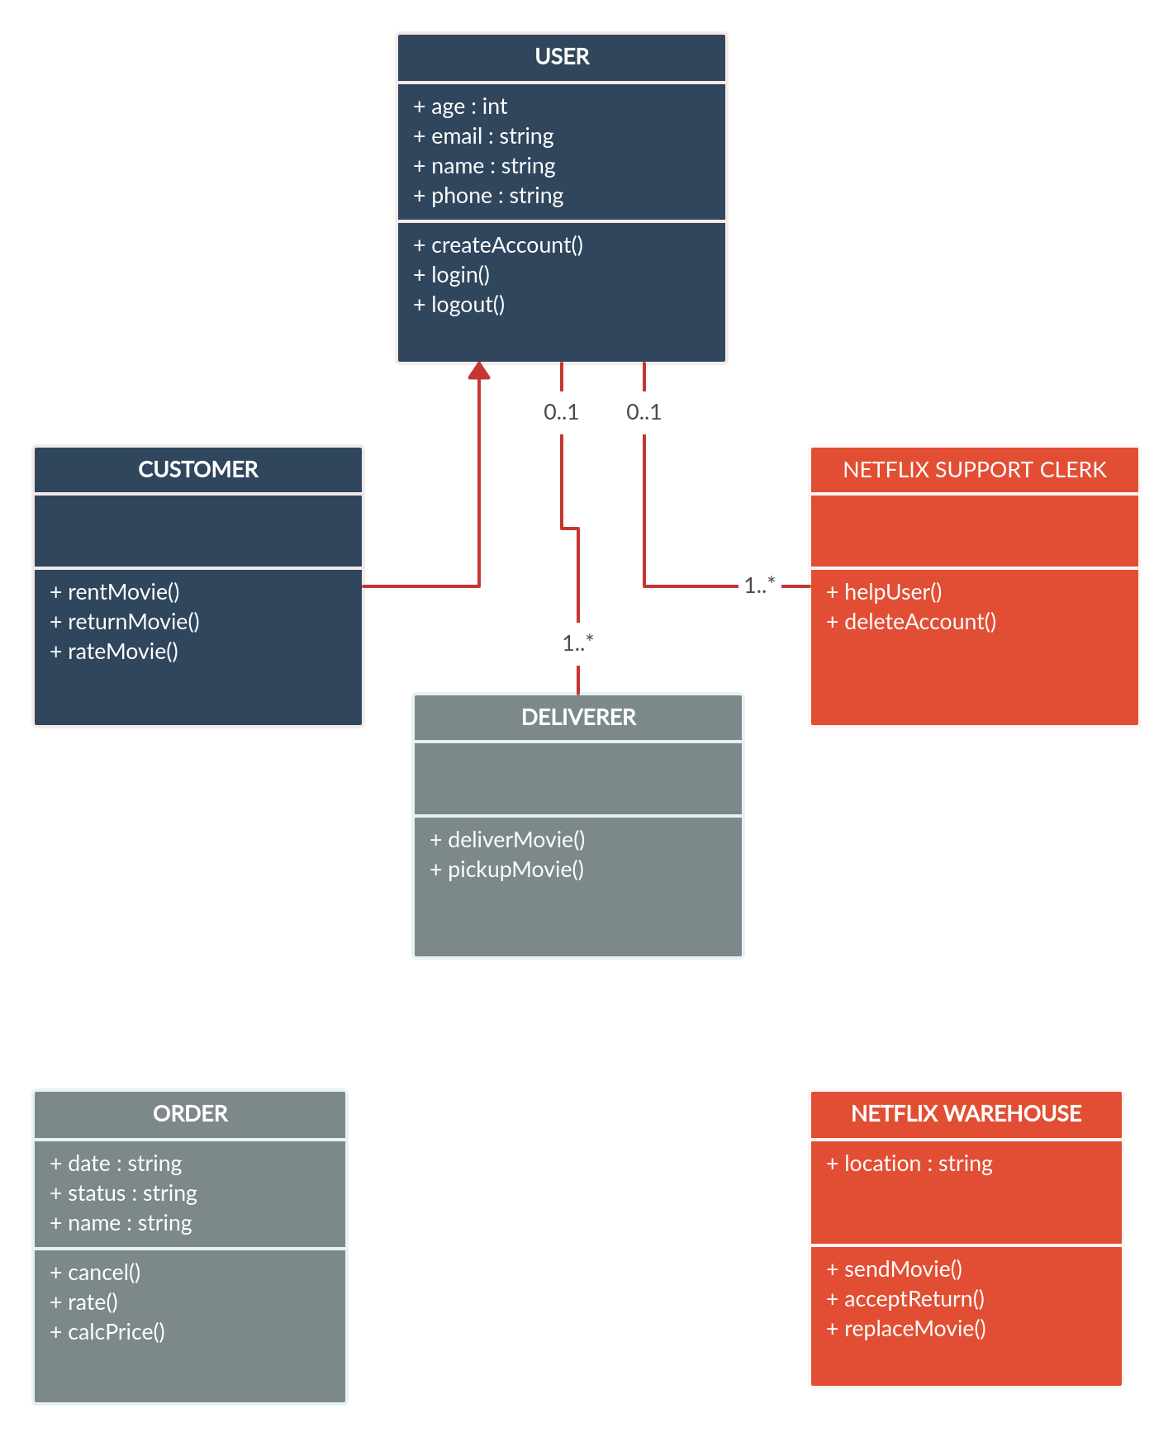**[Fig.4.1.1: Class Diagram]**

##### Data Flow Diagram

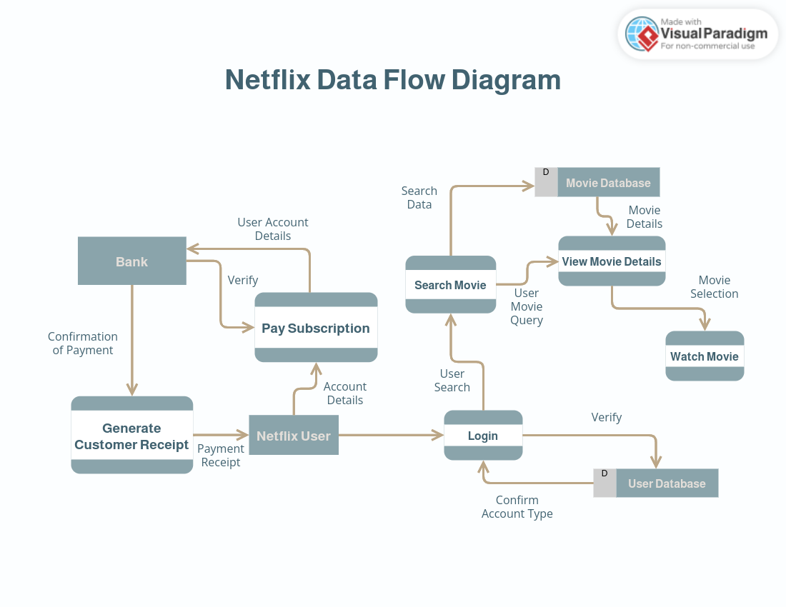

**[Fig.4.1.2: Data Flow Diagram]**

### Input/Output and Interface Design

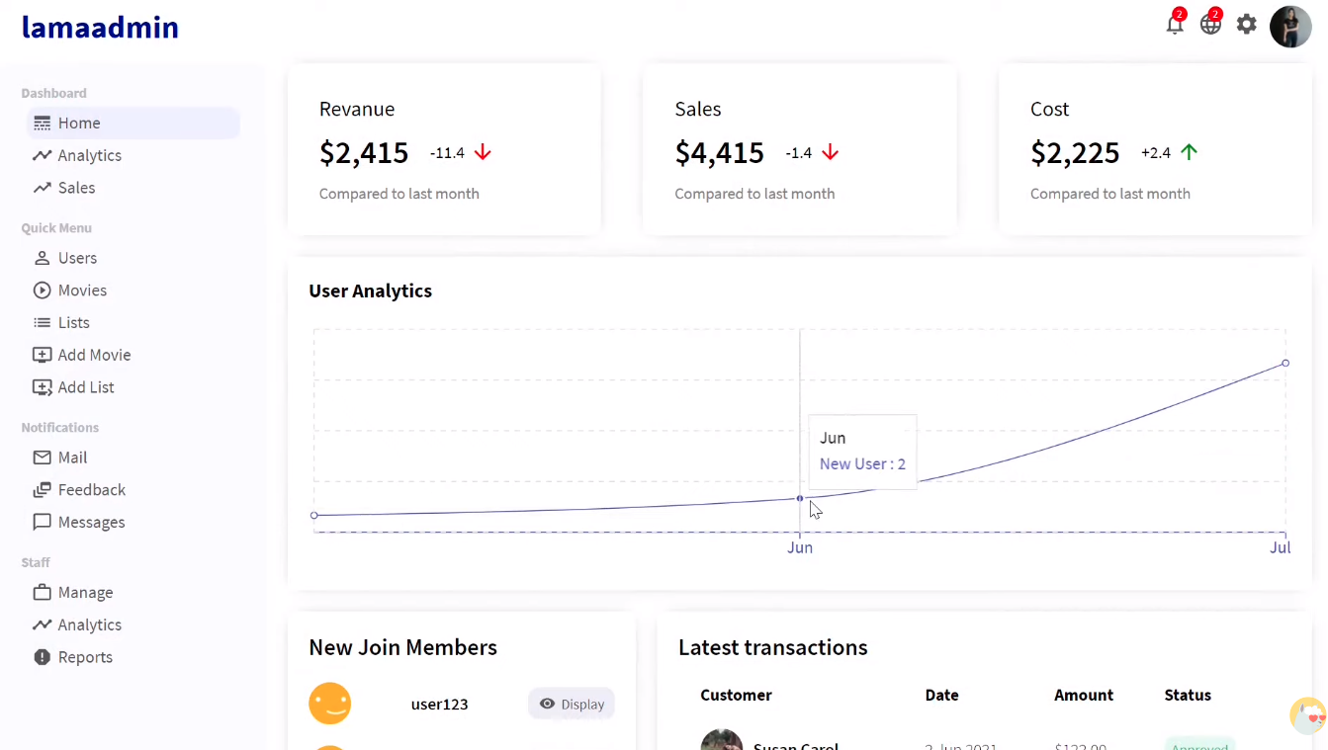

**[Fig.4.2.1: Admin Page]**

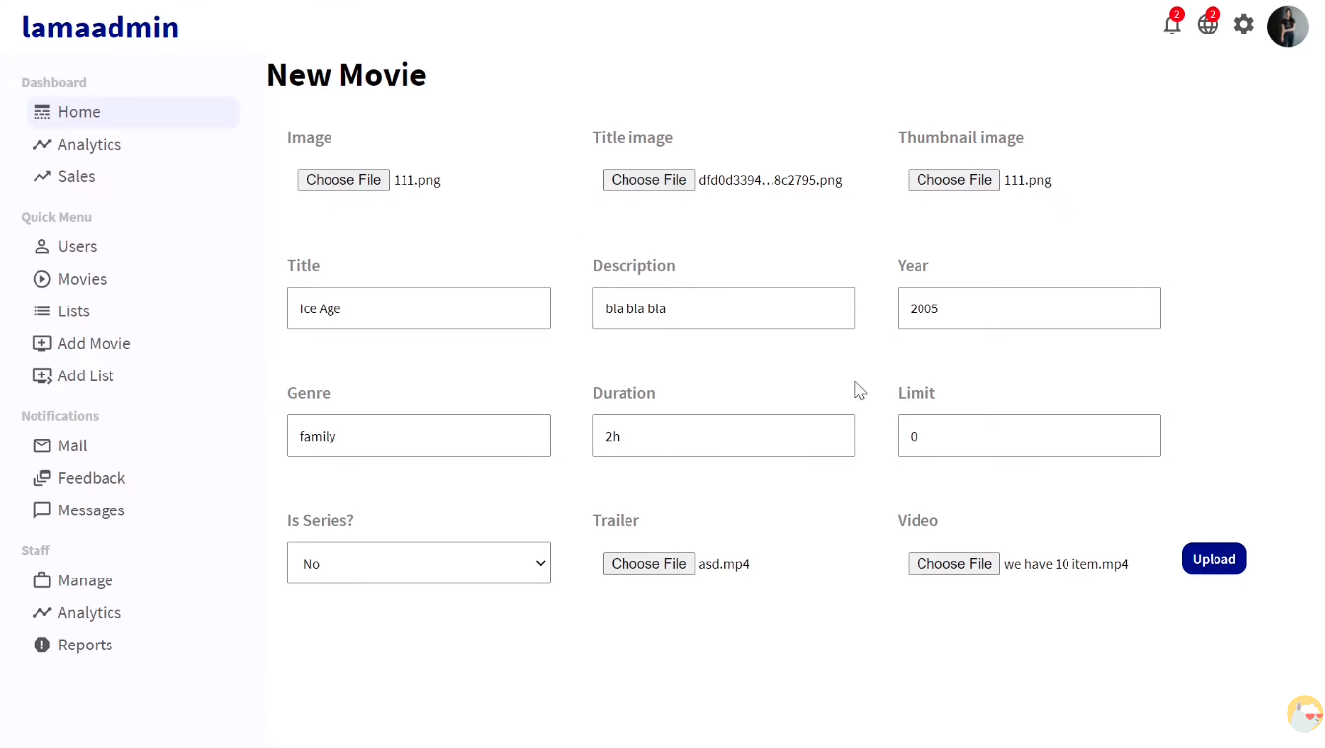

**[Fig.4.2.2:Upload New Movie]**

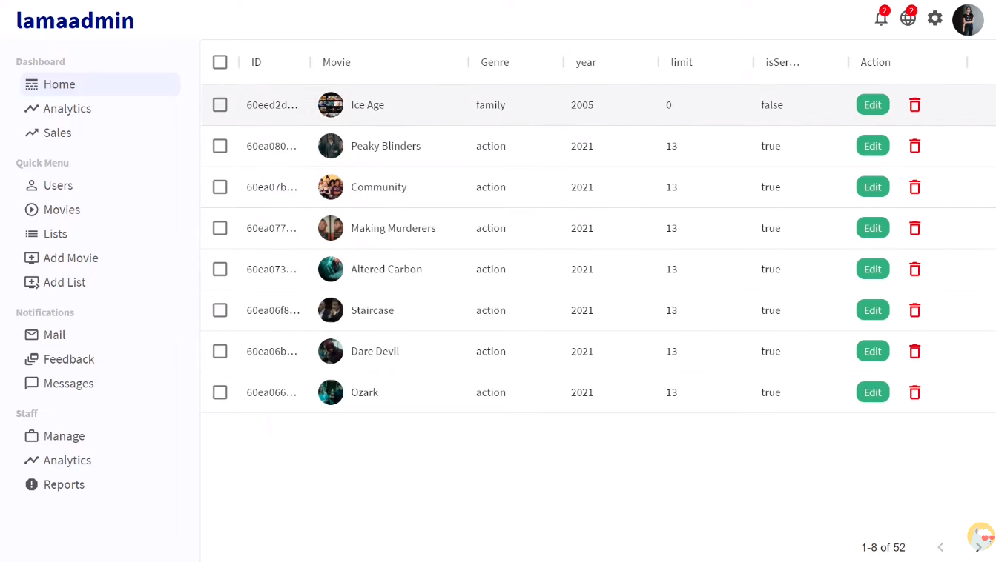

**[Fig.4.2.3: List-of-uploaded-movies]**

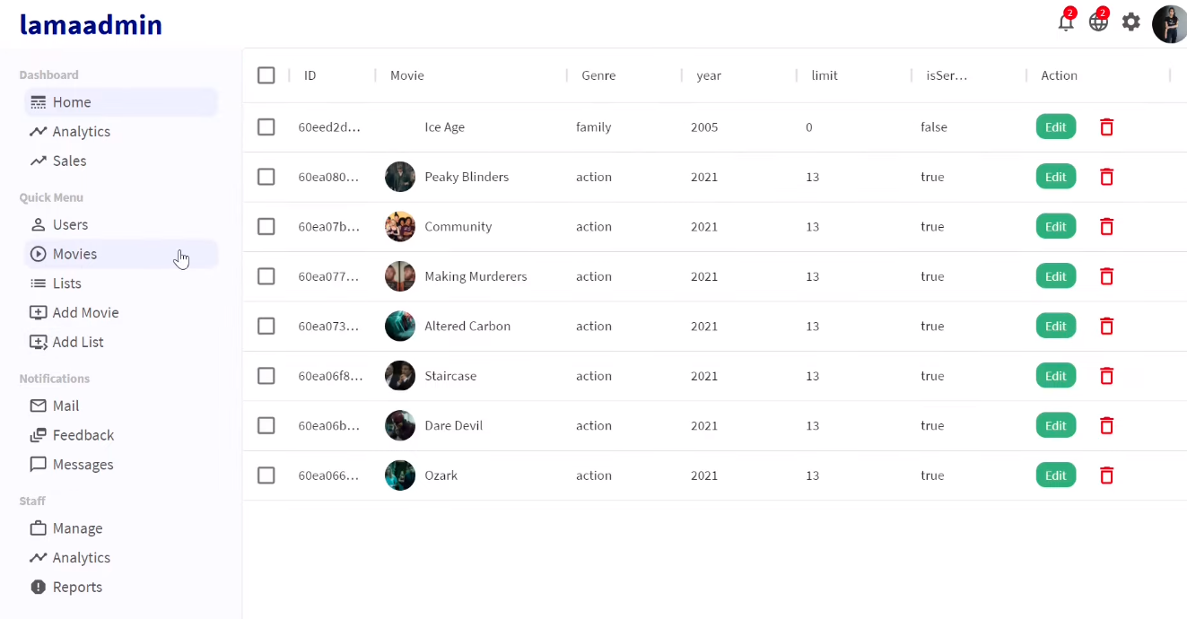

**[Fig.4.2.4:Delete/Edit Movie Details]**

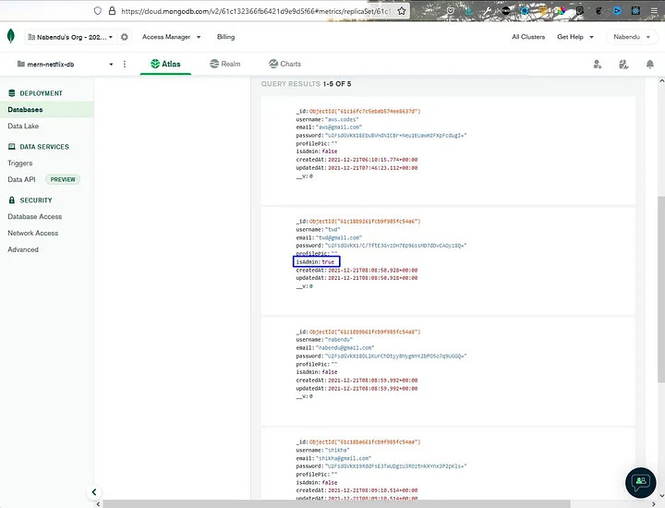

**[Fig.4.2.5: MongoDB Atlas]**

#### Authentication

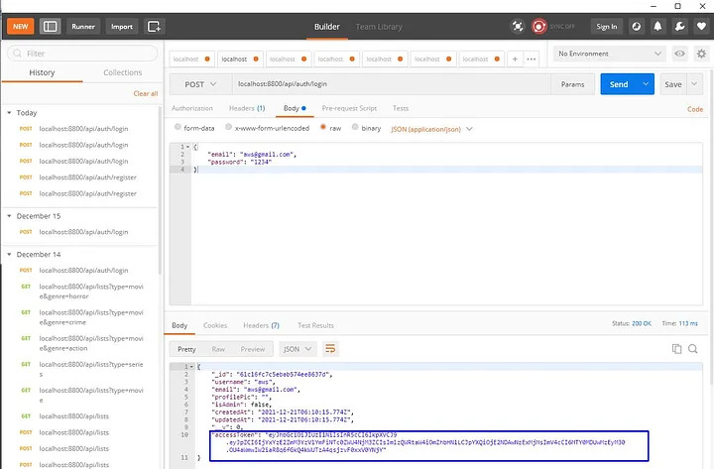

**[Fig.4.3.2: PostMan API]**

# CHAPTER 5

# IMPLEMENTATION PLANNING

#### Implementation Environment

The application is a single-server, multi-client application. Multiple users can log in to use the system.

Multi-user vs. single-user

A single-user web application is designed to serve only one user at a time, while a multi-user web application is designed to be used by multiple users simultaneously. In a single-user web application, the user has exclusive access to the system and can perform any operation in the application without worrying about data conflicts. In a multi-user web application, on the other hand, multiple users can access and use the system simultaneously. The application must handle concurrent access and manage any data conflicts that may arise. Multi-user web applications typically require more complex security and user management features to ensure that the system remains secure and that users can access only the data they are authorized to use.

GUI vs. non-GUI

GUI (Graphical User Interface) and non-GUI are two different approaches to building web applications. GUI-based web applications have a user interface that uses visual elements such as buttons, menus, forms, and images to allow users to interact with the application. Non-GUI web applications, also known as command- line applications, have no graphical interface and rely on text-based input and output.

GUI-based web applications are more user-friendly and intuitive, making it easier for users to navigate and interact with the application. Non-GUI web applications are generally simpler and more streamlined, making them easier to develop and maintain. However, they may not be as accessible to users who are unfamiliar with command-line interfaces.

#### Program/Modules Specification

* + - Web app development made with NodeJs
    - User Module: - User can watch movies, TV series, buy subscription.
    - Admin Module: - Admin can track user, upload videos, delete videos.

#### Coding Standards

Coding techniques incorporate many facts about software development. Although they usually have no impact on the functionality of the application; they contribute to an improved comprehension of source code. All forms of source code arconsidered here, including programming, scripting markup, and query languages

Purpose of Coding Standards and Best Practices

To develop reliable and maintainable applications, you must follow coding standards and best practices. The naming conventions, coding standards and best practices described in this document are compiled from our own experience and by referring to various guidelines. There are several standards that exist in the programming industry. None of them are wrong or bad and you may follow any of them. What is more important is, selecting one standard approach and ensuring that everyone is following it.

In this phase of software development, the design is related to a system converted into a machine-readable code that can be compiled and executed. Although the coding phase does not affect the structure of the system, it has a great impact on the internal structure of the module, which affects the testability, under the stability of the system.

#### Coding Scenario

I used NodeJS in this web app. This way I made each component reusable and reduced the footprint so that each functionality can be reused when needed.

Also, using Firebase helped make the website secure by storing and authenticating each individual user when they log in and make a purchase.

# CHAPTER 6

# TESTING

#### Testing Plan/ Strategy

Testing Screenify involves multiple parts to ensure the application is functioning correctly. The first part is to validate the database design and ensure it matches the required schema. This includes testing the tables, fields, relationships, and data types. The second part is to test the API endpoints and check if they are properly handling requests and responses. This includes testing for proper authentication and authorization, error handling, and input validation. The third part is to check if the backend is able to properly handle and store user data, such as user profiles, preferences, and viewing history. The fourth part is to test the backend's ability to stream video content seamlessly, with no buffering or lag, and to ensure that the video quality is consistent across different devices and network speeds. Overall, thorough testing of a backend Netflix clone is crucial to ensure the application is delivering a seamless and enjoyable streaming experience to its users.

#### Test Cases

To minimize the number of errors in software, a rich variety of test design methods have evolved for software. These methods provide the developer with a systematic approach to testing. More importantly, methods provide a mechanism that can help to ensure the completeness of the test and provide the highest likelihood for uncovering errors in software.

An engineering product can be tested in one of the two ways:

Knowing the specified function that product has been designed to perform, tests can be conducted that demonstrate each function is fully operational while at the same time searching for errors in each function.

Knowing the internal workings of a product, tests can be conducted to ensure that “all gear mesh “, that is, internal oppression are performed according to specifications and all internal components have been adequately exercised. Here are the test cases that we had made for our application.

Test Case for Login

* Check if the email address entered is valid and matches the format of a typical email address.
* Check if the password entered is at least 8 characters long and contains a mix of uppercase and lowercase letters, numbers, and special characters.
* Check if the login credentials are correct and match the records stored in the database.

Test Case for Sign Up

* Check if the email address and username entered are not already registered in the database.
* Check if the password entered is at least 8 characters long and contains a mix of uppercase and lowercase letters, numbers, and special characters.
* Check if all fields are required and that an error message is displayed if any fields are left blank.

Test Case Browse

* Check if the list of available movies and TV shows is displayed correctly.
* Check if the filter and search functionalities work properly and display the correct results.
* Check if the selected movie or TV show details are displayed correctly an

Test Case Watch

* Check if the selected movie or TV show starts playing smoothly and without buffering.
* Check if the player controls (such as play/pause, volume, and skip) work properly.
* Check if the video quality is consistent across different devices and network speeds.

Test Case My List

* Check if the list of saved movies and TV shows is displayed correctly.
* Check if the user can add or remove items from the list.
* Check if the list is properly synced across different devices and browsers.

**CHAPTER 7**

**CONCLUSION AND DISCUSSION**

**Overall Analysis of Internship**

* Overall, I believe that an internship will be a great opportunity for me to gain practical experience and build my skills in web development. Through this internship, I can learn from experienced professionals and work on real-world projects that will challenge me and help me develop problem-solving and critical thinking skills. I'm confident that this experience will prepare me for a successful career in web development and help me build a strong professional network. I'm excited to apply what I learn during the internship and contribute to the growth and success of the company.

#### Limitations

* + - Subscription Required: To access the content on the Netflix clone, users must subscribe to the service and pay a monthly or annual fee. The subscription can be managed through the app or website, but an internet connection is required to process payments.
    - Offline Downloads Available: To overcome the issue of internet connectivity, the Netflix clone allows users to download movies and TV shows for offline viewing. However, the downloads can only be accessed through the app or website, and an internet connection is required to initiate the download process.
    - HD Quality Depends on Internet Speed: The quality of the video on the Netflix clone depends on the speed and stability of the user's internet connection. Users with a slower internet connection may experience lower video quality or buffering while streaming high-definition content.

#### Future Enhancement

* + - Virtual Reality Integration: Adding virtual reality (VR) technology to the Netflix clone would allow users to experience movies and TV shows in a more immersive way. This would require users to have VR headsets, but it could provide a unique viewing experience and attract a new audience to the platform.
    - Interactive Content: Interactive content, such as choose-your-own-adventure style shows, can provide users with a more personalized and engaging experience. By allowing users to make decisions and influence the outcome of the story, this type of content can increase user engagement and create a more memorable experience. Netflix has already experimented with interactive content in shows like "Black Mirror: Bandersnatch," and this trend could continue to grow in the future.

**CHAPTER 8**

##### **REFERENCES**

1. Quora. (2009) For Solution of Question

**[Online] [Accessed from February to April 2022]**

<https://www.quora.com/>

1. Stack Overflow. (2008) Coding Related Question Solution [Online] [Accessed from February to April 2022]

<https://stackoverflow.com/>

1. **GitHub. (2007) GitHub Support Community [Online] [Accessed from February to April 2022]** [https://github.community](https://github.community/)
2. Google Drive API. [~2012] To read, write, and sync files in Google Drive. [Online] [Accessed from February to April 2022]

<https://developers.google.com/drive/api/v3/about-sdk>