This is it!!!

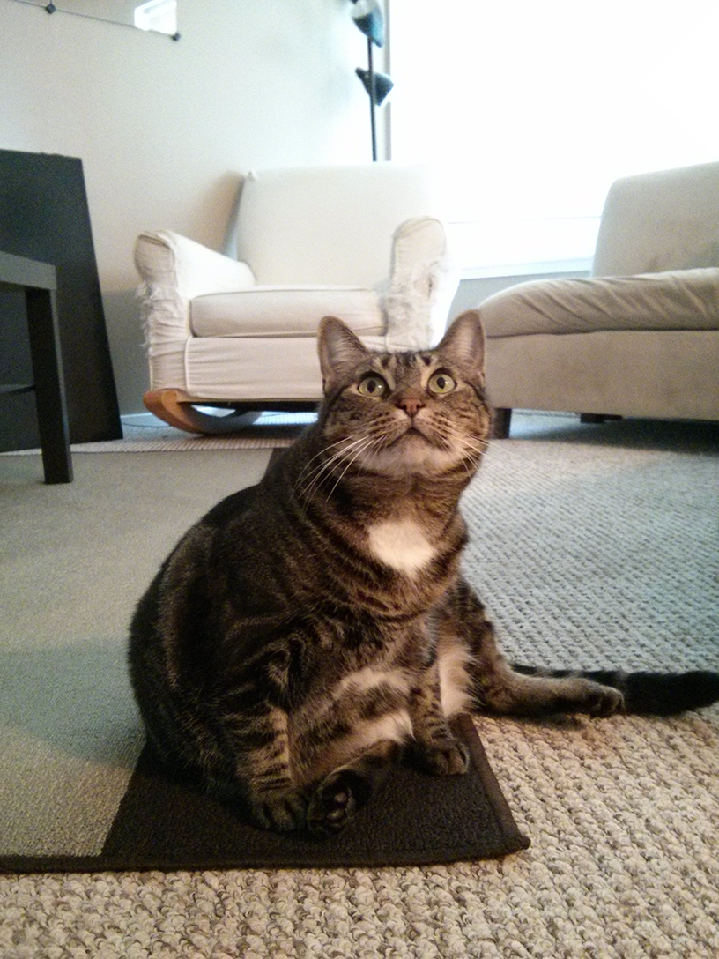

Apna time Aega!!!