**ASSIGNMENT - 1**

* **Create Tables :-**

1. **Create Client_master table :-**

* Query :-

CREATE TABLE CLIENT_MASTER (

CLIENTNO VARCHAR(6),

NAME VARCHAR(20),

ADDRESS1 VARCHAR(30),

ADDRESS2 VARCHAR(30),

CITY VARCHAR(15),

PINCODE NUMERIC(8),

STATE VARCHAR(15),

BALDUE NUMERIC(10,2)

);

1. **Create Product_master table :-**

* Query :-

CREATE TABLE PRODUCT_MASTER (

PRODUCTNO VARCHAR(6),

DESCRIPTION VARCHAR(15),

PROFITPERCENT NUMERIC(4,2),

UNITMASTER VARCHAR(10),

QTYONHAND NUMERIC(8),

REORDERLVL NUMERIC(8),

SELLPRICE NUMERIC(8,2),

COSTPRICE NUMERIC(8,2)

);

1. **Create Salesman_master table :-**

* Query :-

CREATE TABLE SALESMAN_MASTER (

SALESMANNO VARCHAR(6),

SALESMANNAME VARCHAR(20),

ADDRESS1 VARCHAR(30),

ADDRESS2 VARCHAR(30),

CITY VARCHAR(20),

PINCODE NUMERIC(8),

STATE VARCHAR(20),

SALAMT NUMERIC(8,2),

TGTTOGET NUMERIC(6,2),

YTDSALES NUMERIC(6,2),

REMARKS VARCHAR(60)

);

* **Inserting the data into table :-**

1. **Data for Client_master table :-**

* Query :-
* INSERT INTO CLIENT_MASTER(CLIENTNO, NAME, CITY, PINCODE, STATE, BALDUE)

VALUES ('C00001','Rakesh Joshi','Mumbai',400054,'Maharashtra',1500);

* INSERT INTO CLIENT_MASTER(CLIENTNO, NAME, CITY, PINCODE, STATE, BALDUE)

VALUES ('C00002','Mayur Patel', 'Madras', 780001, 'Tamilnadu',0);

* INSERT INTO CLIENT_MASTER(CLIENTNO, NAME, CITY, PINCODE, STATE, BALDUE)

VALUES ('C00003', 'Ishita Mehata','Mumbai', 400057, 'Maharashtra',5000);

- INSERT INTO CLIENT_MASTER(CLIENTNO, NAME, CITY, PINCODE, STATE, BALDUE)

VALUES ('C00004','Amit Solanki','Bangalore', 560001, 'Karnataka', 0);

- INSERT INTO CLIENT_MASTER(CLIENTNO, NAME, CITY, PINCODE, STATE, BALDUE)

VALUES ('C00005', 'Hiren Pandya', 'Mumbai', 400060, 'Maharashtra', 2000);

* INSERT INTO CLIENT_MASTER(CLIENTNO, NAME, CITY, PINCODE, STATE, BALDUE)

VALUES ('C00006', 'Dipak Sharma', 'Mangalore', 560050, 'Karnataka', 0);

* Query :-
* SELECT * FROM CLIENT_MASTER;
* **Output :-**

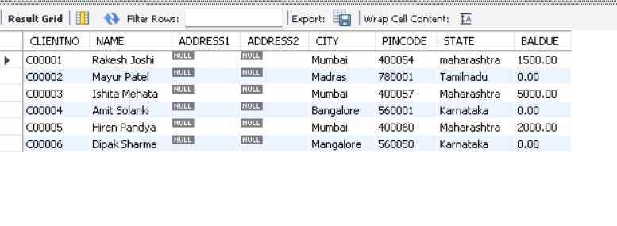

1. **Data for Product_master table :-**

* Query :-

* INSERT INTO PRODUCT_MASTER (PRODUCTNO, DESCRIPTION, PROFITPERCENT, UNITMASTER, QTYONHAND, REORDERLVL, SELLPRICE, COSTPRICE) VALUES ('P00001', 'T-Shirts', 5, 'Piece', 200, 50, 350, 250);
* INSERT INTO PRODUCT_MASTER (PRODUCTNO, DESCRIPTION, PROFITPERCENT, UNITMASTER, QTYONHAND, REORDERLVL, SELLPRICE, COSTPRICE) VALUES ('P0345', 'Shirts', 6, 'Piece', 150, 50, 500, 350);
* INSERT INTO PRODUCT_MASTER (PRODUCTNO, DESCRIPTION, PROFITPERCENT, UNITMASTER, QTYONHAND, REORDERLVL, SELLPRICE, COSTPRICE) VALUES ('P06734', 'Cotton Jeans', 5, 'Piece', 100, 20, 600, 450);
* INSERT INTO PRODUCT_MASTER (PRODUCTNO, DESCRIPTION, PROFITPERCENT, UNITMASTER, QTYONHAND, REORDERLVL, SELLPRICE, COSTPRICE) VALUES ('P07865', 'Jeans', 5, 'Piece', 100, 20, 750, 500);
* INSERT INTO PRODUCT_MASTER (PRODUCTNO, DESCRIPTION, PROFITPERCENT, UNITMASTER, QTYONHAND, REORDERLVL, SELLPRICE, COSTPRICE) VALUES ('P07868', 'Trousers', 2, 'Piece', 150, 50, 850, 550);
* INSERT INTO PRODUCT_MASTER (PRODUCTNO, DESCRIPTION, PROFITPERCENT, UNITMASTER, QTYONHAND, REORDERLVL, SELLPRICE, COSTPRICE) VALUES ('P07885', 'Pull Overs', 2.5, 'Piece', 80, 30, 700, 450);
* INSERT INTO PRODUCT_MASTER (PRODUCTNO, DESCRIPTION, PROFITPERCENT, UNITMASTER, QTYONHAND, REORDERLVL, SELLPRICE, COSTPRICE) VALUES ('P07965', 'Denim Shirts', 4, 'Piece', 100, 40, 350, 250);
* INSERT INTO PRODUCT_MASTER (PRODUCTNO, DESCRIPTION, PROFITPERCENT, UNITMASTER, QTYONHAND, REORDERLVL, SELLPRICE, COSTPRICE) VALUES ('P07975', 'Lycra Tops', 5, 'Piece', 70, 30, 300, 175);
* INSERT INTO PRODUCT_MASTER (PRODUCTNO, DESCRIPTION, PROFITPERCENT, UNITMASTER, QTYONHAND, REORDERLVL, SELLPRICE, COSTPRICE) VALUES ('P08865', 'Skirts', 5, 'Piece', 75, 30, 450, 300);
* Query :-
* SELECT * FROM assignment1.product_master;
* **Output :-**

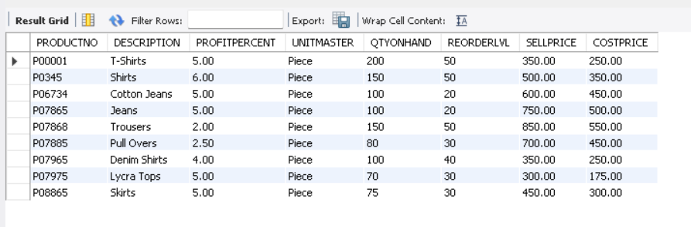

1. **Data for Salesman_master table :-**

* Query :-

- INSERT INTO SALESMAN_MASTER (SALESMANNO, SALESMANNAME, ADDRESS1, ADDRESS2, CITY, PINCODE, STATE, SALAMT, TGTTOGET, YTDSALES, REMARKS) VALUES ('S00001', 'Aman', 'A/14', 'Worli', 'Mumbai', 400002, 'Maharashtra', 3000, 100, 50, 'Good');

- INSERT INTO SALESMAN_MASTER (SALESMANNO, SALESMANNAME, ADDRESS1, ADDRESS2, CITY, PINCODE, STATE, SALAMT, TGTTOGET, YTDSALES, REMARKS) VALUES ('S00002', 'Omkar', 65, 'Nariman', 'Mumbai', 400001, 'Maharashtra', 3000, 200, 100, 'Good');

- INSERT INTO SALESMAN_MASTER (SALESMANNO, SALESMANNAME, ADDRESS1, ADDRESS2, CITY, PINCODE, STATE, SALAMT, TGTTOGET, YTDSALES, REMARKS) VALUES ('S00003', 'Raj', 'P-7', 'Bandra', 'Mumbai', 400032, 'Maharashtra', 3000, 200, 100, 'Good');

- INSERT INTO SALESMAN_MASTER (SALESMANNO, SALESMANNAME, ADDRESS1, ADDRESS2, CITY, PINCODE, STATE, SALAMT, TGTTOGET, YTDSALES, REMARKS) VALUES ('S00004', 'Ashish', 'A/5', 'Juhu', 'Mumbai', 400044, 'Maharashtra', 3000, 200, 100, 'Good');

* Query :-

- SELECT * FROM assignment1.salesman_master;

* **Output :-**

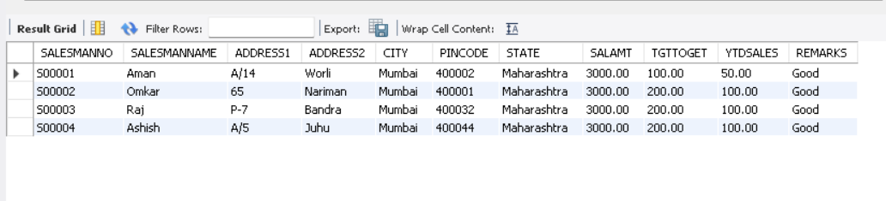

**EXERCISE**

* **Exercise On Retrieving Records From The Table :-**

1. **Find out the names of all the clients.**

* SELECT NAME FROM CLIENT_MASTER;
* 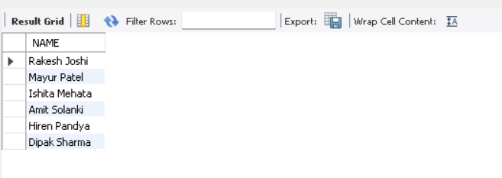

1. **Retrieve the entire contents of the Client Master table.**

* SELECT * FROM CLIENT_MASTER;

* 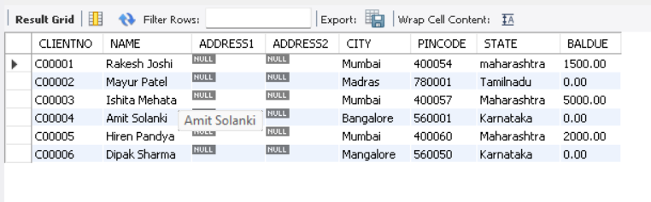

1. **Retrieve the list of names, city and the state of all the clients**.

* SELECT NAME, CITY, STATE FROM CLIENT_MASTER;

* 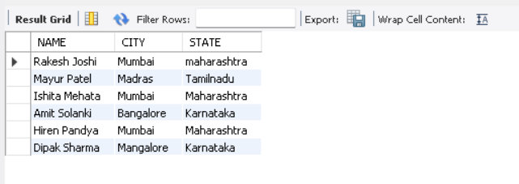

1. **List the various products available from the Product Master table.**

* SELECT DESCRIPTION FROM PRODUCT_MASTER;

* 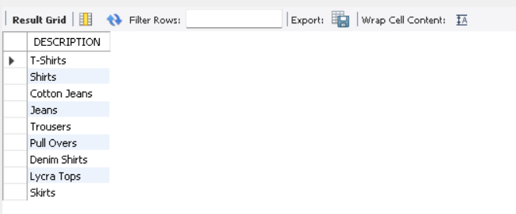

1. **List all the clients who are located in Mumbai.**

* SELECT NAME FROM CLIENT_MASTER WHERE CITY = 'Mumbai';
* 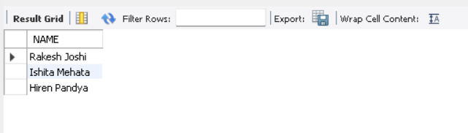

1. **Find the names of salesman who have a salary equal to Rs. 3000.**

* SELECT SALESMANNAME FROM SALESMAN_MASTER WHERE SALAMT = 3000;

* 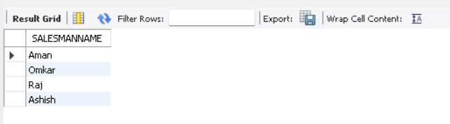
* **Exercise On Updating Records In Table :-**

1. **Change the city of client no. ‘C00005’ to ‘Bangalore’.**

* UPDATE CLIENT_MASTER

SET CITY = 'Bangalore'

WHERE CLIENTNO = 'C00005';

* 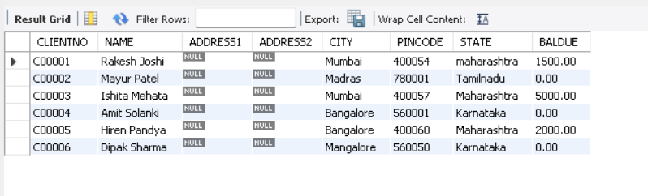

1. **Change the BalDue of client no. ‘C0001’ to Rs. 1000.**

* UPDATE CLIENT_MASTER

SET BALDUE = 1000

WHERE CLIENTNO = 'C00001';

* 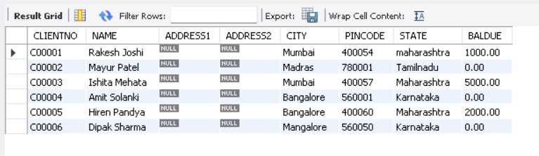

1. **Change the cost price of ‘Trousers’ to Rs. 950.**

* UPDATE PRODUCT_MASTER

SET COSTPRICE = 950

WHERE DESCRIPTION = 'TrouserS';

* 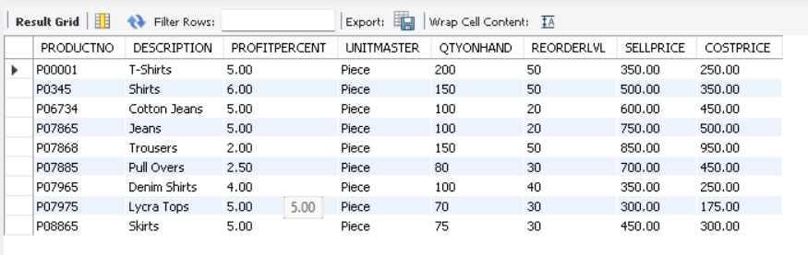

1. **Change the city of the salesman to Pune.**

* UPDATE SALESMAN_MASTER

SET CITY = 'Pune';

* 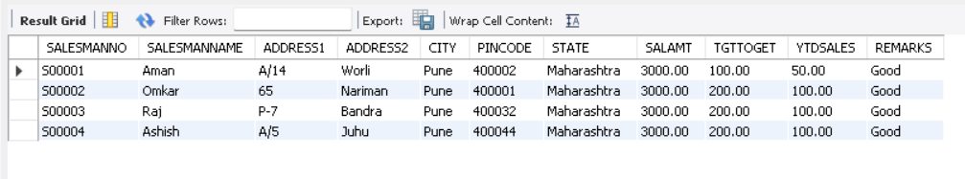

1. **Change the SellPrice of LycraTops to Rs.350.**

* UPDATE PRODUCT_MASTER

SET SELLPRICE = 350

WHERE DESCRIPTION = 'Lycra Tops';

* 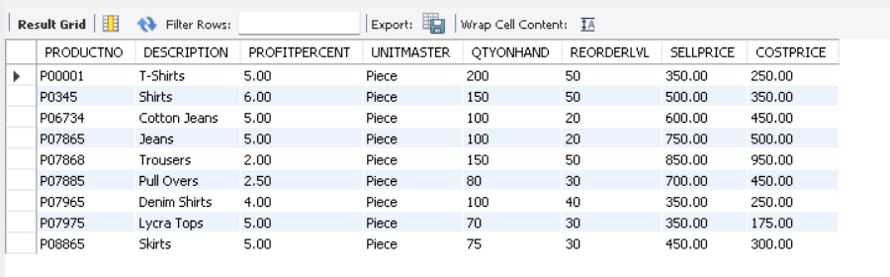

1. **Change the Address1, Address2, City, Pincode, State of Salesman No. S00002.**

* UPDATE SALESMAN_MASTER

SET ADDRESS1 = 'D/3', ADDRESS2 = 312, CITY = 'Surat', PINCODE = 394210, STATE = 'Gujarat'

WHERE SALESMANNO = 'S00002';

* 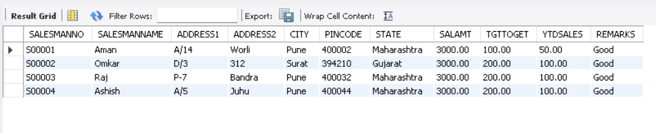
* **Exercise On Deleting Records In A Table :-**

1. **Delete all salesman from the salesman master whose salaries are equal to Rs. 3500.**

* DELETE FROM SALESMAN_MASTER WHERE SALAMT = 3500;

* 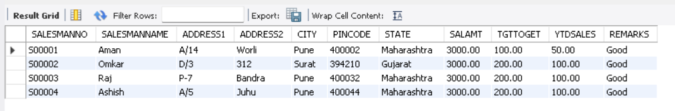

1. **Delete all products from the product master where the quantity on hand is equal to 100.**

* DELETE FROM PRODUCT_MASTER WHERE QTYONHAND = 100;

* 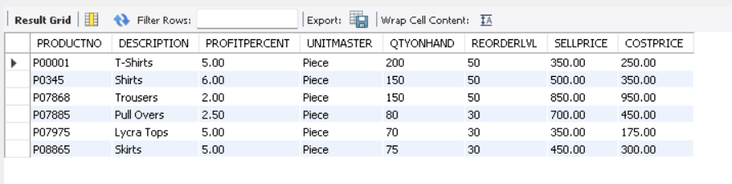

1. **Delete from client master where the column state holds the value ‘Tamil Nadu’.**

* DELETE FROM CLIENT_MASTER WHERE STATE = 'TamilNadu';

* 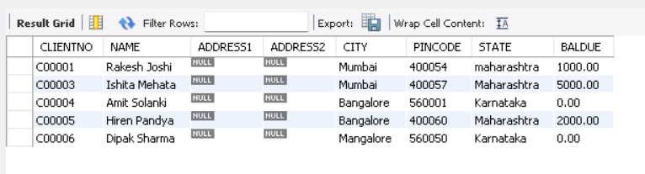
* **Exercise On Altering The Table Structure :-**

1. **Add a column called ‘Telephone’ of data type ‘number’ and size=’10’ to the client Master table.**

* ALTER TABLE CLIENT_MASTER ADD TELEPHONE NUMERIC(10);

* 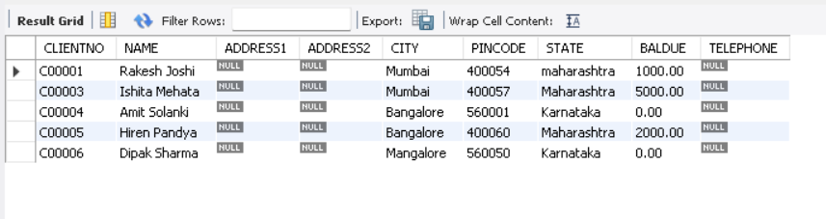

1. **Change the size of sellprice column in Product Master to 10,2.**

* ALTER TABLE PRODUCT_MASTER MODIFY SELLPRICE NUMERIC(10,2);

* 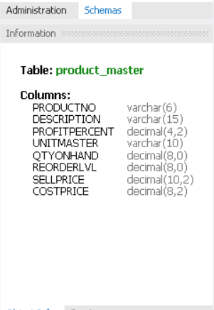

1. **Add a column called ‘Profit’ of data type ‘ number’ and size=’12’ to the product master.**

* ALTER TABLE PRODUCT_MASTER ADD PROFIT NUMERIC(12);

* 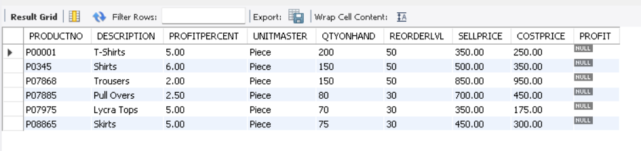

1. **Remove column ‘Profit’ from the product master.**

* ALTER TABLE PRODUCT_MASTER DROP COLUMN PROFIT;

* 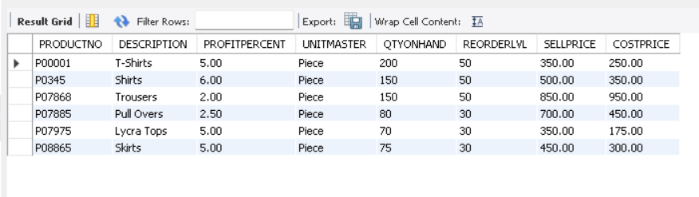

1. **Change the name of the Salesman master table to sman_mast.**

* ALTER TABLE SALESMAN_MASTER RENAME COLUMN SALESMANNAME TO SMAN_MAST;
* 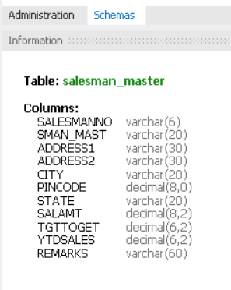

1. **Destroy the table client master along with its data.**

* 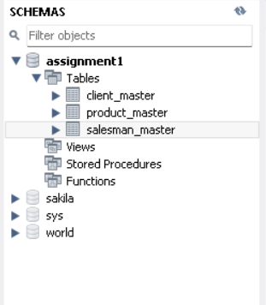

* DROP TABLE CLIENT_MASTER;

* 