**ASSIGNMENT - 2**

* **Create Tables :-**

1. **Create Client_master table :-**

* Query :-

CREATE TABLE CLIENT_MASTER (

CLIENTNO VARCHAR(6) CHECK (CLIENTNO LIKE 'C%' ) NOT NULL,

NAME VARCHAR(20) NOT NULL,

ADDRESS1 VARCHAR(30),

ADDRESS2 VARCHAR(30),

CITY VARCHAR(15),

PINCODE NUMERIC(8),

STATE VARCHAR(15),

BALDUE NUMERIC(10,2),

PRIMARY KEY (CLIENTNO)

);

* Output :-

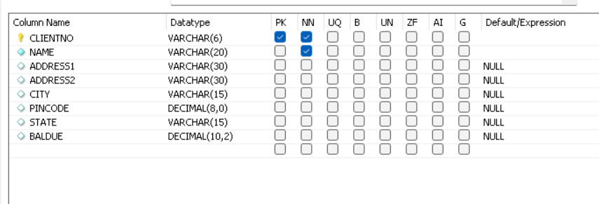

1. **Create Product_master table :-**

* Query :-

CREATE TABLE PRODUCT_MASTER (

PRODUCTNO VARCHAR(6) CHECK (PRODUCTNO LIKE 'P%') PRIMARY KEY,

DESCRIPTION VARCHAR(15) NOT NULL,

PROFITPERCENT NUMERIC(4,2) NOT NULL,

UNITMASTER VARCHAR(10) NOT NULL,

QTYONHAND NUMERIC(8) NOT NULL,

REORDERLVL NUMERIC(8) NOT NULL,

SELLPRICE NUMERIC(8,2) CHECK (SELLPRICE <> 0 ) NOT NULL,

COSTPRICE NUMERIC(8,2) CHECK (COSTPRICE <> 0 ) NOT NULL

);

* Output :-

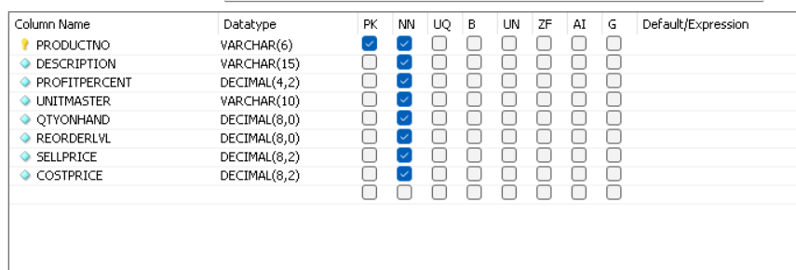

1. **Create Salesman_master table :-**

* Query :-

CREATE TABLE SALESMAN_MASTER (

SALESMANNO VARCHAR(6) CHECK (SALESMANNO LIKE 'S%') PRIMARY KEY,

SALESMANNAME VARCHAR(20) NOT NULL,

ADDRESS1 VARCHAR(30) NOT NULL,

ADDRESS2 VARCHAR(30),

CITY VARCHAR(20),

PINCODE NUMERIC(8),

STATE VARCHAR(20),

SALAMT NUMERIC(8,2) CHECK (SALAMT > 0 ) NOT NULL,

TGTTOGET NUMERIC(6,2) CHECK (TGTTOGET > 0 ) NOT NULL,

YTDSALES NUMERIC(6,2) CHECK (YTDSALES > 0 ) NOT NULL,

REMARKS VARCHAR(60)

);

* Output :-

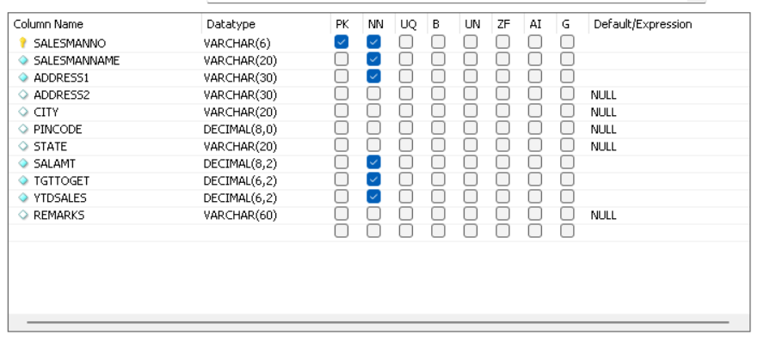

1. **Create Sales_Order table :-**

* Query :-

CREATE TABLE SALES_ORDER (

ORDERNO VARCHAR(6) CHECK (ORDERNO LIKE 'O%' ),

PRIMARY KEY(ORDERNO),

CLIENTNO VARCHAR(6),

FOREIGN KEY (CLIENTNO) REFERENCES CLIENT_MASTER(CLIENTNO),

ORDERDATE DATE NOT NULL,

DELYADDR VARCHAR(25),

SALESMANNO VARCHAR(6),

FOREIGN KEY (SALESMANNO) REFERENCES SALESMAN_MASTER(SALESMANNO),

DELYTYPE CHAR(1) DEFAULT 'F',

BIILYN CHAR(1),

DELYDATE DATE,

CHECK (DELYDATE > ORDERDATE),

ORDERSTATUS VARCHAR(10),

CONSTRAINT CHK_DELYTYPE_VAL CHECK (DELYTYPE IN ('P','F')),

CONSTRAINT CHK_ORDERDSTATUS_VAL CHECK (ORDERSTATUS IN ('InProcess','Fullfilled','BackOrder','Cancelled'))

);

* Output :-

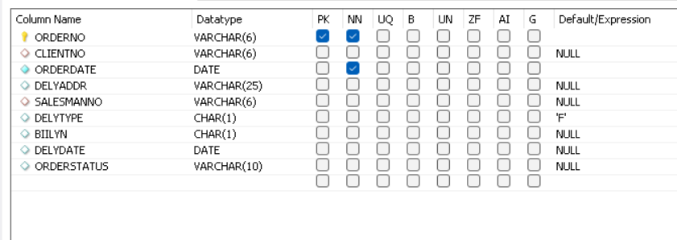

1. **Create Sales_Order_Details table :-**

* Query :-

CREATE TABLE SALES_ORDER_DETAILS (

ORDERNO VARCHAR(6),

FOREIGN KEY (ORDERNO) REFERENCES SALES_ORDER(ORDERNO),

PRODUCTNO VARCHAR(6),

FOREIGN KEY (PRODUCTNO) REFERENCES PRODUCT_MASTER(PRODUCTNO),

QTYORDERED NUMERIC(8),

QTYDISP NUMERIC(8),

PRODUCTRATE NUMERIC(10,2)

);

* Output :-

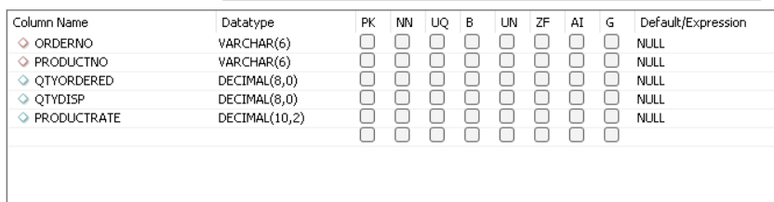

* **Inserting the data into table :-**

1. **Data for Client_master table :-**

* Query :-
* INSERT INTO CLIENT_MASTER(CLIENTNO, NAME, CITY, PINCODE, STATE, BALDUE)

VALUES ('C00001','Rakesh Joshi','Mumbai',400054,'Maharashtra',1500);

* INSERT INTO CLIENT_MASTER(CLIENTNO, NAME, CITY, PINCODE, STATE, BALDUE)

VALUES ('C00002','Mayur Patel', 'Madras', 780001, 'Tamilnadu',0);

* INSERT INTO CLIENT_MASTER(CLIENTNO, NAME, CITY, PINCODE, STATE, BALDUE)

VALUES ('C00003', 'Ishita Mehata','Mumbai', 400057, 'Maharashtra',5000);

- INSERT INTO CLIENT_MASTER(CLIENTNO, NAME, CITY, PINCODE, STATE, BALDUE)

VALUES ('C00004','Amit Solanki','Bangalore', 560001, 'Karnataka', 0);

- INSERT INTO CLIENT_MASTER(CLIENTNO, NAME, CITY, PINCODE, STATE, BALDUE)

VALUES ('C00005', 'Hiren Pandya', 'Mumbai', 400060, 'Maharashtra', 2000);

* INSERT INTO CLIENT_MASTER(CLIENTNO, NAME, CITY, PINCODE, STATE, BALDUE)

VALUES ('C00006', 'Dipak Sharma', 'Mangalore', 560050, 'Karnataka', 0);

* Query :-
* SELECT * FROM CLIENT_MASTER;
* **Output :-**

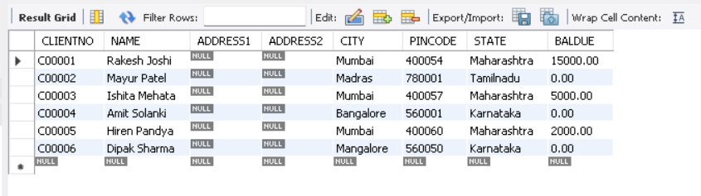

1. **Data for Product_master table :-**

* Query :-

* INSERT INTO PRODUCT_MASTER (PRODUCTNO, DESCRIPTION, PROFITPERCENT, UNITMASTER, QTYONHAND, REORDERLVL, SELLPRICE, COSTPRICE) VALUES ('P00001', 'T-Shirts', 5, 'Piece', 200, 50, 350, 250);
* INSERT INTO PRODUCT_MASTER (PRODUCTNO, DESCRIPTION, PROFITPERCENT, UNITMASTER, QTYONHAND, REORDERLVL, SELLPRICE, COSTPRICE) VALUES ('P0345', 'Shirts', 6, 'Piece', 150, 50, 500, 350);
* INSERT INTO PRODUCT_MASTER (PRODUCTNO, DESCRIPTION, PROFITPERCENT, UNITMASTER, QTYONHAND, REORDERLVL, SELLPRICE, COSTPRICE) VALUES ('P06734', 'Cotton Jeans', 5, 'Piece', 100, 20, 600, 450);
* INSERT INTO PRODUCT_MASTER (PRODUCTNO, DESCRIPTION, PROFITPERCENT, UNITMASTER, QTYONHAND, REORDERLVL, SELLPRICE, COSTPRICE) VALUES ('P07865', 'Jeans', 5, 'Piece', 100, 20, 750, 500);
* INSERT INTO PRODUCT_MASTER (PRODUCTNO, DESCRIPTION, PROFITPERCENT, UNITMASTER, QTYONHAND, REORDERLVL, SELLPRICE, COSTPRICE) VALUES ('P07868', 'Trousers', 2, 'Piece', 150, 50, 850, 550);
* INSERT INTO PRODUCT_MASTER (PRODUCTNO, DESCRIPTION, PROFITPERCENT, UNITMASTER, QTYONHAND, REORDERLVL, SELLPRICE, COSTPRICE) VALUES ('P07885', 'Pull Overs', 2.5, 'Piece', 80, 30, 700, 450);
* INSERT INTO PRODUCT_MASTER (PRODUCTNO, DESCRIPTION, PROFITPERCENT, UNITMASTER, QTYONHAND, REORDERLVL, SELLPRICE, COSTPRICE) VALUES ('P07965', 'Denim Shirts', 4, 'Piece', 100, 40, 350, 250);
* INSERT INTO PRODUCT_MASTER (PRODUCTNO, DESCRIPTION, PROFITPERCENT, UNITMASTER, QTYONHAND, REORDERLVL, SELLPRICE, COSTPRICE) VALUES ('P07975', 'Lycra Tops', 5, 'Piece', 70, 30, 300, 175);
* INSERT INTO PRODUCT_MASTER (PRODUCTNO, DESCRIPTION, PROFITPERCENT, UNITMASTER, QTYONHAND, REORDERLVL, SELLPRICE, COSTPRICE) VALUES ('P08865', 'Skirts', 5, 'Piece', 75, 30, 450, 300);
* Query :-
* SELECT * FROM product_master;
* **Output :-**

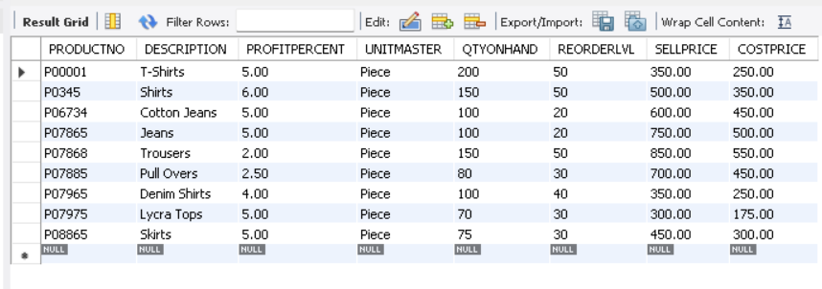

1. **Data for Salesman_master table :-**

* Query :-

- INSERT INTO SALESMAN_MASTER (SALESMANNO, SALESMANNAME, ADDRESS1, ADDRESS2, CITY, PINCODE, STATE, SALAMT, TGTTOGET, YTDSALES, REMARKS) VALUES ('S00001', 'Aman', 'A/14', 'Worli', 'Mumbai', 400002, 'Maharashtra', 3000, 100, 50, 'Good');

- INSERT INTO SALESMAN_MASTER (SALESMANNO, SALESMANNAME, ADDRESS1, ADDRESS2, CITY, PINCODE, STATE, SALAMT, TGTTOGET, YTDSALES, REMARKS) VALUES ('S00002', 'Omkar', 65, 'Nariman', 'Mumbai', 400001, 'Maharashtra', 3000, 200, 100, 'Good');

- INSERT INTO SALESMAN_MASTER (SALESMANNO, SALESMANNAME, ADDRESS1, ADDRESS2, CITY, PINCODE, STATE, SALAMT, TGTTOGET, YTDSALES, REMARKS) VALUES ('S00003', 'Raj', 'P-7', 'Bandra', 'Mumbai', 400032, 'Maharashtra', 3000, 200, 100, 'Good');

- INSERT INTO SALESMAN_MASTER (SALESMANNO, SALESMANNAME, ADDRESS1, ADDRESS2, CITY, PINCODE, STATE, SALAMT, TGTTOGET, YTDSALES, REMARKS) VALUES ('S00004', 'Ashish', 'A/5', 'Juhu', 'Mumbai', 400044, 'Maharashtra', 3000, 200, 100, 'Good');

* Query :-

- SELECT * FROM salesman_master;

* **Output :-**

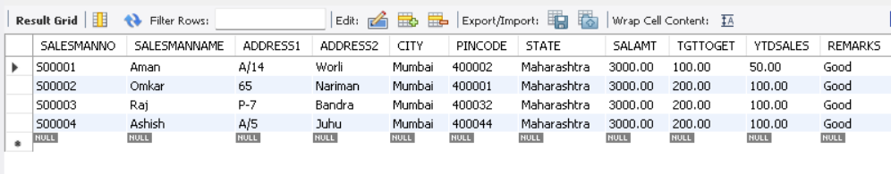

1. **Data for Sales_Order table :-**

* Query :-

- INSERT INTO SALES_ORDER (ORDERNO,CLIENTNO,ORDERDATE,SALESMANNO,DELYTYPE,BIILYN,DELYDATE,ORDERSTATUS) VALUES ('O19001', 'C00001',str_to_date('12-June-04','%d-%M-%y'),'S00001','F','N',str_to_date('20-July-04','%d-%M-%y'),'In Process');

- INSERT INTO SALES_ORDER (ORDERNO,CLIENTNO,ORDERDATE,SALESMANNO,DELYTYPE,BIILYN,DELYDATE,ORDERSTATUS) values

('O19002','C00002',str_to_date('25-June-04','%d-%M-%y'),'S00002','P', 'N', str_to_date('27-June-04','%d-%M-%y'),'Cancelled');

- INSERT INTO SALES_ORDER

(ORDERNO,CLIENTNO,ORDERDATE,SALESMANNO,DELYTYPE,BIILYN,DELYDATE,ORDERSTATUS) values ('O46865','C00003',str_to_date('18-Feb-04','%d-%M-%y'),'S00003','F','Y', str_to_date('20-Feb-04','%d-%M-%y'),'Fullfilled');

* INSERT INTO SALES_ORDER (ORDERNO,CLIENTNO,ORDERDATE,SALESMANNO,DELYTYPE,BIILYN,DELYDATE,ORDERSTATUS) values ('O19003','C00004',str_to_date('03-Apr-04','%d-%M-%y'),'S00001','F','Y', str_to_date('07-Apr-04','%d-%M-%y'),'Fullfilled');

* INSERT INTO SALES_ORDER (ORDERNO,CLIENTNO,ORDERDATE,SALESMANNO,DELYTYPE,BIILYN,DELYDATE,ORDERSTATUS) values ('O46866','C00005',str_to_date('20-May-04','%d-%M-%y'), 'S00002','P','N',str_to_date('22-May-04','%d-%M-%y'),'Cancelled');

* INSERT INTO SALES_ORDER (ORDERNO,CLIENTNO,ORDERDATE,SALESMANNO,DELYTYPE,BIILYN,DELYDATE,ORDERSTATUS) values ('O19008','C00006',str_to_date('24-May-04','%d-%M-%y'),'S00004','F','N',str_to_date('26-July-04','%d-%M-%y'),'Fullfilled');
* Query :-

SELECT * FROM assignment2.sales_order;

* **Output :-**

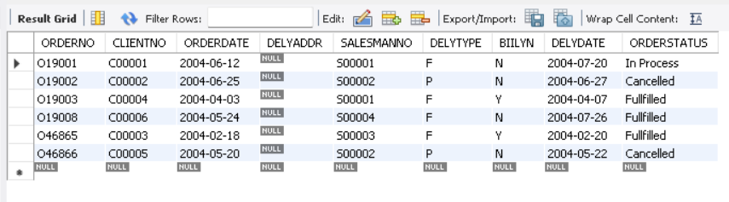

1. **Data for Sales_Order_Details table :-**

* Query :-
* INSERT INTO SALES_ORDER_DETAILS (ORDERNO,PRODUCTNO ,QTYORDERED,QTYDISP,PRODUCTRATE) VALUES ('O19001','P00001', 4, 4, 525);
* INSERT INTO SALES_ORDER_DETAILS (ORDERNO,PRODUCTNO ,QTYORDERED,QTYDISP,PRODUCTRATE) VALUES ('O19001','P07965',2,1,8400);
* INSERT INTO SALES_ORDER_DETAILS (ORDERNO,PRODUCTNO ,QTYORDERED,QTYDISP,PRODUCTRATE) VALUES ('O19001','P07885',2,1,5250);
* INSERT INTO SALES_ORDER_DETAILS (ORDERNO,PRODUCTNO ,QTYORDERED,QTYDISP,PRODUCTRATE) VALUES ('O19002','P00001',10,0,525);
* INSERT INTO SALES_ORDER_DETAILS (ORDERNO,PRODUCTNO ,QTYORDERED,QTYDISP,PRODUCTRATE) VALUES ('O46865','P07868',3,3,3150);
* INSERT INTO SALES_ORDER_DETAILS (ORDERNO,PRODUCTNO ,QTYORDERED,QTYDISP,PRODUCTRATE) VALUES ('O46865','P07885',3,1,5250);
* INSERT INTO SALES_ORDER_DETAILS (ORDERNO,PRODUCTNO ,QTYORDERED,QTYDISP,PRODUCTRATE) VALUES ('O46865','P00001',10,10,525);
* INSERT INTO SALES_ORDER_DETAILS (ORDERNO,PRODUCTNO ,QTYORDERED,QTYDISP,PRODUCTRATE) VALUES ('O46865','P0345',4,4,1050);
* INSERT INTO SALES_ORDER_DETAILS (ORDERNO,PRODUCTNO ,QTYORDERED,QTYDISP,PRODUCTRATE) VALUES ('O19003','P0345',2,2,1050);
* INSERT INTO SALES_ORDER_DETAILS (ORDERNO,PRODUCTNO ,QTYORDERED,QTYDISP,PRODUCTRATE) VALUES ('O19003','P06734',1,1,12000);
* INSERT INTO SALES_ORDER_DETAILS (ORDERNO,PRODUCTNO ,QTYORDERED,QTYDISP,PRODUCTRATE) VALUES ('O46866','P07965',1,0,8400);
* INSERT INTO SALES_ORDER_DETAILS (ORDERNO,PRODUCTNO ,QTYORDERED,QTYDISP,PRODUCTRATE) VALUES ('O46866','P07975',1,0,1050);
* INSERT INTO SALES_ORDER_DETAILS (ORDERNO,PRODUCTNO ,QTYORDERED,QTYDISP,PRODUCTRATE) VALUES ('O19008','P00001',10,5,525);
* INSERT INTO SALES_ORDER_DETAILS (ORDERNO,PRODUCTNO ,QTYORDERED,QTYDISP,PRODUCTRATE) VALUES ('O19008','P07975',5,3,1050);
* Query :-

SELECT * FROM assignment2.sales_order_details;

* **Output :-**

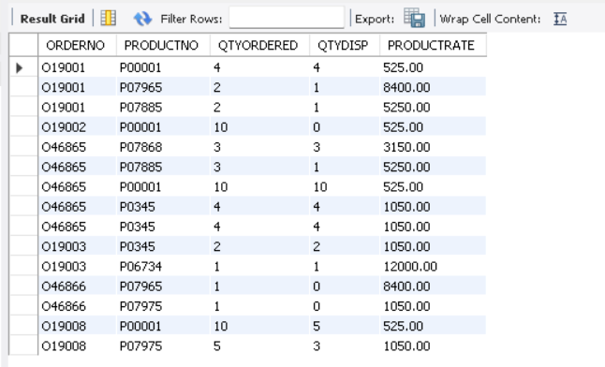

**EXERCISE**

1. **Perform the following computations on table data :-**
2. **List the names of all clients having ‘a’ as the second letter in their names.**

- SELECT NAME FROM CLIENT_MASTER WHERE NAME LIKE '_a%';

- 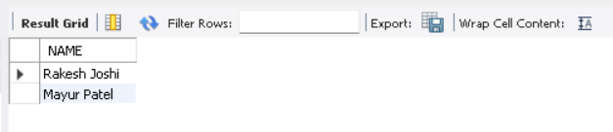

1. **List the clients who stay in a city whose First letter is ‘M’.**

**-** SELECT NAME FROM CLIENT_MASTER WHERE CITY LIKE 'M%';

- 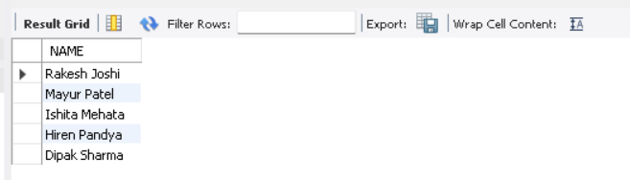

1. **List all the clients who stay in ‘Bangalore’ or ‘Mangalore’.**

- SELECT NAME FROM CLIENT_MASTER WHERE (CITY IN ('Bangalore','Mangalore'))**;**

**-** 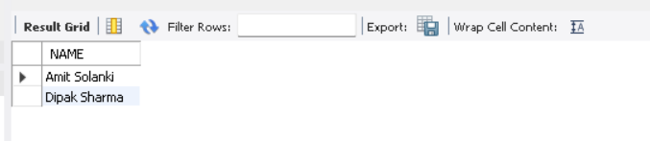

1. **List all clients whose BalDue is greater then value 10000.**

- SELECT NAME FROM CLIENT_MASTER WHERE (BALDUE > 10000);

- 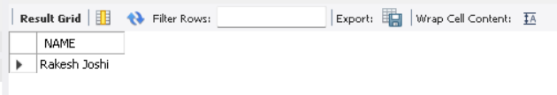

1. **List all information from the Sales_Order table for orders placed in the month of June.**

- SELECT ORDERNO FROM SALES_ORDER WHERE MONTH(ORDERDATE) = '6';

- 