

**Student Numbers: 322786**

**292562**

**309477**

**318987**

**324021**

**Word Count: 6257 (Inclusive everything)**

**MSc in Management**

**2019-2020**

**Module Title**

Evidence-Based Management

**Assessment Type**

Group Assignment

**DECLARATION:**

We certify that this assignment is entirely our team work, except where we have given fully documented references to the work of others, and that the material in this assignment has not previously been submitted in any formal course of study.

**TABLE OF CONTENTS**

**ACKNOWLEDGEMENTS ………………………......................................................................................... 1**

**TITLE ……………………………………………………………………………………………………………………………………….. 3**

**EXECUTIVE SUMMARY …………………………………………………………………………………………………………….. 3**

**CHAPTER 1: INTRODUCTION .......................................................................................................... 4**

**CHAPTER 2: LITERATURE REVIEW .................................................................................................. 5**

2.1 Impact of automation ............................................................................................................... 5

2.2 Impact of blockchain ................................................................................................................. 7

**CHAPTER 3: METHODOLOGY .......................................................................................................... 9**

3.1 Sample........................................................................................................................................ 9

3.2 Instrument ................................................................................................................................. 9

3.3 Measurements ......................................................................................................................... 10

3.4 Procedure ................................................................................................................................. 10

**CHAPTER 4: RESULTS ...................................................................................................................... 11**

4.1 Current level of blockchain implementation in Indian textile industry ……………………………….. 11

4.2 Current level of automation implementation in Indian textile industry ……………………………… 12

4.3 Survey results …………………………………………………………………………………………………………………….. 14

**CHAPTER 5: DISCUSSION ................................................................................................................ 18**

5.1 Discussion on automation ………………………............................................................................... 18

5.1.1 Critical evaluation of automation’s impact on skill requirements based on literature ….. 18

5.1.2 Critical evaluation of automation’s impact on skill requirements based on literature ….. 21

5.2 Discussion on blockchain .......................................................................................................... 21

5.2.1 Critical evaluation of blockchain’s impact on skill requirements based on literature ……. 21

5.2.2 Critical evaluation of blockchain’s impact on skill requirements based on survey …..……. 23

**CHAPTER 6: CONCLUSION .............................................................................................................. 24**

**REFERENCES .................................................................................................................................... 27**

**APPENDICES …………………………………………………………………………………………………………………………….. 30**

**Title:**

“What is the impact of automation and blockchain technology on the skills requirements for the future world of work (up to 2040) in the textile industry?”

**Executive Summary:**

The study consists of our textile industry-based team analysis where new innovations can have various impacts, and these disruptive developments can also alter the entire market setup. It has a broad view of the evidence from a local context, as well as several examples where either of these technologies was set up or worked well even before they were implemented in different areas, countries or locations. Our research is based on a specific Indian market for the textile industry. It has various evidence-based supports and has been properly formed through the introduction of its current level up to its conclusion. The issue has been discussed with the overall effect of emerging technology on the textile industry, as well as its effects on the skills to be learned by managers.

This paper is based on the recommendation for training of the manufacturing sector (Indian textile industry) on the basis of the current view of the industry and potential skills requirements or demands of the industry. All work has been done in a local context. The entire paper consists of a few conclusions as well as clear proof to support them. Critical evaluations have been conducted through a variety of mediums to address the current challenges that will have their future impact. In the basis of all the findings, the recommendation has also been prepared with strong support for the work carried out.

**Chapter 1**

**Introduction**

Looking at the present situation we have selected one problem that has to do with ease the job anyway. Whether it is WFH (work from home) or any other type it has no restriction in terms of a specific working style. The outcome will always be a pattern follow able from anywhere. By providing an overview of different people who have some insight into the business and the people who work for it, it has been found that the automation can help the entire industry operate without any intervention or disruption. This has implications for any single point and will make the entire job easier to run from anywhere in the world but human intervention is still needed. Keeping a challenge at the heart of the organisation as explained earlier, we found eliminating two major things from the textile industry that are transparency and a work setup that could help the industry to function safely and effectively. We have identified two technologies that can help the industry cope with these challenges. This research paper will investigate the impact of new technology and automation on the skills requirements for the future world of work (up to 2040) in the textile industry. Due to the fact that there are various new technologies which can be implemented, this paper will focus only on blockchain. Thus, automation and blockchain will be the two foundations on which recommendations will be built on. By investigating these two topics, there will be a greater understanding on the skills which managers must pay great attention in order to develop a new training programme. The research has a sequential structure, consisting of separate chapters, starting with the introduction, literature review, methodology, results, discussion and conclusion, along with references, supporting data and figures.

**Chapter 2**

**Literature review**

**2.1 Impact of automation**

Textile industry is the world's oldest industry, even in India it contributes a lot to employment generation, research indicates that 40 million people were given work directly and 60 million people were given work indirectly through or inside the industry. (*Textile Industry & Market Growth March 2017 in India | IBEF*, no date) In the wake of the Industrial Revolution, Man's experiment with machine began in late 18th century. Before the advent of machinery and factories, the majority of manufacturing took place either in local homes or with the help of the large work force. Automation implementation has greatly enhanced this sector in terms of growth, performance and quality, from fiber production to spinning, knitting, and finishing. The packaging is now also made using automation. Following the introduction of shuttle-free looms, robotic handling tools and ERP systems, further sectors in the textile industry have also developed, including weaving, dyeing and clothing.

Automation would have benefited from creating a safer environment at work while at the same time achieving the best possible results at once and the results are all known to different sectors of the industry. (Choubey and Agrawal, 2016) In an interview with Palaniswamy "Raj" Rajan, SoftWear Automation's chairman and CEO, it was heard that the turning point came when SoftWear Automation introduced LOWRY, a sewing robot or sewbot that can manufacture as many as 1,142 t-shirts in just 8 hours. (*SEWBOTS® Transforming The Sewn Products Industry | Textile World*, no date)

Indeed, it not only indicates the loss of human work, but also points to the future working culture that can now be experienced in the pandemic time of today. This method has solved the problem with the demand and the likelihood of forecasting as it operates on JIT basis (just in time) which is again a very broad view of looking at such technology. It has another advantage of reducing warehouse operation, as it always works at manufacturing on demand. Today, various processes have been automated, such as cotton picking and ginning, which had been manual earlier. Due to the High Volume Instrument (HVI) method, cotton fibre tests can now be carried out in seconds. In addition, automation has allowed uninformed yarn quality to be obtained using the yarn fault detection program. Success Increase due to automation has led to a decrease in overall manpower in the textile sector.

The Government of India reports that only 4.69% of the total workforce has undertaken formal skills training. (*Skill Development and Entrepreneurship National Policy for 2015 AND*, no date) Jobs involving data collection and processing and predictable physical exercise are much more vulnerable. As a result, the risk of automation is higher for low-skilled employees and low-wage jobs. It has been projected that by 2022 industries, such as Textiles, Building and Construction, Vehicle and Auto Parts, Real Estate Services and Organised Retail, would double their workforce requirements compared to few years back. (*OVERVIEW OF INDIA’S EVOLVING SKILL DEVELOPMENT LANDSCAPE www.britishcouncil.in*, no date).

It is projected that 37% of the workforce will be working in occupations requiring drastically different skills by 2022 and even more in future. It is therefore important to provide the workforce with the requisite tools in terms of skills and education to cope with these changes. (*Future of jobs and its implications on Indian higher education*, 2016) Machine alone will never be able to do the task, but research shows that the garment manufacturing industry alone has replaced 10,000 workers with robots over three years. The focus shifts from the size of the business to the expertise of the staff. (Krishnan, no date) The challenge, though, would be that the lifecycle of skills is getting shorter than ever before. The skilled labor force has much less time to market its acquired knowledge and skills than before they need to be re-killed. (*Final Report Future Skills in India-Foundation Report Future Skills in India-Foundation Report 2*, 2018)

**2.2 Impact of blockchain**

Blockchain is one of the key technologies which will impact skill requirements for the future world of works in the textile industry. Blockchain is a distributed open ledger of information that can be verified across a peer-to-peer network. (Cole et al., 2019) Most importantly, a decentralised environment for transactions is represented through blockchain, as all entries are recorded on a private or public ledger which can be visible to all users. Thus, no one can alter the data, which makes the system highly transparent. (Cole et al., 2019)

For instance, H&M Group has collaborated with VeChain, a Singaporean blockchain company, to secure product data traceability for several products that it sells. The VeChain app is downloaded from buyers, who scan a near-field communication (NFC) chip from the product, which finally enables them to check the origin of the shirts or pants and how ethically they were produced. (Sillitoe, 2019) Blockchain is seen as a solution to counterfeiting, as it allows customers to verify authenticity and track the source of goods. As a result, this gives shoppers more confidence in their brands. (ISE, 2020) Research from Kantar Group shows that ‘company values beyond brand name and product’ are the main drivers for shoppers, suggesting it is a prudent path for brands to follow. (Sillitoe, 2019)

Additionally, adaptions need to be made in an organisation in order to improve its fit to new technology like blockchain according to Holotiuk and Moorman (2018). This implies that the ways of collaboration and the set-up of teams need to be updated. Given that this technology is complex, organisations must allow early involvement of business departments in the idea development phase and easy collaboration regarding its application and adoption (Holotiuk and Moorman, 2018). Therefore, leadership and teamwork skills are essential in the implementation of blockchain in the textile industry.

Holotiuk and Moorman (2018) argue that certain skills are required with the introduction of new technology since its application changes the way that business requirements are implemented (as they can be based on new technology). Subsequently, there is the need to direct activities towards making people more familiar with blockchain and strengthen its integration within the company. Holotiuk and Moorman (2018) state that there is the possibility to transfer skills from other technologies, which can also be applied to blockchain. However, other skills needed for its full implementation need to be attained from outside and there are certain issues related to this.

Even though blockchain’s capabilities have gained wide recognition, there is still a lot of progress needed to be done, as the technology is still in its infancy from an utilisation standpoint. Research shows that there is a shortage of skills in IT Job Market, given that more positions are open compared to the qualified professionals available to fill them. (Janco Associates, 2019) Furthermore, organisations that have already found blockchain developers are experiencing higher attrition rates, as consulting firms are actively recruiting blockchain professionals by offering higher salaries and benefits. (Janco Associates, 2019)

**Chapter 3**

**Methodology**

The goal of this study was to examine the state of technology adoption and to evaluate organisational factors that promote the adoption of technology by major textile firms in India. Primary data for this study was obtained through an online survey using a self-directed questionnaire to test the hypotheses. The reason for choosing this methodology was to save time, increase efficiency while receiving responses, and it is also an electronic communication method used by every individual every day. Apart from this, the majority of secondary data collected in the sense of the Indian textile industry would come either from previous research papers or from government sources. It should be noted that the collection of secondary data may be risky as Wilson (2014, p. 1919) argues, the sources provided may not be reliable at times.

**3.1 Sample**

We conducted a survey of 53 different samples taken randomly from people as consumers, people from industry and others who have some interest in it. Another form of sampling that we did was focused on secondary data collected from skills gap research in the Indian textile industry, research papers and journals that had insights into automation in the sector, as well as a credible source of data from government skills development and the national business policy document. Additional pages for appendices containing the first view of the survey pages and the results of the SPSS are given, please refer to the appendices.

**3.2 Instruments**

The tools used were the google survey page, along with its assessment in the SPSS tool, and some of the excel sheets used to draft them in order to find out their results. The Internet has been helpful in finding out about the related research papers, journals and other types of data.

**3.3 Measurements**

All measurements were made after considering the current situation and the requirements of the sector with the demand of the industry in the future. This has been assessed in such a way that the situation has even more to change in terms of potential aspirations and is backed by the documentation and other findings of the research.

**3.4 Procedure**

Initially, details of the current situation with its overall impact on the industry were provided. On the basis of such assumptions and the gaps, it was evaluated to focus on the follow-up of the survey, which consists with details of the hypotheses to be either supported or rejected. Upon collecting feedback from the survey, a full review was carried out through the SPSS along with a brief discussion focused on the supporting elements, which was then contrasted with the potential importance of the industry. Finally, a decision was reached on the basis of which recommendations were made.

**Chapter 4**

**Results**

**4.1 Current level of blockchain implementation in Indian textile industry**

Research shows that the implementation of blockchain technology to support India’s textile manufacturing is still in its nascent stage (Queiroz and Wamba, 2018). One of the reasons is that India is still in the process of providing a firm regulatory direction to the blockchain ecosystem. Thus, regulations and policy can help drive the growth of Blockchain innovation and ecosystem in the country. (Jani, 2019) Nevertheless, there is no doubt that this technology has the potential to improve operations and disrupt inefficient models (Queiroz and Wamba, 2018). Furthermore, the figure below shows the current sector wise blockchain adoption in India.



Figure 1: Sector wise blockchain adoption in India (Jani, 2019)

The figure shows that there is still no wide adoption of blockchain in India’s textile manufacturing, proving the fact that its implementation is still in an initial stage. This assertion comes due to the fact that, the manufacturing sector contributes to about 5% of ongoing blockchain projects in the country compared to 60% of the banking, financial services and insurance sector (BFSI) (Jani, 2019). This suggest that there are several challenges which must be undertaken so that more textile manufacturers adopt this technology (Jani, 2019)

India currently has the second largest textile manufacturing capacity globally. Subsequently, Indian textile industry is one of the highly disintegrated industries and production costs are on the upper side due to lack of technological advantage. Authors Premji and Preetha (2019) argue that India can become number one in textile production and exports. They state that this can be achieved if textile manufacturers document entire operations in blockchain technology, therefore their products can flood in both national and export market. (Premji and Preetha, 2019)

**4.2 Current level of automation implementation in Indian textile industry**

The technology upgrade in the Indian apparel industry began just after 2001 when India shifted to a quantitative restrictions-free trade regime that left the door open to the import of clothing from China and the South-East Asian economies. Automation has redefined the development cycle through manufacturing sectors, creating significant concerns about the extent of manufacturing jobs. Recent inventions like 'Sewbot' and other CNC machines have expanded the scope for automation in the clothing industry that was unimaginable until a few years ago. Automation took part in a series of phase right from cotton harvesting and ginning, which were 100% manually controlled prior to winding and rewinding.

However, despite the current unit labor production cost, full automation is not economically viable for Indian clothing manufacturers. (Vashisht and Rani, 2019b) There are very few Mills in the region that have fully revamped themselves with the technological surge. Most of them still operate on the basis of mixed technologies using some new and old machines. Others also work entirely on a traditional basis. The development of technology and the acceptance of technology are two issues. Research suggests that the cost-effective firm is still not looking for automation completely. There may be other reasons, such as availability of technical skills, the size of firm, the degree of firm’s orientation, the management’s commitment, poor electricity supply, slow internet connection, cost of capital etc. (Vashisht and Rani, 2019a)

The IT industry should do more in fewer, as companies need a technological area to operate in the sense of globalisation. Enterprise Resource Planning (ERP) and Management Information System (MIS) products solutions nowadays are available for use by small, medium and large organisations. MIS packages for enhancing the product range in textiles will help to reduce costs and improve productivity, ERP solutions can also be used to achieve efficiency and improve production quality. Even handloom & power loom craftsmen may have direct exposure to CAD-CAM assisted designs and color schemes with internet updates on the latest fashion trends in India and abroad. (Agarwal, no date)

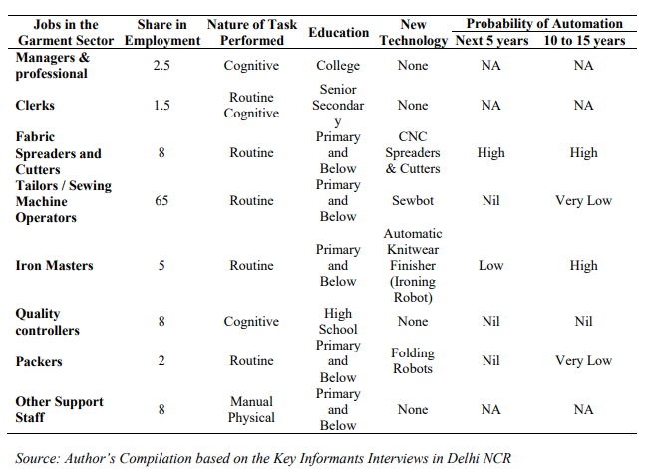

Figure 2: Probability of Automation in Textile sector (Vashisht and Rani, 2019a)

Figure 2 shows the probability of automation that may be implanted at different levels of the textile industry.

**4.3 Survey results**

In a survey we conducted, we came to the point that, automation in the textile industry will play an important role among all the factors, also, along with automation, another factor that will make it perfect is blockchain. While blockchain has received less response, our team members still believe that it will have a major effect on the overall growth of the textile industry. For comparison and performance, see the figure below.A screenshot of a cell phone

Figure 3

From the chart, it is clear that about 71.2% of people thought that automation had a greater effect than any other.

If we incorporate automation in the manufacturing sector, then our concern is to have an effect on the design and embroidery of clothing. In view of this particular concern, we have received clear insights from our survey participants. Their feedback says that about 70% will have a positive impact on the design process, which means that the product’s appearance will be enhanced. This response is more than enough for us to move forward, and it also makes our decision on automation stronger.

As we all know, any technological transition requires expertise, and these skills are usually linked to technical and common sense. Our survey participants believe that combining technical and common-sense related knowledge is important for smoother transformation from a human-driven system to a machine-driven one. Observe the pie diagram shown.

Figure 4

The next issue, which comes together with the previous one, concerns the work of the textile industry. Many assume that integrating human and machine-based systems would make working more effective rather than only choosing one from both systems. 93.2 supports this philosophy of working, which is very bold and transparent to us.

New technology and automation require a high level of skills and/or an increase in the skills of existing workers in the textile industry. The challenges also lie in the implementation of technology. During our survey process, we found about five main challenges during the implementation of the new system at manufacturing level. Out of these five, people have listed two major challenges, they are 1. Availability of technical skills 2. Cost of Capital. Both of these challenges received exactly the same amount of votes from the participants. See the map below for further clarification.

Figure 5

From the chart, we can see that the technical skills received 58.2% and the cost of capital received 61.8% share from the participants, which decides that they are key challenges.

Now move on to the other survey questions, which focus mainly on blockchain. We asked participants about their choices and criteria for buying clothes and garments. In that we also covered the question of blockchain, asking them whether they would like to know the digital details of their purchase item, in that survey question, 50.8% showed interest in obtaining information. Another question which concerns the introduction of the blockchain concept in the manufacturing process, for which the score 3 on the scale of 0 to 5 was about 39%. These two questions make our judgment on the selection of blockchain stronger. Analytical charts are shown in Figures 6 and 7.

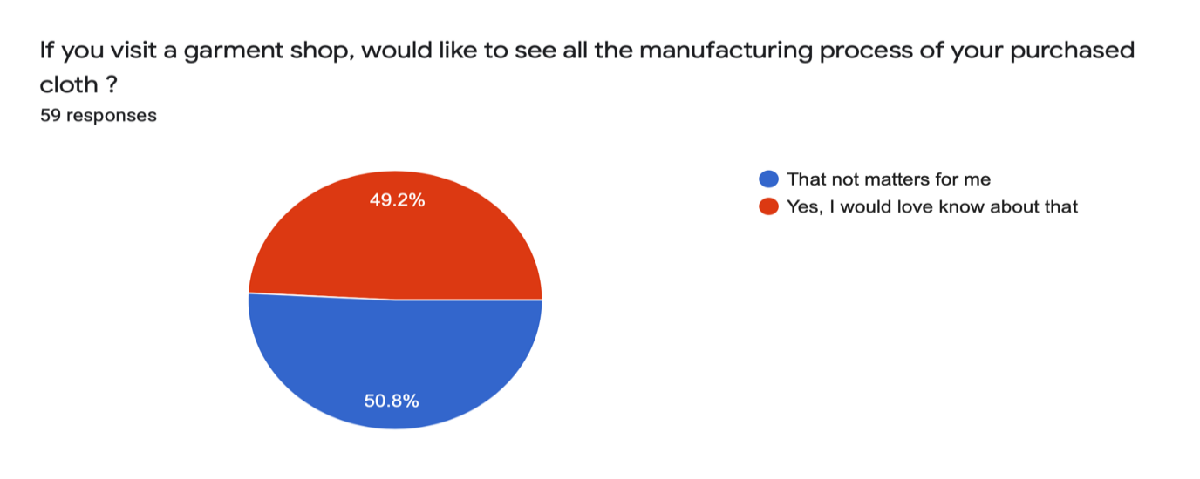

Figure 6

Figure 7

Our next survey question relates to the skills required for the successful implementation of blockchain. So, our survey says that the blockchain process should meet "Learn to Simplify" about 54.5% of the total participants hold that belief. Another skill they found important is "Blockchain Architectural Patterns" and "Standards and Ecosystems," both of which were voted around 42%.

**Chapter 5**

**Discussion**

**5.1 Discussion on automation**

**5.1.1 Critical evaluation of automation’s impact on skill requirements based on literature**

Technology is projected to threaten just 15 to 25 per cent of current employment in the near future, as automation is projected to be limited to spread & cutting and finishing processes only. (Vashisht and Rani, 2019b) India's spinning and knitting market is highly competitive, tiny-scale and labor-intensive. This sector comprises of approximately 38.9 lakh handlooms and also 4,70,000’s textile units working about 21.1 lakh power looms. The apparel industry is labor-intensive throughout and accounts for 12 % of total cloth production in the country. This sector is heavily decentralised and weavers can be observed in more than 400 clusters across the country. (*Disclaimer for the Skill Gap Report: NSDC engaged IMaCS (ICRA Management Consulting Services*, no date). Figure 9 shows the contribution of the sectors to the production of total cloths.

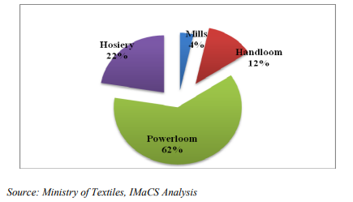

Figure 8 (*Disclaimer for the Skill Gap Report: NSDC engaged IMaCS (ICRA Management Consulting Services*, no date)

The introduction of new technologies and management methods has had two qualitative effects on labor demand. First, it increased the demand for high ability managers and workers, and secondly, it decreased the need for weavers, such as tailors and cutters, to the advantage of machine operators.

Below is a pattern of drivers of competitiveness in the textile industry which clearly indicates that technology may have a major impact because it has no presence.

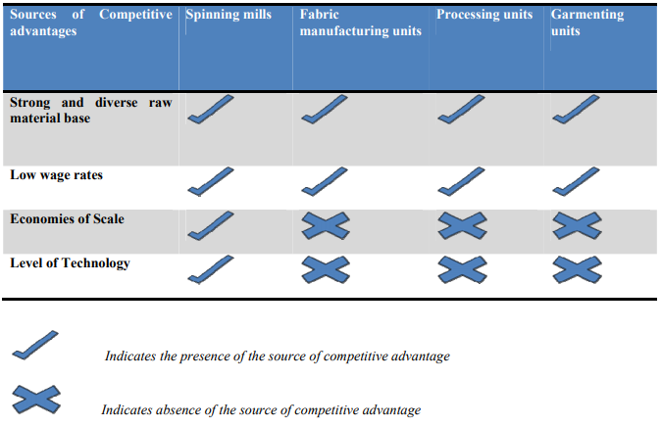

Figure 9 (*Disclaimer for the Skill Gap Report: NSDC engaged IMaCS (ICRA Management Consulting Services*, no date)

Analysis of garment sector jobs by occupation shows that the share of high-skill managers and professionals in the traditional segment of the Indian clothing industry increased by more than 1.86 percentage points between 2004-2005 and 2011-12, whereas the share of machine operators as well as primary employees increased by more than 21.54 and 15.1 percentage points, respectively. These professions, in particular, have been acquired at the detriment of craftsmen (tailors and cutters). The share of tailors and cutters in total employment decreased by 43.9 percentage points. Figure 10 shows the evolving work structure in the Indian textile and clothing industry. (Vashisht and Rani, 2019b)

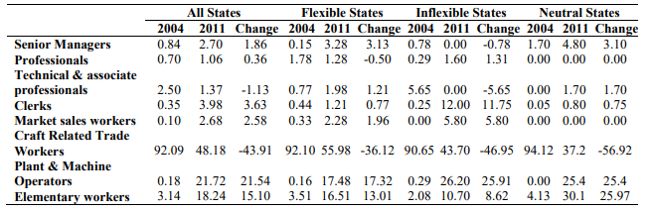

Figure 10 (Vashisht and Rani, 2019b)

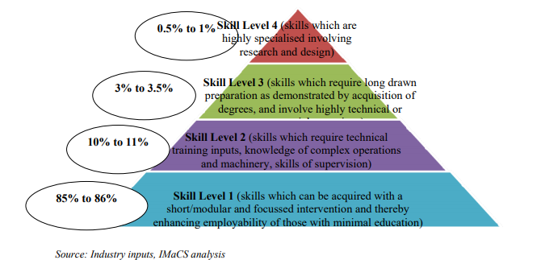

Figure 11 (*Disclaimer for the Skill Gap Report: NSDC engaged IMaCS (ICRA Management Consulting Services*, no date)

From Figure 11, it can be understood that the highest incremental human resource requirement is where level 1 can be met by people who are minimally trained but who can perform simple and/or routine tasks (persons working in activities such as basic machine operations, knitting, cutting, and stitching / sewing, etc.). In addition, the other levels require technical skills. The point of fact is that it is easy to get people for level 1 compared to engineers and ITI holders. Overall, some 13-15% of employees need to be skilled or hire accordingly. (*Disclaimer for the Skill Gap Report: NSDC engaged IMaCS (ICRA Management Consulting Services*, no date)

**5.1.2 Critical evaluation of automation’s impact on skill requirements based on survey**

In the current scenario, automation in the textile industry in India is at a moderate stage, so that it will be impressive and sustainable until 2040, following the recommendations made by considering the numerous evidence mentioned earlier.

Automation, along with the initial and final manufacturing process of the product, should be carried out throughout the system. This implementation should be consistent with the objectives set out in the following automation.

1. Reduced labour cost

2. Improved work-based industrial equipment

3. Reduced waste

4. Increased quality and efficiency

In 2040, the textile industry will operate by integrating both a machine and a human-based system; thus, effective implementation would only be possible if the necessary human resource is available. As a result, technical institutions such as ITI, NIFT and ATDC should provide more technical labour force in the coming years, as they are now giving training to 50,000 per year, this number should be increased in order to bring automation completely in the textile industry. In order to maintain product and cost competitiveness, the industry would have to invest more in both process and product R&D. This requires collaboration between industry and academia, as well as individual R&D efforts by companies.

**5.2 Discussion on blockchain**

**5.2.1 Critical evaluation of blockchain’s impact on skill requirements based on literature**

Many analysts argue that there would be no substantial change in the overall qualitative and quantitative makeup of the workforce due to blockchain. Such professionals claim that this development is just part of the process of digitalisation, which has no clear impact on ability requirements, and is thus an evolution, not a revolution (Swan et al., 2018, p. 115).

On the other hand, there are technology experts who do not agree with the comments made above, because they have opposing opinions on the matter. Their reasoning is that there will be a decrease in routine labor due to the automation and introduction of blockchain technology in manufacturing, but this will be offset by a corresponding rise in demand for highly skilled labor (Swan et al., 2018, p. 116). This assertion is proven, as hired, which is a recruiting marketplace that connects companies with technology talent, reports that market demand for blockchain developers increased by 517% worldwide in 2018 (Hired, 2020). Technology experts are broadening their rationale by suggesting that the overall skills requirements for workers will inevitably increase, which would entail up-skilling skills. Subsequently, the current shortage of highly qualified blockchain developers will become more severe in the future unless action is taken to build successful training programs on this problem (Swan et al., 2018, p. 116).

Jani (2019) supports the assertions of the second group of experts, who defend the idea that application of blockchain in textile manufacturing is not just another digitalisation trend. Furthermore, he emphasises the fact that blockchain implementation in India’s textile industry will be accompanied with the challenge of finding the necessary talent to perform these technology-related jobs (Jani, 2019). Moreover, Jani (2019) states that Indian companies are finding it hard to hire blockchain developers with experience and expertise, therefore training related to this capability must be a priority recommendation for the development of the training programme.

Nevertheless, trainings should not be limited only to blockchain skills’ proficiency even though it is a crucial part. Moorman and Holotiuk (2018) discussed that organisations adopting blockchain in textile manufacturing must facilitate collaboration between business departments to generate ideas, which would allow employees to contribute to existing projects and increase the rate of blockchain’s adoption within their working environment. In addition, blockchain is a technology which leverages its potential in a network with multiple partners, and organisations enabling open innovation can leverage from the exchange across departments. Consequently, another important recommendation is that trainings related to enhancing teamwork and leadership skills are essential requirements to succeed in the future world of work in a blockchain related environment (Moorman and Holotiuk, 2018).

**5.2.2 Critical evaluation of blockchain’s impact on skill requirements based on the survey**

The blockchain concept is new for the Indian textile industry, our survey also depicts that. So, before introducing it in the manufacturing process, skillful training must should be done. Along with this, skill development within people is the mandatory job of management. So, here we come with a few recommendations.

Blockchain should not be used as a resource planning tool, it can be used as simplifying the complex working and manufacturing process of the textile industry. Hence, it should be introduced in that way only, to make work simpler and understandable. This collectively benefits to deliver an error-free product as well to create transparency in the process in the customer context. (Shaik, 2018)

Blockchain enables us to review the technical designs and architectural patterns under which the product manufactured. Also, it helps in analysing manufacturing and selection process. This together sometimes encourage us to think about alternative process and selection, which is cheaper and convenient. So, the ability to develop different architectural patterns should be learning or developed within the managers of industry.

Successful implementation of blockchain is only possible when the practitioner knows the blockchain principles and practices and its implementation within the organisation. So, this knowledge depth should be understood by blockchain practitioner (Shaik, 2018).

As discussed earlier, blockchain is a new concept. Its implementation requires a high set of skills and capabilities. So, before applying it, the company need to check about their skill availability and relevant resources, this pre-research work should be done for smoother and successful implementation of blockchain in the textile industry (Shaik, 2018).

**Chapter 6**

**Conclusion**

This study was conducted in order to understand what impact automation and blockchain technology will have on skill requirements for the future world of work (up to 2040) in India’s textile industry. The authors have gathered understanding regarding this matter through the methodology discussed earlier in this paper.

On the basis of the above discussion, it can be seen that the key skill set needed for the industry to enable the technology to enter will often be around machine operators. On the basis of our survey results, we have the fact that people still believe that the industry can grow if their workers have adequate technical knowledge.

Research shows that the demand for skills in the textile industry is also around three key areas, namely the manufacture of fabrics, the processing of fabrics and garmenting. There are different types of machines that have different sets of operations that require different operators, for example machine operators in the manufacturing and processing sector, Operators of stitching and sewing machines in the manufacture of clothes, etc.

Apart from the fact that there was one kind of problem with the implementation of the automation, there was a commitment from the top management and that some skill set must also be dealt with, even though it contributes only 1% as shown in Figure 11 at level 4.

Study shows that the demand for skills in the textile industry is also around three key areas, namely the manufacture of fabrics, the processing of fabrics and garmenting. Figure 12 shows this.

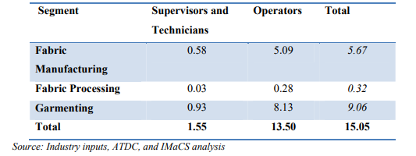

Figure 12 (*Disclaimer for the Skill Gap Report: NSDC engaged IMaCS (ICRA Management Consulting Services*, no date)

There is indeed a hierarchy of operations that handles hierarchical operational activities, and more or less they have some of the easiest way to do this through system automation. The Indian textile industry is so conventional that its maximum labor force does not require this training, but after a critical evaluation of the results, it still points to those 15-25% who certainly need to be trained, well equipped for these technologies.

Depending on the data collected and the research carried out, different skill sets need to be assessed and discussed by the manager in terms of training planning such as,

* MIS (Management Information System), ERP (Enterprise Resource Planning) tools, etc.
* Operators with various devices for various parts of the industry, such as fabric production, processing, knitting, etc.
* Preparing the workforce for the future generation of technology or currently unimplemented machinery, such as sewbots, CAD-CAM, etc.

The specifics of the very brief skills set out in each project, along with some basic designation of the industrial workforce, have been listed in the National Skills Development Corporation report. Please refer for further information. (*Disclaimer for the Skill Gap Report: NSDC engaged IMaCS (ICRA Management Consulting Services*, no date)

It is undeniable that both blockchain technology and automation will impact skill requirements in the future world of work despite criticism from several experts. They are considered to be part of the main levers which will shape the future of work.

Blockchain’s application is also influenced from customer requirements who demand to track the process of how their clothes have been manufactured since its initial stages.

Therefore, the skills which require the most attention from managers, in order to develop an effective training programme in India’s textile manufacturing context, taking into account automation’s and blockchain technology’s impact on this industry are:

* IT skills, especially blockchain developing ones given that the current demand for blockchain developers is higher than the supply.
* Teamwork skills, as blockchain requires collaboration between business departments in order to be successfully adopted in the organisation.

Leadership is an essential skill which must be given attention as managers should encourage employees to contribute to existing projects and increase the success rate of blockchain’s organisational adoption

**References**

Agarwal, S. (no date) *AUTOMATION IN TEXTILES FOR GLOBAL CHALLENGES*.

Choubey, N. S. and Agrawal, M. (2016) *Automation in Textile Industry*, *International Journal on Textile Engineering and Processes*.

*Disclaimer for the Skill Gap Report: NSDC engaged IMaCS (ICRA Management Consulting Services* (no date). Available at: www.nsdcindia.org (Accessed: 26 June 2020).

*Final Report Future Skills in India-Foundation Report Future Skills in India-Foundation Report 2* (2018). Available at: www.camecon.com (Accessed: 24 June 2020).

*Future of jobs and its implications on Indian higher education* (2016).

Krishnan, T. N. (no date) *Technological Change & Employment Relations in Indi a*.

*OVERVIEW OF INDIA’S EVOLVING SKILL DEVELOPMENT LANDSCAPE www.britishcouncil.in* (no date). Available at: www.britishcouncil.in (Accessed: 24 June 2020).

*SEWBOTS® Transforming The Sewn Products Industry | Textile World* (no date). Available at: https://www.textileworld.com/textile-world/2019/07/sewbots-transforming-the-sewn-products-industry/ (Accessed: 22 June 2020).

*Skill Development and Entrepreneurship National Policy for 2015 AND* (no date).

*Textile Industry & Market Growth March 2017 in India | IBEF* (no date). Available at: https://www.ibef.org/archives/detail/b3ZlcnZpZXcmMzcxMTAmMTEy (Accessed: 24 June 2020).

Vashisht, P. and Rani, N. (2019a) *A Service of zbw Automation and future of garment sector jobs: A case study of India Standard-Nutzungsbedingungen: Automation and Future of Garment Sector Jobs: A Case Study of India INDIAN COUNCIL FOR RESEARCH ON INTERNATIONAL ECONOMIC RELATIONS*.

Vashisht, P. and Rani, N. (2019b) *Automation and Future of Garment Sector Jobs: A Case Study of India INDIAN COUNCIL FOR RESEARCH ON INTERNATIONAL ECONOMIC RELATIONS*.

*Jani, S. (2019) The Emergence of Blockchain Technology & its Adoption in India. MSc thesis. Indira Gandhi National Open University.* Available at: <https://www.researchgate.net/publication/334163042_The_Emergence_of_Blockchain_Technology_its_Adoption_in_India?channel=doi&linkId=5d1afde5458515c11c096234&showFulltext=true>(Accessed 23 June 2020).

*Premji, P. and Preetha, D. (2018) Rebooting India through Practical Integral Humanism. Chennai: Notion Press.*

*Queiroz, M. M. and Wamba S. F. (2018)’Blockchain adoption challenges in supply chain: An empirical investigation of the main drivers in India and the USA’, International Journal of Information Management, 46(1), pp. 70-82.* Available at: <https://www.sciencedirect.com/science/article/pii/S0268401218309447#bib0330> (Accessed 24 June 2020).

*Cole, R., Stevenson, M. and Aitken, J. (2019) ‘Blockchain technology: implications for operations and supply chain management’, Supply Chain Management, 24(4), pp. 469-483.* Available at: <https://doi.org/10.1108/SCM-09-2018-0309>

*Holotiuk, F. and Moorman, J. (2018) Case No. 202: ORGANIZATIONAL ADOPTION OF DIGITAL INNOVATION: THE CASE OF BLOCKCHAIN TECHNOLOGY. Frankfurt: Frankfurt School of Finance & Management.* Available at:<https://aisel.aisnet.org/ecis2018_rp/202/> (Accessed 14 June 2020).

*ISE (2020) ‘Reducing fashion fakery through blockchain: Industry seeks to reduce counterfeiting, improve transparency’, ISE: Industrial & Systems Engineering at Work, 52(4), pp. 16-16.* Available at: <https://web.b.ebscohost.com/ehost/pdfviewer/pdfviewer?vid=6&sid=6cbcbfcd-5e35-43d2-a945-59fde18ed6a7%40sessionmgr103> (Accessed 13 June 2020).

*Janco Associates (2019) CIOs Face a Tight IT Job Market according to Janco.* Available at:<https://www.e-janco.com/press/2019/2019-04-05-cios-face-tight-it-job-market.html> (Accessed 20 June 2020).

*Sillitoe, B. (2019) ‘How technology can help fashion retail’s eco ambition’, Computer Weekly, pp. 19-22.* Available at: <https://web.a.ebscohost.com/ehost/pdfviewer/pdfviewer?vid=8&sid=47a3527d-50e5-48dd-9bdf-fa1791847c1c%40sessionmgr4006> (Accessed 20 June 2020).

Wilson, J. (2014) Essentials of Business Research. 2nd ed. London: Sage

*Agarwal, S. (2006) AUTOMATION IN TEXTILES FOR GLOBAL CHALLENGES.* Available at:<https://static1.squarespace.com/static/5ac089c912b13f7c187af332/t/5b902793352f53d3e8c7d249/1536173972838/Shekhar+Agarwal+-+Keynote+address+-+Automation+in+Textiles+for+Global+Challenges.pdf> (Accessed 26 June 2020)

*Hired (2020) State of Software Engineers.* Available at: <https://hired.com/state-of-software-engineers>. (Accessed 23 June)

*Shaik, K. (2018) ‘The top 10 blockchain skills you need to develop’, [Blog]* [Blockchain Pulse: IBM Blockchain Blog](https://www.ibm.com/blogs/blockchain/)*. 1 March.* Available at: <https://www.ibm.com/blogs/blockchain/2018/03/the-top-10-blockchain-skills-you-need-to-develop/> (Accessed 23 June 2020)

*Swan, M., Potts, J., Takagi, S., Witte, F. and Tasca, P. (2018) Blockchain Economics: Implications of Distributed Ledgers. New Jersey: World Scientific Publishing*

**APPENDICES**

**Data findings on SPSS**

**First view of the survey pages**

