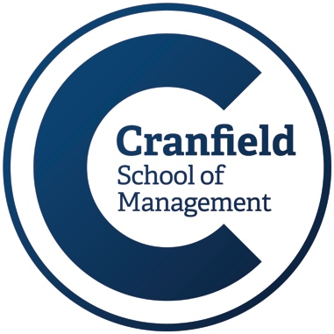

**Student Number: 322786**

**Word Count: 3009 (Inclusive all)**

**MSc in Management**

**2019-2020**

**Module Title**

Management Consulting

**Assessment Type**

Self-reflection assessment

**DECLARATION:**

I certify that this assignment is entirely my work, except where I have given fully documented references to the work of others, and that the material in this assignment has not previously been submitted in any formal course of study.

**TABLE OF CONTENTS**

**ACKNOWLEDGEMENTS ………………………......................................................................................... 1**

**EXECUTIVE SUMMARY …………………………………………………………………………………………………………….. 3**

**COMPANY PROFILE………………………………………………………………………………………………………………….. 3**

**CHAPTER 1: CONSULTING PROCESS................................................................................................ 4**

1.1 Literature Review (Consulting Process for Baker Hughes) ……................................................. 5

1.1.1 Friday 1st May 2020 First Meeting with ‘Marcin’ (BH Executive) …………………………………… 6

1.1.2 Wednesday 6th May 2020 Second Meeting with ‘Marcin’ …………………………………………….. 6

1.1.3 Monday 18th May 2020 Clinic for the Evaluation of Work Done ……………………………………. 6

1.1.4 Wednesday 20th May 2020 Mock Presentation …………………………………………………………….. 6

1.1.5 Friday 22nd May 2020 Final Presentation to ‘Marcin’ …………………………………………………….. 7

**CHAPTER 2: THE PROCESS EVALUATION AND ANALYSIS ................................................................ 8**

**CHAPTER 3: THE OVERALL EXPERIENCE OF THE MODULE ............................................................. 9**

**CHAPTER 4: LEARNINGS AND TAKE AWAY .................................................................................... 10**

**CHAPTER 5: CONCLUSION .............................................................................................................. 11**

**REFERENCES .................................................................................................................................... 12**

**APPENDICES …………………………………………………………………………………………………………………………….. 13**

**Executive Summary**

The paper is based on my knowledge of the subject matter of management consulting. It consists of the specifics of three separate stages, one of which concerns my thoughts that I had before studying the subject, the other focuses on the thoughts that I've been creating while learning, and the finals are my take-ups that I can certainly claim to be what I've learned and will carry out in my career. It has been compiled at different levels, such as a full overview of the project, with its evaluation and analysis, followed by my overall experience and the future takeaway. At the end, it has the conclusion to summarise my thoughts based on the whole journey.

**Company Profile**

(*We are Baker Hughes, an energy technology company | Baker Hughes*, no date)

“**Baker Hughes”** corporation is an American international energy firm and one of the largest oil field service companies in the world. The company supplies products and services for oil exploration, training assessment, completion, development, and reservoir consulting to the oil and gas industry. The company was formerly known as integrated Baker Hughes until 2017, when it merged GE Oil and Gas to become Baker Hughes, a GE Company (BHGE), and in 2019 the company split from General Electric and became Baker Hughes Company. Following the split, General Electric still retains a 38.4% interest in the firm. (*We are Baker Hughes, an energy technology company | Baker Hughes*, no date)

**Chapter 1. Consulting process**

First of all, we began our journey by learning some information on what the consultancy entails. At first, I had some formal knowledge that, on the basis of some evidence and the requirements of the firm, presenting a proposal to drive the firm towards its goal, which could be vision, shared goal within the organisation or target, etc., would be called consultancy. Yet I am very grateful to "Monica" who showed me the true variations in my beliefs and the challenge of the modern world. She explained in such a way that I came to the conclusion that the consultancy could have different types, such as internal and external consultancy, critical and evidence-based consulting, there must be specific dimensions and a strong justification for the trustworthiness of the clients and the process itself. Now I see consulting as a process that has a kind of relationship within its own peers, such as evidence, results, effect, learning, etc.

I have learned that the important points in management consulting are-

* **Problem resolution** based on critical thinking, adult learning, etc.
* **Learning** at every stage to expand the solution within a specific area, or even in a broad way, if it has an affection for other tasks as well.
* **Change** every bit with the speed of the changing environment in order to ease the challenge of the future and still be successful on the market.

To understand this, 'Monica' showed us a clip from the movie, 'Margin Call,' which changed my mind a bit, and I realised that the consultancy was at the heart of the investigation. This task can change with time and personality, but the consultant can only notice this and keep all the facts and figures to fix the problem. Everyone in the film looked like a consultant because they all had different opinions on different points, but they all had to be combined in order to see a clear picture, so that's what the role of a consultant had to be. There are three types of definitions for problem-recognition that are as follows: Simple, Complex, and Wicked shown by 'Monica' from the clips of the movie "Moneyball" and video “Flying Car”. These problems need to be addressed by critical thinking and adult learning, depending on the nature of the question, and they can also differ in their solutions.

**1.1 Literature Review**

We were given a problem statement to understand from 'BH' and then to address the solution in terms of creating a training module for their employees to deal with them. The entire method was described in the frame by 'Monica', which I liked the most as it has various steps to find the solution and fix the whole problem. After we had this problem statement, we were told to plan our problem identification and checklist to see if we understood them well, accompanied by assumptions and questions that reflect the work done previously on this subject. It wasn't just that, but also that, with its effect, knew how large it was and what all the departments it had impacted, It had sections that asked us how we see it and what we can do best if there is anything in our minds, who would be the stakeholder to consider and, most importantly, how long it would take to create and implement a training pattern to address and resolve all of these issues.

With all these steps, my perception has completely changed that every stage has to be addressed even before I think about the problem or its solution. Having a first-hand experience could be the key in-order to understand the entire problem of its effects, consistency with the objective of the company, the client's own viewpoint on this, whether any research has been done in the past, and a complete picture of any future solution. My approach to researching the subject may have been to gather information on the basis of the client's requirements, but here in this case, I have learned that I first gather all the information that it has and then look forward to the client's requirements in order to reach them or at least surpass the limit that can be accomplished.

The pages can be read from the appendices section where I will enclose my research done on this in my diary on behalf of my entire team.

* + 1. **Friday 1st May 2020 First Meeting with ‘Marcin’ (BH Executive)**

It was the first formal meeting as a team with the client. At the meeting, for us, it was all about understanding the client, trying to understand the issue and the problems which the client was facing from his point of view, and drawing the scope of the project on the basis of our strengths and expectations.

Lecturer demonstrated very well that a successful first meeting would usually mean winning the contract from the competitors. Lecturer demonstrated very well that a successful first meeting would usually mean winning the contract from the competitors in a session that had taken place long before that meeting.

* + 1. **Wednesday 6th May 2020 Second Meeting with ‘Marcin’**

Based on the client's availability at the last meeting, several questions remained unanswered, so the lecturer made some extra effort to evaluate the students' interest and called him back to the second meeting. Most of the other key objectives of the project were discussed during the meeting. It was partly due to a different viewpoint on the issue that the company was facing.

* + 1. **Monday 18th May 2020 Clinic for the Evaluation of Work Done**

We had an opportunity provided by the lecturer to discuss with her after all the research completed before May 18th and that's the stage when I realised that this is another consulting project I'm learning during the lecture. This was the opportunity to present a few minutes about how we have so far worked out the resolution.

We could not do well because of my absence due to the travel circumstances, so on that day I was very upset by the team too, which put me in stress. However, I kept pushing and continuing to work.

* + 1. **Wednesday 20th May 2020 Mock Presentation**

We did this through a presentation of a formal power-point. Bearing in mind all the limitations, because it was a kind of rehearsal. The main challenge was the current situation in which everything is virtual and our presentation was also about to be delivered through zoom, but it went well and we got good feedback on what we learned to use the key points on the basis of how.

* + 1. **Friday 22nd May 2020 Final Presentation to ‘Marcin’**

After collecting data and analysing it through multiple feedback sessions, we came to the day when we had to present our solution to the client's problem. We presented our work done next to the client and received good feedback, he, as well as lecturer, appreciated and noted some of the points. We have also submitted the report which includes all the presentation information and our prepared training action plan.

**Chapter 2. The process evaluation and analysis**

At first, when we had a client meeting, I confronted my whole team who did not respond, and the first experience of learning this module turned into peer learning, but I kept on working and encouraging everyone to come up with something. We were running out of time so I drew up some work from my usual routine within and after the lecture and sent it to the lecturer for evaluation, keeping my peers up-to-date and following the consulting concept.

Once again I approached the team to collect more information for future project research and the same thing happened, but I chose to take the first step again and ask the necessary questions for which I am grateful to the lecturer for her support, who also encourages learning for all. I contributed to the Executive Summary and Presentation until it was submitted in writing. I could not have been a part of the presentation due to some of the uncertain circumstances, but I am grateful to one of my teammates who finally supported me and the entire team with his presentation prepared on our points of view.

I have encountered different attributes, such as cognitive, motivational, and interactive, in the relationship of clients and consultants among colleagues. I have missed the team effort from the very start, so it has been very tough, but I have learned how to cope with it by continuing to push all the participants, and at the end of the day, I was positive when we had to present the solution as others were glad to be part of it.

The whole process was very smooth as everything was prepared in steps, first asking the details of the problem then eliminating the various aspects and clarifying the objectives. Conducting analysis and collecting the evidence to narrow down the possibilities and trying to ensure a rigorous solution is in place. Feedback and improvisation all the time and then how to express them next to the client. And then to present the findings to the client. The model proposed in Sadler's book has largely mirrored this. (James, 1998)

**Chapter 3. The overall experience of the module**

I didn't only see the 'BH' project as a consulting process, but the whole module was a consulting project alone, and "Monica" taught me every bit of consulting in the module by all of her actions. In fact, she attempted to be a consultant between both the students and the module, and to understand the gap to be taught, she took every action on the basis of evidence and to keep the results at the middle. She was closely associated with the problem and her approach was a personalization strategy that typically involves a method of transferring knowledge from people to people. (*What’s Your Strategy for Managing Knowledge?*, no date)

From my experience, I realised that people have different capabilities, process of thinking, way of communication, understanding, etc. In-order take some inputs out of them, they should be dealt with differently, and that's when I think of the picture of different targets.

This is a very broad subject, because it always has a connection with others, and I am very excited about that. I have learned how to measure and interpret inputs to frame outputs. I also experienced different types of listening techniques from the module such as repeating, appreciating, summarizing and asking (RASA), the pyramid principle, SCQA (situation, complication, question and answer), etc.

Based on the experience, the understanding of the module and the feedback, I prepared a cross-skilling document to dig further into, but my team did not help me so I could give it to the instructor for feedback. Images are presented in the section Appendices.

It has always been enjoyable when sitting in a boat and enjoying every scene rather than driving, but it would be better if someone who knows how to drive could shed more light on each scene and add to your experience. This was my journey with this module and I thank "Monica" for all of it.

**Chapter 4. Learnings and take away**

My learning from this module is really vast and it is going to be with me all my life because now I see that consulting is focused on the whole life. For example talking to someone (client) and addressing a problem, then searching for the appropriate solution after taking some necessary steps, this is what consultancy means, but before that there are different things to keep in mind.

Ethan M. Rasiel and Paul N. Friga write about the understanding and implementation of problem solving technique in The Mckinsey Mind and explains that all is around a few key attributes that are

* Framing the problem
* Designing the analysis
* Gathering the data
* Interpreting the results
* Presenting your ideas
* Managing your team
* Managing your client
* Managing yourself (RASIEL, 2015)

I encountered every single attribute as and when it was required while studying the modules, the entire module was prepared in this way of learning. From my past experience, I can now also co-relate these ideas and points in order to be a better consultant and they're all my future take away. With the insight I have gained from this module working with different individuals, I would also improvise the team work principle and I will certainly know more about different best suited partnerships between client and consultant. Another thing I have learned from this module is to prioritise the problem to narrow down the work in various categories as in routine and creative problems, exact and inaccurate problems etc.

**Chapter 5. Conclusion**

On the basis of the structure and the efforts made on this module by the entire MIM team, I completely grasped what consultancy is. Moreover, with its full rationale, it helped me to grasp the various steps and apply my insight to adult learning and complexity thinking. This would have been a tremendous accomplishment to understand in order to solve a situation what all the challenges could be and how to tackle them first-hand. In the process, I have defined different main positions and their presence that must be approached in the same way and that is something else I have learned here.

Through the study I learned the meaning of a lot of new words and they will all be my take away. I really appreciate how 'Monica' led this project, and now I'm really clear to convey to anyone about linearity, complexity, adult learning, feedback loops, emergence, constraints, resilience , self-organisation, performance variation, equivalence, and so on. Throughout the sessions, I spoke to her about the real-life situations in this field of work and how she explained it to me, feeling like I was leaving the same profession at that moment, it was because of her experience.

I simplify as I started to know from why, when and how about consulting with intangible subject management in addition. Management consultancy product is an intangible experience that can not be owned. (Bowen and Schneider, 1988) I learned information about the different divisions of duties between client and consultant through a complete procedure followed by multiple consultants that are related to a consultant's expertise and skills. I have full understanding and differentiation between internal and external consulting, as well as learning about the nature of customer-consultant ties.

I always remember describing the "death and Life in the Hands of the Tongue" from the butterfly effect video, which is valid as little things that are difficult to foresee can have a lot of impact. I want to emphasise this point as it demonstrates the state of life that there is no reason for a minor mistake and that's what I've learned with 'Monica' and this module.

**References**

James, M. (1998) ‘Challenges and prospects: a SWOT analysis of the consultancy industry as it approaches the millennium’, *Management Consultancy: A Handbook for Best Practice*.

RASIEL, E. M. A. P. N. F. (2015) *Understanding and Implementing the Problem- Solving Tools and Management Techniques of the World’s Top Strategic Consulting Firm*, *Journal of Chemical Information and Modeling*. doi: 10.1017/CBO9781107415324.004.

*We are Baker Hughes, an energy technology company | Baker Hughes* (no date). Available at: https://www.bakerhughes.com/ (Accessed: 29 June 2020).

*What’s Your Strategy for Managing Knowledge?* (no date). Available at: https://hbr.org/1999/03/whats-your-strategy-for-managing-knowledge (Accessed: 30 June 2020).

Bowen, D.E. and Schneider, B. (1988) *Service Marketing and Management:* *Implication for Behaviour.* Greenwich, CT: JAI Press.

**APPENDICES**

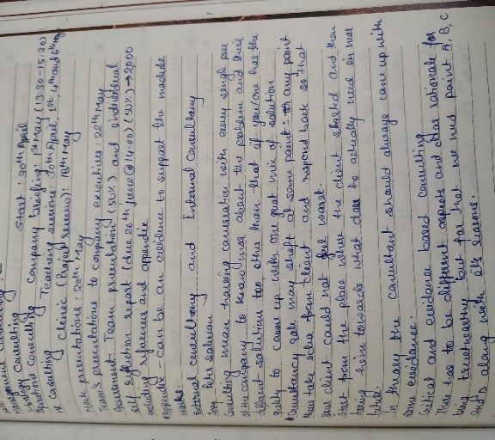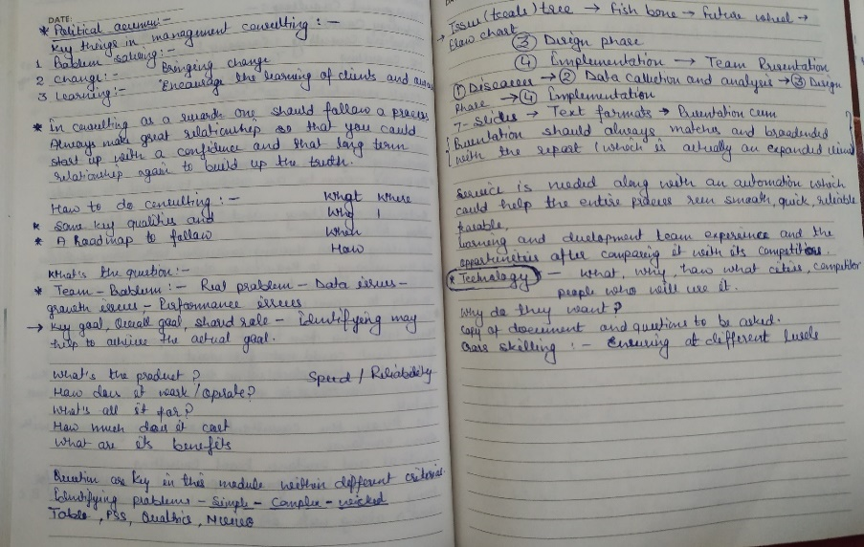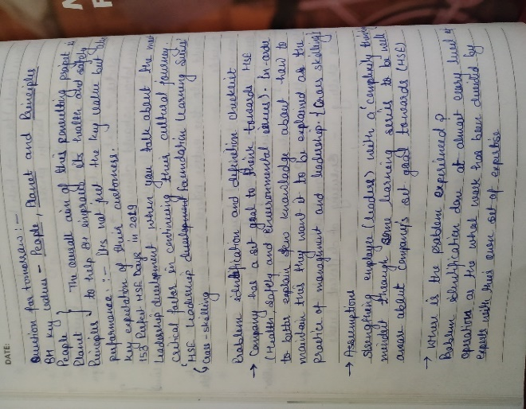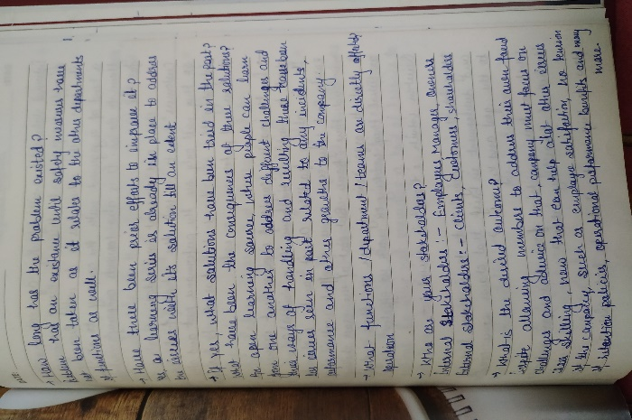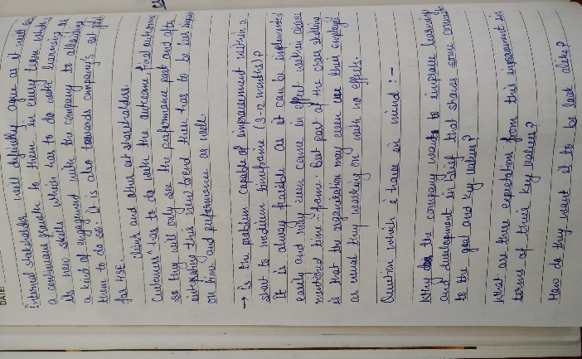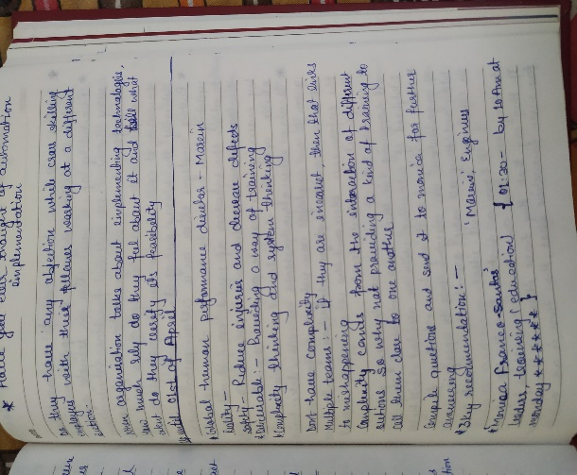 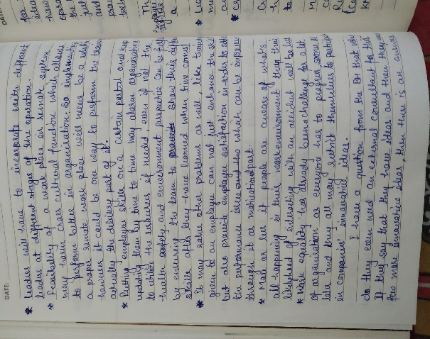 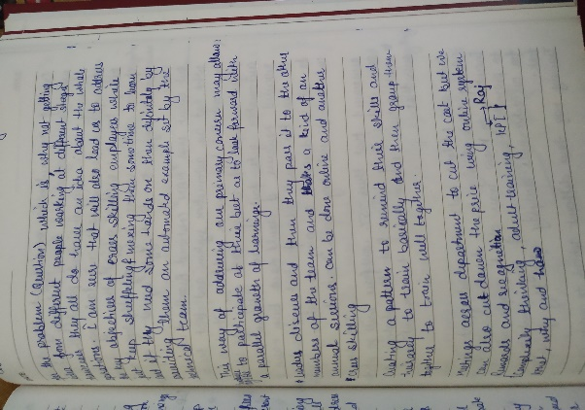

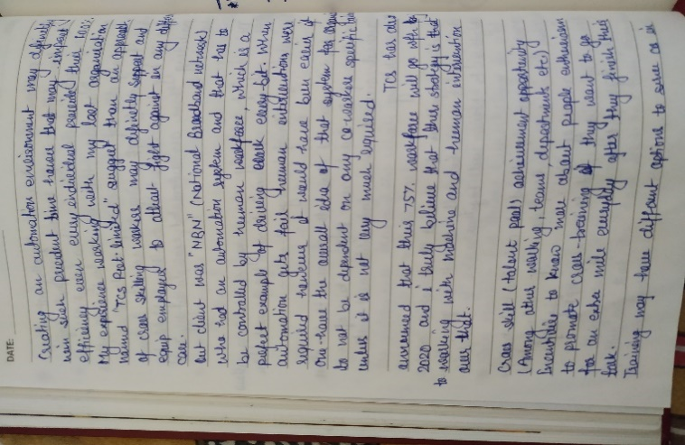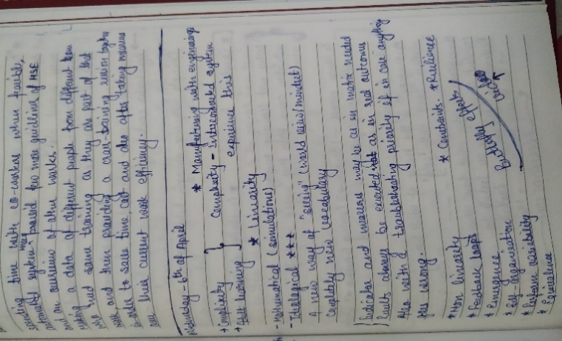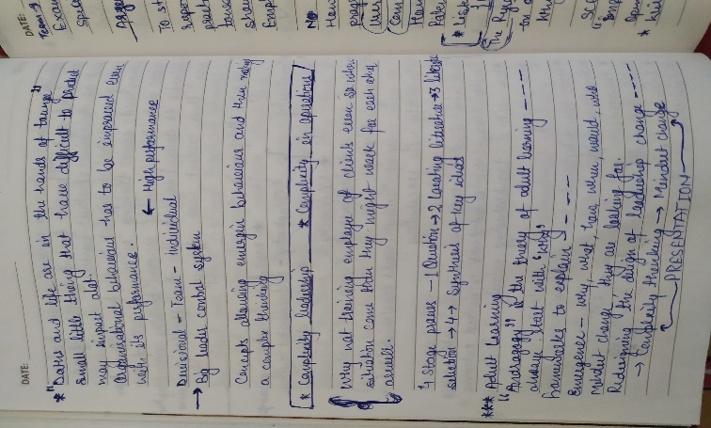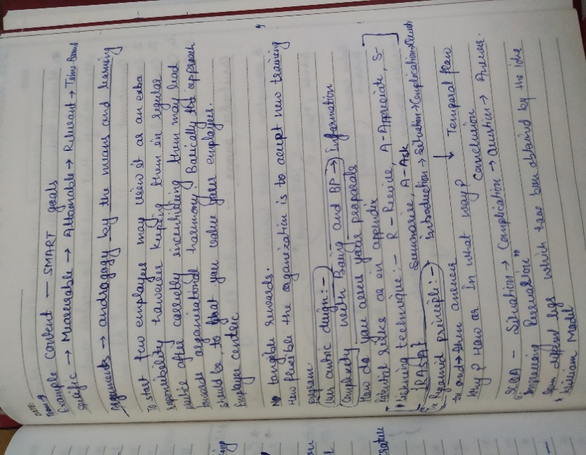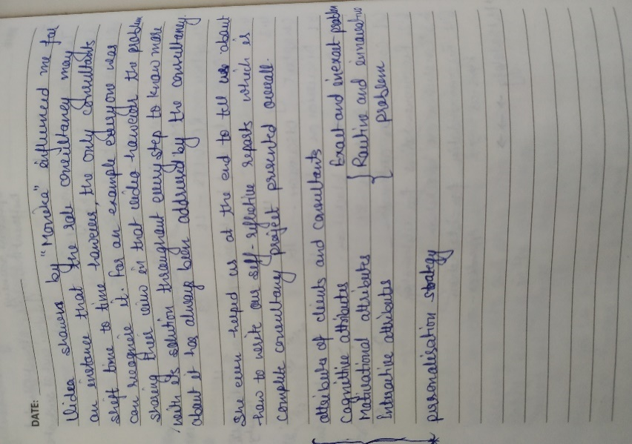

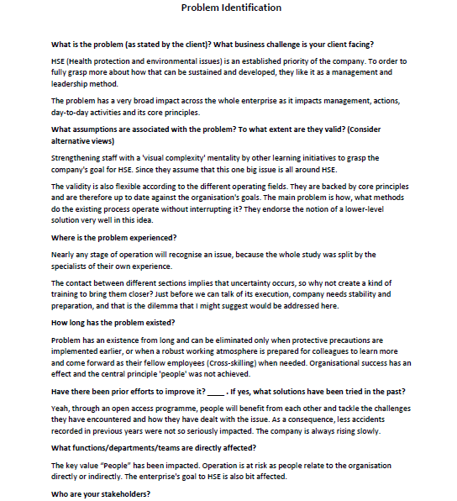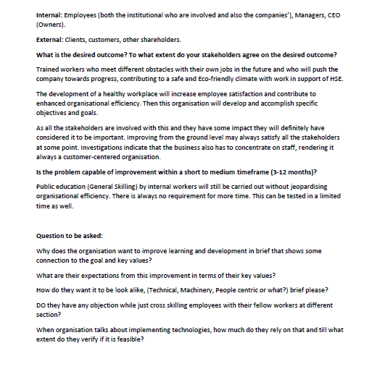

**Problem Identification.docx**

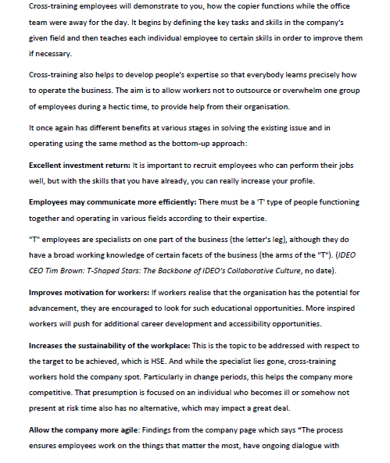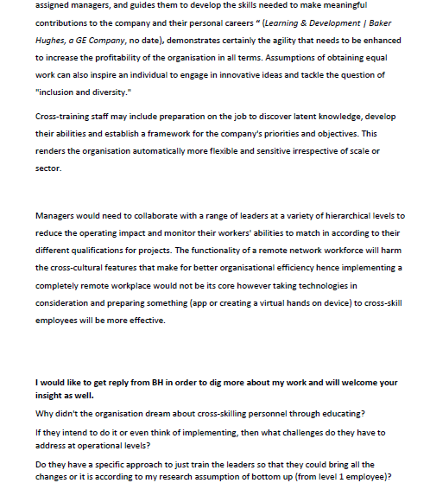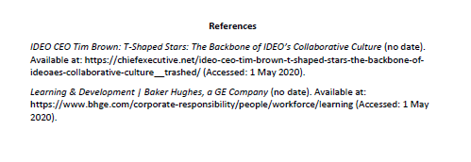 Cross-Skilling document.docx