
Copyright © AZILEN TECHNOLOGIES PVT. LTD. PRIVATE & CONFIDENTIAL
Version 2.0 | 24 April 2026

Azure AD App Registration & Configuration Guide






AZILEN TECHNOLOGIES PVT. LTD.
UNITED STATES | GERMANY | SWITZERLAND | INDIA

Version History 3
1. Pre-Requisites: Azure Account & Subscription Setup 4
Scenario A: You Already Have an Azure Account (Company/Work Account) 4
Scenario B: You Have a Personal Microsoft / Outlook Account (No Azure Tenant Yet) 4
Scenario C: You Have No Microsoft Account at All 4
Free Services Confirmation 5
2. Purpose: 6
3. Azure AD App Registration: 6
2.1 Login and start app registration 6
3.2 Configure app registration settings: 7
3. Authentication settings: 8
4. Assign app owners 10
5. API permissions 11
6. Summary: 12
7. Architecture flow overview: 12
8. Scope and usage notes: 12
9. Azure App Configuration Export (For .env or client config): 13
10 MSAL Client Configuration Example (Angular): 13

Version History
Version | Date | Amendment
1.0 | 2026-02-18 | Initial version for Email Integration – Azure AD
2.0 | 2026-04-23 | Added pre-requisite account setup sections (new Azure account, existing account upgrade, no Microsoft account flow) and credit card clarification notes

Pre-Requisites: Azure Account & Subscription Setup
Before registering an application, you must have an active Azure account with an Azure Active Directory (Azure AD) tenant. Follow the applicable scenario below based on your current account status.
⚠ Important Note on Credit Card:
Microsoft requires a credit or debit card during Azure free account signup for identity verification only. A temporary hold of ₹2–5 may appear on your card and will be automatically reversed within 3–5 business days. You will never be automatically charged unless you manually upgrade to a “Pay-As-You-Go” subscription. All services required for this application (Azure AD, App Registration, Microsoft Graph Mail API) are completely free and remain free forever — they do not consume any paid credits.

Scenario A: You Already Have an Azure Account (Company/Work Account)
If you have an existing company Microsoft account (e.g., yourname@company.com) and can already sign in at portal.azure.com, skip Scenarios B and C and proceed directly to Section 2: Azure AD App Registration.
Verification steps:
- Go to portal.azure.com and sign in with your company account.
- In the top-right corner, confirm you see your Directory/Tenant name (e.g., “Default Directory” or your company name).
- If you see your tenant — you are ready. Proceed to Section 2.

Scenario B: You Have a Personal Microsoft / Outlook Account (No Azure Tenant Yet)
If you have a personal Microsoft account (e.g., yourname@outlook.com or yourname@hotmail.com) but it is not linked to an Azure subscription, follow these steps to attach a free Azure account. This will automatically create an Azure AD tenant.
- Go to https://azure.microsoft.com/en-us/free and click “Start free”.
- Click “Sign in” and use your existing Outlook/Hotmail account — do not create a new account.
- Fill in your details: Country (India), First/Last name, Phone number. Click “Send verification code”, enter the received code and verify.
- Enter your credit or debit card details (for identity verification only — no charges will be made).
- Accept the agreement and click “Sign up”.
- You will see the “Welcome to Microsoft Azure” screen. An Azure AD tenant is now automatically created for your account.
- Go to portal.azure.com and confirm you see “Default Directory” in the top-right corner. You are now ready for Section 2.

Scenario C: You Have No Microsoft Account at All
If you do not have any Microsoft account, you must first create one and then follow Scenario B above.
- Go to https://account.microsoft.com and click “Create a Microsoft account”.
- Choose “Get a new email address” to create a free @outlook.com address, or use your existing Gmail or other email as a Microsoft account.
- Complete the account creation (name, password, phone verification).
- Once your Microsoft account is created, return to Scenario B above to link it to a free Azure subscription.

Free Services Confirmation
All services required by this application are free and will remain free regardless of your Azure subscription type:
Service | Used For | Cost | Duration
Microsoft Entra ID (Azure AD) | User authentication & login | Free | Forever
App Registration | Registering your desktop application | Free | Forever
Microsoft Graph API (Mail) | Reading/sending emails via API | Free | Forever
OAuth 2.0 / MSAL Login | Secure user sign-in flow | Free | Forever

Purpose:
This document outlines the steps required to register an Azure Active Directory (Azure AD) application and configure it for use with Microsoft Graph API, specifically for accessing Outlook emails and related resources.

Azure AD App Registration:

2.1 Login and start app registration
- Sign in to the Azure Portal.
- Navigate to:
Azure Active Directory → App Registrations
- Click "New Registration".

(See reference screenshot in the actual documentation repository if applicable.)
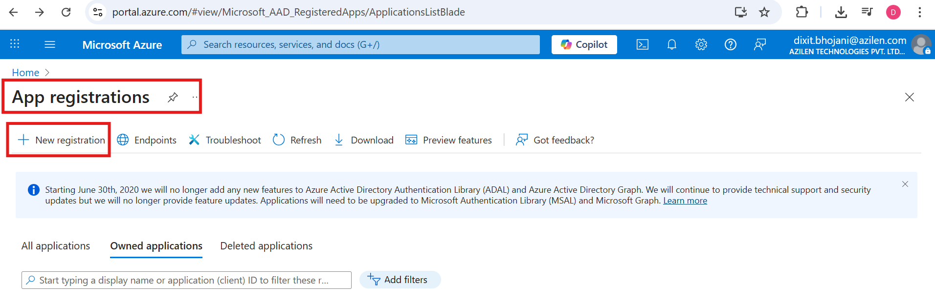
Figure 1: Azure AD - App registrations (New registration)

Configure app registration settings:

During registration:
- Supported Account Types:
Select: Accounts in any organizational directory (Any Microsoft tenant - multitenant) and personal Microsoft accounts (e.g., Skype, Xbox).
- Redirect URI:
- Choose "Single-page application (SPA)" as the platform.
- Set the redirect URI to:http://localhost:4200/ (This is temporary and used while developing the Electron-based desktop app.)
Once completed, click "Register".
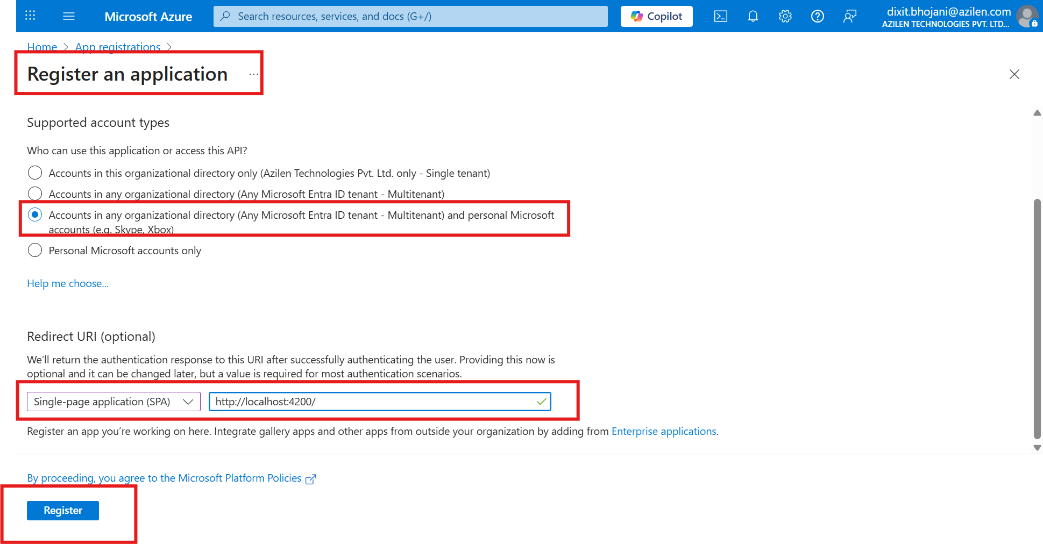
Figure 2: Register an application - account types and redirect URI

3. Authentication settings:
After the app is created:
- Go to the Overview page.
- Under Supported account types, ensure “All Microsoft account users” is selected.
- Scroll to the Authentication tab.
- Under “Select the tokens you would like to be issued by the authorization endpoint”, enable:
- ✔ Access Tokens
- ✔ ID Tokens
Click Save to apply the changes.
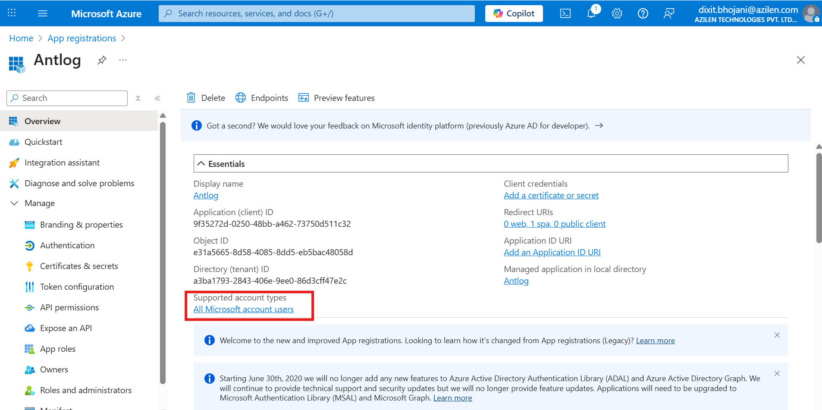
Figure 3: Overview page - supported account types
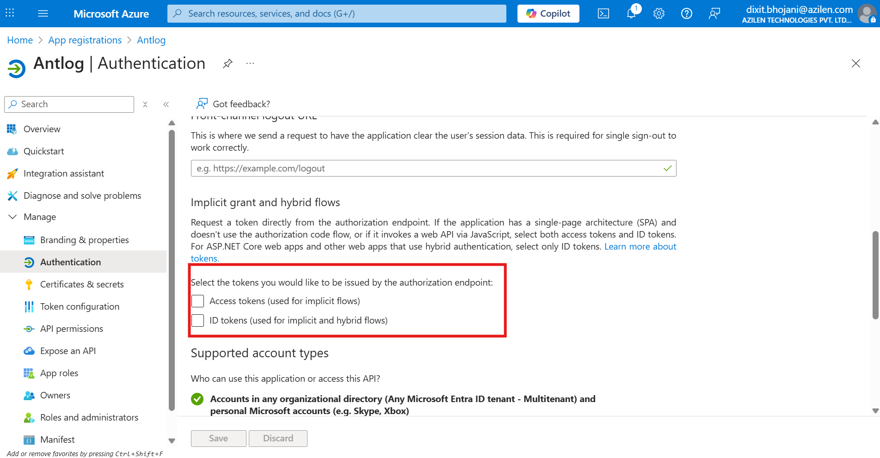
Figure 4: Authentication tab - token settings
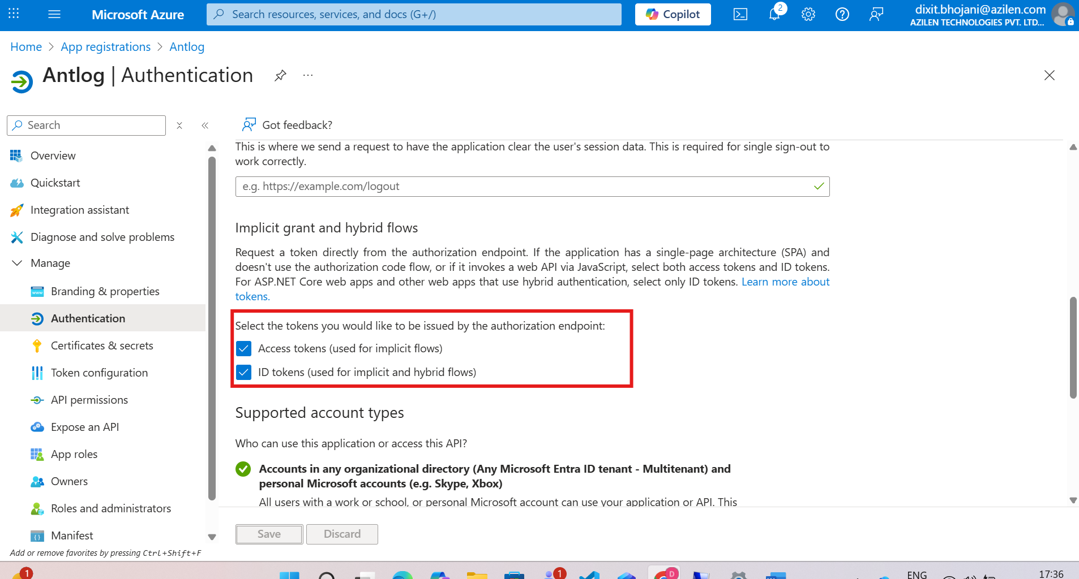
Figure 5: Token settings saved
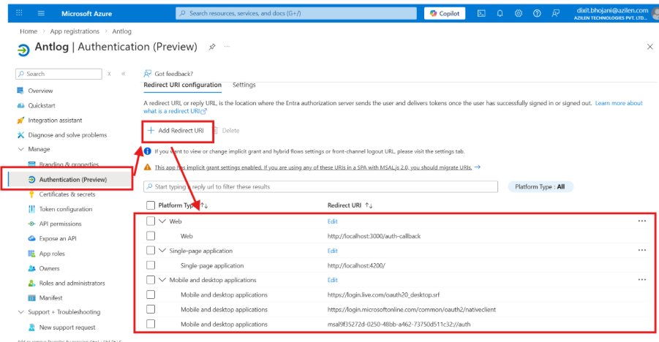
Figure 6: Add Redirect URIs for 3 platforms (Web, single page application & Mobile/Desktop application)
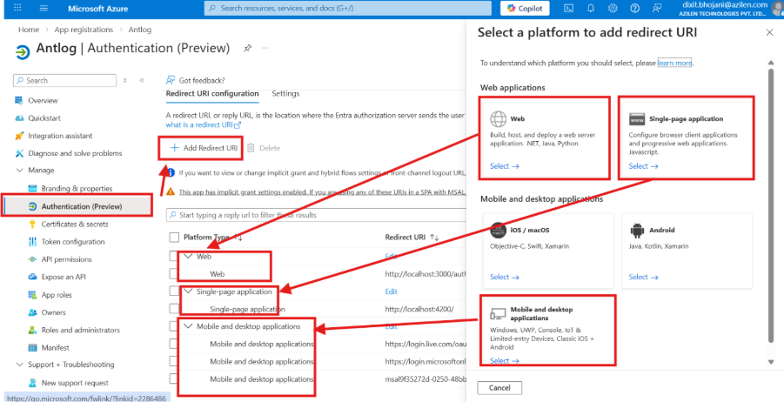
Figure 7: Add Redirect URIs for 3 platforms (Web, single page application & Mobile/Desktop application)

4. Assign app owners
- Navigate to the Owners tab.
- Click Add Owners to assign team members who need administrative access to this app.
(All required team members are already added as owners.)
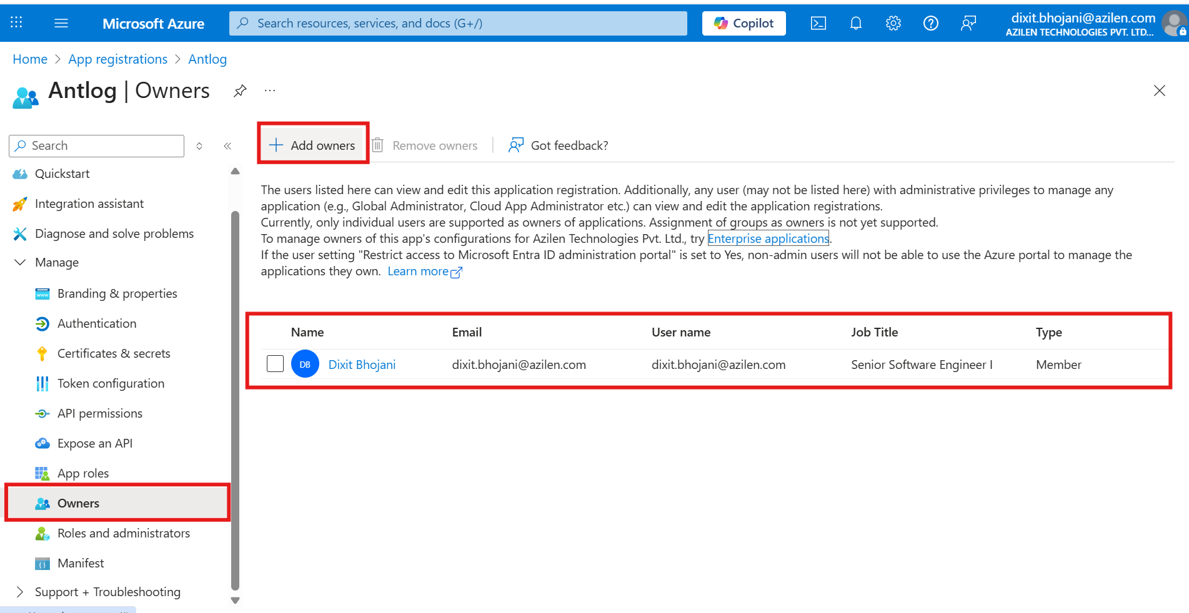
Figure 8: Owners configuration

5. API permissions
To enable Microsoft Graph email access:
- Go to the API Permissions tab.
- Click Add a Permission → Microsoft Graph.
- Add the following permissions (Delegated Permissions):
- Files.Read
- Files.ReadWrite
- Mail.Read
- offline_access
- User.Read
These permissions allow fetching email metadata, content, attachments, and support .eml generation where applicable.
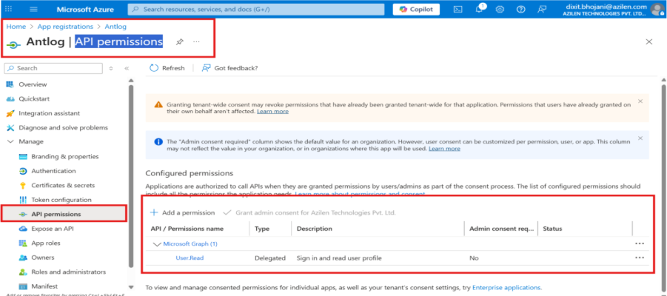
Figure 9: Microsoft Graph delegated permissions
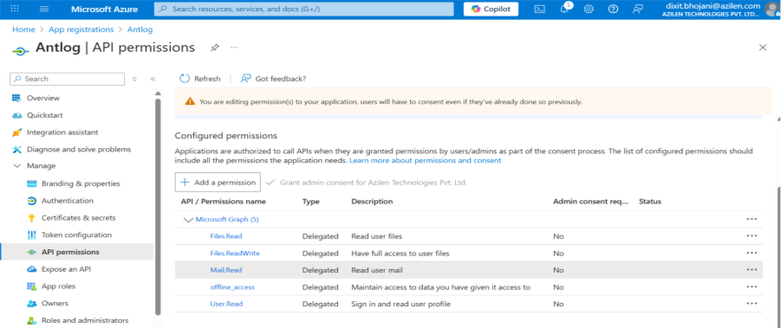
Figure 10: Add permissions to Use Selected Microsoft Graph APIs

6. Summary:
The configuration steps above enable the app to authenticate using Microsoft identity and interact with Microsoft Graph API for reading Outlook emails and associated data.
Once permissions are added and the configuration is saved, the Azure AD app is ready to be integrated into the Electron + Angular application.

7. Architecture flow overview:
Below is the high-level workflow illustrating how the Electron + Angular application interacts with Azure AD and Microsoft Graph API:
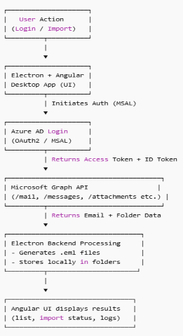
Figure 11: High-level integration flow

8. Scope and usage notes:

Area | Responsibility | Notes
Azure AD App | Auth, token issuing | Must remain configured with selected permissions
Electron Backend | File operations, local storage, EML handling | Token must be passed securely
Angular Frontend | UI, dialogs, email display, import UI | Uses MSAL for authentication
Microsoft Graph API | Email, attachments, metadata fetching | Requires valid access token

Important notes:
- If the app is deployed outside localhost, the redirect URI must be updated.
- offline_access permission is required to allow refresh tokens.

9. Azure App Configuration Export (For .env or client config):
Once the app is registered, collect the following values from Azure → App Registration → Overview:
Name | Example | Usage
Tenant ID | xxxxxxxx-xxxx-xxxx-xxxx-xxxxxxxxxxxx | Required for OAuth authority
Client ID (Application ID) | yyyyyyyy-yyyy-yyyy-yyyy-yyyyyyyyyyyy | Identifies the app
Redirect URI | http://localhost:4200/ | Required in MSAL configuration

Sample .env File Format:
AZURE_TENANT_ID=xxxxxxxx-xxxx-xxxx-xxxx-xxxxxxxxxxxx
AZURE_CLIENT_ID=yyyyyyyy-yyyy-yyyy-yyyy-yyyyyyyyyyyy
REDIRECT_URI=http://localhost:4200/
GRAPH_SCOPE="offline_access Mail.Read Files.Read Files.ReadWrite User.Read"

10 MSAL Client Configuration Example (Angular):
export const msalConfig = {
auth: {
clientId: environment.AZURE_CLIENT_ID,
authority: `https://login.microsoftonline.com/${environment.AZURE_TENANT_ID}`,
redirectUri: environment.REDIRECT_URI
},
cache: {
cacheLocation: 'localStorage',
storeAuthStateInCookie: false
}
};

export const azureScopes = [
'Files.Read',
'Files.ReadWrite',
'offline_access',
'User.Read',
'Mail.Read',
'Mail.ReadBasic',
'Mail.ReadWrite',
'IMAP.AccessAsUser.All'
];

