BIKE SHARING DATA ANALYSIS
Project Report
Nexthike Internship Project

Submitted By | Dhanashri Barve Dixit
Analysis Tool | Microsoft Excel
Final Dataset | 1,000 Records

1. Executive Summary
This report presents an analysis of bike-sharing rental data completed as part of the Nexthike Internship Project. The analysis used Microsoft Excel to clean, preprocess, merge and analyze multiple datasets, followed by Pivot Table analysis, charts, KPI summaries and an interactive dashboard. The final integrated dataset contains 1,000 records.
The analysis identifies clear demand patterns by hour, weekday, weather condition, temperature, humidity, wind speed, holiday status and user type. Registered users account for the majority of recorded rentals, while demand is concentrated around morning and evening commuting periods. Weather also has a material effect on usage, with rainy and windy conditions associated with substantially lower average rentals.

2. Project Objectives
- Analyze bike-sharing rental data using Microsoft Excel.
- Clean, preprocess and integrate multiple datasets into one final dataset.
- Calculate descriptive statistics including Mean, Median, Mode, Standard Deviation and Variance.
- Identify rental patterns based on hour, weekday, weather conditions, temperature and user type.
- Create interactive charts and a dashboard for effective data visualization.
- Provide business insights and recommendations based on the analysis.

3. Dataset Overview
Dataset | Description
Dataset 1 | Date & Time Information
Dataset 2 | Weather & Rental Information
Dataset 3 | Additional Rental Records
DataSet A(DataSet 1+DataSet2) | Combined DataSet 1 And DataSet 2(Using PowerQuery)
Final Dataset(Data Set A+DataSet 3) | Combined Dataset (1,000 Records)
Total records analyzed: 1,000.

4. Data Cleaning and Preprocessing
- Imported the raw datasets.
- Renamed column headers for consistent analysis.
- Checked for missing values.
- Removed duplicate records.
- Calculated descriptive statistics.
- Merged datasets using Power Query.
- Created Pivot Tables and charts.
- Built an interactive dashboard using KPIs, slicers and a timeline.

5. Data Analysis and Key Findings

5.1 Dataset 1 – Temperature and Environmental Factors
- Average temperature changes across different hours of the day.
- Weather conditions influence temperature variations.
- Time and weather are important environmental factors considered in the analysis.
Instant | Date | Season | Year | Month | Hour | Holiday | Weekday | Weathersit | Temp
1 | 01-01-2011 | 1 | 0 | 1 | 0 | FALSE | 6 | 1 | 0.24
2 | 01-01-2011 | 1 | 0 | 1 | 1 | FALSE | 6 | 1 | 0.22
3 | 01-01-2011 | 1 | 0 | 1 | 2 | FALSE | 6 | 1 | 0.22
4 | 01-01-2011 | 1 | 0 | 1 | 3 | FALSE | 6 | 1 | 0.24
5 | 01-01-2011 | 1 | 0 | 1 | 4 | FALSE | 6 | 1 | 0.24
7 | 01-01-2011 | 1 | 0 | 1 | 6 | FALSE | 6 | 1 | 0.22
8 | 01-01-2011 | 1 | 0 | 1 | 7 | FALSE | 6 | 1 | 0.2
9 | 01-01-2011 | 1 | 0 | 1 | 8 | FALSE | 6 | 1 | 0.24
10 | 01-01-2011 | 1 | 0 | 1 | 9 | FALSE | 6 | 1 | 0.32
11 | 01-01-2011 | 1 | 0 | 1 | 10 | FALSE | 6 | 1 | 0.38
12 | 01-01-2011 | 1 | 0 | 1 | 11 | FALSE | 6 | 1 | 0.36
13 | 01-01-2011 | 1 | 0 | 1 | 12 | FALSE | 6 | 1 | 0.42

5.2 Dataset 2 – Feeling Temperature and User Type
- Higher apparent (feels-like) temperature is associated with increased bike rentals.
- Registered users account for a much larger share of rentals than casual users.
- User type and weather conditions play a significant role in bike-sharing demand.
- Humidity influences bike rental activity.
- Wind speed also affects rental demand, although its impact appears less pronounced.

Bike Sharing Demand Analysis
Instant | Atemp | Humidity | Windspeed | Casual | Registered | Count
1 | 0.288 | 0.81 | 0 | 3 | 13 | 16
2 | 0.273 | 0.8 | 0 | 8 | 32 | 40
3 | 0.273 | 0.8 | 0 | 5 | 27 | 32
4 | 0.288 | 0.75 | 0 | 3 | 10 | 13
5 | 0.288 | 0.75 | 0 | 0 | 1 | 1
6 | 0.258 | 0.75 | 0.09 | 0 | 1 | 1
7 | 0.273 | 0.8 | 0 | 2 | 0 | 2
8 | 0.258 | 0.86 | 0 | 1 | 2 | 3

5.3 Dataset 3 – Hourly, Weather and Daywise Trends
- Hourly demand shows strong peaks during commuting periods.
- Weather conditions create clear differences in average bike usage.
- Daywise usage varies across the week, with higher demand on several weekdays and lower demand on weekends.

 | Bike Sharing Demand Analysis
Instant | Date | Season | Year | Month | Hour | Holiday | Weekday | Weathersit | Temp | Atemp | Humidity | Windspeed | Casual | Registered | Count
611 | 28-01-2011 | 1 | 0 | 1 | 16 | FALSE | 5 | 1 | 0.22 | 0.2727 | 0.8 | 0 | 10 | 70 | 80
612 | 28-01-2011 | 1 | 0 | 1 | 17 | FALSE | 5 | 1 | 0.24 | 0.2424 | 0.75 | 0.1343 | 2 | 147 | 149
613 | 28-01-2011 | 1 | 0 | 1 | 18 | FALSE | 5 | 1 | 0.24 | 0.2273 | 0.75 | 0.194 | 2 | 107 | 109
614 | 28-01-2011 | 1 | 0 | 1 | 19 | FALSE | 5 | 2 | 0.24 | 0.2424 | 0.75 | 0.1343 | 5 | 84 | 89
615 | 28-01-2011 | 1 | 0 | 1 | 20 | FALSE | 5 | 2 | 0.24 | 0.2273 | 0.7 | 0.194 | 1 | 61 | 62
616 | 28-01-2011 | 1 | 0 | 1 | 21 | FALSE | 5 | 2 | 0.22 | 0.2273 | 0.75 | 0.1343 | 1 | 57 | 58
617 | 28-01-2011 | 1 | 0 | 1 | 22 | FALSE | 5 | 1 | 0.24 | 0.2121 | 0.65 | 0.3582 | 0 | 26 | 26
618 | 28-01-2011 | 1 | 0 | 1 | 23 | FALSE | 5 | 1 | 0.24 | 0.2273 | 0.6 | 0.2239 | 1 | 22 | 23
619 | 29-01-2011 | 1 | 0 | 1 | 0 | FALSE | 6 | 1 | 0.22 | 0.197 | 0.64 | 0.3582 | 2 | 26 | 28
620 | 29-01-2011 | 1 | 0 | 1 | 1 | FALSE | 6 | 1 | 0.22 | 0.2273 | 0.64 | 0.194 | 0 | 20 | 20
621 | 29-01-2011 | 1 | 0 | 1 | 2 | FALSE | 6 | 1 | 0.22 | 0.2273 | 0.64 | 0.1642 | 0 | 15 | 15
622 | 29-01-2011 | 1 | 0 | 1 | 3 | FALSE | 6 | 1 | 0.2 | 0.2121 | 0.64 | 0.1343 | 3 | 5 | 8
623 | 29-01-2011 | 1 | 0 | 1 | 4 | FALSE | 6 | 1 | 0.16 | 0.1818 | 0.69 | 0.1045 | 1 | 2 | 3

5.4 Dataset A -Combined DataSet A(DataSet 1 And DataSet2)
DataSet A is merging of Data Set 1 AND Data set 2.it includes records of 610 bike-sharing records covering 1–28 January 2011. Total bike usage was 33,898 rides, with an average of 55.57 rides per hour and a median of 47 rides.
Key Findings
- Total rides: 33,898
- Average hourly demand: 55.57 rides
- Median hourly demand: 47 rides
- Highest hourly demand: 249 rides
- Lowest hourly demand: 1 ride
- Registered users: 31,151 rides (91.9%)
- Casual users: 2,746 rides (8.1%)
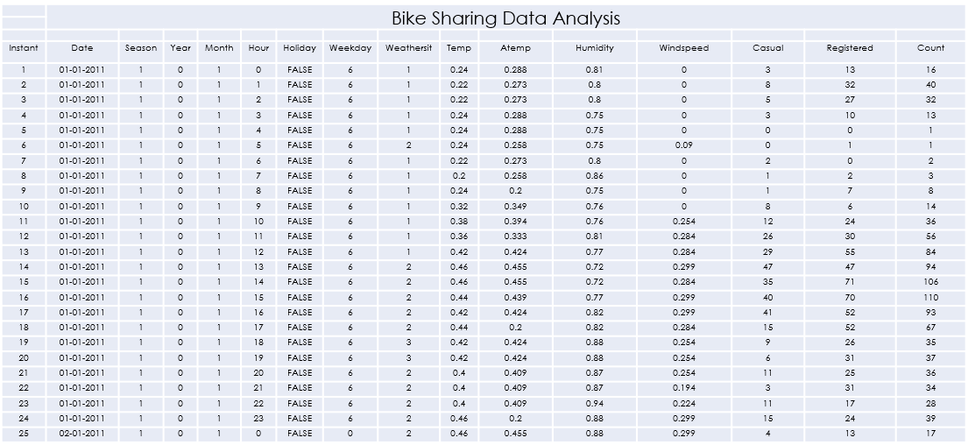

5.5 Final Dataset Analysis
- The final dataset contains 1,000 records.
- There are 976 non-holiday records (97.6%) and 24 holiday records (2.4%).
- Total user volume is 58,304, comprising 4,921 casual users and 53,383 registered users.
- Registered users represent approximately 91.6% of total user volume, while casual users represent approximately 8.4%.
- January has substantially higher user volume than February in both casual and registered segments.

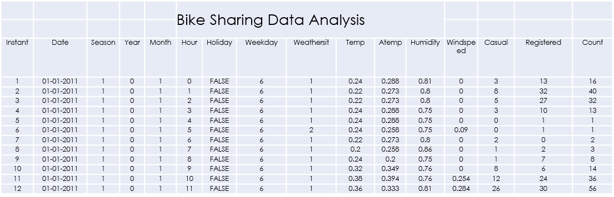

5.6 Weather and Temperature Findings
- Average temperature by weather condition varies only slightly, with values around 0.20–0.22.
- Sunny conditions show the highest average bike-user count in the final dashboard analysis (61.67), followed by cloudy conditions (58.60).
- Rainy conditions reduce average usage to 33.20, while windy conditions record 36.00.
- Humidity and wind speed contribute to changes in rental activity.

6. Dashboard and Visualization
The dashboard combines KPIs, charts, slicers and a timeline into a single analytical view. It is designed to provide a quick interpretation of rental patterns and support data-driven decision-making.
- Total rentals: 58,304.
- Registered rentals: 53,383.
- Casual rentals: 4,921.
- Average count reported in the dashboard: 55.57.
- The dashboard supports monthwise, seasonwise, daywise and holidaywise interpretation through slicers and timeline controls.

7. Business Insights and Recommendations
Business Insight | Recommendation
Bike rental demand is influenced by weather and environmental factors. | Increase bike availability during peak demand periods and incorporate weather forecasts into operational planning.
Registered users contribute significantly more rentals than casual users. | Develop targeted offers and promotions to increase casual-user participation.
Temperature and apparent temperature show a positive relationship with bike rentals. | Use weather and temperature trends to improve demand forecasting and resource allocation.
Humidity and wind speed also affect rental demand. | Schedule maintenance and redistribution activities during lower-demand periods.

8. Conclusion
The Bike Sharing Data Analysis project demonstrates how Microsoft Excel can be used to transform raw rental data into meaningful business insights. Multiple datasets were cleaned, preprocessed and integrated into a final dataset of 1,000 records. Descriptive statistics, Pivot Tables, charts, KPI cards and an interactive dashboard were used to identify important patterns related to weather, user type, time and rental behaviour.

9. Key KPI Reference
KPI | Value
Final dataset records | 1,000
Overall total rentals | 58,304
Registered rentals | 53,383
Casual rentals | 4,921
Overall average count – Pivot analysis | 55.57

