# **DWT-DCT-SVD Watermarking Algorithm**

coverImage resize to 512x512

watermarkImage

Resize to 32x32

DWT2(coverImage)

H,V,D

A,H,V,D

Get 8x8 block of A

Process till all A 8x8 block processed

Apply DCT get DctBlock

Read DCT Value at (8,8) and store it to DMat

Apply SVD (DMat)

Simg

Vimg

Uimg

Simg_tmp

Simg=Simg + alpha*Iwb

SVD (Simg)

V_SHL_w

S_SHL_w

U_SHL_w

Uimg

Vimg

Inverse SVD

Watermarked DMat2

Get 8x8 block of A

Apply DCT =DctBlock

Store DMat2 pixel at DctBlock(8,8)

Apply inverse DCT

Updated block store at A2

A2

Inverse DWT

H,V,D

Watermarked Image

Ig2

# **Extraction Process:**

Apply DWT on watermark Image

Da, Dh, Dv, Dd

Get 8x8 block of A

Apply DCT =DctBlock

Read DctBlock(8,8) pixel value and store to DMatD

Apply SVD

VWimg

SWimg

Wimg

U_SHL_w

V_SHL_w

Apply inverse SVD=D_1

Simg_tmp

Watermark=

(D_1-Simg_temp) / temp

Watermark=255*Watermark

# **Algorithm Detail:**

Initially individual folder created to store the output and results of each simulation methods

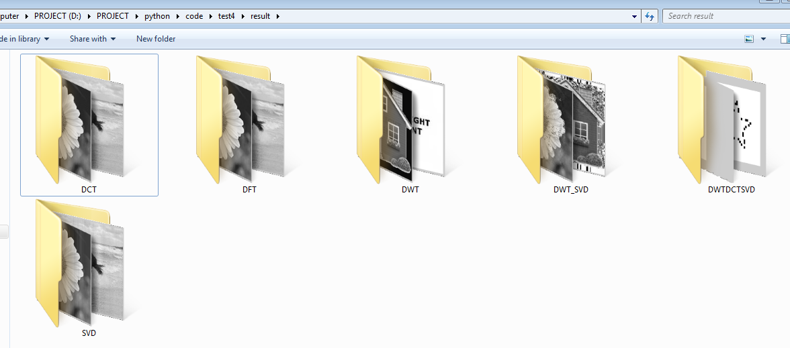

1. All images to be processed are stored at folder ‘/coverimages/’ folder

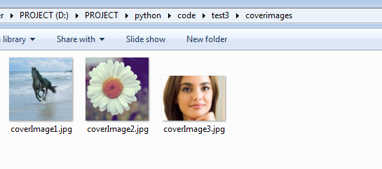

2. The python script first finds all .jpg extension images of ‘/coverimage/’ folder.

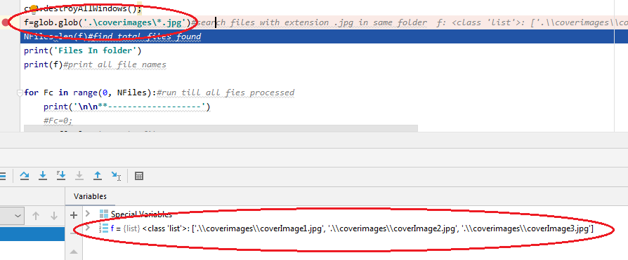

3. Algorithm ask for the option to be performed

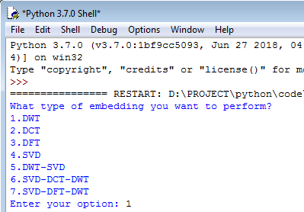

4. According to the option selected the algorithm will be applied on cover image and watermark image

5.Initally first image file coverImage1.jps is read, files name to be read are stored at st variable

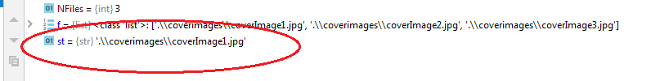

6. File name is displayed on Console Output

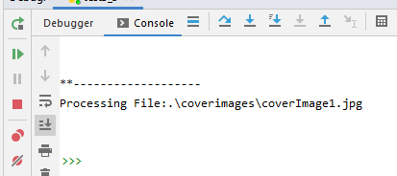

7. the algorithm used is followed as per paper

‘DWT, DCT and SVD based Digital Image, Watermarking,

Manie Kansal, Gursharanjeet Singh, B V Kranthi

, International Conference on Computing Sciences, 2012’

As per reference research paper image is resized to 512x512 and watermark image resized to 32x32

# 1. DWT Watermarking

Console output option 1 : DWT

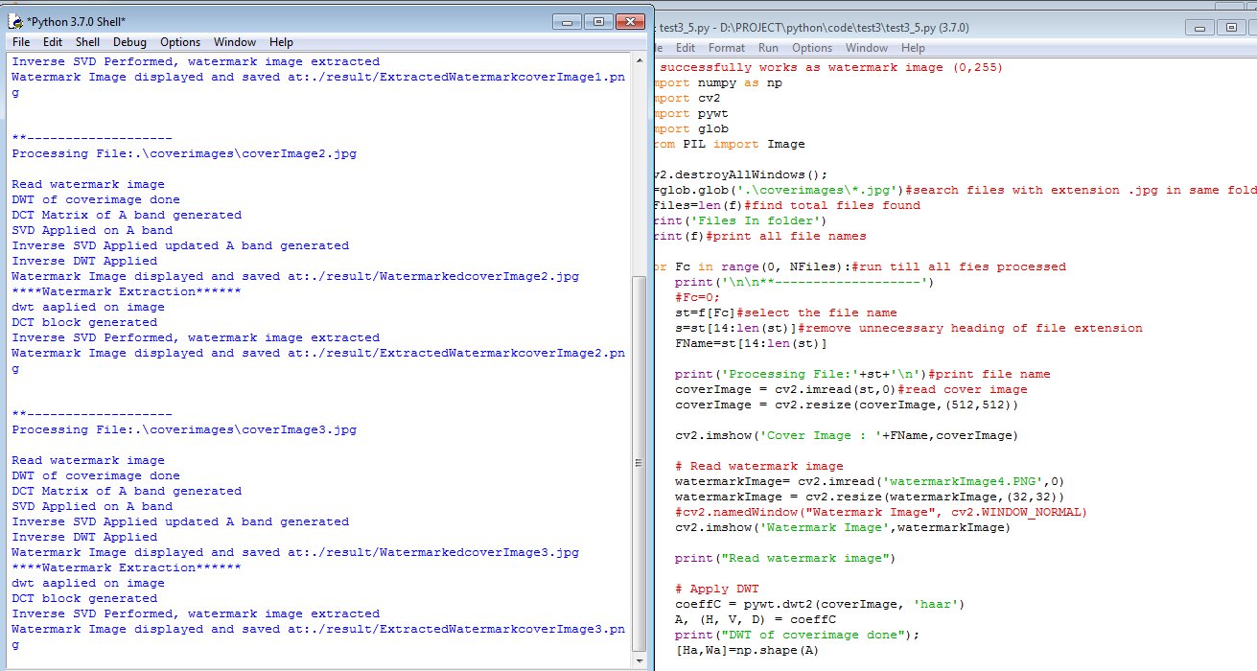

Simulation screenshot cover image 1

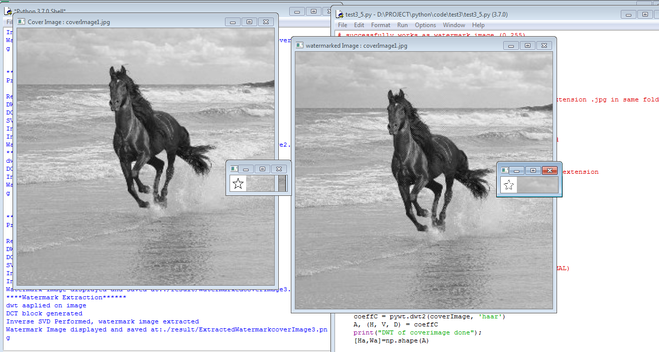

like wise above process all cover image will be processed and will be stored at ‘result/DWT/’ folder location

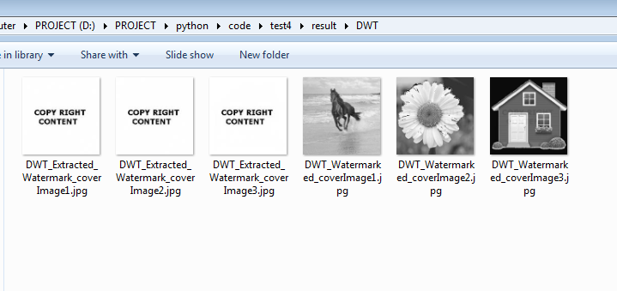

# 2. DCT Watermarking

Console output option 2 : DCT

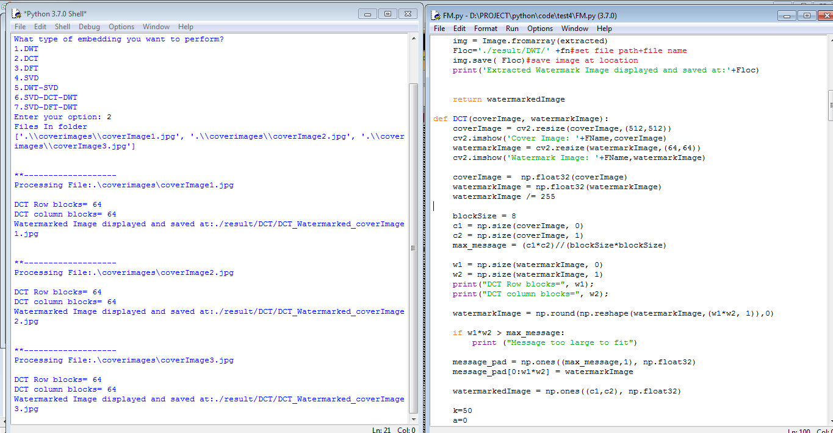

Simulation screenshot cover image 1

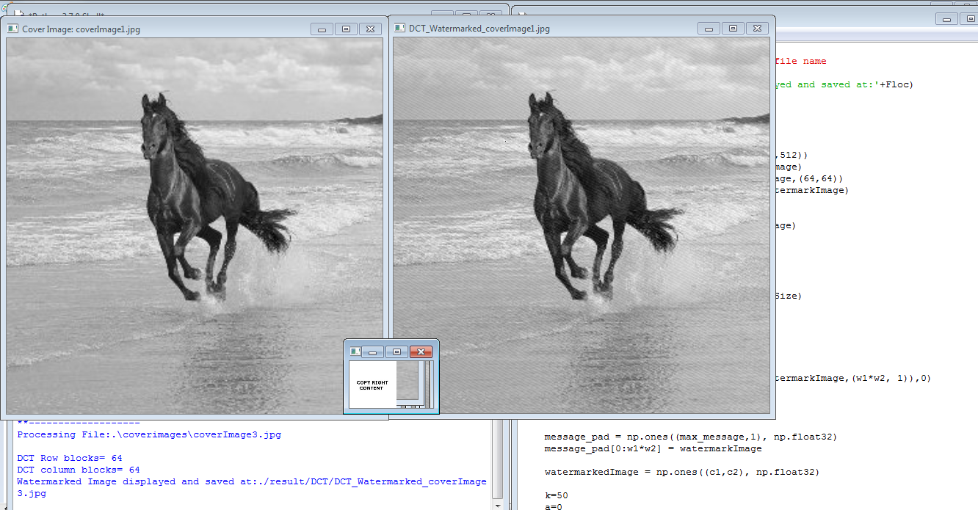

like wise above process all cover image will be processed and will be stored at ‘result/DCT/’ folder location

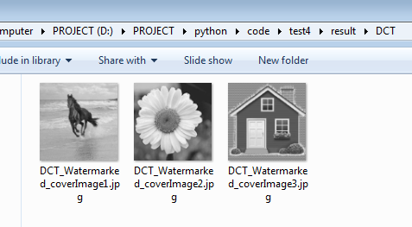

# 3. DFT Watermarking

Console output option 3 : DWT

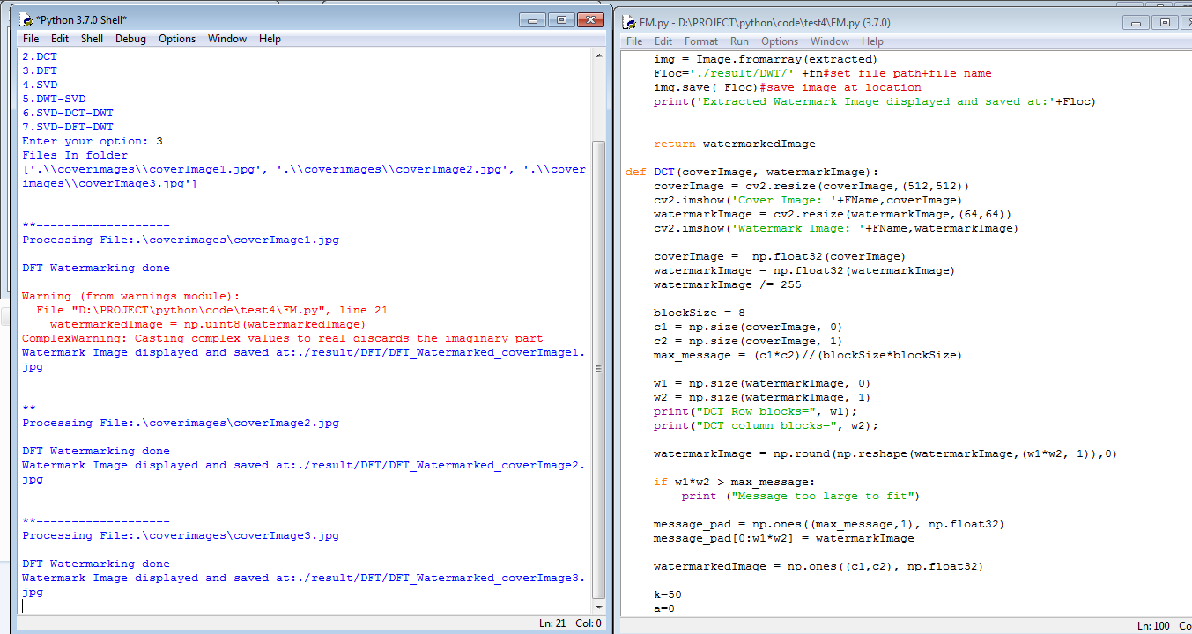

Simulation screenshot cover image 1

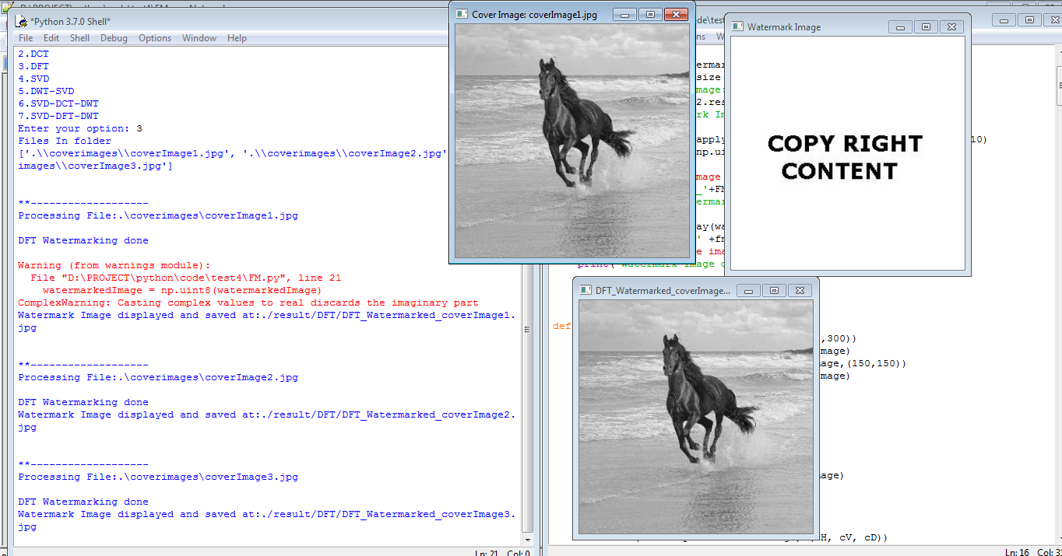

like wise above process all cover image will be processed and will be stored at ‘result/DFT/’ folder location

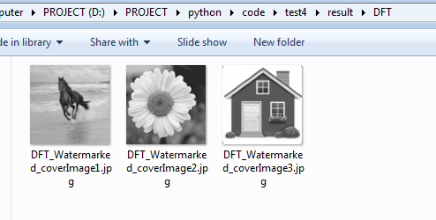

# 4. SVD Watermarking

Console output option 4 : SVD

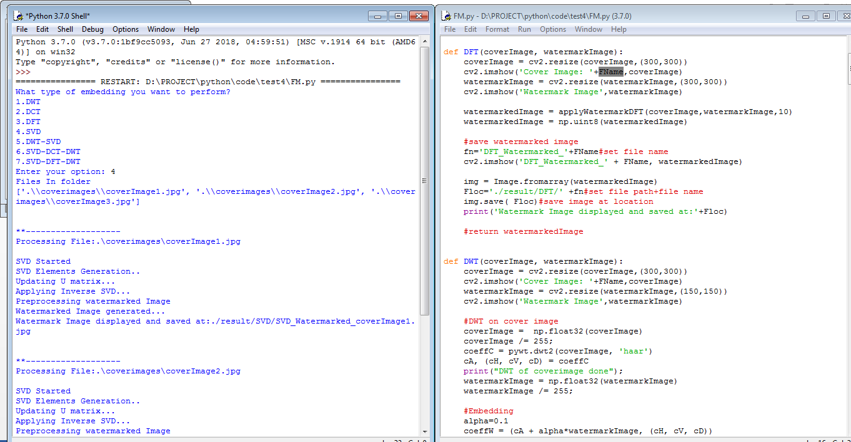

Simulation screenshot cover image 1

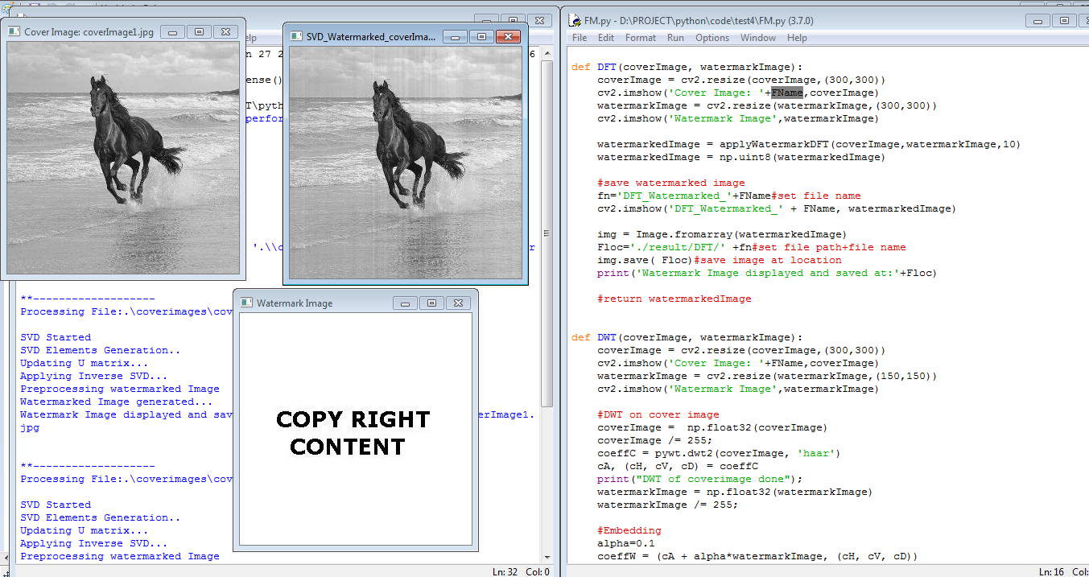

like wise above process all cover image will be processed and will be stored at ‘result/SVD/’ folder location

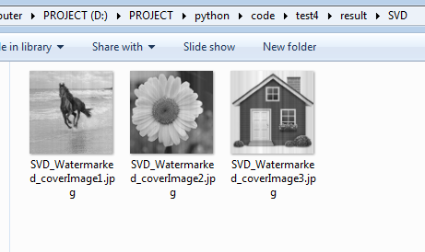

# 5. DWT-SVD Watermarking

Console output option 5 : DWT-SVD

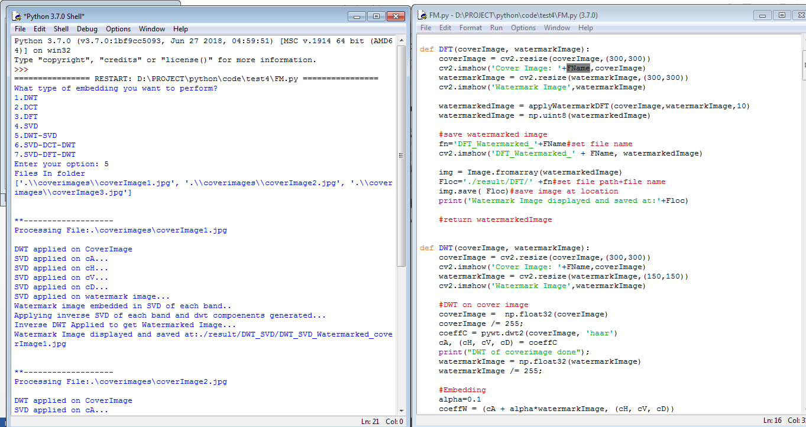

Simulation screenshot cover image 1

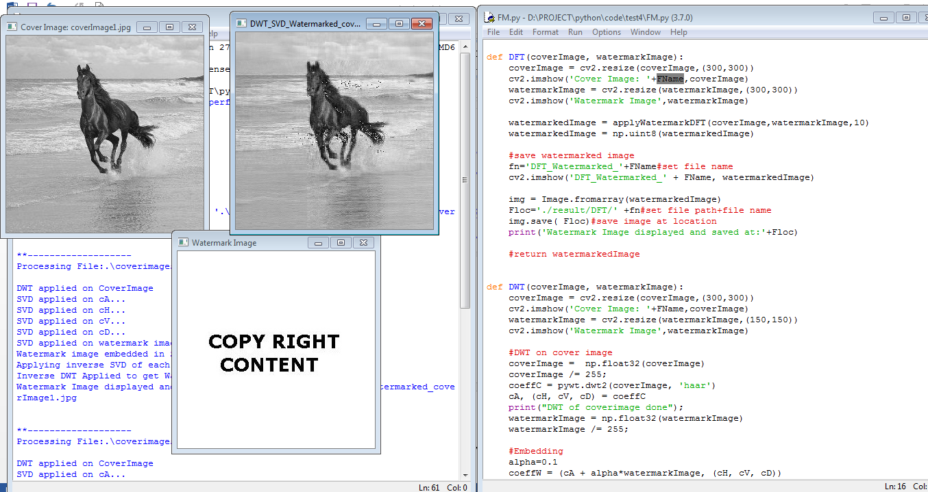

like wise above process all cover image will be processed and will be stored at ‘result/DWT_SVD/’ folder location

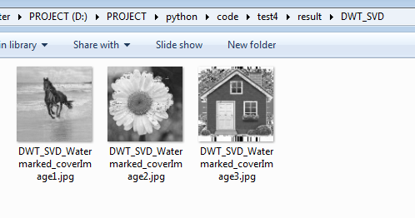

# 6. DWT-DCT-SVD Watermarking

Console output option 6 : DWT-SVD

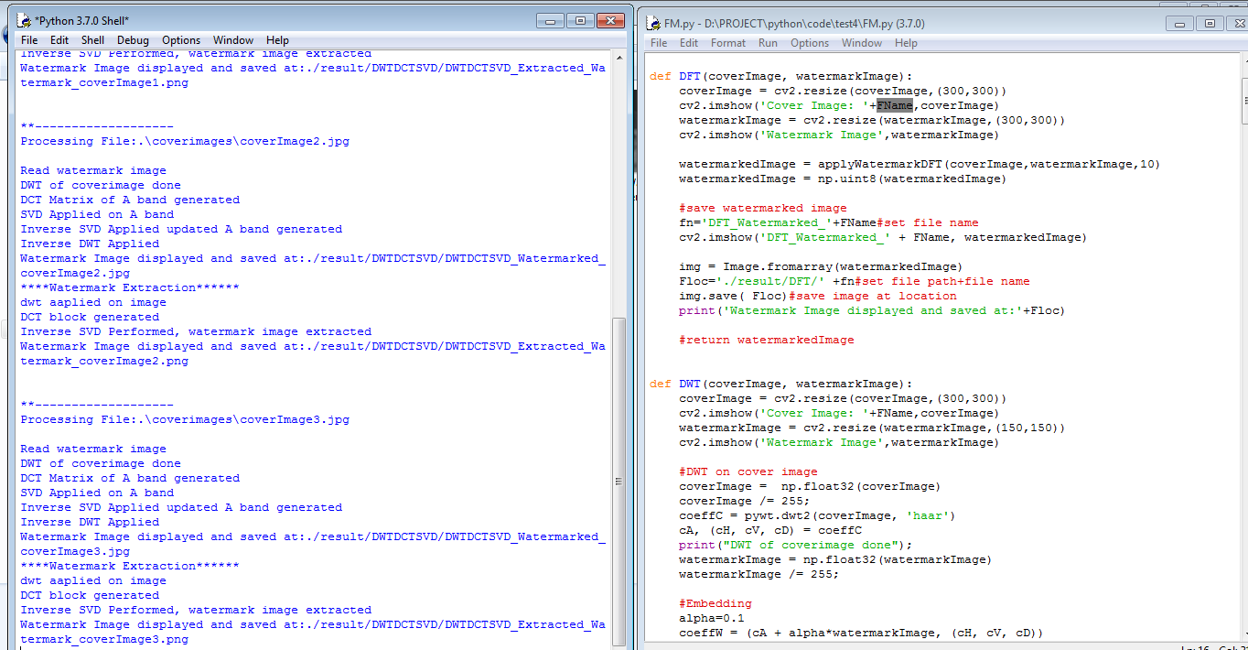

Simulation screenshot cover image 1

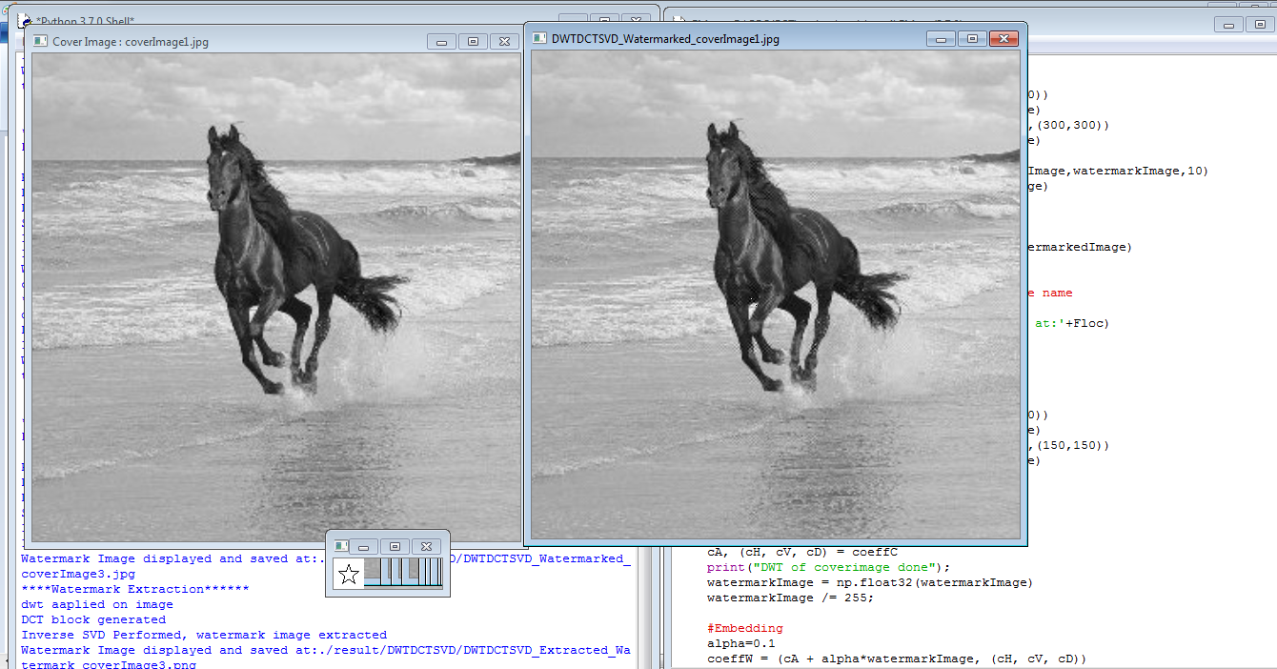

like wise above process all cover image will be processed and will be stored at ‘result/DWT_SVD/’ folder location

