**Soccer Transfers**

Bhargav K (459835646, vkonakan@syr.edu)

Dixitha K (309010286,

dkasturi@syr.edu

)

GROUP

-

7



An application in which multiple teams with multiple players are present. Each team will have a manager. For each player multiple teams can bid. The bid will be accepted /rejected/stalled by the manager. Highest bids are accepted. If bid amount is not greater than the current highest bid, the bid will not go through.

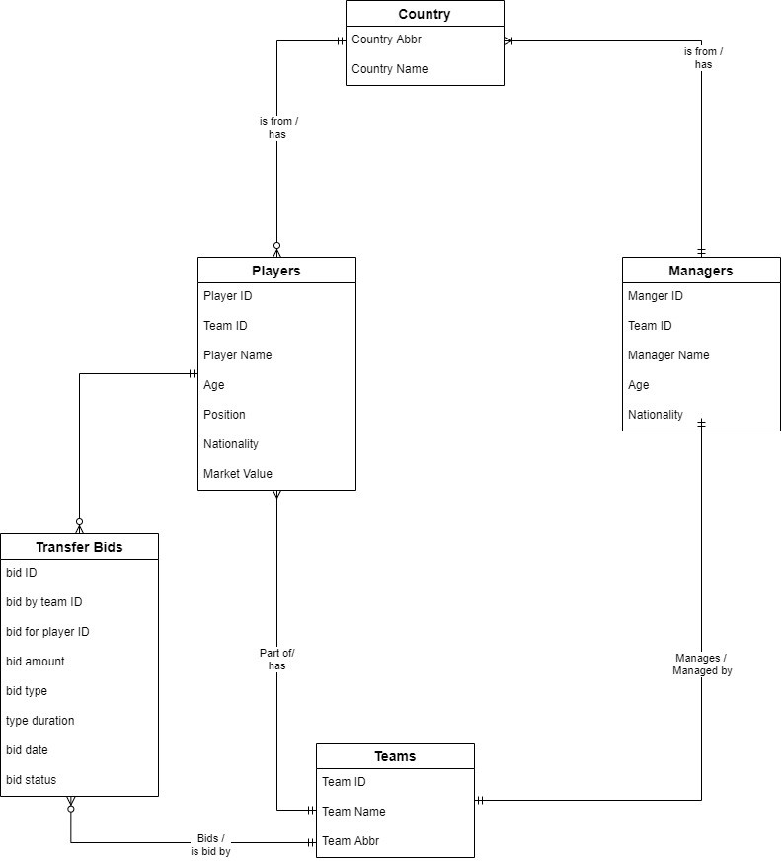

**Tables:**

Player

Manager Transfer bids Teams

Countries Team Stats

**Views:**

Each team has a view ( eg : fc Barcelona, Real Madrid, FC Bayern Munich, Manchester City, Manchester United) Transfers accepted.

Transfers rejected.

**Transactions:**

For each player only one bid is accepted, transaction on transfer request.

**Triggers:**

When a bid is accepted, as the date changes, the bid status changes from pending bid to approved. The status is changed from pending to approved and the player is team ID is upated.

While actually implementing the project we made multiple changes to our design.

We generated a different ER diagram compared to the one that we submitted as the initial idea.

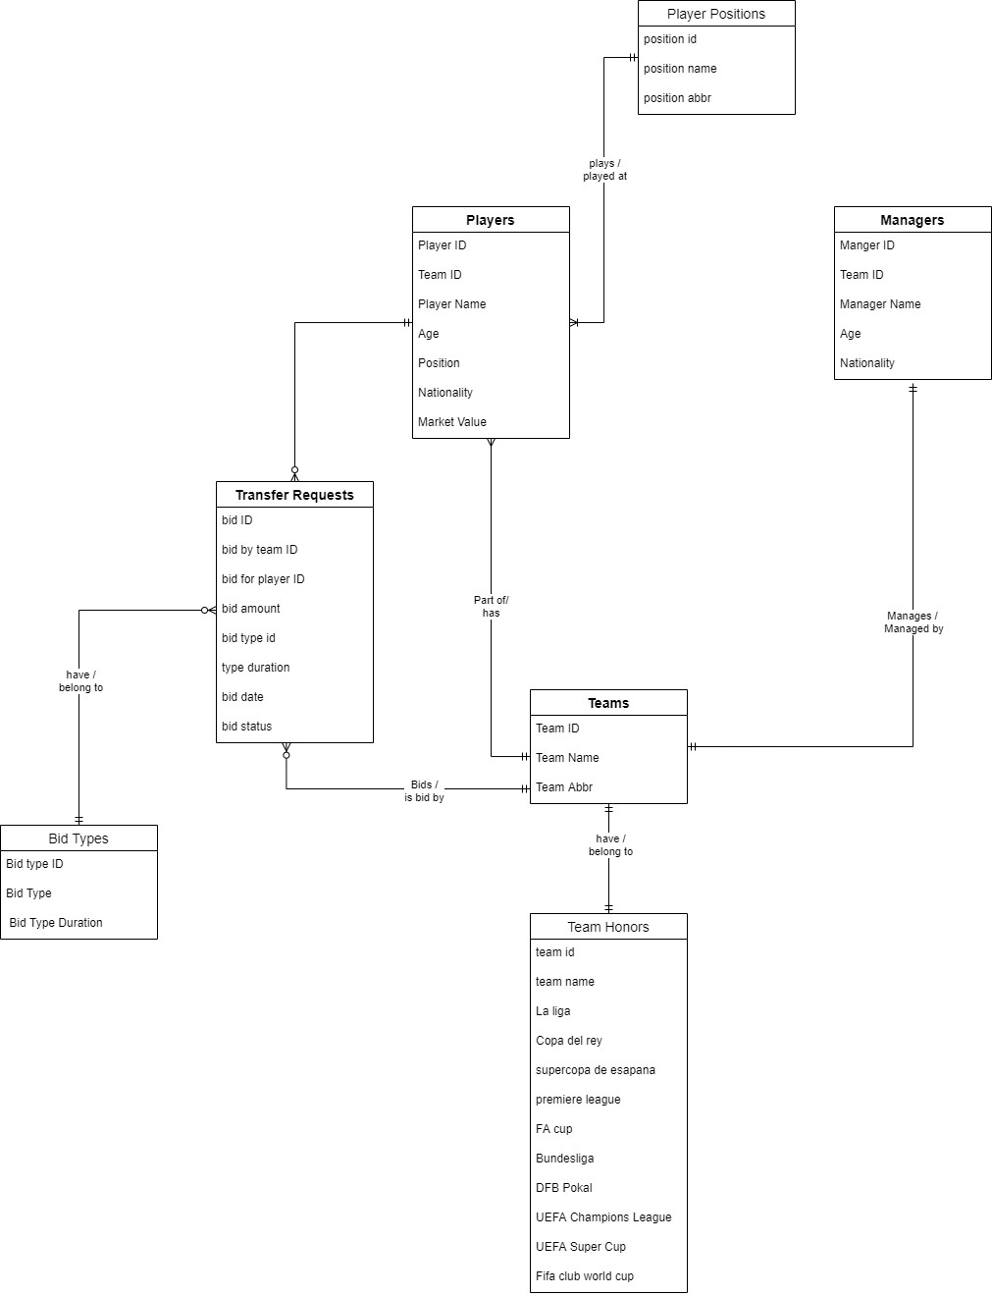

**Logical model for the generated database application**

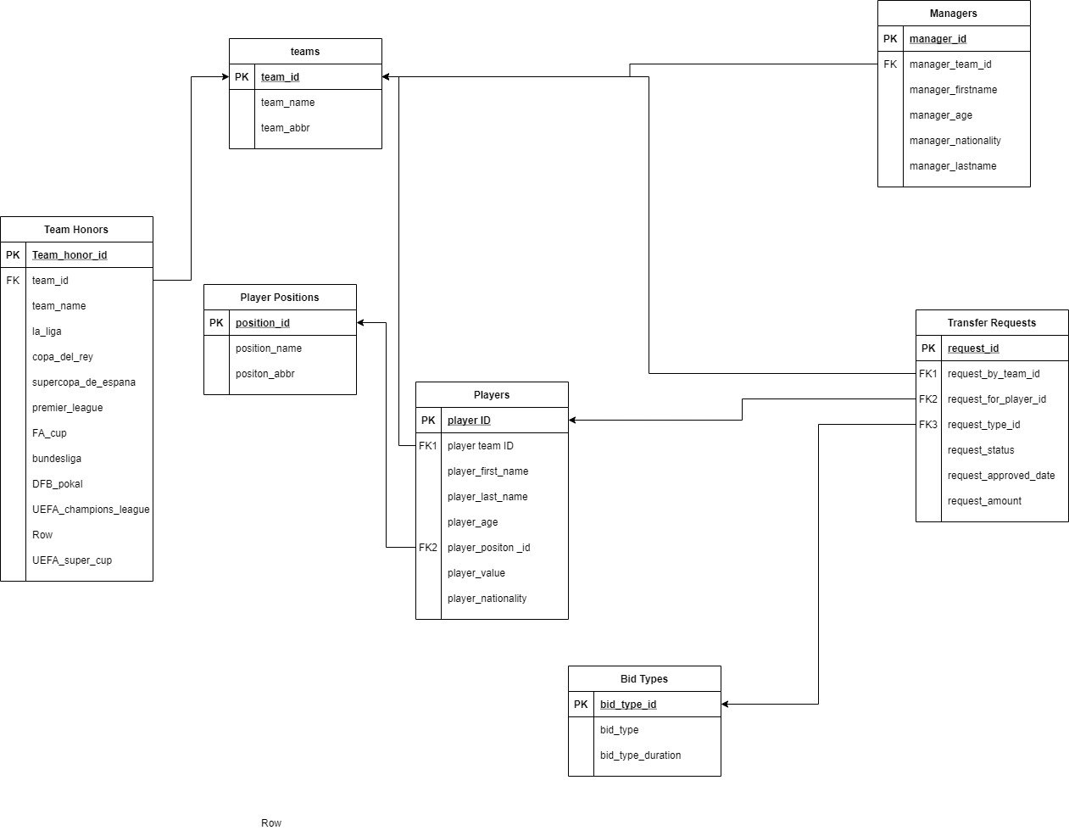

**Design of screens planned:**

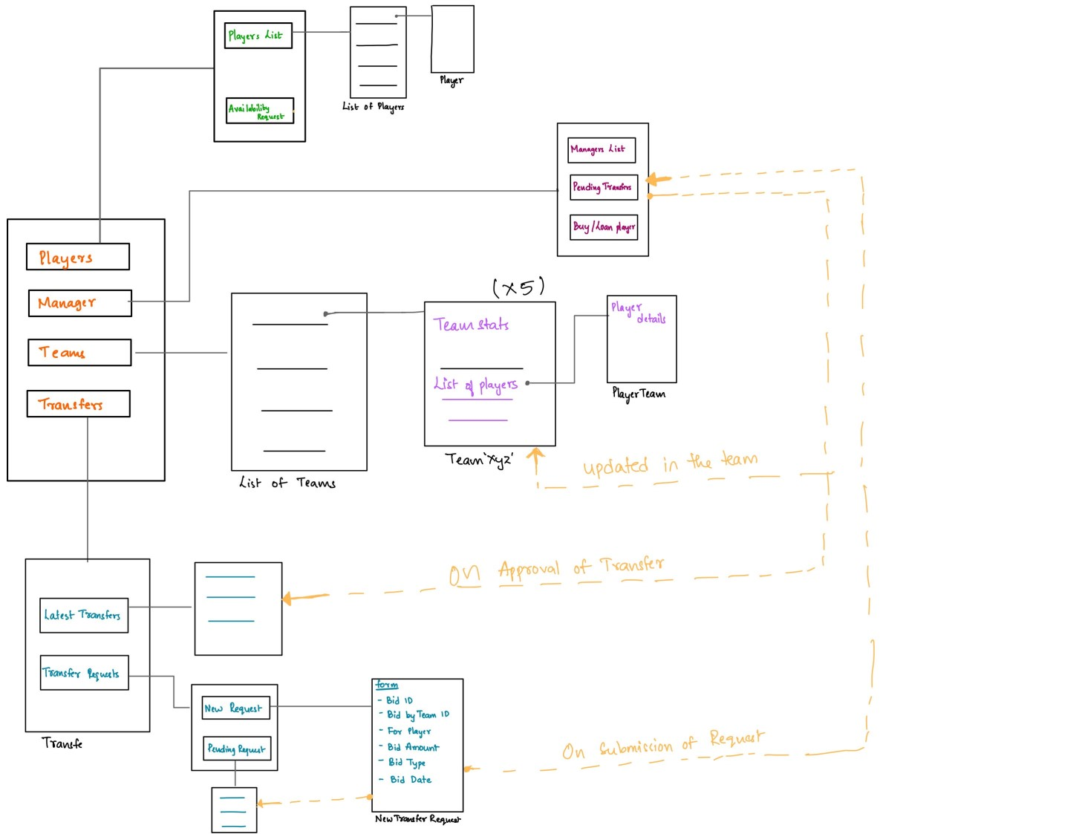

**All Screens:**

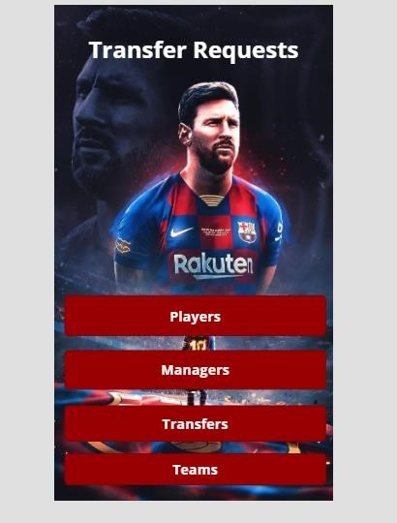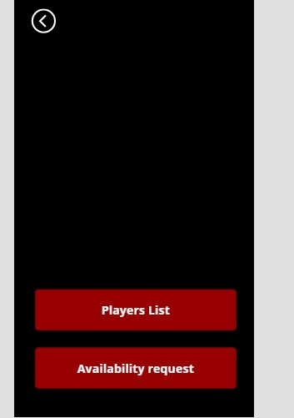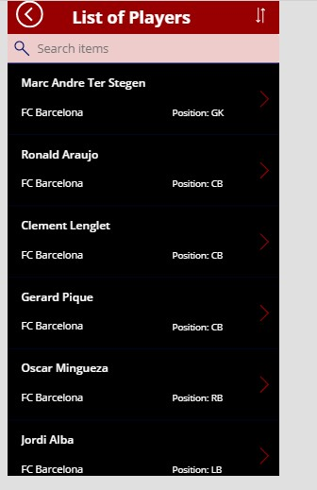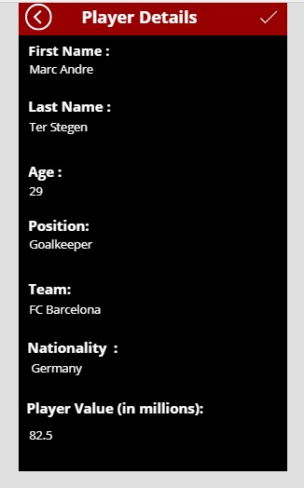

**Managers :**

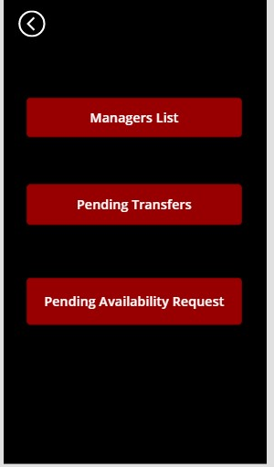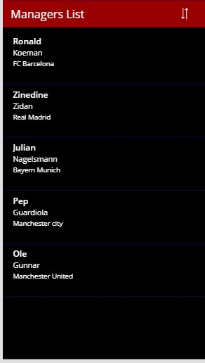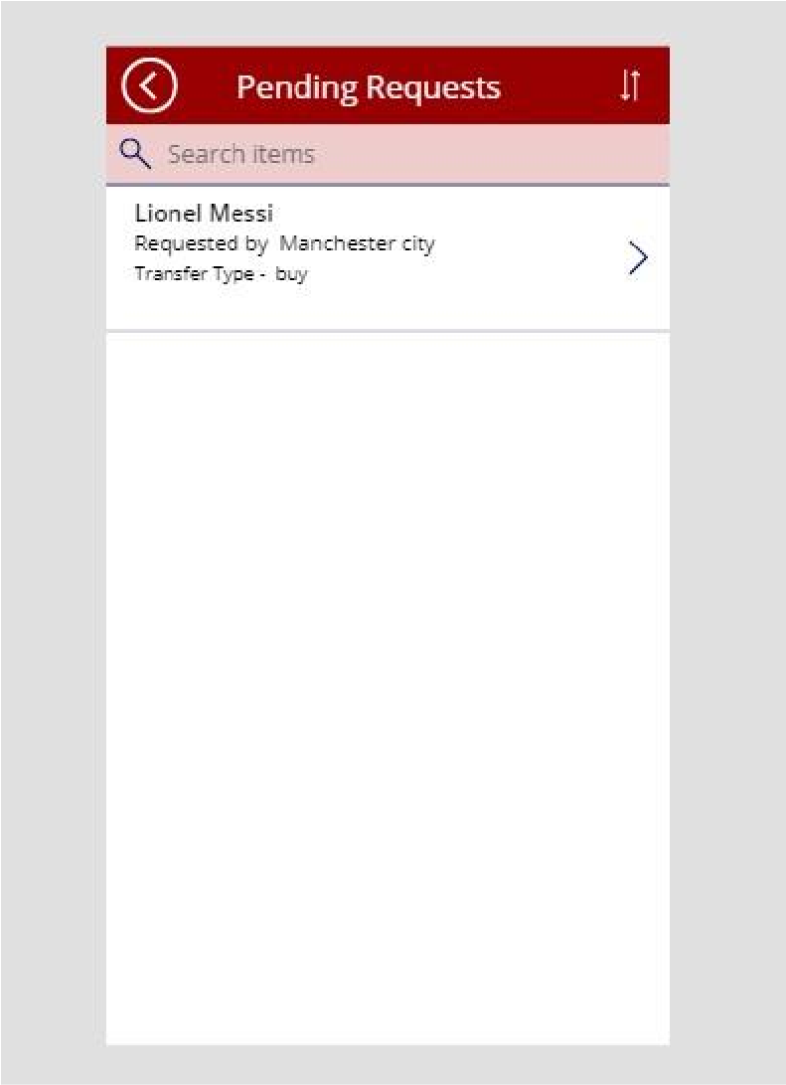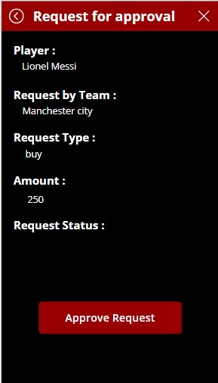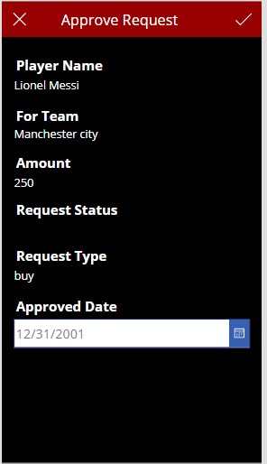

**Teams :**

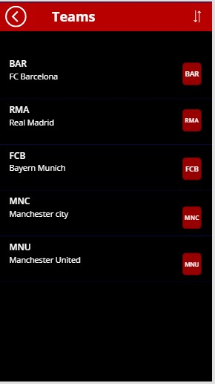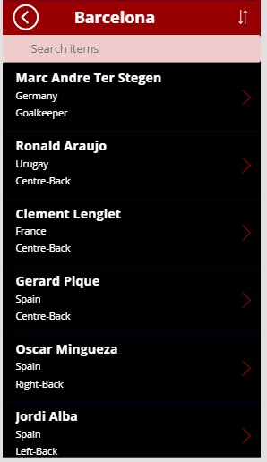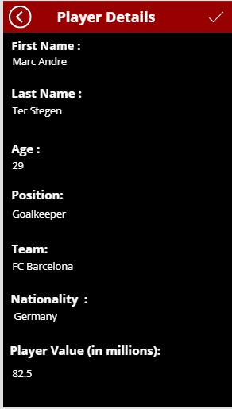

**Transfers :**

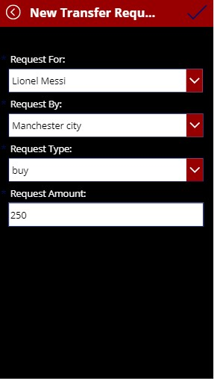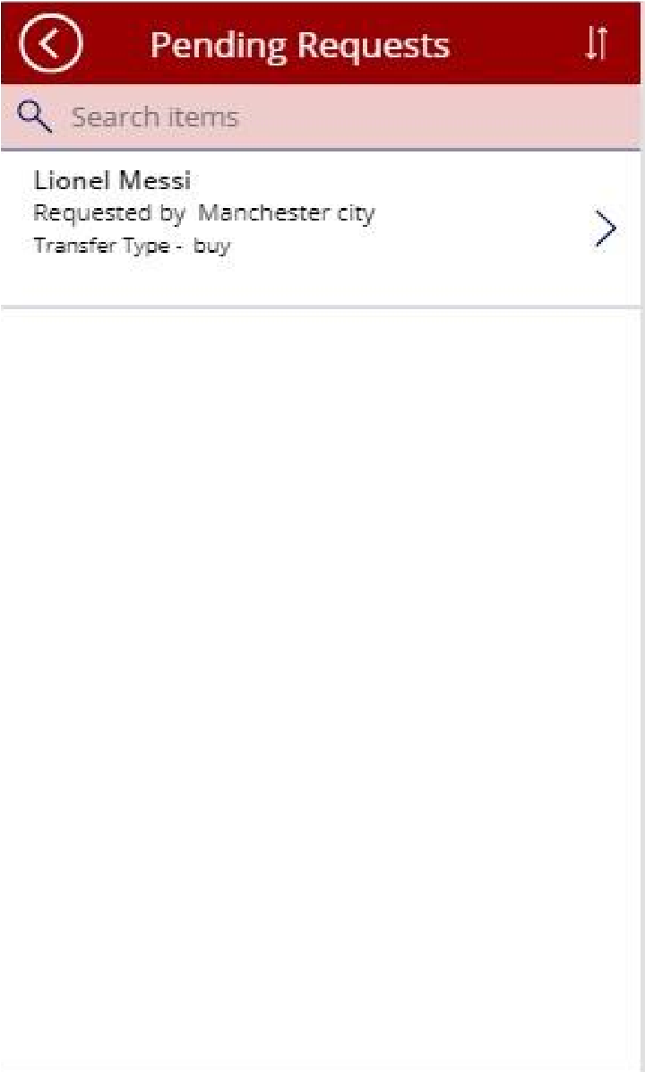

**Link to Video:**

<https://youtu.be/X3sivqBneZw>

If we had more time we would have implemented more features for live bidding and transfer requests. We would have made the availability requests possible too. We could have used procedures and indexes too.

**LOG :**

All throughout the weeks that we worked, both of us combined our efforts to do the project. The initially the idea was brought up by Bhargav. Creating Tables, Views initially was done by Dixitha. Tiggers and

Transactions were done by Bhargav after team discussion. Power apps were done collaboratively by both.

**sql code:**

--tables --down script if exists (select * from INFORMATION_SCHEMA.CONSTRAINT_TABLE_USAGE where CONSTRAINT_NAME = 'fk_team_honors_team_id') alter table team_honors drop fk_team_honors_team_id GO if exists (select * from INFORMATION_SCHEMA.CONSTRAINT_TABLE_USAGE where CONSTRAINT_NAME = 'fk_transfer_requests_request_type_id') alter table transfer_requests drop fk_transfer_requests_request_type_id GO if exists (select * from INFORMATION_SCHEMA.CONSTRAINT_TABLE_USAGE where CONSTRAINT_NAME = 'fk_transfer_requests_request_for_player_id') alter table transfer_requests drop fk_transfer_requests_request_for_player_id GO if exists (select * from INFORMATION_SCHEMA.CONSTRAINT_TABLE_USAGE where CONSTRAINT_NAME = 'fk_transfer_requests_request_by_team_id') alter table transfer_requests drop fk_transfer_requests_request_by_team_id GO if exists (select * from INFORMATION_SCHEMA.CONSTRAINT_TABLE_USAGE where CONSTRAINT_NAME = 'fk_managers_manager_team_id') alter table managers drop fk_managers_manager_team_id GO if exists (select * from INFORMATION_SCHEMA.CONSTRAINT_TABLE_USAGE where CONSTRAINT_NAME = 'fk_players_player_position_id') alter table players drop fk_players_player_position_id GO if exists (select * from INFORMATION_SCHEMA.CONSTRAINT_TABLE_USAGE where CONSTRAINT_NAME = 'fk_players_player_team_id') alter table players drop fk_players_player_team_id GO

drop table if exists team_honors GO

drop table if exists player_positions GO

drop table if exists bid_types GO

drop table if exists teams GO

drop table if exists transfer_requests GO

drop table if exists managers GO

drop table if exists players

GO

--up script create table players ( player_id int IDENTITY not NULL, player_firstname varchar(50) not NULL, player_lastname varchar(50) not NULL, player_age int not NULL, player_team_id int not NULL, player_position_id int not null, player_value money not NULL, player_nationality varchar(15) not NULL,

constraint pk_players_player_id primary key(player_id) )

GO

create table managers ( manager_id int IDENTITY not NULL, manager_firstname varchar(50) not NULL, manager_lastname varchar(50) not NULL, manager_age int not NULL, manager_team_id int not NULL, manager_nationality varchar(15) not NULL

constraint pk_managers_manager_id primary key(manager_id)

)

GO

create table transfer_requests ( request_id int IDENTITY not null, request_by_team_id int not NULL, request_for_player_id int not null, request_amount money not null, request_type_id int not null, request_status varchar(10) null, request_approved_date date null, request_approved_by_manager_id int null, constraint pk_transfer_requests_request_id primary key (request_id)

)

GO

create table teams ( team_id int IDENTITY not null, team_name varchar(20) not null, team_abbr char(3) not NULL, team_transfer_budget_in_millions money not null, constraint pk_teams_team_id primary key (team_id)

) create table bid_types ( bid_type_id int IDENTITY not null, bid_type varchar(20) not null, bid_type_duration varchar(20) not null, constraint lookup_bid_types_bid_type_id primary key (bid_type_id)

) create table player_positions ( position_id int IDENTITY not null, position_name varchar(20) not null, position_abbr varchar(3) not null, constraint lookup_player_positions_position_id primary key (position_id)

) create table team_honors( team_id int not null, team_name varchar(20) not null,

La_liga int null,

Copa_del_Rey int null,

Supercopa_de_Espana int null,

Premier_League int null,

FA_Cup int null,

Bundesliga int null,

DFB_Pokal int NULL,

UEFA_Champions_League int not null,

UEFA_super_Cup int not null,

FIFA_club_world_cup int NOT NULL

)

GO

--foreign keys

GO alter table players add constraint fk_players_player_team_id foreign key (player_team_id) references teams(team_id) GO alter table players add constraint fk_players_player_position_id foreign key (player_position_id) references player_positions (position_id) GO alter table managers add constraint fk_managers_manager_team_id foreign key (manager_team_id) references teams(team_id) GO alter table transfer_requests add constraint fk_transfer_requests_request_by_team_id foreign key (request_by_team_id) references teams(team_id), constraint fk_transfer_requests_request_for_player_id foreign key (request_for_player_id) references players(player_id), constraint fk_transfer_requests_request_type_id foreign key (request_type_id) references bid_types(bid_type_id) GO alter table team_honors add constraint fk_team_honors_team_id foreign key (team_id) references teams(team_id)

GO

-- inserting data

begin transaction insert into teams (team_name, team_abbr, team_transfer_budget_in_millions) values ('FC Barcelona', 'BAR', 500),

('Real Madrid', 'RMA', 500),

('Bayern Munich', 'FCB', 500),

('Manchester city', 'MNC', 500), ('Manchester United', 'MNU', 500) commit

GO begin TRANSACTION insert into bid_types (bid_type, bid_type_duration) values ('buy', 'permanent'), ('short-loan','1 season' ), ('long-loan', '2 seasons') commit GO begin transaction insert into player_positions (position_name, position_abbr) values('Goalkeeper', 'GK'),

('Centre-Back', 'CB'),

('Left-Back', 'LB'),

('Right-Back', 'RB'),

('Denfensive Midfield', 'DM'),

('Central Midfield', 'CM'),

('Right Midfield', 'RM'),

('Left Midfield', 'LM'),

('Atacking Midfield', 'AM'),

('Left Winger', 'LW'),

('Right Winger', 'RW'),

('Second Striker', 'SS'), ('Centre-Forward', 'CF') commit GO begin transaction insert into players (player_lastname, player_firstname, player_age, player_value, player_team_id, player_ nationality, player_position_id) values ('Ter Stegen', 'Marc Andre', 29, 82.5, 1, 'Germany', 1),

('Araujo', 'Ronald', 22, 27.5, 1, 'Urugay', 2),

('Lenglet', 'Clement', 25, 27.5, 1, 'France', 2),

('Pique', 'Gerard', 34, 13.2, 1, 'Spain', 2),

('Mingueza', 'Oscar', 21, 11, 1, 'Spain', 4),

('Alba', 'Jordi', 32, 27.5, 1, 'Spain', 3),

('Roberto', 'Sergi', 29, 27.5, 1, 'Spain', 3),

('Busquets', 'Sergio', 32, 11, 1, 'Spain', 5),

('De Jong', 'Frenkie', 23, 88, 1, 'Netherlands', 6),

('Philippe', 'Coutinho', 28, 44, 1, 'Brazil', 9), ('Fati', 'Ansu', 18, 88, 1, 'Spain', 10),

('Messi', 'Lionel', 33, 150, 1, 'Argentina', 11),

('Griezmann', 'Antoine', 30, 66, 1, 'France', 12),

('Gonzalez Lopez', 'Pedri', 18, 77, 1, 'Spain', 9),

('Dembele', 'Ousmane', 24, 55, 1, 'France', 11),

('Ramos', 'Sergio', 35, 15.4, 2, 'Spain', 2),

('Courtois', 'Thibaut', 28, 82.5, 2,'Belgium', 1),

('Varane', 'Raphael', 28, 77, 2, 'France', 2),

('Vieira da Silva Junior', 'Marcelo', 32, 11, 2, 'Brazil', 3),

('Carvajal', 'Daniel', 29, 44, 2, 'Spain', 4),

('Casemiro', 'Carlos Henrique',29 ,77 ,2 , 'Brazil', 5),

('Kroos', 'Toni ',31 ,55 ,2 , 'Germany', 6),

('Valverde', 'Federico ',22 ,77 , 2, 'Uruguay ', 6),

('Modric', 'Luka ',35 ,11 , 2, 'Croatia ', 6),

('Hazard', ' Eden', 30, 44, 2, ' Belgium', 10),

('Asensio', ' Marco', 25,38.5 , 2, 'Spain', 11),

('Benzema', 'Karim ',33 ,27.5 , 2, 'France ', 13),

('Junior', ' Vinicius', 20, 44, 2, 'Brazil ', 10),

('Vazquez', ' Lucas', 29, 16.5, 2, 'Spain', 11),

('Santana de Moraes', 'Ederson ',27 , 61.6, 4, 'Brazil', 1),

('Dias ', 'Ruben ', 23, 77, 4, ' Portugal', 2),

('Laporte', 'Aymeric ', 26, 55, 4, 'France ', 2),

('Stones ', 'John ', 26, 33, 4, 'England ', 2),

('Zinchenko', 'Oleksandr ', 24, 22, 4, ' Ukraine', 3),

('Kyle', 'Walker', 30, 38.5, 4, 'England', 4),

('Luiz Roza', 'Fernandinho ', 36, 2.75, 4, 'Brazil', 5),

('Foden', 'Phil', 36, 77, 4, 'England', 10),

('Gundogan', 'Ilkay', 30, 44, 4, ' Germany', 6),

('De Bruyne', 'Kevin ', 29, 110, 4, 'Belgium', 9),

('Silva ', 'Bernardo ', 26, 77, 4, 'Portugal', 9),

('Sterling', 'Raheem', 26, 110, 4, 'England', 10),

('Torres', 'Ferran', 21, 55, 4, 'Spain', 11),

('Mahrez', 'Riyad', 30, 46.2, 4, 'Algeria', 11),

('Jesus', 'Gabriel', 24, 66, 4, 'Brazil', 13),

('Aguero', 'Sergio', 32, 27.5, 4, 'Argentina', 13),

('de Gea', 'David', 30, 24.2, 5, 'Spain', 1),

('Maguire', 'Harry', 28, 44, 5, 'England', 2),

('Lindelof', 'Victor', 28, 26.4, 5, 'Sweden', 2),

('Telles', 'Alex', 28, 30.8, 5, 'Brazil', 3),

('Shaw', 'Luke', 25, 27.5, 5, 'England', 3),

('Matic', 'Nemanja', 32, 11, 5, 'Serbia', 5),

('Pogba', 'Paul', 28, 66, 5, 'France', 6),

('Van de Beek', 'Donny', 24, 38.5, 5, 'Netherlands', 6),

('Fernandes', 'Bruno', 26, 99, 5, 'Portugal', 9),

('Rashford', 'Marcus', 23, 93.5, 5, 'England', 10),

('Martial', 'Anthony', 25, 55, 5, ' France', 13),

('Greenwood', 'Mason', 19, 55, 5, 'England', 11),

('Neuer', 'Manuel', 35, 19.8, 3, 'Germany', 1),

('Alaba', 'David', 28, 60.5, 3, 'Austria', 2),

('Sule', 'Niklas', 25, 40.7, 3, 'Germany', 2),

('Boateng', 'Jerome', 32, 11, 3, 'Germany', 2),

('Davies', 'Alphonso', 20, 82.5, 3, 'Canada', 3),

('Hernandez', 'Lucas', 25, 49.5, 3, 'France', 3),

('Pavard', 'Benjamin', 25, 38.5, 3, 'France', 4), ('Kimmich', 'Joshua', 26, 99, 3, 'Germany', 5),

('Coman', 'Kingsley', 24, 71.5, 3, 'France', 10),

('Gnabry', 'Serge', 25, 77, 3, 'Germany', 11),

('Sane', 'Leroy', 25, 77, 3, 'Germany', 11),

('Muller', 'Thomas', 31, 38.5, 3, 'Germany', 12),

('Lewandowski', 'Robert', 32, 66, 3, 'Poland', 13), ('Goretzka', 'Leon', 26, 77, 3, 'Germany', 6) commit

GO begin transaction insert into managers(manager_firstname, manager_lastname, manager_team_id, manager_age, manager_nationali ty) values ('Ronald', 'Koeman', 1, 58, 'Netherlands'),

('Zinedine', 'Zidan', 2, 48, 'France'),

('Julian', 'Nagelsmann', 3, 33, 'Germany'),

('Pep', 'Guardiola', 4, 50, 'Spain'), ('Ole', 'Gunnar', 5, 48, 'Norway') commit GO begin transaction

insert into team_honors(team_id, team_name, La_liga, Copa_del_Rey, Supercopa_de_Espana, Premier_League, F A_Cup, Bundesliga, DFB_Pokal, UEFA_Champions_League, UEFA_super_Cup, FIFA_club_world_cup) values(1, 'Barcelona', 26, 31, 13, null, null, null, null, 5, 5, 3 ), (2, 'Real Madrid', 34, 19, 11, null, null, null, null, 13, 5, 4),

(3, 'Bayern Munich', null, null, null, null, null, 31, 20, 6, 2, 2),

(4, 'Manchester City', null, null, null, 7, 6, null, null, 0, 0, 0), (5, 'Manchester United', null, null, null, 20, 12, null, null, 3, 1, 1) commit

GO

/* La liga copa del rey supercopa champions league super cup club world cup

Barcelona 26 31 13 5 5 3 Real Madrid 34 19 11 13 4 4 Premier FA cup

Man city 7 6 0 0

0

Man u 20 12 3 1

1

Bundesliga DFB Pokal 6 2

2

Bayern Muhich 31 20 6 2

2

*/

--Views

--down script drop view if exists latest_transfers drop view if exists Bayern_Munich drop view if exists Manchester_United drop view if exists Real_Madrid drop view if exists Manchester_City drop view if exists FC_Barcelona

--up script GO create VIEW FC_Barcelona as select p.player_id, p.player_firstname + ' ' + p.player_lastname as player_name, p.player_age, pp.pos ition_name as player_position, p.player_value, p.player_nationality from players p join teams t on t.team_id = p.player_team_id join player_positions pp on pp.position_id = p.player_position_id where t.team_name = 'FC Barcelona'

GO create VIEW Manchester_City as select p.player_id, p.player_firstname + ' ' + p.player_lastname as player_name, p.player_age, pp.pos ition_name as player_position, p.player_value, p.player_nationality from players p join teams t on t.team_id = p.player_team_id join player_positions pp on pp.position_id = p.player_position_id where t.team_name = 'Manchester City'

GO create VIEW Real_Madrid as select p.player_id, p.player_firstname + ' ' + p.player_lastname as player_name, p.player_age, pp.pos ition_name as player_position, p.player_value, p.player_nationality from players p join teams t on t.team_id = p.player_team_id join player_positions pp on pp.position_id = p.player_position_id

where t.team_name = 'Real Madrid'

GO create VIEW Manchester_United as select p.player_id, p.player_firstname + ' ' + p.player_lastname as player_name, p.player_age, pp.pos ition_name as player_position, p.player_value, p.player_nationality from players p join teams t on t.team_id = p.player_team_id join player_positions pp on pp.position_id = p.player_position_id where t.team_name = 'Manchester United'

GO create view Bayern_Munich as select p.player_id, p.player_firstname + ' ' + p.player_lastname as player_name, p.player_age, pp.pos ition_name as player_position, p.player_value, p.player_nationality from players p join teams t on t.team_id = p.player_team_id join player_positions pp on pp.position_id = p.player_position_id where t.team_name = 'Bayern Munich'

GO

create view latest_transfers as select p.player_id, p.player_firstname + ' ' + p.player_lastname as player_name, bf.team_name as from

_team, bb.team_name, tb.request_amount, bt.bid_type from transfer_requests tb join players p on p.player_id = tb.request_for_player_id join teams bb on bb.team_id = tb.request_by_team_id join teams bf on bf.team_id = p.player_team_id

join bid_types bt on bt.bid_type_id = tb.request_type_id

GO select* from teams select * from players select* from FC_Barcelona select m.manager_firstname + ' ' + m.manager_lastname as manager_name, t.team_name from managers m join teams t on t.team_id = m.manager_team_id select * from player_positions

select * from team_honors

/* Transfer News -> Latest transfers,

Transfer Request -> New Request

Pending Requests

*/

GO

DROP TRIGGER if exists t_transfer_requests_bid_status

GO --up create trigger t_transfer_requests_bid_status on transfer_requests after insert, update as BEGIN declare @playerid int; declare @teamid int; declare @reqid int; select @playerid = i.request_for_player_id from inserted i select @teamid = i.request_by_team_id from inserted i begin transaction if update(request_approved_date) BEGIN

update transfer_requests SET request_status = CASE when request_approved_date is not null then 'Approved' when request_approved_date is null then 'Pending'

END

End commit

END

GO

drop trigger if exists t_transfer_requests_request_status

GO create trigger t_transfer_requests_request_status on transfer_requests after UPDATE as BEGIN

declare @playerid int; declare @teamid int;

select @playerid = i.request_for_player_id from inserted i select @teamid = i.request_by_team_id from inserted i Begin transaction if update(request_status) begin

## update players

# set player_team_id = @teamid

where player_id = @playerid

END

COMMIT

End

DROP TRIGGER if exists t_team_transfer_requests_request_status

GO --up create trigger t_team_transfer_requests_request_status on transfer_requests after update as BEGIN declare @playerid int; declare @teamid int; declare @reqid int; select @playerid = i.request_for_player_id from inserted i select @teamid = i.request_by_team_id from inserted i

-- if update(request_status) begin

# -- update players

-- set player_team_id = @teamid -- where player_id = @playerid if update(request_status) BEGIN

update players

SET player_team_id = case when i.request_approved_date is not null then @teamid end from players p join transfer_requests tr on p.player_id = tr.request_for_player_id join inserted i on i.request_for_player_id = p.player_id

end

End

drop trigger if exists t_t GO create trigger t_t on transfer_requests after update as BEGIN declare @playerid int; declare @teamid int; declare @reqid int; select @playerid = i.request_for_player_id from inserted i select @teamid = i.request_by_team_id from inserted i

-- if update(request_status) begin

-- update players

-- set player_team_id = @teamid -- where player_id = @playerid if (select count(*) from inserted where request_status = 'Approved' ) BEGIN update players

SET player_team_id = case when i.request_approved_date is not null then @teamid end from players p join transfer_requests tr on p.player_id = tr.request_for_player_id join inserted i on i.request_for_player_id = p.player_id

end

End update p set player_team_id = @teamid from players p

join inserted i on p.player_id = i.request_for_player_id where i.request_approved_date is not null

select * from transfer_requests