W.A.J.P to Take three numbers from the user and print the greatest number.
package basic;
import java.util.Scanner;

public class Assignment {

public static void main(String[] args) { Scanner sc = new Sanner(System.in);
System.out.print("Enter the first number: "); int num1 = sc.nextInt();
System.out.print("Enter the second number: "); int num2 = sc.nextInt();
System.out.print("Enter the third number: "); int num3 = sc.nextInt();
int greatest;
if (num1 >= num2 && num1 >= num3) { greatest = num1;
}
else if (num2 >= num1 && num2 >= num3) { greatest = num2;
}
else {
greatest = num3;
}
System.out.println("The greatest number is: " + greatest); sc.close();

}
}

OUTPUT:

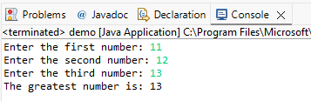

W.A.J.P in Java to display the first 10 natural numbers using while loop.
package basic;
import java.util.Scanner;

public class Assignment {

public static void main(String[] args) { int i = 1;
System.out.println("The first 10 natural numbers are:"); while (i <= 10) {
System.out.println(i); i++;
}
}
}

OUTPUT:
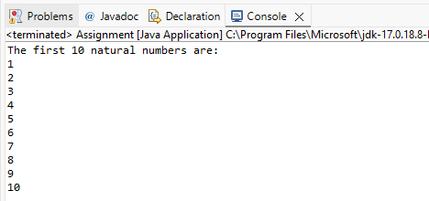

W.A.J.P to find factorial for Given Number.
package basic;
import java.util.Scanner;
public class Factorial {

public static void main(String[] args) {

Scanner sc = new Scanner(System.in);
System.out.print("Enter a number to find its factorial: ");
int number = sc.nextInt();
long factorial = 1;
for (int i = 1; i <= number; i++) {
factorial *= i;
}
System.out.println("Factorial of " + number + " is: " + factorial);

sc.close();
}
}

OUTPUT:
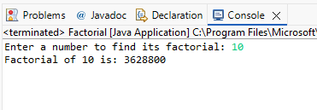

W.A.J.P to check given number is Prime or not?
package basic;
import java.util.Scanner;
public class PrimeCheck {

public static void main(String[] args) {

Scanner sc = new Scanner(System.in);
System.out.print("Enter a number to check if it is prime: ");
int num = sc.nextInt();
int count = 0;
for (int i = 1; i <= num; i++) {

if (num % i == 0) {
count++;
}
}
if (count == 2) {
System.out.println(num + " is a Prime Number.");
}
else {
System.out.println(num + " is NOT a Prime Number.");
}
sc.close();
}
}

OUTPUT:
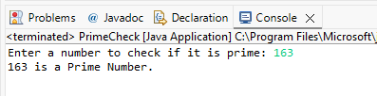
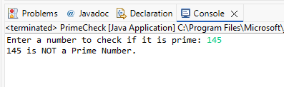

W.A.J.P to check given number is Armstrong or not?
package basic;
import java.util.Scanner;
public class ArmstrongCheck {

public static void main(String[] args) {

Scanner sc = new Scanner(System.in);
System.out.print("Enter a number to check if it is an Armstrong number: ");
int num = sc.nextInt();
int sum = 0;
int tmp = num;
while (num > 0) {

int digit = num % 10;
sum = sum + (digit * digit * digit);
num = num / 10;
}

if (sum == tmp) {
System.out.println(tmp + " is an Armstrong number.");
}
else {
System.out.println(tmp + " is NOT an Armstrong number.");
}

sc.close();
}
}

OUTPUT:
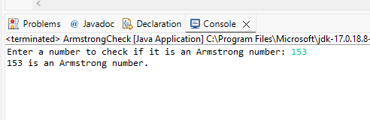

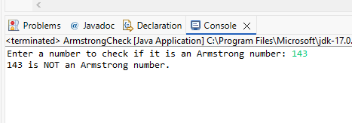

W.A.J.P for create Fibonacci Series.
package basic;
import java.util.Scanner;
public class FibonacciSeries {

public static void main(String[] args) {

Scanner sc = new Scanner(System.in);
System.out.print("Enter number of terms for Fibonacci series: ");
int n = sc.nextInt();
int a = 0, b = 1;
System.out.println("Fibonacci Series up to " + n + " terms:");
for (int i = 1; i <= n; i++) {
System.out.print(a + " ");
int c = a + b;
a = b;
b = c;
}
sc.close();
}
}

OUTPUT:
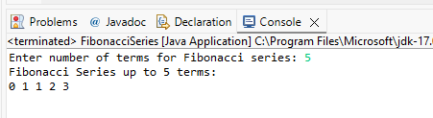

W.A.J.P to Print pattern Given Below.
  - Pattern-1
package basic;

public class IncrementNumberPattern {

public static void main(String[] args) {

for (int i = 1; i <= 5; i++) {
for (int j = 1; j <= i; j++) {
System.out.print(j);
}
System.out.println();
}
}
}

OUTPUT:
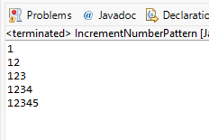

Pattern-2
package basic;

public class RepeatedRowNumberPattern {

public static void main(String[] args) {

for (int i = 1; i <= 5; i++) {
for (int j = 1; j <= i; j++) {
System.out.print(i + " ");
}
System.out.println();
}
}
}
OUTPUT:
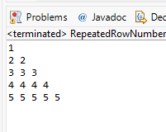

  - Pattern-3
package basic;
public class BinaryPattern {

public static void main(String[] args) {

for (int i = 1; i <= 5; i++) {
for (int j = 1; j <= i; j++) {
if ((i + j) % 2 == 0) {
System.out.print("1");
}
else {
System.out.print("0");
}
}
System.out.println();
}
}
}
OUTPUT:
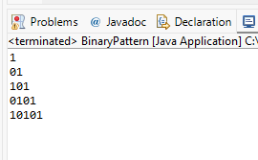

Pattern-4
package basic;

public class RightTriangleNumberPattern {

public static void main(String[] args) {

for (int i = 1; i <= 4; i++) {
for (int space = 1; space <= 4 - i; space++) {
System.out.print(" ");
}
for (int j = 1; j <= i; j++) {
System.out.print(i + " ");
}
System.out.println();
}
}
}

OUTPUT:
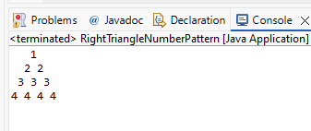

Pattern-5
package basic;

public class StarDiamondPattern {

public static void main(String[] args) {

// Upper Part
for (int i = 1; i <= 3; i++) {
for (int space = 1; space <= 3 - i; space++) {
System.out.print(" ");
}
for (int star = 1; star <= (2 * i - 1); star++) {
System.out.print("* ");
}
System.out.println();
}

// Lower Part
for (int i = 2; i >= 1; i--) {
for (int space = 1; space <= 3 - i; space++) {
System.out.print(" ");
}
for (int star = 1; star <= (2 * i - 1); star++) {
System.out.print("* ");
}
System.out.println();
}
}
}

OUTPUT:
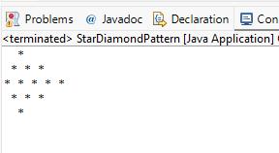

WAP to compute the sum of the first 100 prime numbers.
package basic;

public class SumOfPrimes {

public static void main(String[] args) {
int sum = 0;

System.out.println("Prime numbers from 1 to 100 are:");
for (int num = 2; num <= 100; num++) {
int count = 0;
for (int i = 1; i <= num; i++) {
if (num % i == 0) {
count++;
}
}
if (count == 2) {
System.out.print(num + " ");
sum = sum + num;
}
}
System.out.println("\n\nSum of prime numbers from 1 to 100 is: " + sum);
}
}

OUTPUT:

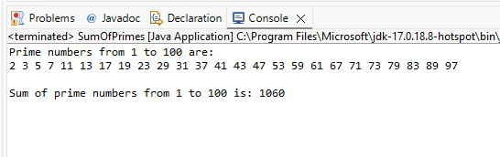

WAP to sum values of an array.
package basic;

public class SumOfArray {

public static void main(String[] args) {

int[] a = {10, 20, 30, 40, 50};
int sum = 0;
for (int i = 0; i < a.length; i++) {
sum = sum + a[i];
}
System.out.println("Sum of array elements is: " + sum);
}
}

OUTPUT:
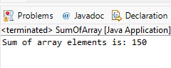

WAP to calculate the average value of array elements.
package basic;
public class AverageOfArray {
public static void main(String[] args){
int[] a = {10, 20, 30, 40, 50, 60};
int sum = 0;
for (int i = 0; i < a.length; i++){
sum = sum + a[i];
double avg = (double) sum / a.length;
System.out.println("Average of array elements is: " + avg);
}
}
OUTPUT:

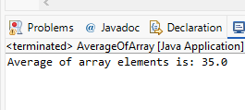

WAP to find the index of an array element.
package basic;

public class FindIndexInArray {

public static void main(String[] args) {
int[] a = {10, 20, 30, 40, 50};
int number = 10;
for (int i = 0; i < a.length; i++) {
if (a[i] == number) {
System.out.println(number + " is at index " + i);
}
}
}
}

OUTPUT:
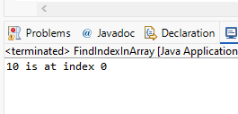

WAP to find the maximum and minimum value of an array.
package basic;

public class MaximumMinimumArray {

public static void main(String[] args) {
int[] numbers = {25, 78, 12, 90, 3, 55};
int max = numbers[0];
int min = numbers[0];
for (int i = 1; i < numbers.length; i++) {
if (numbers[i] > max) {
max = numbers[i];
}
if (numbers[i] < min) {
min = numbers[i];
}
}
System.out.println("Maximum number is: " + max);
System.out.println("Minimum number is: " + min);
}
}

OUTPUT:
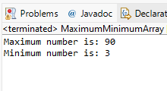

WAP to Compare Two String.
package basic;
import java.util.Scanner;
public class StringCompare {

public static void main(String[] args) {

Scanner sc = new Scanner(System.in);
System.out.print("Enter first string: ");
String str1 = sc.nextLine();
System.out.print("Enter second string: ");
String str2 = sc.nextLine();
if (str1.equals(str2)) {
System.out.println("Both strings are equal.");
}
else {
System.out.println("Both strings are not equal.");
}
sc.close();
}
}

OUTPUT:
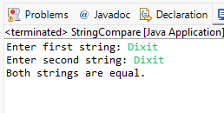

14. WAP to concatenate a given string to the end of another string.
package basic;
import java.util.Scanner;
public class StringConcatenation {

public static void main(String[] args) {
Scanner sc = new Scanner(System.in);
System.out.print("Enter first string: ");
String str1 = sc.nextLine();
System.out.print("Enter second string: ");
String str2 = sc.nextLine();
String result = str1 + str2;
System.out.println("Concatenated String is: " + result);
sc.close();
}
}

OUTPUT:
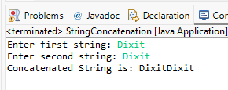

WAP to demonstrate try catch block.
package basic;
public class TryCatchExample {

public static void main(String[] args) {
try {
int a = 10;
int b = 0;
int result = a / b;
System.out.println("Result is: " + result);
}
catch (ArithmeticException e) {
System.out.println("Cannot divide by zero.");
}
System.out.println("Rest of code...");
}
}

OUTPUT:
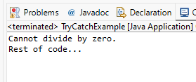

15) WAP to demonstrate multiple catch blocks.
package basic;
public class MultipleCatchExample {

public static void main(String[] args) {
int[] arr = new int[5];
try {
arr[5] = 10;
System.out.println("Hello");
}
catch (ArithmeticException e) {
System.out.println("Arithmetic Error: " + e);
}
catch (Exception e) {
System.out.println("Exception Error: " + e);
}
System.out.println("Rest of code...");
}
}

OUTPUT:

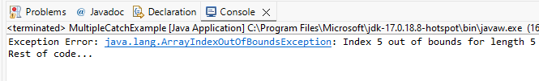

- WAP to create one thread by implementing Runnable interface in Class.
package basic;

public class RunnableThreadDemo implements Runnable {

public void run() {

System.out.println("Runnable Thread is Running...");
}

public static void main(String[] args) {

RunnableThreadDemo t1 = new RunnableThreadDemo();

Thread thread = new Thread(t1);

thread.start();
}
}

OUTPUT:
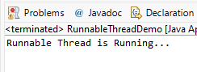
- WAP to create one thread by extending Thread class in another Class.
package basic;

public class ThreadClassDemo extends Thread {

public void run() {

System.out.println("Threaddemo is Running...");
}

public static void main(String[] args) {

ThreadClassDemo t1 = new ThreadClassDemo();

t1.start();
}
}

OUTPUT:
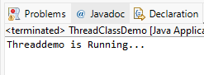

WAP to iterate through all elements in an array list.
package basic;
import java.util.ArrayList;
public class ArrayListExample {

public static void main(String[] args) {
ArrayList<String> fruits = new ArrayList<>();
fruits.add("Apple");
fruits.add("Banana");
fruits.add("Mango");
fruits.add("Orange");
System.out.println("Fruit List:");
for (String fruit : fruits) {
System.out.println(fruit);
}
}
}

OUTPUT:
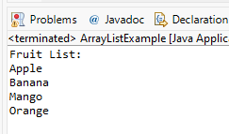

WAP to update specific array element by given element.
package basic;
import java.util.Scanner;
public class UpdateArray {

public static void main(String[] args) {
int[] numbers = {10, 20, 30, 40, 50};
Scanner sc = new Scanner(System.in);
System.out.print("Enter index to update: ");
int index = sc.nextInt();
if (index < 0 || index >= numbers.length) {
System.out.println("Invalid Index!");
}
else {
System.out.print("Enter new value: ");
int newValue = sc.nextInt();
System.out.println("Before Update:");
for (int num : numbers) {
System.out.print(num + " ");
}
numbers[index] = newValue;
System.out.println("\nAfter Update:");
for (int num : numbers) {
System.out.print(num + " ");
}
}

sc.close();
}
}

OUTPUT:
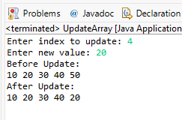

WAP to remove the third element from an array list.
package basic;
import java.util.ArrayList;
public class RemoveElement {

public static void main(String[] args) {
ArrayList<String> animals = new ArrayList<>();
animals.add("Cow");
animals.add("Dog");
animals.add("Cat");
animals.add("Lion");
System.out.println("Before Remove: " + animals);
animals.remove(2);
System.out.println("After Remove: " + animals);
}
}

OUTPUT:
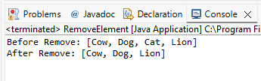

WAP to Copy one array into another.
package basic;
public class CopyArray {
public static void main(String[] args) {

int[] a = {10, 20, 30, 40, 50};
int[] b = new int[a.length];
for (int i = 0; i < a.length; i++) {
b[i] = a[i];
}
System.out.print("Original Array: ");
for (int num : a) {
System.out.print(num + " ");
}
System.out.print("\nCopied Array: ");
for (int num : b) {
System.out.print(num + " ");
}
}
}

OUTPUT:
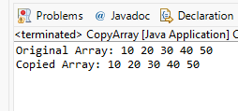

WAP to reverse an array of integer values.
package basic;
public class ReverseArray {

public static void main(String[] args) {
int[] a = {10, 20, 30, 40, 50};
System.out.println("Reverse Array:");
for (int i = a.length - 1; i >= 0; i--) {
System.out.print(a[i] + " ");
}
}
}

OUTPUT:
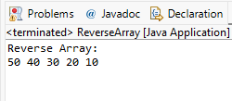

WAP to find the second largest element in an array.
package basic;

public class SecondLargestNumber {

public static void main(String[] args) {

int[] arr = {45, 22, 89, 65, 12};

int largest = arr[0];
int second = arr[0];

for (int i = 1; i < arr.length; i++) {

if (arr[i] > largest) {

largest = arr[i];
}
}

for (int i = 0; i < arr.length; i++) {

if (arr[i] > second && arr[i] < largest) {

second = arr[i];
}
}

System.out.println("Second Largest Number is: " + second);
}
}

OUTPUT:
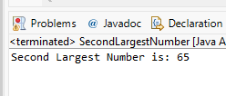

W.A.J.P. Create an abstract class 'Parent' with a method 'message'. It has two subclasses each having a method with the same name 'message' that prints "This is first subclass" and "This is second subclass" respectively. Call the methods 'message' by creating an object for each subclass.
package basic;

abstract class Parent {

abstract void message();
}

class FirstChild extends Parent {

void message() {

System.out.println("This is first subclass.");
}
}

class SecondChild extends Parent {

void message() {

System.out.println("This is second subclass.");
}
}

public class AbstractDemo {

public static void main(String[] args) {

Parent p1 = new FirstChild();

Parent p2 = new SecondChild();

p1.message();

p2.message();
}
}

OUTPUT:
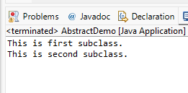
- W.A.J.P. which will ask the user to enter his/her marks (out of 100). Define a method that will display grades according to the marks entered as below:
Marks Grade
91-100 AA
81-90 AB
71-80 BB
61-70 BC
51-60 CD
41-50 DD
< = 40 Fail
package basic;

import java.util.Scanner;

public class GradeCalculator {

static void displayGrade(int marks) {

if (marks >= 91 && marks <= 100) {

System.out.println("Grade: AA");
}

else if (marks >= 81) {

System.out.println("Grade: AB");
}

else if (marks >= 71) {

System.out.println("Grade: BB");
}

else if (marks >= 61) {

System.out.println("Grade: BC");
}

else if (marks >= 51) {

System.out.println("Grade: CD");
}

else if (marks >= 41) {

System.out.println("Grade: DD");
}

else {

System.out.println("Fail");
}
}

public static void main(String[] args) {

Scanner sc = new Scanner(System.in);

System.out.print("Enter Marks: ");

int marks = sc.nextInt();

displayGrade(marks);

sc.close();
}
}
OUTPUT:
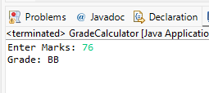

W.A.J.P. to create a custom exception if Customer withdraw amount which is greater than account balance then program will show custom exception otherwise amount will deduct from account balance. Account balance is:2000 Enter withdraw amount:2500 Sorry, insufficient balance, you need more 500 Rs. To perform this transaction.
package basic;

import java.util.Scanner;

class InsufficientBalanceException extends Exception {

InsufficientBalanceException(int amount) {

super("Insufficient Balance. Need Extra " + amount + " Rs.");
}
}

public class BankAccountDemo {

public static void main(String[] args) {

int balance = 2000;

Scanner sc = new Scanner(System.in);

System.out.println("Current Balance: " + balance);

System.out.print("Enter Withdraw Amount: ");

int withdraw = sc.nextInt();

try {

if (withdraw > balance) {

int shortage = withdraw - balance;

throw new InsufficientBalanceException(shortage);
}

else {

balance = balance - withdraw;

System.out.println("Transaction Successful.");

System.out.println("Remaining Balance: " + balance);
}
}

catch (InsufficientBalanceException e) {

System.out.println(e.getMessage());
}

sc.close();
}
}

OUTPUT:
