Programs Priority,java and client_program.java has been attached.

Outputs:

1. Eneque:

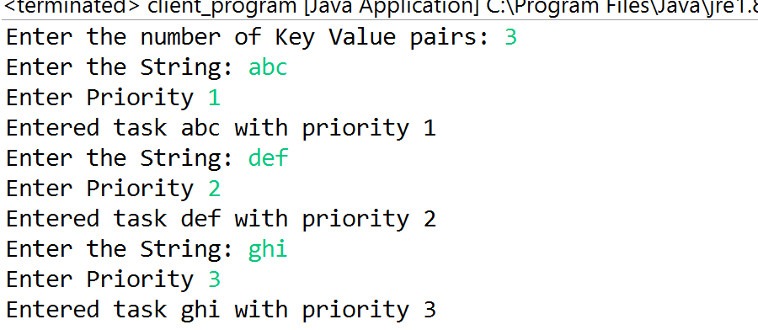

2. Deque:



3. Compare:



4. Cloning:

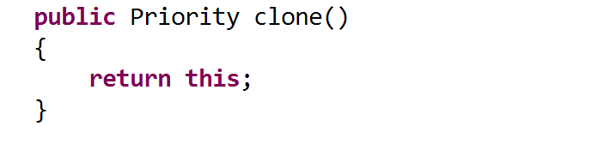

5. toString:

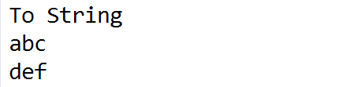

6. HashCode:

