1. Install Python.

2. Install nltk package

pip install nltk

3. Upgrade all elements of nltk.

nltk.download()

4. Install textblob for sentiment analysis.

pip install textblob

5. Install twitter api.

pip install tweepy

5. Run create_directories.bat to create directories.

6. Run data_collection.py to collect data (If you want to create new data file .skip this step to find results from data set extracted by us.

7. Run sentiment_overall.py to find overall sentiments.

8. Run sentiment_india.py to find sentiments in India.

9. Run sentiment_ny.py to find sentiments in NY.

10. Run sentiment_price.py to find sentiments for price.

11. Run sentiment_screen.py to find sentiments for screen.

12. Run sentiment_color.py to find sentiments for color.

13. To visualize, download WEKA.

14. From WEKA Explorer, select open file and select directory Desktop\project_python\Submission\Overall.

Note: In this double click on Desktop then project_python then Submission and click onve on Overall. Then click on open.

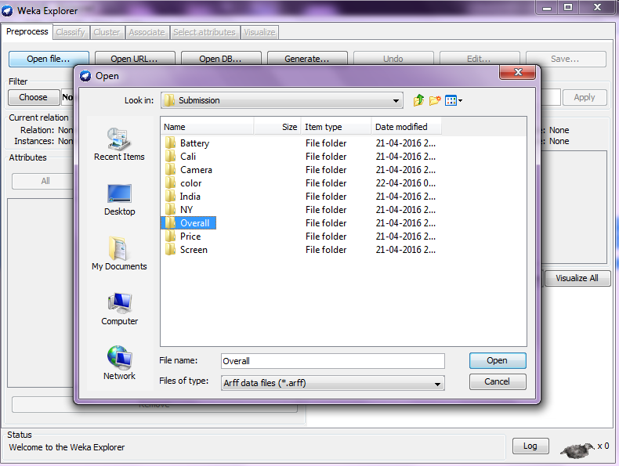

15. It will say cannot determine file loader automatically

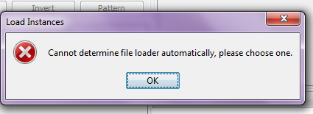

then click ok and choose Textdirectoryloader.

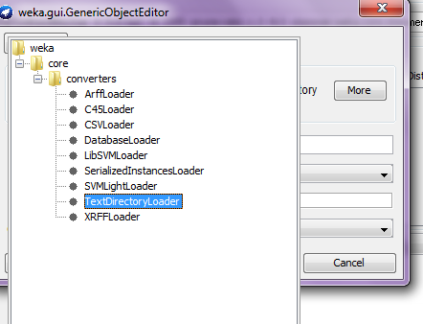

16. Apply filter weka->filters->unsupervised->attribute->stringtowordvector filter and then apply it.

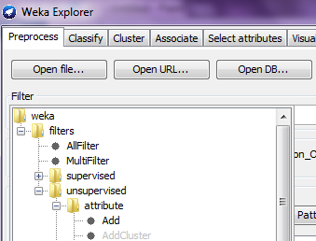

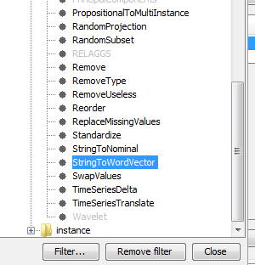

17. You will see the results.

18. Choose classifier Naïve Bays multinomial and see the results

19 Repeat steps from 13 to 18 for viewing results for price, screen and colour by selecting folders price, screen and colour respectively.