**A**

Synopsis

On

**Digital Clock(Smart Watch)**

Submitted in partial fulfilment of the requirement for the award of

Bachelor of Technology

In

**COMPUTER SCIENCE & ENGINEERING**

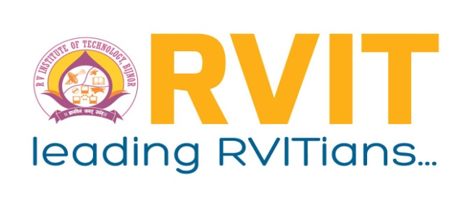

**Submitted by**

Deepanshu Haritwal Roll No. 1905010100008

Vicky Giri Roll No. 1905010100038

Vansh Dixit Roll No. 1905010100037

Ramit Kumar Dixit Roll No. 1905010100024

**Under the Guidance of**

Mr. Himanshu Goel (Head of Department of CSE)

Mr. Deepak Chauhan (Assistant Professor)

**RV INSTITUTE OF TECHNOLOGY, BIJNOR**

**Affiliated to AKTU, Lucknow**

**2022-23**

**INTRODUCTION**

A Digital Clock is an alternative to a traditional analogue clock. This type of clock shows number to display the time in a digital format, such as on a watch ,phone or an alarm clock. This can be in both 12 and 24-hour formats.

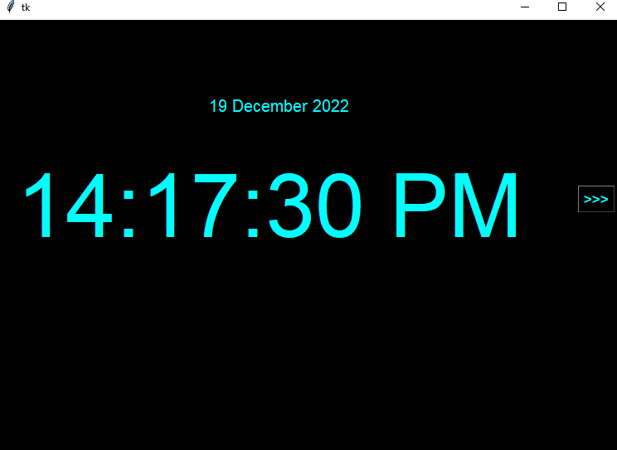

**(Digital Clock)**

**Functionalities what added:**

* Alarm Clock
* Music Player
* Calculator
* Image Viewer

**Functionalities what will be added:**

* Sound Recorder
* Browsing
* Speech to text
* Voice Assistant

**Software used:**

* Vs code(IDE)
* Python 3.11.0
* Pycharm(Python IDE)

# 