Global Cost of Living Comparison and Relocation Analytics System

1. Project Overview
The project implements a database system for comparing living costs, salaries and affordability across cities and countries. It contains two PostgreSQL databases: coursework_oltp for current data and coursework_olap for analytical snapshots. SQL scripts load the data, calculate the measures and prepare them for a Power BI report.
The source is the Kaggle Global Cost of Living dataset:
https://www.kaggle.com/datasets/mvieira101/global-cost-of-living
Technology stack: PostgreSQL, SQL, Python with pandas, CSV and Microsoft Power BI.

2. Source Data and CSV Preparation
The source archive cost-of-living.csv.zip contains city and country names, a data-quality flag and 55 cost indicators (x1–x55). The script scripts/0_prepare_csv_from_zip.py converts the source into five CSV files that match the OLTP model. Surrogate database identifiers are intentionally excluded from CSV.
CSV file | Rows | Purpose
countries.csv | 204 | Unique countries
cities.csv | 4,874 | Cities, countries and data-quality codes
cost_items.csv | 55 | Cost indicators, units and categories
city_cost_values.csv | 222,981 | City-level values converted from wide to long format
user_favorite_cities.csv | 375 | Synthetic favourites for 250 application users
CSV files use natural keys: country name, the city and country pair, item code and user email. Missing cost values are skipped and zero values are preserved. Duplicate city and country pairs are rejected. Prices and salaries are in USD; x55 is an interest rate in percent. The users and favourites are generated sample data.

3. OLTP Database
The oltp schema in coursework_oltp stores countries, cities, cost indicators, users and favourite cities. Each price belongs to one city and one cost item.
Table | Purpose | Main keys and constraints
countries | Country reference data | PK country_id; UNIQUE country_name
data_quality_levels | Meaning of source quality codes | PK data_quality_code; allowed values 0 and 1
cost_categories | Groups of cost indicators | PK category_id; UNIQUE category_name
cities | Cities belonging to countries | PK city_id; FK to country and quality; UNIQUE city and country
cost_items | Definitions of x1–x55 | PK item_id; UNIQUE item_code; FK to category
city_cost_values | Cost value for a city and item | PK city_cost_value_id; FKs city_id and item_id; UNIQUE (city_id, item_id); value >= 0
app_users | Application users | PK user_id; UNIQUE user_email
user_favorite_cities | User-to-city favourites | Composite PK and FKs user_id, city_id
Main relationships are one country to many cities, one category to many cost items, one city to many cost values and one item to many cost values. Users and cities have a many-to-many relationship implemented through user_favorite_cities.
The schema separates attributes according to their dependencies. A country ID determines the country name; an item ID determines its name, unit and category; a city and item pair determines the price. Country and category names are stored in their own tables. This avoids repeating them in every price row and keeps the tables in Third Normal Form.
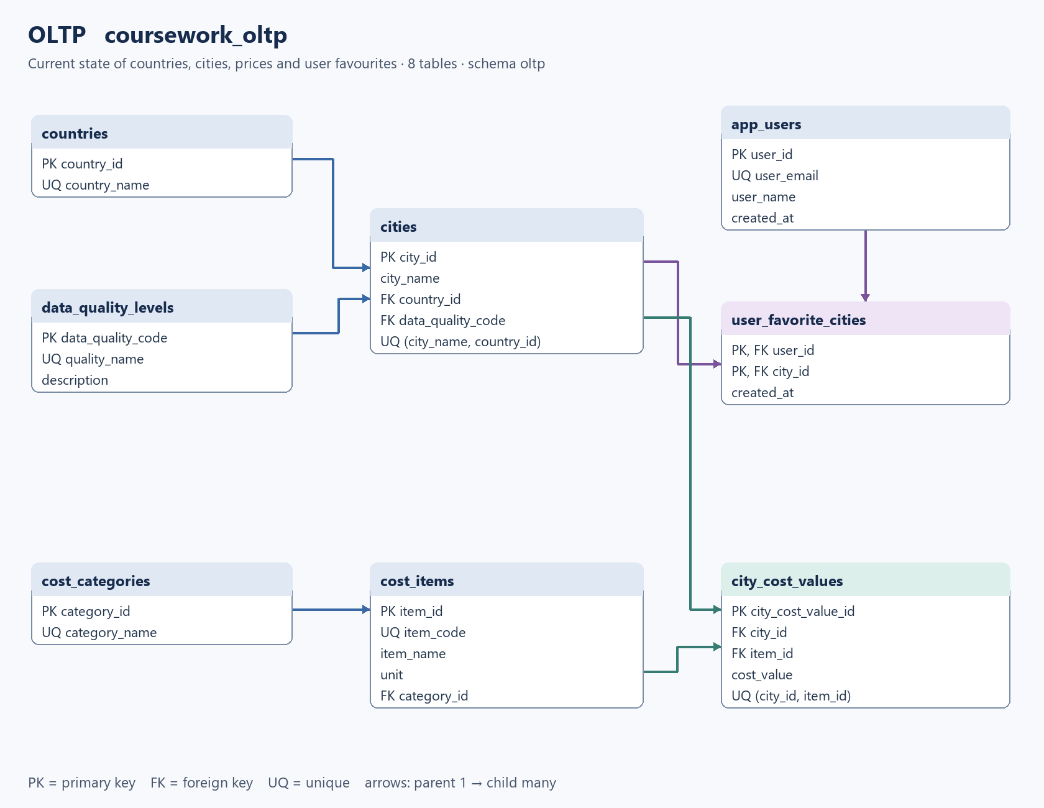
OLTP logical schema

4. OLAP Database
The olap schema is stored in the separate database coursework_olap. It uses a snowflake model with seven dimensions, two fact tables and a bridge table. The postgres_fdw extension exposes six OLTP tables through source_oltp; the ETL reads those tables and writes the analytical data.

4.1 Analytical Questions
- Which cities have the highest salary-to-cost ratio?
- How do salary, rent and the monthly budget differ by city and country?
- Which cities are budget-friendly, high-salary or premium locations?
- How does average affordability vary between countries?
- How do city analytical tiers change between snapshots?

4.2 OLAP Tables
Table | Type | Purpose or grain
dim_country | Dimension | One row per country
dim_data_quality | Dimension | One row per quality code
dim_cost_category | Dimension | One row per cost category
dim_cost_item | Snowflaked dimension | Cost item linked to its category
dim_date | Dimension | Snapshot date, year, quarter and month
dim_city_scd | SCD Type 2 dimension | Historical city analytical profile
dim_lifestyle_tag | Dimension | Lifestyle classification definitions
bridge_city_lifestyle_tag | Bridge | One snapshot date, city version and lifestyle tag
fact_city_cost | Fact | One cost item, city version and snapshot date
fact_affordability_snapshot | Aggregate fact | One city version and snapshot date; salary and budget measures
Facts refer to OLAP dimension keys. The city dimension has a separate city_key for each historical version and retains the source city_id. The date key is the snapshot date in YYYYMMDD form. Unique constraints enforce the grain shown above.
dim_city_scd stores valid_from, valid_to and is_current. A later snapshot creates a new version when the city name, country, quality or one of its three tiers changes. The old version ends on the previous day. A correction on the version start date updates that row in place. A price change within the same tiers updates the facts without creating a city version.
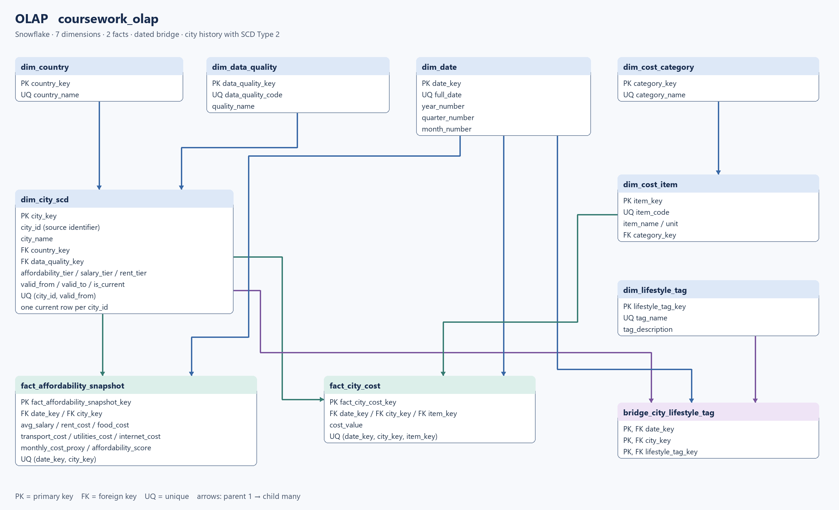
OLAP snowflake logical schema

4.3 Analytical Measures
The salary measure uses x54. Rent uses x49, the price of a one-bedroom flat outside the centre, or x48 if x49 is missing. The monthly food basket uses eight products: x9 × 8, x10 × 8, x11 × 2, x12 × 2, x13 × 1, x14 × 4, x16 × 4 and x20 × 4. Transport uses x29, utilities x36 and internet x38.
monthly_cost_proxy = rent_cost + food_cost + transport_cost
+ utilities_cost + internet_cost
affordability_score = avg_salary / monthly_cost_proxy
Food cost is calculated only when all eight product prices are available. A missing budget component leaves the total as NULL; missing salary or a zero budget leaves affordability as NULL. The basket is an estimate of selected monthly expenses. For example, utilities refer to an 85 m² flat, while rent refers to a one-bedroom flat.
Affordability tiers are high from 2.5, medium from 1.5 and low below 1.5. Salary tiers use 3,000 and 1,500 USD; rent tiers use 1,500 and 700 USD. Missing values receive the unknown tier.
The bridge assigns budget_friendly when affordability is at least 1.5, high_salary from 3,000 USD salary, expensive_housing from 1,500 USD rent, and reliable_data for quality code 1. premium_city requires both the high salary and high rent thresholds. A city can have several tags on the same date.

5. Loading and ETL Instructions

5.1 Prerequisites
- PostgreSQL is installed and psql is available in PATH.
- The PostgreSQL user can create databases and configure postgres_fdw.
- Python 3 and pandas are needed only to regenerate the supplied CSV files.
- All five prepared CSV files are present in the data folder.
- Commands are executed from the project root in PowerShell.

5.2 Execution Order
powershell -NoProfile -ExecutionPolicy Bypass `
-File .\scripts\run.ps1
The script runs SQL files 0, 1, 2, 3, 3a, 4 and 5 in order. It uses localhost:5432 and user postgres by default. The password comes from PGPASSWORD, the local password file, or an interactive prompt. Optional queries can then be run against the corresponding database:
psql -U postgres -d coursework_oltp `
-f sql/6_oltp_queries.sql
psql -U postgres -d coursework_olap `
-f sql/7_olap_queries.sql

5.3 Rerun Behaviour
The OLTP loader reads all five CSV files into temporary staging tables and validates their keys, values and references. New rows are inserted; changed values are updated with ON CONFLICT DO UPDATE. IS DISTINCT FROM avoids rewriting unchanged rows. Rows absent from the full CSV snapshot are deleted. Each CSV load and each OLAP ETL run has its own transaction; a failure rolls back that stage.
The CSV input must remain a complete dataset. Replacing the price file with only the changed rows would delete the omitted prices. Changes made directly in OLTP are replaced by the CSV values on the next full run.
The default snapshot date is the current date. Repeating the latest date corrects that snapshot; a later date adds a snapshot, and an earlier date is rejected. Older facts remain when a city disappears. Snapshot dates record when ETL ran, not when the source prices were observed. A city rename is treated as a new city because the source has no permanent city identifier.

6. Power BI Report
The report file is power_bi_report.pbix. It imports three tables from the olap schema:
- dim_country
- dim_city_scd
- fact_affordability_snapshot
Two one-to-many relationships link country to city and city to the affordability fact. Filters flow in that direction. Power Query selects current city versions and the latest fact snapshot. The three SQL views remain available for the insight queries.
The single report page has country and city slicers, three cards for affordability, salary and monthly budget, and three charts: affordability by city, salary versus budget, and rent versus other budget costs. DAX calculates averages for the selected cities. Average affordability is the mean of city ratios, not the ratio of average salary to average budget. AVERAGE ignores missing values, so the measures may cover different sets of cities.
After a successful database load, Refresh in Power BI imports the latest results. Refresh does not run the SQL loading scripts. The saved report can display its imported data before a connection is established.

7. Insight Queries
sql/6_oltp_queries.sql contains four operational analytical queries:
- Top 20 cities by average monthly salary.
- Average value of each cost item by country, with the number of available observations.
- Most frequently favourited cities.
- Number of cities by country and data-quality level.
sql/7_olap_queries.sql contains four DWH queries:
- Top 20 cities by affordability score.
- Average affordability and salary by country.
- Average affordability by country and snapshot date.
- City statistics grouped by lifestyle tag.

8. Project Deliverables
The project contains the source ZIP, five prepared CSV files, the Python preparation script, requirements.txt, the PowerShell runner, nine SQL scripts, two logical schema images, the Power BI report, this documentation and the run instructions.

