

|  |  |
| --- | --- |
|  | **BackgroundSystem** |
|  |  |
|  | Azure |
|  |  |
|  | Cloud Settings / Active Directory |
|  |  |
|  | Technical Description |
|  |  |
|  | Version: 1.0 |
|  | State: Released |
|  | Classification: Internal use only |
|  | Author: EPT |
|  | Creation date: 2015-06-03 |
|  | Repository: $/Gorba/Main/Center/BackgroundSystem/Documents/TD_BackgroundSystemAzureSettings.docx |
|  | Gorba AG  Sandackerstrasse  9245 Oberbüren  Switzerland |

**Table of contents**

1 Introduction 4

1.1 Scope 4

1.2 Intended Audience 4

2 Azure Cloud Settings 4

3 Portal using Https 5

3.1 Enable Https 5

3.2 Http redirection 5

4 Enable user authentication through Azure Active Directory 5

4.1 Register an application on the Azure Active Directory 5

**Modification management**

|  |  |  |  |  |  |
| --- | --- | --- | --- | --- | --- |
| **Version** | **Date** | **Name** | **Dept.** | **Modifications** | **State** |
| 0.1 | 03.06.2015 | EPT | SW | Initial draft | Draft |
| 0.2 | 18.06.2015 | LEF | SW | Updated list of settings. Added explanation about Https | Draft |

**Review**

|  |  |  |  |  |
| --- | --- | --- | --- | --- |
| **Version** | **Date** | **Name** | **Dept.** | **Remarks** |
| 0.2 | 16.09.2015 | EPT | SW | Fixed some typos |
|  |  |  |  |  |
|  |  |  |  |  |
|  |  |  |  |  |

**Release**

|  |  |  |  |  |
| --- | --- | --- | --- | --- |
| **Version** | **Date** | **Name** | **Dept.** | **Remarks** |
| 1.0 | 16.09.2015 | EPT | SW | 1st release |
|  |  |  |  |  |
|  |  |  |  |  |
|  |  |  |  |  |

# Introduction

## Scope

This document is a technical description of the Azure configuration part of the BackgroundSystem (BGS). It gives all information to Gorba internal people to be able to configure the BGS on an Azure portal.

This document is not intended to be a user manual.

## Intended Audience

This document is written to be understood by Gorba Software Development and Project Management. Skills with Azure management portal are needed.

# Azure Cloud Settings

The following table shows the settings that can be configured in the Azure management portal:

|  |  |
| --- | --- |
| **Parameter** | **Description** |
| BackgroundSystem.CenterDataContext | The connection string pointing to the SQL database on Azure |
| BackgroundSystem.NotificationsConnectionString | (optional) The connection string for medi. The default value is “medi://{HostName}” |
| BackgroundSystem.StartPortalHost | Value indicating if the portal should run on the same cloud service as the BGS |
| BackgroundSystem.Host | The host address for the BGS |
| Center.StorageConnectionString | The connection string for resource storage. e.g:  DefaultEndpointsProtocol=https;AccountName={Storage Account Name};AccountKey={Primary access key}. Both values can be found on  Azure portal -> Storage -> Manage Access Keys |
| ActiveDirectory.Tenant | (optional) The id of the Active Directory. This value can be found on the management portal going to the Active Directory. You can copy the GUID from the browser URL. (e.g. Url: https://manage.windowsazure.com/@{Subscription}#Workspaces/ActiveDirectoryExtension/Directory/**{Tenant}**/users) |
| ActiveDirectory.ClientId | (optional) The id of the client application registered in Active Directory. (See chapter 3.1) |
| ActiveDirectory.AuthorizationUrl | (optional) The URL that is used to authorize a user with the Active Directory. This value depends on the permissions set in the registered application.  The default value is “https://graph.windows.net/ |
| Portal.EnableHttps | Value indicating whether https is enabled for the gorba portal. If enabled, all simple http requests will be redirected to secure scheme |
| Wcf.ConnectionLimit | Maximum amount of open WCF connections |
| Portal.ClickOnceUseBeta | Value indicating whether the portal should provide the links to the Beta versions (true) or the official version (false) |
| Diagnostics.LogLevel | Inclusive minimum level for logging. All NLog levels are valid. |

# Portal using Https

This chapter is relevant only when you decide to run the Portal within the same cloud service setting the “BackgroundSystem.StartPortalHost” flag to **True**.

## Enable Https

Https can be enabled setting the Azure setting “Portal.EnableHttps” to **True**.

## Http redirection

When Https is enabled, every request[1] is automatically redirected to the equivalent Https url.

# Enable user authentication through Azure Active Directory

This chapter explains the needed steps to enable the user authentication for the client applications (icenter.admin, icenter.media, icenter.diag) through Azure Active Directory.

**Attention: The following part must be done by an Azure Active Directory administrator!**

## Register an application on the Azure Active Directory

The first thing to do is to register an application on the Azure Active Directory and give permissions to access the directory.

* Login on the management portal
* Go to ActiveDirectory and choose the tab “Applications”

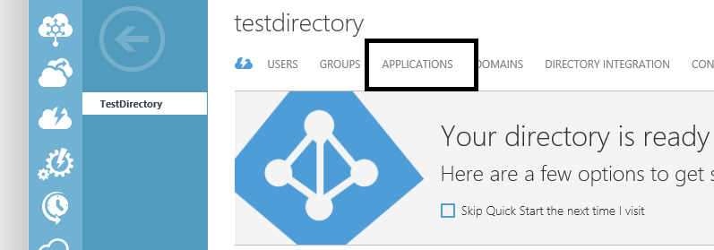

* Click on “Add” on the bottom bar and choose “Add an application my organization is developing”
* Enter a name and choose “Native client application”
* On the next page enter a redirect URL. This value is never used so just enter “https://{a path} (e.g. https://gorba.backgroundsystem).
* On the “Configure” tab of the newly created application you can find the ClientId which is mentioned in chapter 2

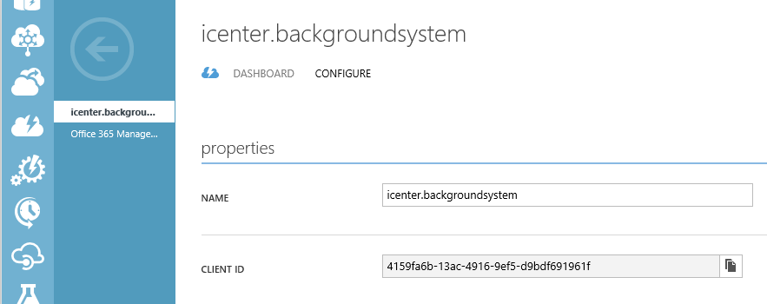

* Scroll down the “Configure” tab to “permissions to other applications” and enable the following Delegated Permissions of the application “Windows Azure Active Directory”:

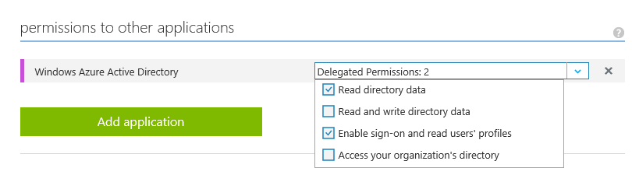

1. ClickOnce requests are not affected