

|  |  |
| --- | --- |
|  | **icenter** |
|  |  |
|  | Portal |
|  |  |
|  | Installing the client certificate |
|  |  |
|  | Technical Description |
|  |  |
|  | Version: 1.0 |
|  | State: Released |
|  | Classification: Internal use only |
|  | Author: LEF |
|  | Creation date: 2015-01-29 |
|  | Repository: |
|  | Gorba AG  Sandackerstrasse  9245 Oberbüren  Switzerland |

**Table of contents**

1 Introduction 4

2 Get the certificate 4

3 Procedure 4

**Modification management**

|  |  |  |  |  |  |
| --- | --- | --- | --- | --- | --- |
| **Version** | **Date** | **Name** | **Dept.** | **Modifications** | **State** |
| 0.1 | 29.01.2015 | LEF | SW | Initial draft | Draft |

**Review**

|  |  |  |  |  |
| --- | --- | --- | --- | --- |
| **Version** | **Date** | **Name** | **Dept.** | **Remarks** |
| 0.1 | 29.01.2015 | EPT | SW | “Repaired” table of contents |
|  |  |  |  |  |
|  |  |  |  |  |
|  |  |  |  |  |

**Release**

|  |  |  |  |  |
| --- | --- | --- | --- | --- |
| **Version** | **Date** | **Name** | **Dept.** | **Remarks** |
| 1.0 | 29.01.2015 | LEF | SW | First release |
|  |  |  |  |  |
|  |  |  |  |  |
|  |  |  |  |  |

# Introduction

This document provides the procedure to install a certificate on a Windows machine.

# Get the certificate

Get the icenter-dev.gorba.com.cer file from source control ($/Gorba/Main/Center/BackgroundSystem/Deploy/Source/Certificates/icenter-dev.gorba.com.cer)

Install the certificate

# Procedure

Start the Microsoft Management Console:

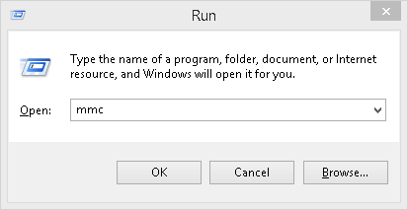

Select ***Add/Remove Snap-in…*** from the *File* menu

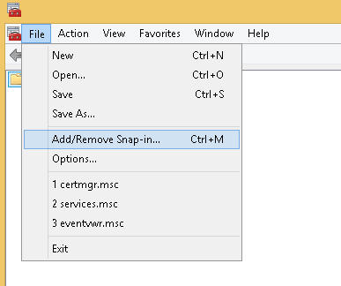

Double click the **Certificates** snap-in

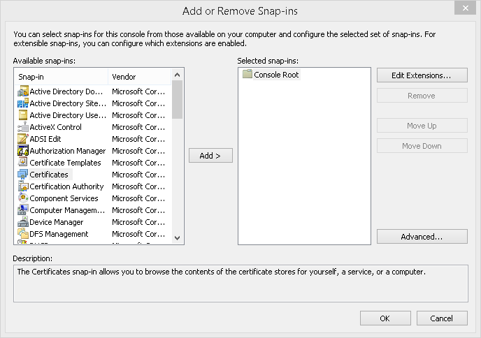

Select **Computer account** and click *Next*

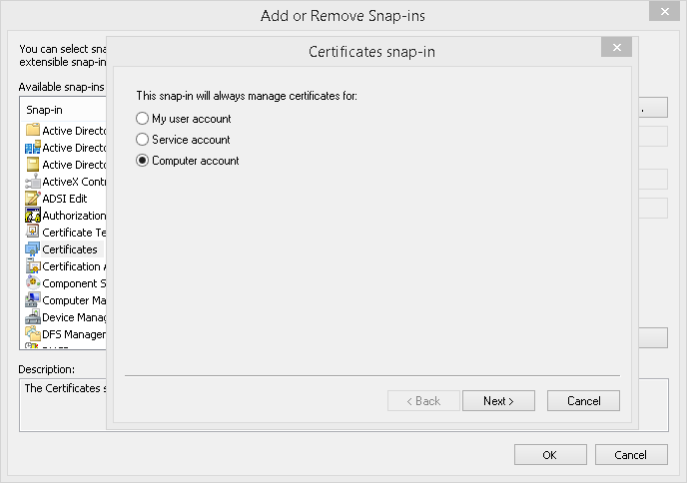

Select **Local computer** and click Finish

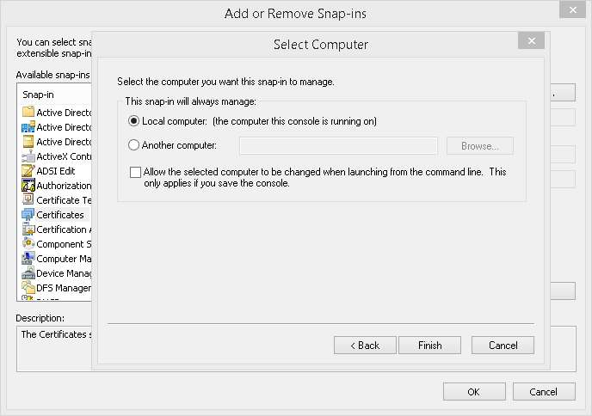

Click *Ok* to close the dialog

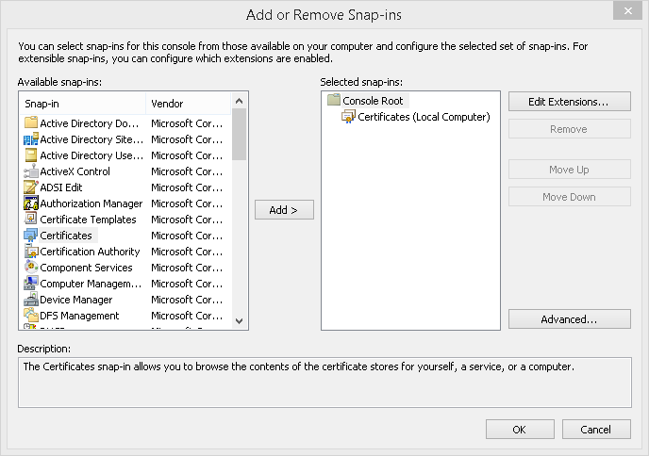

Right Click *Certificates (Local Computer)\Trusted Root Certification Authorities* and select *All Tasks\Import…*

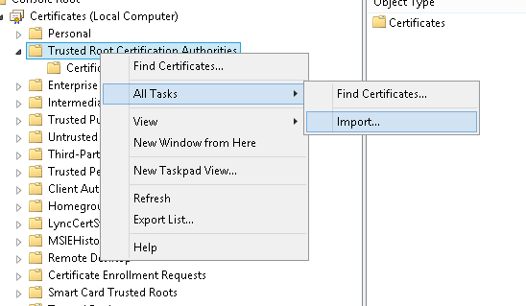

Verify that the *Store Location* is set to **Local Machine** and click *Next*

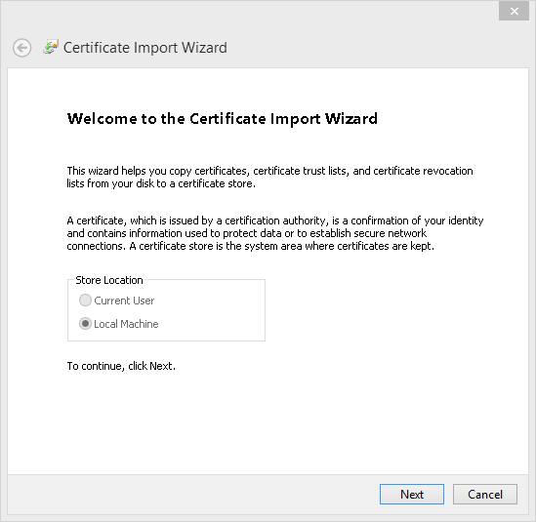

Select the certificate to import with the *Browse…* button/dialog and click *Next*

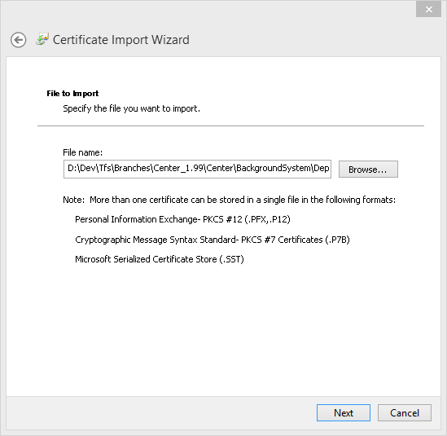

Select *Place all certificates in the following store* and with the *Browse…* button and its dialog select **Trusted Root Certification Authorities**

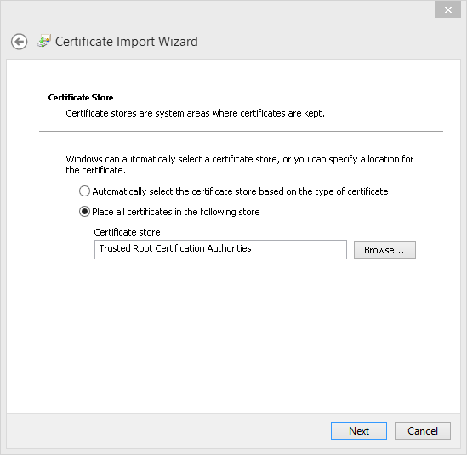

Verify the information and click *Finish*

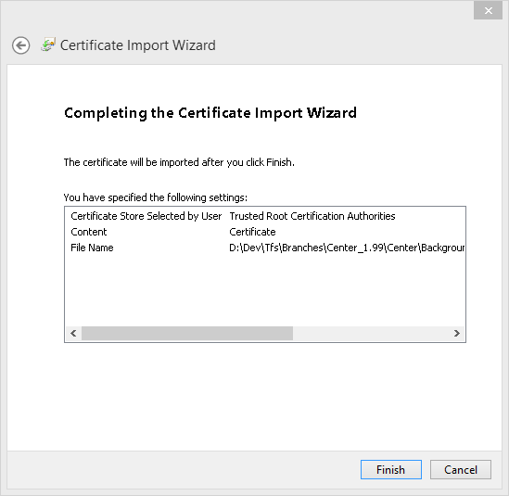

Click Finish. A dialog should confirm the successful import.

