

|  |  |
| --- | --- |
|  | **icenter** |
|  |  |
|  | BackgroundSystem |
|  |  |
|  | How to setup ServiceBus on server |
|  |  |
|  | Technical Description |
|  |  |
|  | Version: 1.0 |
|  | State: Released |
|  | Classification: Internal use only |
|  | Author: LEF |
|  | Creation date: 2015-01-29 |
|  | Repository: TFS $/Gorba/Branches/Center_1.99/Center/BackgroundSystem/Documents/icenter-dev.gorba.com/TD_HowToSetupServiceBusOnServer.docx |
|  | Gorba AG  Sandackerstrasse  9245 Oberbüren  Switzerland |

**Table of contents**

1 Open the Service Bus PowerShell console 4

2 Create and install the certificate 4

3 Set the SB certificate 4

4 Create a namespace 5

**Modification management**

|  |  |  |  |  |  |
| --- | --- | --- | --- | --- | --- |
| **Version** | **Date** | **Name** | **Dept.** | **Modifications** | **State** |
| 0.1 | 29.01.2015 | LEF | SW | Initial draft | Draft |

**Review**

|  |  |  |  |  |
| --- | --- | --- | --- | --- |
| **Version** | **Date** | **Name** | **Dept.** | **Remarks** |
| 0.1 | 29.01.2015 | EPT | SW | “Repaired” table of contents |
|  |  |  |  |  |
|  |  |  |  |  |
|  |  |  |  |  |

**Release**

|  |  |  |  |  |
| --- | --- | --- | --- | --- |
| **Version** | **Date** | **Name** | **Dept.** | **Remarks** |
| 1.0 | 29.01.2015 | LEF | SW | First release |
|  |  |  |  |  |
|  |  |  |  |  |
|  |  |  |  |  |

# Open the Service Bus PowerShell console

All commands mentioned in the document must be executed from the Service Bus PowerShell console. You can open it from the Windows Start menu

# Create and install the certificate

Create a valid certificate using the CN icenter-dev.gorba.com.

You can use the Pluralsight’s Self-Cert tool (<http://blog.pluralsight.com/selfcert-create-a-self-signed-certificate-interactively-gui-or-programmatically-in-net>) and export the certificate to a PFX file.

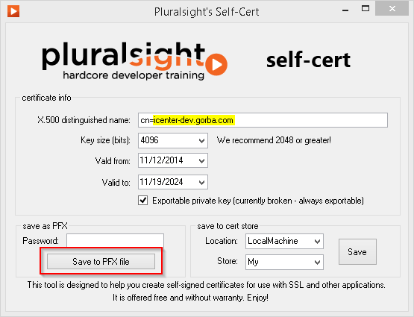

Install the certificate on the server under **Local Machine\Personal** store[1]

Find the thumbprint for the certificate. You can use the following PowerShell commands:

pushd Cert:\LocalMachine\My

ls

You will need the Thumbprint later on.

# Set the SB certificate

Set the SB certificate in the Service Bus PowerShell console

Set-SBCertificate -FarmCertificateThumbprint 631770553081E2FB628948A4E4245265D838E67B -EncryptionCertificateThumbprint 631770553081E2FB628948A4E4245265D838E67B

Note: Replace the thumbprint values with the thumbprint of your certificate as evaluated in step 2

Restart the farm using the following commands:

Stop-SBFarm

Update-SBHost

Start-SBFarm

Remark: starting the SB farm can require several minutes

# Create a namespace

Type the following command to create a namespace bound to the DNS entry

New-SBNamespace -AddressingScheme DNSRegistered -DnsEntry **icenter-dev.gorba.com** -Name **icenter-dev** -PrimarySymmetricKey **I10aA2qzGGwJn2xfSKlf0gslt7scFRsED5dmHh0hRbk=** -ManageUsers sb -IssuerName icenter-dev -IssuerUri **icenter-dev.gorba.com**

The primary symmetric key is used for security. It can be generated using the following PowerShell snippet:

$key = New-Object byte[](32)

$rng = [System.Security.Cryptography.RNGCryptoServiceProvider]::Create()

$rng.GetBytes($key)

[Convert]::ToBase64String($key)

Add the required authorization rules to the namespace, if any.

1. If applications using the ServiceBus are installed on the same server, it is also required to add the certificate to the **Local Machine\Trusted Root Certification Authorities** store