

|  |  |
| --- | --- |
|  | **Center** |
|  |  |
|  | Portal |
|  |  |
|  |  |
|  |  |
|  | Technical Description |
|  |  |
|  | Version: 2.0 |
|  | State: Released |
|  | Classification: Internal use only |
|  | Author: LEF |
|  | Creation date: 2011-11-15 |
|  | Repository: $/Gorba/Main/Center/Portal/Documents/TD_CenterPortal.docx |
|  | Gorba AG  Sandackerstrasse  9245 Oberbüren  Switzerland |

**Table of contents**

1 Introduction 4

2 Functionalities 4

2.1 BackgroundSystem configuration 4

2.2 BackgroundSystem repository 4

2.3 Install ClickOnce Applications 4

3 Configure Https 4

3.1 Install the certificate 4

3.2 Add the SslCert entry 11

**Modification management**

|  |  |  |  |  |  |
| --- | --- | --- | --- | --- | --- |
| **Version** | **Date** | **Name** | **Dept.** | **Modifications** | **State** |
| 0.1 | 10.12.2014 | LEF | SW | Initial draft | Draft |
| 0.2 | 29.01.2015 | LEF | SW | Added configuration section; used generic {portal-address} to reference the portal; fixed table of contents | Draft |
| 1.1 | 26.06.2015 | LEF | SW | Added instructions to setup SSL required for Https | Draft |

**Review**

|  |  |  |  |  |
| --- | --- | --- | --- | --- |
| **Version** | **Date** | **Name** | **Dept.** | **Remarks** |
| 0.2 | 29.01.2015 | EPT | SW | Document ready for release |
|  |  |  |  |  |
| 1.1 | 29.06.2015 | EPT | SW | Fixed current version  Fixed wrong command in chapter3.2 |
|  |  |  |  |  |

**Release**

|  |  |  |  |  |
| --- | --- | --- | --- | --- |
| **Version** | **Date** | **Name** | **Dept.** | **Remarks** |
| 1.0 | 29.01.2015 | LEF | SW | First release |
|  |  |  |  |  |
| 2.0 | 16.09.2015 | EPT | SW | Second release |
|  |  |  |  |  |

# Introduction

This document provides a list of functionalities implemented in Center Portal 1.2

# Functionalities

## BackgroundSystem configuration

The portal will provide the configuration relative to the corresponding BackgroundSystem.

The configuration is available at:

**{portal-address}/Configuration****[1]**

## BackgroundSystem repository

The portal will provide the repository configuration for units. The repository configuration will be available at:

**{portal-address}/Repository1**

## Install ClickOnce Applications

It is possible to install ClickOnce applications through the Portal.

Go to **{portal-address}/Applications** and, when prompted, insert your credentials (username/password).

On submission, the browser will be redirected to a page containing the list of available ClickOnce applications.

Click on any application to install it.

REMARK: only Internet Explorer is fully supported.

# Configure Https

Windows must be configured to allow Https for the console application hosting the portal.

## Install the certificate

First, you’ll need to install the certificate. It must be installed under the LocalMachine\Personal store.

Open the run dialog (Win+R), type the following command (mmc) and then Enter:

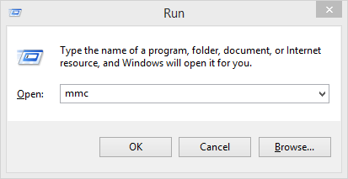

Select File -> Add/Remove SnapIn…

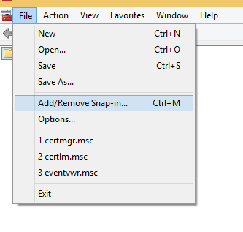

Select the Certificates SnapIn and click add

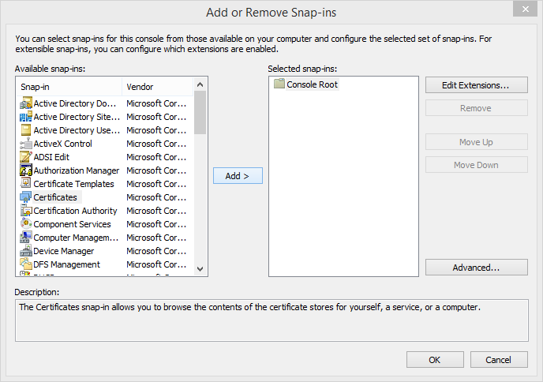

In the opened wizard, select Computer account

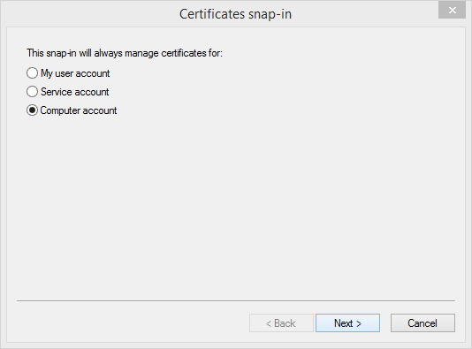

In the following screen select Finish

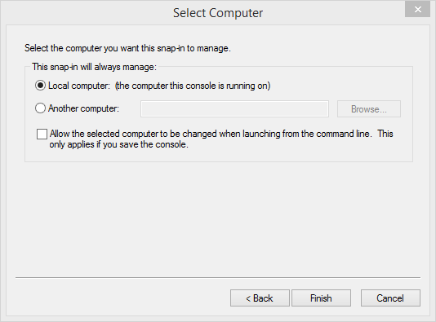

The Certificates (Local Computer) SnapIn should be added to the selected ones (right pane). Type Ok

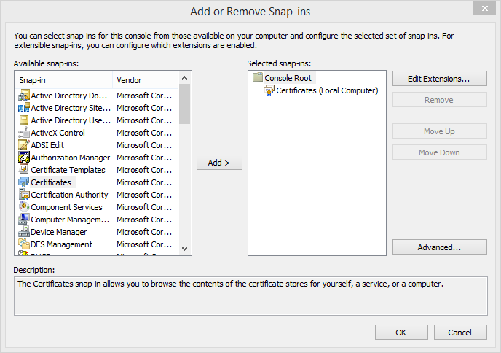

Right click on Certifcates (Local Computer)/Personal/Certificates and select All Tasks/Import...

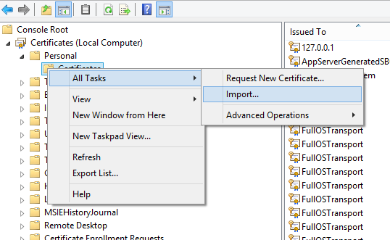

Select next in the welcome page of the Wizard (Local Machine should be selected as Store Location)

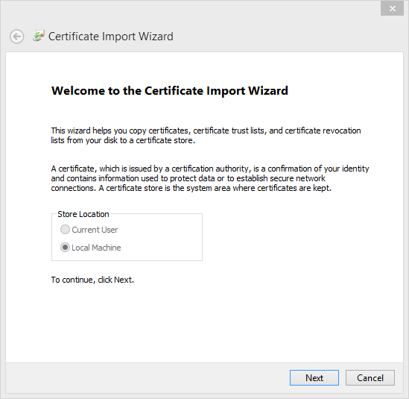

Browse and select the certificate, then click Next

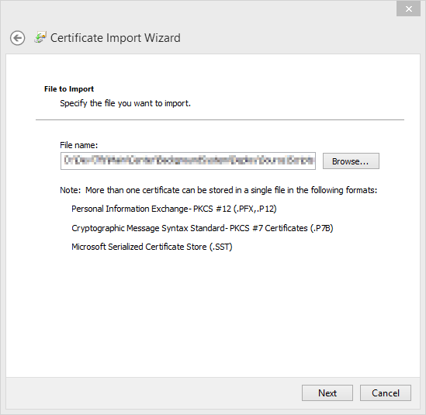

Enter the password and click Next

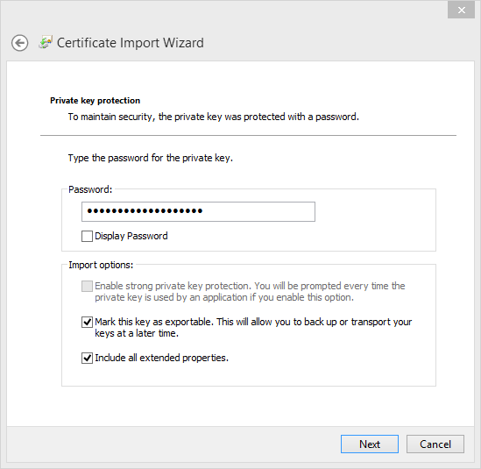

Select Personal as Certificate Store and click Next

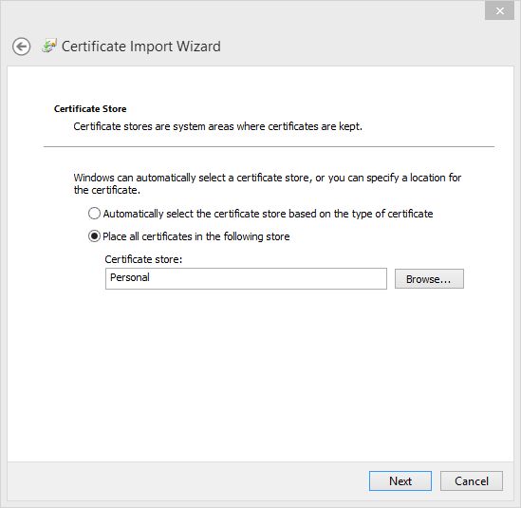

Click Finish

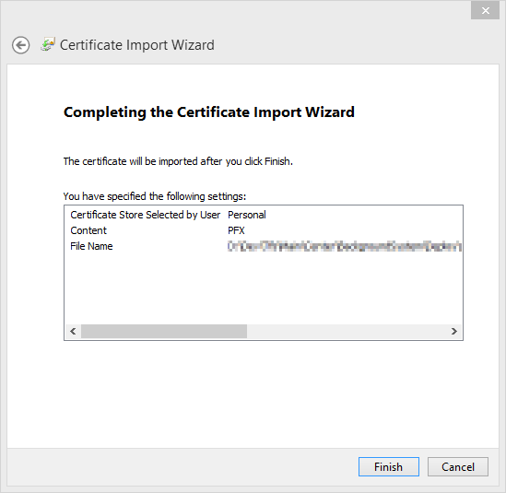

In the list of certificates, find the one you added and double-click it

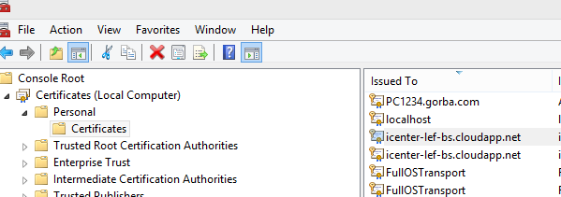

Go to the Details tab and find the Thumbprint field. This value (without spaces) will be needed in the next step

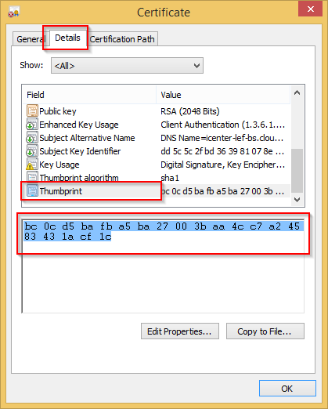

## Add the SslCert entry

Open an elevated command prompt and type the following command:

**Netsh http add sslcert ipport=0.0.0.0:{{port}} certhash={{hash}} appid={4e6ddf06-33e3-4c21-99bc-fd097241bad0}**

Where:

*{{port}}* is the port number as configured for the application (HttpsPort entry)

*{{hash}}* is the certificate Thumbprints as mentioned in the chapter 3.1.

1. {portal-address} must be replaced with the full Uri of the system (including scheme and port). The full address is case-sensitive