

|  |  |
| --- | --- |
|  | **Abu Dhabi** |
|  |  |
|  | CTU Topbox Simulator |
|  |  |
|  | Quick Start Guide |
|  |  |
|  | Technical Description |
|  |  |
|  | Version: 0.9 |
|  | State: Draft |
|  | Classification: Internal use only |
|  | Author: WES |
|  | Creation date: 2012-04-16 |
|  | Repository: $/Gorba/Main/Motion/Protran/Documents/TD_CTUTopboxSimulator.docx |
|  | Gorba AG  Sandackerstrasse  9245 Oberbüren  Switzerland |

**Table of contents**

1 Introduction 4

1.1 Scope 4

1.2 Intended Audience 4

2 Product Overview 4

2.1 System Overview 4

2.2 Components 4

3 Function Description 5

3.1 Connect to CU5 5

3.2 Sending Status Update Datagrams 5

3.3 Sending Line Information Datagrams (Obsolete) 5

3.4 Sending Trip Information Datagrams (Obsolete) 6

3.5 Sending Extended Line Information Datagrams 6

3.6 Sending Countdown Number Datagrams 7

3.7 Sending SpecialInput Info Datagrams 7

3.8 Receiving Datagrams 7

3.9 FTP File Exchange 8

4 Configuration 9

5 Installation 9

5.1 Full installation 9

6 Maintenance 9

6.1 Common errors 9

7 References 9

**Modification management**

|  |  |  |  |  |  |
| --- | --- | --- | --- | --- | --- |
| **Version** | **Date** | **Name** | **Dept.** | **Modifications** | **State** |
| 0.1 | 2012-04-16 | WES | SW | Initial version | Draft |
| 0.2 | 2012-04-16 | COS | SW | Reviewed. Added footnotes and specified the required .NET Framework’s version. | Draft |
| 0.3 | 2012-06-18 | COS | SW | Added the paragraph about the FTP file exchange. | Draft |
| 0.4 | 2012-06-22 | COS | SW | Reviewed the paragraph about the FTP file exchange due to the new buttons added in the graphical user interface: “Request” and “Abort”. | Draft |
| 0.5 | 2012-07-30 | WES | SW | Added Line Info telegram paragraph | Draft |
| 0.6 | 2012-08-06 | RAN | SW | Added Extended Line Info telegram paragraph | Draft |
| 0.7 | 2013-02-21 | WES | SW | Added Countdown Number telegram paragraph, updated all screenshots where necessary, added “Obsolete” for obsolete telegrams | Draft |
| 0.8 | 2013-03-21 | RAN | SW | Added SpecialInput Info telegram paragraph | Draft |
| 0.9 | 2013-11-12 | RAN | SW | Updated chapter 3.8 with display status | Draft |

**Review**

|  |  |  |  |  |
| --- | --- | --- | --- | --- |
| **Version** | **Date** | **Name** | **Dept.** | **Remarks** |
|  |  |  |  |  |
|  |  |  |  |  |
|  |  |  |  |  |
|  |  |  |  |  |

**Release**

|  |  |  |  |  |
| --- | --- | --- | --- | --- |
| **Version** | **Date** | **Name** | **Dept.** | **Remarks** |
|  |  |  |  |  |
|  |  |  |  |  |
|  |  |  |  |  |
|  |  |  |  |  |

# Introduction

## Scope

This document is a technical description of Topbox Simulator for the Abu Dhabi project. It gives all information to Gorba and Hengartner eployees to be able to work with this tool.

This document is not intended to be a user manual.

This document gives a short introduction into using the Topbox Simulator to send CTU datagrams to a CU5 control unit.

## Intended Audience

This document is written to be understood by Gorba and Hengartner staff familiar with Gorba products. Technical skills are required.

# Product Overview

## System Overview

The Topbox Simulator runs on a Windows computer having at least the .NET Framework 2.0 installed, and connects to the CU5 through Ethernet:

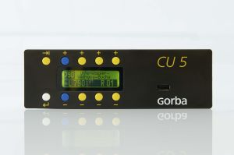

UDP / IP / Ethernet

The communication happens through UDP / IP (usually) using port 32021 (see the protocol specification for more details[1]).

## Components

The Topbox Simulator is a single application (EXE) using several DLLs. There is no configuration file (except for NLog).

# Function Description

## Connect to CU5

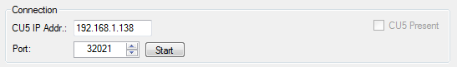

In the text box “CU5 IP Addr.” you need to enter the IP Address of the CU5 you want to connect to. To make sure, the CU5 is reachable, try doing a “Ping” first with the command line. The last entered IP address will be restored upon the next restart of the application.

The “Port” number should never be changed since 32021 is the default port for the protocol.

The button “Start” starts trying to connect to the CU5 and will send some datagrams as defined in the protocol specification[2].

The (disabled) checkbox “CU5 Present” shows if the CU5 is present:

* Unchecked: CU5 is not found
* Checked: the CU5 is found and it is answering regularly with status telegrams
* Indeterminate: the CU5 did not send any telegrams in the last 60 seconds

## Sending Status Update Datagrams

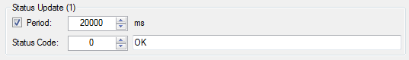

If the checkbox is checked, the Topbox Simulator sends every x milliseconds a status update to the CU5. This should always be enabled once a connection was made to the CU5 because otherwise the CU5 has to assume the Topbox is not available anymore. The period should be set to a value between 20 and 30 seconds.

The “Status Code” can be any signed integer. Please refer to the protocol specification for valid values.

The textbox can contain any status message. This value is not of importance to the CU5.

## Sending Line Information Datagrams (Obsolete)

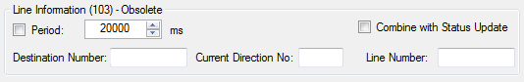

If the checkbox is checked, the Topbox Simulator sends every x milliseconds a line information datagram to the CU5. This should always be enabled once a connection was made to the CU5 because otherwise the CU5 has to assume the Topbox is not available anymore. The period should be set to a value between 20 and 30 seconds.

The “Destination Number”, “Current Direction No” and “Line Number” can contain any text (numbers and characters are allowed).

The “Combine with Status Update” checkbox allows the Line Information TLV triplet to be combined in a single CTU datagram with the Status Update TLV triplet. This can be used to reduce the number of telegrams and to test the option to send multiple TLVs in one datagram.

## Sending Trip Information Datagrams (Obsolete)

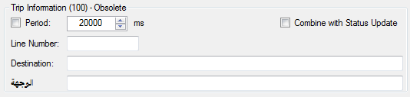

If the checkbox is checked, the Topbox Simulator sends every x milliseconds a trip information datagram to the CU5. This should always be enabled once a connection was made to the CU5 because otherwise the CU5 has to assume the Topbox is not available anymore. The period should be set to a value between 20 and 30 seconds.

The “Destination Number”, “Current Direction No” and “Line Number” can contain any text (numbers and characters are allowed).

The “Line Number” can contain any text (numbers and characters are allowed).

The “Destination” text box contains the English destination name, it can contain any text.

The “الوجهة” text box contains the Arabic destination name, it can contain any text.

The “Combine with Status Update” checkbox allows the Trip Information TLV triplet to be combined in a single CTU datagram with the Status Update TLV triplet. This can be used to reduce the number of telegrams and to test the option to send multiple TLVs in one datagram.

## Sending Extended Line Information Datagrams

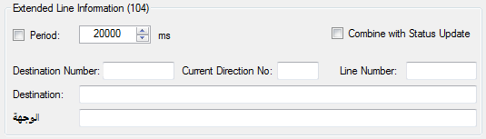

If the checkbox is checked, the Topbox Simulator sends every x milliseconds an extended line information datagram to the CU5. This should always be enabled once a connection was made to the CU5 because otherwise the CU5 has to assume the Topbox is not available anymore. The period should be set to a value between 20 and 30 seconds.

The “Line Number” can contain any text (numbers and characters are allowed).

The “Destination” text box contains the English destination name, it can contain any text.

The “الوجهة” text box contains the Arabic destination name, it can contain any text.

The “Combine with Status Update” checkbox allows the Extended Line Information TLV triplet to be combined in a single CTU datagram with the Status Update TLV triplet. This can be used to reduce the number of telegrams and to test the option to send multiple TLVs in one datagram.

## Sending Countdown Number Datagrams



Fill in the countdown number (a value between -128 and 127) and press the “Send” button to send the number exactly once to the CU5. This datagram is not repeated nor combined with another datagram.

## Sending SpecialInput Info Datagrams

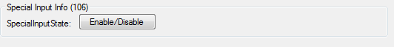

Click on the button “Enable/Disable“to send the SpecialInput Info with the state true or false. When the button is clicked, if the text on the button shows “Enabled”, then the value “True” is sent to the Cu5 once. If the test on the button shows “Disabled”, then the value “False” is sent to the Cu5 once. This datagram is not repeated nor combined with another datagram.

## Receiving Datagrams

All information received from the CU5 is displayed in the lower part of the application:

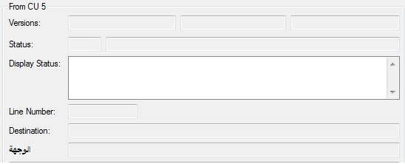

The “Versions” textboxes contain the CU5 version information (from left to right):

* Serial Number
* Software Version
* Data Version

The “Status” textboxes contain the status code (on the left) and the status message.

The “Display Status” textbox contains the different display status of the exterior displays that is received from the CU5.

The “Line Number”, “Destination” and “الوجهة” textboxes contain the respective information received from the CU5. These values should only be shown if the CU5 is in fallback mode (i.e. not getting line information from the Topbox Simulator); for more information please refer to the protocol specification.

The textbox at the bottom contains all CTU log messages received from the CU5 since the last application start-up.

## FTP File Exchange

TopBoxSimulator can exchange files with the CU5. The file exchange process starts and ends with specific CTU datagrams sent from TopBoxSimulator to the CU5. During a file exchange process, TopBoxSimulator can ask the CU5 about the current download status.   
Attention: TopBoxSimulator doesn’t implement the FTP server. You need to install one (FileZilla server is recommended) in the same PC where the TopBoxSimulator is also running and using the port 21. There’s no direct FTP connection between TopBoxSimulator and the CU5. The first just only notifies the second about the existence of files to be downloaded.

Here below are shown the UI controls that manage the whole file exchange. To start it, it’s only needed to specify the absolute path of the FTP root directory containing the files to be exchanged and then press “Start”. To select the “ISM” directory’s path, you can directly edit in the available text box or select it browsing in the file system after a click on the button “ISM Dir Path”.

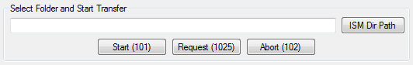

It’s possible to send to the CU5, whenever needed, also the other CTU datagrams: “Download Abort” and “Download Progress Request” just clicking respectively on the buttons “Abort” and “Request”.

During the download process may be useful to see the logs produced by TopBoxSimulator. To do this is enough to click on the menu “Transfer Files” 🡺 “Status Tab”, as shown below:

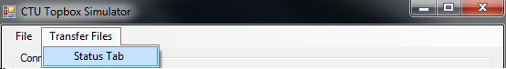

It will appear a new window having two sections: the first contains all CTU datagrams sent from TopboxSimulator to the CU5, the second for all the CTU datagrams sent from the CU5 to TopBoxSimulator.

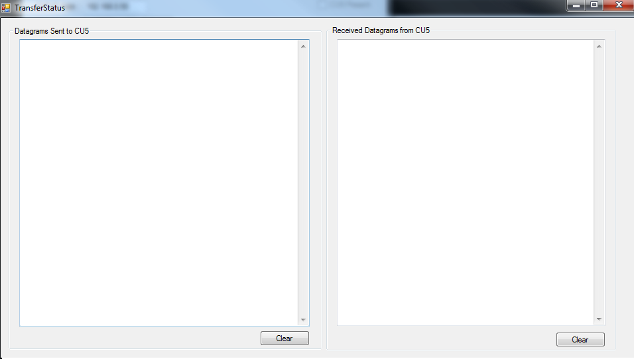

# Configuration

Currently no configuration is required. To enable or change logging, one can add a “NLog.config” file in the same directory as the application. Please refer to the NLog configuration website for more information about this configuration:

<http://nlog-project.org/wiki/Configuration_file>

# Installation

## Full installation

The application and all required files can be copied from the delivery folder:

\\softwareserver\delivery$\Gorba\SW\02_imotion\02_TFT\09_ProtocolTranslator\TfsBuild\Motion_Protran_Tools

# Maintenance

## Common errors

# References

* CTU Protocol Specification <https://tfsgorba.gorba.com/sites/teamsoftware/Shared%20Documents/Products/Motion/CUx/Documentation/TD_CTU_Protocol_Specification.docx>

1. See chapter 7 References 9
2. See chapter 7 References 9