

|  |  |
| --- | --- |
|  | **imotion** |
|  |  |
|  | Protran |
|  |  |
|  | Installation |
|  |  |
|  | Technical Description |
|  |  |
|  | Version: 1.0 |
|  | State: Released |
|  | Classification: Internal use only |
|  | Author: COS |
|  | Creation date: 2012-02-28 |
|  | Repository: $/Gorba/Main/Motion/Protran/Documents/TD_ProtranInstallation/ TD_ProtranInstallation.docx |
|  | Gorba AG  Sandackerstrasse  9245 Oberbüren  Switzerland |

**Table of contents**

1 Introduction 4

1.1 Purpose 4

1.2 Intended Audience and Reading Suggestions 4

2 Requirements 4

3 Get the Softare 4

4 Software Installation 7

5 Run 7

5.1 Launch in execution with mouse 7

5.2 Launch in execution with the commad line 7

6 System‘s Components 8

7 Utils 10

**Modification management**

|  |  |  |  |  |  |
| --- | --- | --- | --- | --- | --- |
| **Version** | **Date** | **Name** | **Dept.** | **Modifications** | **State** |
| 0.1 | 2012-02-28 | COS | SW | Initial version | draft |
| 0.2 | 2012-02-29 | COS | SW | First review. | draft |
| 0.3 | 2012-03-07 | COS | SW | Second review. | draft |

**Review**

|  |  |  |  |  |
| --- | --- | --- | --- | --- |
| **Version** | **Date** | **Name** | **Dept.** | **Remarks** |
|  | 2012-03-12 | WES | SW | ok |
| 0.3 |  |  |  |  |
|  |  |  |  |  |
|  |  |  |  |  |

**Release**

|  |  |  |  |  |
| --- | --- | --- | --- | --- |
| **Version** | **Date** | **Name** | **Dept.** | **Remarks** |
|  | 2012-03-12 | WES | SW | First release |
| 1.0 |  |  |  |  |
|  |  |  |  |  |
|  |  |  |  |  |

**References**

|  |  |
| --- | --- |
| **ID** | **Path** |
| R1 | $/Gorba/Main/Motion/Protran/Documents/TD_ProtranDocumentation/TD_ProtranDocumentation.docx |
| R2 | $/Gorba/Main/Common/Documents/ TD_MediServerConfig.docx |

# Introduction

## Purpose

The goal of this document is to describe in detail everything is required to install and run Protran starting from its version number **1.0.0.16**.

Attention: this document doesn’t cover the Protran’s configuration. For that, please see the reference document R1.

## Intended Audience and Reading Suggestions

This document is addressed to product managers or project people that are familiar with this product and are able to install, operate and maintain it.

# Requirements

Before starting to install Protran, make sure to have the following requirements:

1. Windows XP, Windows XP Embedded, Windows Vista 32/64 bit, Windows 7 32/64 bit
2. .NET Framework 2.0 installed
3. At least 10 MB of space in the hard disk for Protran

If you don’t have the .NET Framework 2.0, you can download it from:   
  
<http://www.microsoft.com/download/en/details.aspx?id=19>

In the rest of this document will be used the O.S. Windows 7 64 bit with the English language.

# Get the Softare

The latest delivered version of Protran is downloadable at:

\\Softwareserver\Release\SW\02_imotion\02_TFT\09_ProtocolTranslator

In this directory are stored all the Protran’s released versions. The last is of course always the most recent (in the example below, the latest is the version 1.0.0.11):

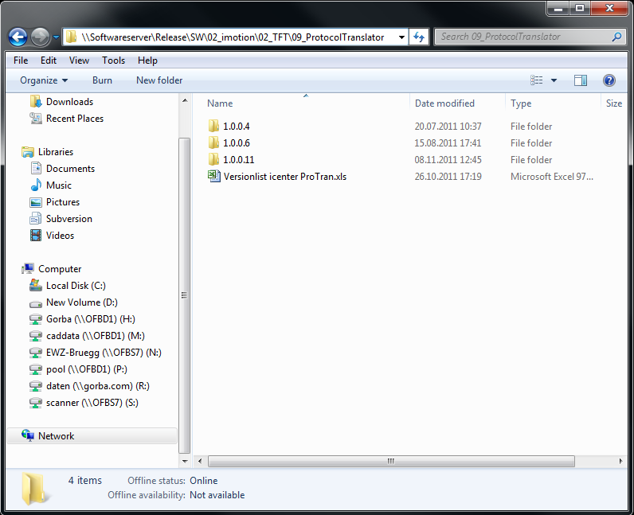

Latest Protran

This is the official path where get the latest Protran’s release.

Figure 3‑1 Server’s Directory for the latest delivered Protran release

Inside the releases directory there are all the binary files and all the configuration files required to install Protran properly.

Make sure to have at least the following set of files:

|  |  |
| --- | --- |
| **File** | **Description** |
| **Protran.exe** | This file launches in execution Protran as a console application. All the logs produced during the Protran’s activity can be viewwe here (if enabled in NLog.config). |
| **Gorba.Motion.Protran.Core.dll** | Library containing the Protran’s engine required to start the communications with remote board computers and with the Gorba’s server. |
| **Gorba.Common.Medi.Core.dll** | Library for the communications with the Gorba’s server. |
| **Gorba.Motion.Protran.Protocols.dll** | Library for the communications with the remote board computers. |
| **Gorba.Common.Protocols.Ximple.dll** | Library for the translations to the Gorba’s protocol XIMPLE. |
| Gorba.Common.ExceptionHandling.dll | Library for the eventual exceptions that might occur in Protran during its execution. |
| Gorba.Common.Util.dll | Library for common utilities required for the Protran’s execution. |
| Gorba.Common.CSUtil.dll | Library for other common utilities required by Protran. |
| Gorba.Common.Ftp.dll | Library for communications using the FTP protocol. |
| ICSharpCode.SharpZipLib.dll | Library for compressiong/decompressing .zip archives functions. |
| NLog.dll | Library that manages all the Protran’s log activities. |
| NLog.config | Configuration file for the Protran’s log activities. |
| **cfg.xml** | Configuration file for the Protran’s execution and for the establishment of the connections with the remote board computers and the Gorba’s server. |
| **dictionary.xml** | Configuration file for the translations to XIMPLE protocol. |
| **ibis.xml** | Configuration file for the communications with a specific IBIS master. |

Table 3‑1

Also, make sure that the Protran’s version is bigger or equal than **1.0.0.16** and the files:

1. Protran.exe
2. Gorba.Motion.Protran.Core.dll
3. Gorba.Motion.Protran.Protocols.dll

have all the same version number as shown below: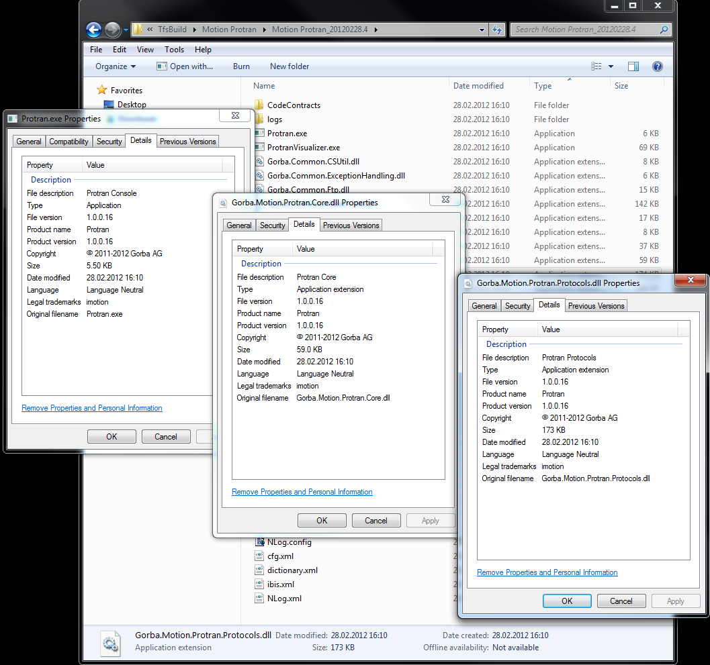

Figure 3‑2 Protran’s version

Once you checked all the things shown above, you can proceed with the Protran installation (see chapter 4).

# Software Installation

For the rest of this document will be assumed that the target computer is a Windows 7 64 bit with the English language, and the installation directory is **D:\Protran**. Whenever is specified *[Protran]*, the user has to replace it with the proper installation directory (in the chapter is D:\Protran).

To install Protran are required the following steps:

1. Copy the latest Protran’s release from \\Softwareserver\Release\SW\02_imotion\02_TFT\09_ProtocolTranslator
2. Paste the directory in *[Protran]*

As result, you have the whole Protran software locally and ready to run.

# Run

There are different ways to run Protran. Hereafter are presented the main two of them.

## Launch in execution with mouse

1. Double left click on the file Protran.exe stored in the directory *[Protran]*
2. Eventually, sblock the firewall in order to allow Protran to establish Ethernet connections

## Launch in execution with the commad line

1. One left click on the “Start” button of Windows
2. One left click on “All Programs”
3. One left click on “Accessories”
4. One left click on “Command Prompt”
5. Using the command prompt, enter in the *[Protran]* directory
6. Using the command prompt, type Protran.exe and press ENTER
7. Eventually, sblock the firewall in order to allow Protran to establish Ethernet connections

As result you should see something as shown below (depending on your log configuration):

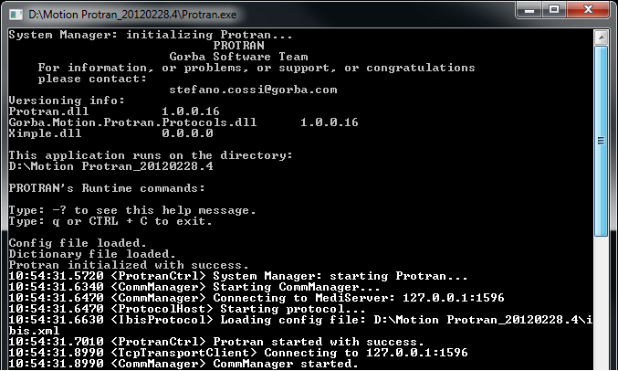

Figure ‑ Running Protran

# System‘s Components

To work properly, Protran needs to establish a connection with the Gorba’s server: **MediServer**. This last is an application tasked to receive the XIMPLE Protran’s telegrams and to forward all of them to the Gorba’s media player (because there is no direct connection between Protran and the media player itself). A simple schema is shown below:

Media Player

MediServer

Protran

Gorba’s System

Remote board computer

TCP/IP

TCP/IP

TCP/IP or serial

Figure 6‑1 System’s components.

In order to check that Protran has really established a TCP/IP connection with MediServer, it’s enough to see the logs on the Protran’s console, as shown below:

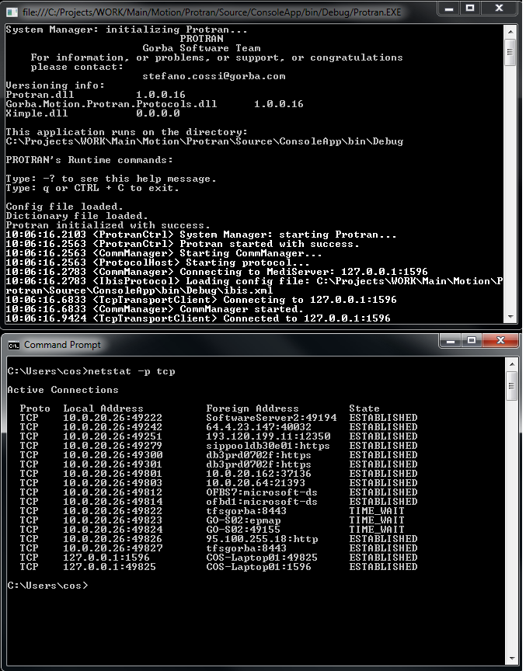

Figure 6‑2 Connection between Protran and MediServer

For the example above, Protran tries to establish the connection on localhost at the port 1596 (for Protran’s configuration, see R1). If you disable the logs, you can also check the connection with the command “netstat –p tcp”.

To have more information about MediServer, see document R2.

# Utils

There is another Gorba’s application that you can use to test if your Protran’s installation works fine: **ProtranVisualizer** (downloadable from the same path of Protran). It is basically, a graphical user interface attached to Protran because it uses the same dlls and the same configuration files of Protran itself. Also it can be thought as a complete IBIS master because can simulate completely the main IBIS telegrams, as shown in the figure below:

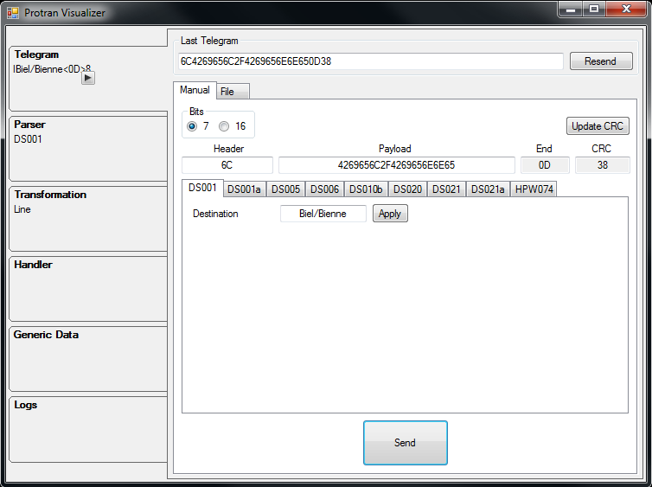

1) type here and apply

2) send

Figure 7‑1 ProtranVisualizer

To run ProtranVisualizer you need the additional files:

* Gorba.Motion.Protran.Controls.dll

that contains the graphical controls (such as buttons, tabs, labels and so on…)

If ProtranVisualizer runs, it means that in your Protran’s directory you have all the required files for its installation.