

|  |  |
| --- | --- |
|  | **imotion** |
|  |  |
|  | Update Migration |
|  |  |
|  | User Manual |
|  |  |
|  | Technical Description |
|  |  |
|  | Version: 0.3 |
|  | State: Draft |
|  | Classification: Internal use only |
|  | Author: RAN |
|  | Creation date: 2012-11-27 |
|  | Repository: $/Gorba/Main/Motion/Protran/Documents/TD_ProtranInstallation/ TD_UpdateMigration.docx |
|  | Gorba AG  Sandackerstrasse  9245 Oberbüren  Switzerland |

**Table of contents**

1 Introduction 4

1.1 Scope 4

1.2 Intended Audience 4

2 System Overview 4

3 Concept 4

3.1 Batch File content 4

3.2 Conversion to executable 5

3.3 Folder structure for USB 6

3.3.1 Folder Program_Update 6

3.3.2 ImageUpdate 6

4 Installation 7

4.1 Full installation 7

**Modification management**

|  |  |  |  |  |  |
| --- | --- | --- | --- | --- | --- |
| **Version** | **Date** | **Name** | **Dept.** | **Modifications** | **State** |
| 0.1 | 2012-11-28 | RAN | SW | Initial version | draft |
| 0.2 | 2012-12-03 | WES | SW | Unofficial review | draft |
| 0.3 | 2013-03-12 | RAN | SW | Updates to sections 1.1, 1.2, 3.3, 3.3.1, 3.3.2 based on inputs from SEM | draft |

**Review**

|  |  |  |  |  |
| --- | --- | --- | --- | --- |
| **Version** | **Date** | **Name** | **Dept.** | **Remarks** |
| 0.3 | 2013-03-18 | COS | SW | Ok |
|  |  |  |  |  |
|  |  |  |  |  |
|  |  |  |  |  |

**Release**

|  |  |  |  |  |
| --- | --- | --- | --- | --- |
| **Version** | **Date** | **Name** | **Dept.** | **Remarks** |
|  |  |  |  |  |
|  |  |  |  |  |
|  |  |  |  |  |
|  |  |  |  |  |

# Introduction

## Scope

This document is a description and user manual about Update Migration. The document covers a description of the process of Update Migration with the involved files.

Update Migration is to migrate from a customer system using Infomedia 1.0.x or TFTPlayer and TFTUpdate to TFTStartup.bat and install Gorba’s current software like Protran, Infomedia, MediServer etc. via USB without user intervention during the process. The user only has to put in and remove the USB stick.

## Intended Audience

This document is written to be understood by Gorba staff familiar with Gorba products and mainly the “ImageUpdate” procedure. Minimal technical skills are required.

# System Overview

The example system described in this document consists of a TFT with TFTUpdate running on it. The shortcut to TFTUpdate.exe is present in autostart (“C:\Documents and Settings\infomedia\Start Menu\Programs\StartUp\”). The system also contains the software Infomedia.exe. The process described for this example system can be modified and applied to a system with TFTUpdate and TFTPlayer software’s. The minimum requirement for the Update migration to work is that TFTUpdate detects that an update is available via USB. It copies the relevant directories like Infomedia and then launches Infomedia.exe.

# Concept

To replace the software from TFTUpdate and Infomedia or TFTPlayer, create a batch file to perform certain operations described in the next section. Convert the batch file to an executable (*.exe) called Infomedia.exe or TFTPlayer.exe depending on the software currently installed on the system before update migration.

## Batch File content

Create a batch file called “Infomedia.bat” which performs the following:

* Copy the application “taskkill.exe” to C:\WINEMB21\system32
* Kill the application “TFTUpdate.exe”
* Delete the directory D:\Progs on the system if it exists
* Copy the directory “Startup” to D:\Progs\Startup
* Delete all shortcuts in the autostart
* Place the shortcut present in D:\Progs\Startup in autostart
* Do a commit to save the shortcut in autostart
* Shutdown the system
* Close the batch file

xcopy D:\Infomedia\Program\ReplaceUpdate\taskkill.exe C:\WINEMB21\system32 /Y

TASKKILL /IM TftUpdate.exe /f

del D:\Progs\ /s /q /f

rmdir D:\Progs\ /s /q

xcopy D:\Infomedia\Program\ReplaceUpdate\Startup D:\Progs\Startup\ /R /S /E /Y

del "C:\Documents and Settings\infomedia\Start Menu\Programs\StartUp\*.lnk" /F

xcopy "D:\Progs\Startup\*.lnk" "C:\Documents and Settings\infomedia\Start Menu\Programs\StartUp" /I /E /H /Q

EwfMgr c: -commit

shutdown.exe -r -t 03 -d p

EXIT

Figure 3‑1 Infomedia.bat batch file contents

## Conversion to executable

Convert the batch file “Infomedia.bat” into an executable Infomedia.exe using a free batch to executable conversion tool. An example tool to use is “advbattoexe.exe” is available at the location <http://www.softoxi.com/advanced-bat-to-exe-converter.html>.

To convert the file using advbattoexe.exe, click on File->Open and select the batch file for conversion, in this instance, it is Infomedia.bat. Next, click again on File->Build EXE.



Figure 3‑2 Select executable name

Select the name of the executable as “Infomedia.exe” and save it as seen in Figure 3‑2 Select executable name.

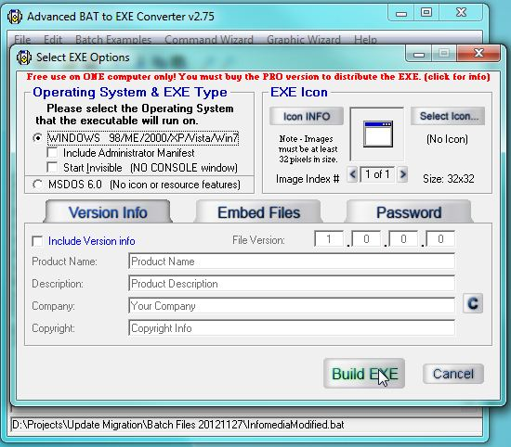

Figure 3‑3 Converting batch file to executable

Click on the button “Build EXE” to start the conversion as seen in Figure 3‑3 Converting batch file to executable. The converted file Infomedia.exe is now available for use.

## Folder structure for USB

This section provides the folder structure to perform Update migration.

Place the following folders at the root of the USB stick



Figure 3‑4 Folders at USB root

### Folder Program_Update

This is the folder updated by TFTUpdate.exe. It contains the new batch file converted to executable “Infomedia.exe” and a folder “ReplaceUpdate”.

The folder ReplaceUpdate contains a folder “Startup” and an application “taskkill.exe”. The folder “Startup” contains an application “sleep.exe”, TFTStartup.bat and a shortcut of TFTStartup.bat.

The folder Program_Update can have a different name depending on the contents of TFTUpdate.ini.



Figure 3‑5 Contents of Folder Program_Update



Figure 3‑6 Contents of Folder ReplaceUpdate

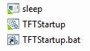

Figure 3‑7 Contents of folder Startup

### ImageUpdate

This is the standard update folder with a batch file “ImageUpdate.bat” and the folders required to perform an update. Below is an example of the contents of the folder ImageUpdate.

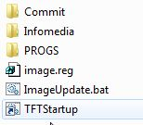

Figure 3‑8 Contents of ImageUpdate folder

The contents of the folder ImageUpdate are project specific and hence need to be decided by the customer project manager.

# Installation

## Full installation

The complete Update Migration installation, updates the system from TFTUpdate and Infomedia or TFTPlayer to a system with TFTStartup.bat with other Gorba software like Protran, Infomedia and Mediserver.

Follow the steps below to perform the Update migration.

1. Clear a USB stick. Prepare the USB stick based on the folder structure in section 3.3.
2. Plug in the USB stick into a TFT and power it on.
3. TFTUpdate.exe starts and detects the USB stick. It performs an update of the folder Program_Update and prompts the user to remove the USB stick.
4. Remove the USB stick upon this prompt. TFTUpdate starts the newly copied Infomedia.exe. This is the batch file which was converted to an executable. The batch file performs the actions and then shuts down the TFT.
5. Plug in the USB stick when the TFT begins to restart. TFTStartup.bat placed in autostart by Infomedia.exe starts.
6. TFTStartup.bat detects the USB stick and locates ImageUpdate.bat file and begins the standard update process using ImageUpdate folder and ImageUpdate.bat
7. Upon completion of update, the new set of Gorba software is launched either after a restart or directly.