

|  |  |
| --- | --- |
|  | **Update** |
|  |  |
|  | USB Update Manager Tool |
|  |  |
|  | User Manual |
|  |  |
|  | Technical Description |
|  |  |
|  | Version: 2.0 |
|  | State: Released |
|  | Classification: Internal use only |
|  | Author: RAN |
|  | Creation date: 2013-09-04 |
|  | Repository: $/Gorba/Main/Motion/Update/Documents/ TD_USBUpdateManager_UserManual.docx |
|  | Gorba AG  Sandackerstrasse  9245 Oberbüren  Switzerland |

**Table of contents**

1 Introduction 4

1.1 Scope 4

1.2 Intended Audience 4

2 Installation 4

3 Product Overview 4

3.1 Create/Open update project 4

3.2 Unit configuration tab 4

3.2.1 Import Feedback and Log Files 5

3.2.1.1 Import from USB stick 5

3.2.1.2 Import from FTP server 6

3.2.2 Update details 6

3.3 Update tab 8

3.3.1 Add/Remove folders 8

3.3.2 Add/Remove files 9

3.3.3 Export all 9

3.3.3.1 Export to USB stick 9

3.3.3.2 Configure FTP servers 10

3.3.3.3 Export to FTP server 10

3.3.3.4 Pre- and post-installation actions 11

3.3.3.5 Parked update 12

3.3.3.6 Completing the export 12

4 Folder structure of exported update on USB and FTP 12

**Modification management**

|  |  |  |  |  |  |
| --- | --- | --- | --- | --- | --- |
| **Version** | **Date** | **Name** | **Dept.** | **Modifications** | **State** |
| 0.1 | 2013-09-04 | RAN | SW | Initial version | draft |
| 0.2 | 2013-09-11 | RAN | SW | Minor modifications to sections 2.1, 2.2, 2.3 | draft |
| 0.3 | 2013-09-20 | WES | SW | Added pre- and post-installation scripts Clarifications in sections 3.2 and 3.3 | draft |
| 1.1 | 2014-06-18 | RAN | SW | Added parked update in section 3.3.3.4 and FTP update in sections 3.2.1.2 and 3.3.3.2 | draft |

**Review**

|  |  |  |  |  |
| --- | --- | --- | --- | --- |
| **Version** | **Date** | **Name** | **Dept.** | **Remarks** |
| 0.3 | 2014-01-08 | WES | SW | Reviewed |
|  |  |  |  |  |
| 1.1 | 2014-06-19 | WES | SW | Reviewed: also updated chapter 4, separated chapter 3.3.3.2 |
|  |  |  |  |  |

**Release**

|  |  |  |  |  |
| --- | --- | --- | --- | --- |
| **Version** | **Date** | **Name** | **Dept.** | **Remarks** |
| 1.0 | 2014-01-08 | WES | SW | Release for USB Update Manager 2.0.1402 |
|  |  |  |  |  |
| 2.0 | 2014-06-19 | WES | SW | Release for USB Update Manager 2.2.1426 |
|  |  |  |  |  |

# Introduction

## Scope

This document is a user manual of USB Update Manager tool. It gives all information to Gorba internal people to be able to use this product. This document covers the features of **version 2.2.1426**.

The document describes the features of USB Update Manager tool. The document also covers how to use it to create USB updates for TFT 2.0 system, export the updates onto a USB stick or an FTP server and how to read the feedback for all the units present on the USB stick or FTP server.

## Intended Audience

This document is written to be understood by Gorba staff familiar with Gorba products. Minimal technical skills are required.

# Installation

There is no specific installation process for the USB Update Manager tool. Copy the application to a local directory and then double click on the “USBUpdateManager.exe” to start the tool. The minimum requirements to run the tool are Windows XP with .NET 2.0 framework.

# Product Overview

The USB Update Manager tool has two-fold purpose:

* Creating an update for a TFT System 2.0
* Reading feedback of different units from a USB stick or FTP server

## Create/Open update project

To create an update, the user must first create a new project or open an existing project. This is done by going to the “File” menu and select either “New Project” to create a new project or “Open Project” to open an existing project. When the tool is started, the last used project is opened automatically.

A project contains information about all the unit groups and units under them. The complete folder and file structure with the resource hash for the files is available for each unit group. The update state of the unit group is also available within the project. The project also contains a folder with all the resources. Hence, this project contains the complete information of all updates for all units on all unit groups. The open project is saved implicitly when the user changes something in the application.

It is strongly suggested that the initial project structure is defined by Gorba Product Management or an experienced Project Manager.

## Unit configuration tab

Click on the icon in the “Unit Configuration Tab” to add units which require an update. Two options are available, add a “Unit group” and add a “Unit”. All units must belong to a unit group, so first a “Unit Group” must be added. A unit group must have a unique name and the user can add some description about it. A unit group has only one level. It can only have multiple units and not another unit group. Now, the user can add units under the unit group. Each unit must have a unique name, which is the hostname of the PC and the user can add a description about the unit. To delete a unit group/unit, select the unit group/unit and then click on the icon. A unit can belong to only one unit group. An update is defined for a unit group. All units under the unit group are updated with the defined update.

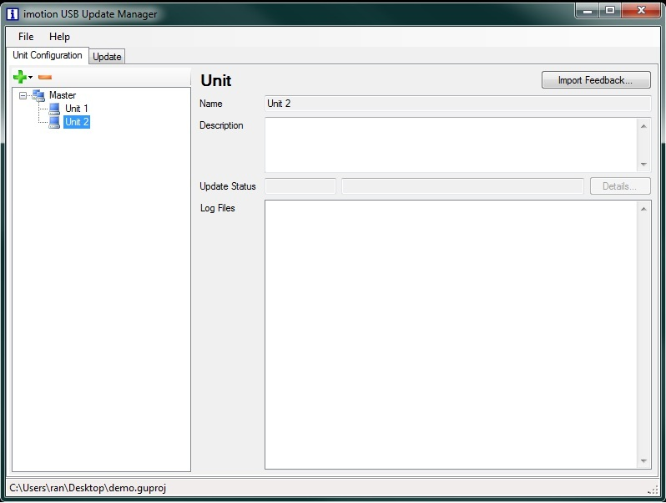

Figure 3‑1 Unit Configuration tab with a Master containing two units for update

When the user clicks on a unit, details of the unit like the description, Update Status and the log files associated with that unit will be seen if present to the right.

Deleting a unit or an entire unit group will delete all information associated with the unit(s). This includes update status, log files and in the case of unit groups the entire directory structure for this unit group. This operation can’t be undone.

### Import Feedback and Log Files

Once the feedback is imported, it is visible to the right for each unit. The Update status shows the latest status of the update for the unit. Click on the “Details” button to have the complete list of updates with details. The Log files show the list of all the log files from the unit. To view a specific log file, double click on the file.

#### Import from USB stick

To import the feedback from the USB stick, the user has to click on the “Import Feedback…” button. A dropdown of all available USB sticks is shown under the button. User must select the required USB stick to import the feedback from. All the available feedback from the folder “Gorba\Update\Feedback” is imported to the tool and then deleted from the USB stick immediately.

#### Import from FTP server

To import the feedback from the FTP server, the user has to click on the “Import Feedback…” button. A dropdown of all available FTP servers is shown under the button. User must select the required FTP server to import the feedback from. All the available feedback from the folder “Gorba\Update\Feedback” is imported to the tool.

A detailed description of how to add FTP servers can be found in chapter 3.3.3.2 below.

### Update details

To see the details of an update or the complete history of the all the updates for a unit, click on the unit and then click on the “Details” button.

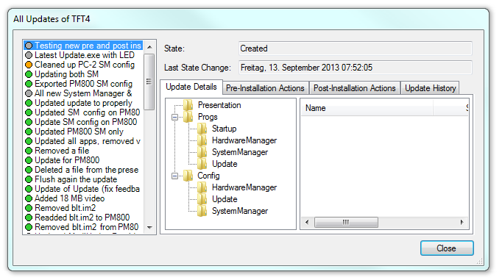

Figure 3‑2 Details of all update and update details for a unit

To the left, the list of all the updates of the unit is seen. Upon selecting an update, to the right the complete details of the update with the folder and file structure is visible under the “Update Details” tab.

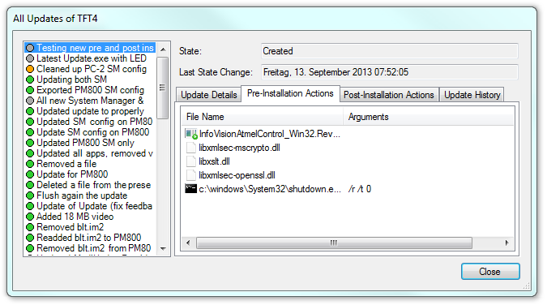

Figure 3‑3 Details of all update and update pre- and post-installation actions for a unit

The “Pre-Installation Actions” and “Post-Installation Actions” tabs show the actions performed before and after the actual file update.

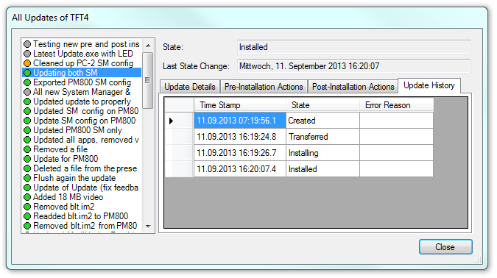

Figure 3‑4 Details of all update and update history for a unit

The “Update History” tab shows the full update history for the selected update with the timestamps, update state and error reasons if any.

## Update tab

In the Update tab, the user can select the Unit group that requires an update using the drop down menu. Upon, selecting the Unit group, the folder configuration for the unit group is seen in the tree view. If it is a new unit group, then the folder configuration is a default one, else the previously selected folder configuration is visible.

The folder structure shown in the USB Update Manager GUI is always the entire structure of files and folders that should be available on a unit. Only the following folders are controlled by the update application:

* “Presentation” – Infomedia presentation(s)
* “Progs” – all application binaries (DLLs and EXEs)
* “Config” – all configuration files

The fact that USB Update Manager always represents the entire directory structure on the unit means that when you only want to update a single file or a single application, still all applications to be available on the unit must be configured in USB Update Manager. This is especially true for “SystemManager” and “Update”; if you delete one of these applications or their configuration, the system will no longer work properly and automatic updates won’t be possible anymore.

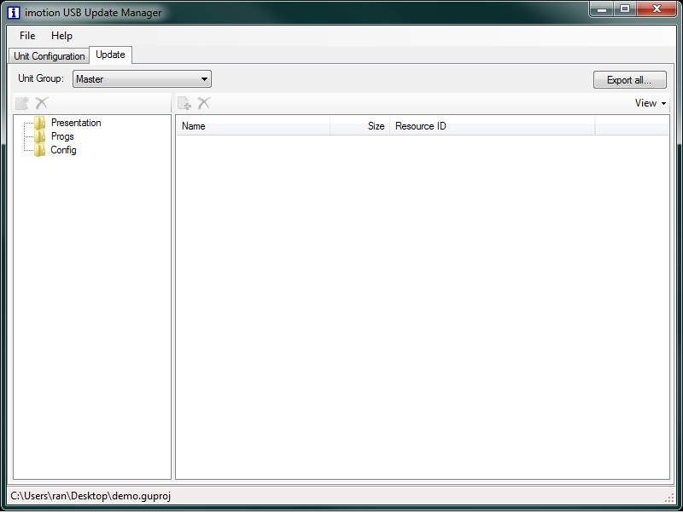

Figure 3‑5 Unit group folder configuration

### Add/Remove folders

The user can add or remove folders from the existing configuration using the icon or icon just above the folder tree view on the left. The folders that are added are empty folders. The files for the specific folders must be added separately. When a folder is removed, all files and folders within that folder are removed too.



### Add/Remove files

To add files into a selected folder, click on the folder and then using the icon on the right, browse and select the file/files to be added to the folder. Once added, the files with their size and the resource id (hash of the file) are visible on the right side.

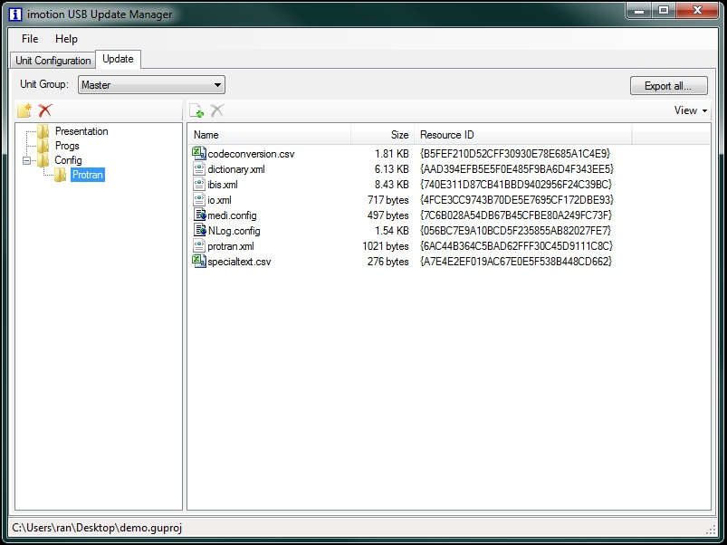

Figure 3‑6 View of files added to a folder

To remove a file/files from a folder, click on the file/files to be removed (multiple selected is allowed) and then use the icon to delete the selected files. Deleting files or folders from the structure will also delete them on the target systems as soon as an update is done.



### Export all

Once the user has added all the required folders and files required for the update, the next step is to export this update for all the units under its unit group for all unit groups in the project. The update can be exported to a USB stick or to an FTP server.

#### Export to USB stick

When the user clicks on the “Export all…” button, all the available USB sticks are shown in a dropdown menu.

When the user selects the correct USB stick, the user has to provide a name for the update and has the option to define pre- and post-installation actions to be performed for each unit group.

#### Configure FTP servers

When the user clicks on the “Export all…” button, “Manage FTP Servers” menu is shown in a dropdown menu. When the user selects this option, a pop-up dialog to configure the FTP server is shown. Click on the icon to create a new FTP server. To the right of the dialog, the configuration setting options are available. The user must enter the “Host”, “Username” and the “Password” for the FTP server. This configuration must match the configuration set in the Update.xml for the FTPClient. To delete a FTP server, select the FTP server and then click on the icon.

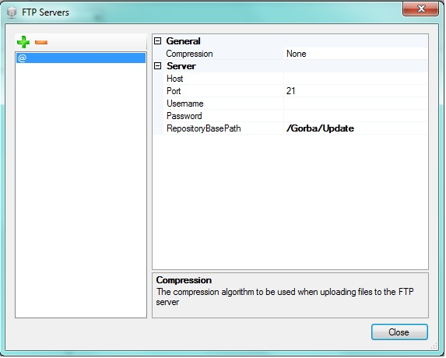

Figure 3‑7 FTP server configuration dialog

#### Export to FTP server

Once the FTP server is created, the user must click on the “Export all…” button. All the configured FTP servers are shown in a dropdown menu. When the user selects the correct FTP server, the user has to provide a name for the update and has the option to define pre- and post-installation actions to be performed for each unit group.

#### Pre- and post-installation actions

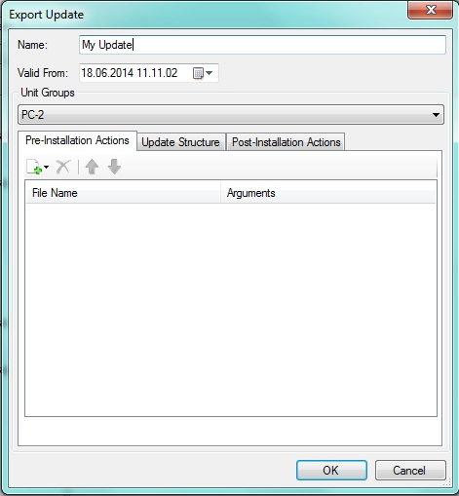

Figure 3‑8 Defining pre- and post-installation actions as well as reviewing the update structure

To define actions, the user has to select the unit group first; actions are always the same for all units of a given unit group and they have to be defined for each unit group separately.

There are three types of items that can be added to either pre or post installation:

* Executable File: choose an EXE or batch file on your system to be (temporarily) copied to the target system and then executed before or after the update
* Regular File: if an executable from above requires additional files (config files, DLLs, …), the user can choose to add them as regular files
* Execute Local Application: an application that already exists on the target system can be executed as part of the update; the entire path to the application has to be provided

For the first and third option, the user has the possibility to add command line arguments. The applications will always be executed with the temporary folder as the working directory (also for executing local applications); this allows the command to reference files from the temporary folder. The actions are executed top to bottom (skipping regular files of course). It is guaranteed that each action is executed exactly once.

#### Parked update

The “Valid From” seen in Figure 3‑1, allows the user to define the time at which the update being exported must be installed on all the units under its unit group for all unit groups in the project. If the user wants to install the update immediately, the user does not need to modify the “Valid From” option as it is always set to the current date and time when the user selects the “Export All…” button. Nonetheless it is suggested to change the time to the past to compensate possible time differences between the PC running USB Update Manager and the target TFT system.

If the user wants to park the update, then the date and time at which the update must be installed must be set in the “Valid From” option.

**Important:** The time defined in “Valid From” is checked on the TFT against the local system time. If this time is not set correctly, updates might be delayed or installed in advance. Therefore make sure to always use a kind of time synchronization (IBIS, SNTP or VDV 301) on the TFT when creating parked updates.

#### Completing the export

Once the user clicks “OK”, the update is exported to the USB stick root with the folder structure “Gorba\Update” if there is enough space on the USB stick; else a message indicating lack of space is seen. If FTP update was chosen, the update is uploaded to the FTP server.

An exported update will always contain the entire structure expected on the target systems. This means, there are no “partial” updates of selected folders or files. The update system on the unit will automatically only update whatever is required to save time.

# Folder structure of exported update on USB and FTP

* The root directory of the folder structure is:
  + “*:\Gorba\Update” on a USB stick where * is the drive letter of the USB stick
  + the configurable “RepositoryBasePath” for FTP
* The repository.xml is present in the root directory. The repository.xml is a XML file which describes the repository structure provided by an update provider and to be used by the update client to perform an update.
* All the resource files are inside the folder “Resources” under the root directory.
* All the update commands for the different units are under the folder “Commands”
  + The commands for each unit are in a folder with the name of the unit under “Commands”.
* All the feedback from different units are under the folder “Feedback”
  + The feedback for each unit is in a folder with the name of the unit under “Feedback”.