Policy Change System
Design Overview
Current Approach, Limitations, and Recommended Improvements
Prepared for: Business and Technology Leadership
March 2026

Executive Summary
This document describes the design of a Policy Change System that uses artificial intelligence to help organizations understand the full impact of policy changes across their business. It explains how the system works today, where it runs into practical limitations as it grows, and what a smarter, more efficient design would look like.

The system has two core jobs:
- Impact Assessment — When a policy changes, automatically determine which business groups are affected by each specific requirement in that policy, and explain why.
- Analysis Assessment — For each affected business group, identify exactly which sections of the supporting documentation they need to review and take action on.

The current experimental approach is a valuable proof of concept that has demonstrated the AI-driven approach can work accurately. However, it processes every possible combination of groups, requirements, and documents individually. This becomes impractical at the scale of real operations. The improved approach uses smarter batching and intelligent document retrieval to deliver the same — or better — results with a fraction of the effort, making the system viable for routine production use.

Key Takeaway: The current approach would require up to 6,000 individual AI calls to process a single policy with 200 supporting documents. The improved design reduces this to fewer than 30 calls — without sacrificing accuracy, and with meaningfully better reasoning quality.

1. What the System Does
When an organization updates a policy, the change ripples outward. Different departments, teams, and business groups may be affected in different ways — and each one needs to know what they are responsible for. Figuring this out manually across complex policies and hundreds of supporting documents is time-consuming, error-prone, and inconsistent from one policy to the next.

The Policy Change System automates this process using artificial intelligence. It reads a policy change, examines its individual requirements, and — for each business group — determines whether that group is affected and what specific actions they need to take.

1.1 How Policy Documents Are Structured
A policy document is not a single block of text. It is organized into sections, and each section contains individual requirements. For example:
- Section 1 — Data Handling: Requirement 1.1 (Data Collection), Requirement 1.2 (Data Retention), Requirement 1.3 (Data Deletion)
- Section 2 — Access Controls: Requirement 2.1 (User Authentication), Requirement 2.2 (Role-Based Access)

Different requirements affect different business groups. Requirement 1.1 might affect Groups A, B, and C. Requirement 1.2 in the same section might affect only Groups B and D. The system needs to determine these relationships accurately for every requirement and every group — and explain its reasoning.

1.2 The Role of Supporting Documents
Beyond the policy itself, each policy is accompanied by a library of supporting documents — procedures, standards, guidelines, and reference materials. A single policy can have up to a few hundred of these. Once the system determines which business groups are affected by which requirements, it then needs to identify exactly which items in those supporting documents each group must review and act on.

This second step — the Analysis Assessment — is where the scale challenge becomes most significant.

1.3 The Role of Historical Data
The system has access to historical records showing how previous policy changes were mapped to business groups. This is a useful reference — it tells us what groups were affected by similar changes in the past. However, it cannot be treated as definitive truth. Policies evolve, organizational structures change, and new types of requirements emerge. The historical data should inform the system's reasoning, not replace it.

2. The Current Approach
The current design is based on a working experiment that proved the concept is sound. The system loops through every combination of business group and requirement, sending a separate question to the AI for each one. For each combination it asks: "Is this business group affected by this requirement, and why?" It has produced accurate results in small-scale testing and laid the foundation for everything that follows.

2.1 Part 1: Impact Assessment — How It Works Today
The system takes the policy document, the list of business groups with their descriptions, and the historical signal, and creates one AI prompt for every group-requirement pair. Each prompt asks whether that business group is affected by that specific requirement, and returns a Yes or No decision with a plain-language explanation.

For example, if there are 5 business groups and a policy with 5 sections of 5 requirements each (25 requirements total), the system makes 125 separate AI calls — one for every possible group-requirement combination.

By the numbers: 5 groups × 25 requirements = 125 individual AI calls for Part 1 alone.

2.2 Part 2: Analysis Assessment — The Proposed Extension
The proposed extension to Part 2 follows the same loop logic. For each combination of impacted group, impacted requirement, and supporting document, the system would make another separate AI call — asking: "What specific items in this document does this group need to address for this requirement?"

This is where the approach runs into a significant scaling problem. Even with a modest set of inputs, the number of AI calls grows very quickly — faster than any of the individual inputs.

By the numbers: 3 impacted groups × 10 impacted requirements × 200 supporting documents = 6,000 individual AI calls for Part 2 alone.

At larger scale — more groups, more requirements, or more documents — this number grows even further and becomes impractical from both a cost and a time perspective. A system that takes hours to process a single policy change is not usable in practice.

Figure 1: The Current Approach — Visualized
The diagram below illustrates how the current approach processes every combination as an independent AI call. The two separate explosion points — one in Part 1 and a much larger one in Part 2 — show how the workload multiplies as inputs scale up.

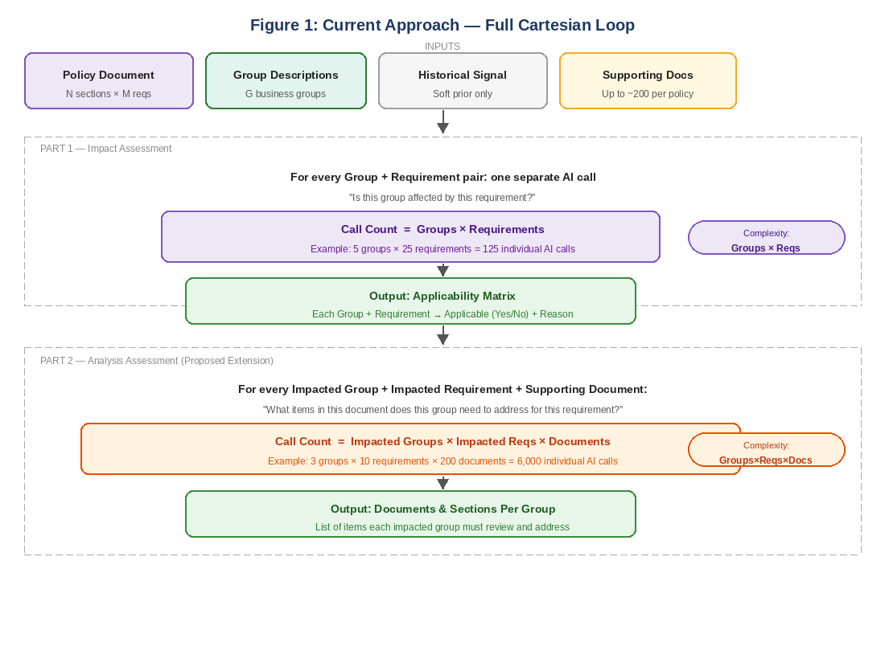
Figure 1: The current approach processes every Group × Requirement pair in Part 1, and every Group × Requirement × Document combination in Part 2. Each box represents a separate AI call, leading to thousands of calls at realistic input sizes.

2.3 Limitations of the Current Approach
While the current approach works for small experiments, it has several important limitations that prevent it from being used reliably in a production environment:

- Volume at scale: At real-world input sizes, the number of AI calls required is impractical. A policy with 200 supporting documents and a reasonable breadth of impact can easily require thousands of calls per run.
- Isolated reasoning: Each call sees only one requirement at a time. Requirements within the same policy section often have meaningful relationships — they may build on each other or share conditions — but the system misses these connections by evaluating each requirement in isolation.
- No cross-document view: In Part 2, each call examines only one supporting document at a time. The system cannot recognize when multiple documents address the same obligation, which leads to duplicate or contradictory outputs for the same business group.
- History as a bias risk: Injecting historical data into every prompt can cause the AI to anchor on past decisions, even when the current policy change is genuinely different. This reduces the system's ability to handle novel requirements accurately.
- Cost and processing time: Thousands of API calls translate directly into financial cost and wall-clock time, making the system slow and expensive to run on a routine basis.

3. The Improved Approach
The improved design keeps everything that works — the AI-driven applicability reasoning, the use of group descriptions, the consideration of historical patterns — but reorganizes how the work is done. Instead of asking the AI thousands of isolated questions, it asks fewer, smarter questions. Each AI call is given more relevant context and produces richer, more coherent output.

The improved design operates in four stages that build on each other:

3.1 Stage 1: Pre-Processing — Prepare Once, Reuse Everywhere
Before any AI calls are made, the system prepares all of its inputs in a structured, reusable way. This preparation step is an investment that pays off by making every subsequent step much faster and cheaper.

- All supporting documents are broken into smaller, logically coherent chunks and organized using a technique called "embedding" — a way of representing text so that similar content can be found quickly and accurately. This index is built once and reused for every group and every requirement without being rebuilt.
- The policy document is analyzed once to extract a clean, structured list of all requirements, organized by section. This means downstream steps do not need to re-read and re-interpret the full policy.
- Business group profiles — their descriptions, responsibilities, and scope — are loaded and stored once, rather than being re-sent in every AI call. This alone reduces the data volume flowing to the AI significantly.

3.2 Stage 2: Batch Impact Assessment — Smarter Part 1
Instead of one AI call per individual requirement, the improved approach sends all requirements from a section together in a single call, alongside the relevant group profile. This change produces two important benefits simultaneously.

First, the AI can reason about how requirements within the same section relate to each other. In the current approach, if Requirement 1.1 and Requirement 1.2 are closely related, the system evaluates them in complete isolation and may reach inconsistent conclusions. In the improved approach, they arrive together and the AI can apply consistent, contextual reasoning across them.

Second, the number of AI calls drops from Groups × Requirements down to Groups × Sections. Since a policy typically has far fewer sections than individual requirements, this is usually a five to ten times reduction in call volume.

Concrete example: A policy with 5 groups, 5 sections, and 25 requirements drops from 125 calls to 25 calls — the same coverage and accuracy, with 80% fewer API calls.

3.3 Stage 3: Retrieval-Augmented Analysis — Solving the Part 2 Scale Problem
This is the most significant improvement, and the one that directly solves the scaling problem in Part 2. Rather than looping through every supporting document one by one, the system uses the indexed document library from Stage 1 to retrieve only the most relevant content for each impacted group.

Think of it as the difference between asking someone to read every book in a library looking for relevant passages versus giving them a smart search tool that surfaces only the pages that matter. The end result is the same — the right information — but the effort is dramatically reduced.

The process works as follows:
- For each impacted business group, the system searches the pre-built document index and retrieves the sections most relevant to that group's impacted requirements. This retrieval step takes milliseconds and returns a focused, manageable set of content.
- Those retrieved sections are then passed together in a single AI call, which synthesizes them and returns a consolidated, actionable list of items the group needs to address.
- Because all relevant document sections arrive in one prompt, the AI can identify overlaps, resolve apparent conflicts, and produce a coherent set of recommendations — eliminating the duplicate and contradictory outputs that the current approach produces.

Concrete example: 3 impacted groups with 200 supporting documents is no longer 6,000 calls. It becomes 3 calls — one per impacted group — each with the most relevant content intelligently pre-selected.

3.4 Stage 4: Validation and Quality Assurance — Keeping Humans in Control
The final stage adds a layer of quality control and human oversight that was not present in the original experiment. This is important for building the trust and accountability that a compliance-related system requires.

- Historical data is used here — after the AI has made its decisions — to flag any results that differ significantly from how similar past changes were handled. This surfaces genuinely novel changes for human review without biasing the AI's primary reasoning process.
- Each applicability decision is assigned a confidence level based on how clearly the policy language and group descriptions align. Decisions the AI is uncertain about are automatically flagged for review rather than passed through unchecked.
- A review queue allows policy owners and business group representatives to quickly validate the flagged items before final outputs are distributed, ensuring a human checkpoint on all ambiguous or high-stakes decisions.

Figure 2: The Improved Architecture — Visualized
The diagram below shows how the improved four-stage design organizes the work. Notice how the pre-processing stage feeds into both Part 1 and Part 2 improvements, and how the validation layer acts as a safety net before outputs are finalized.

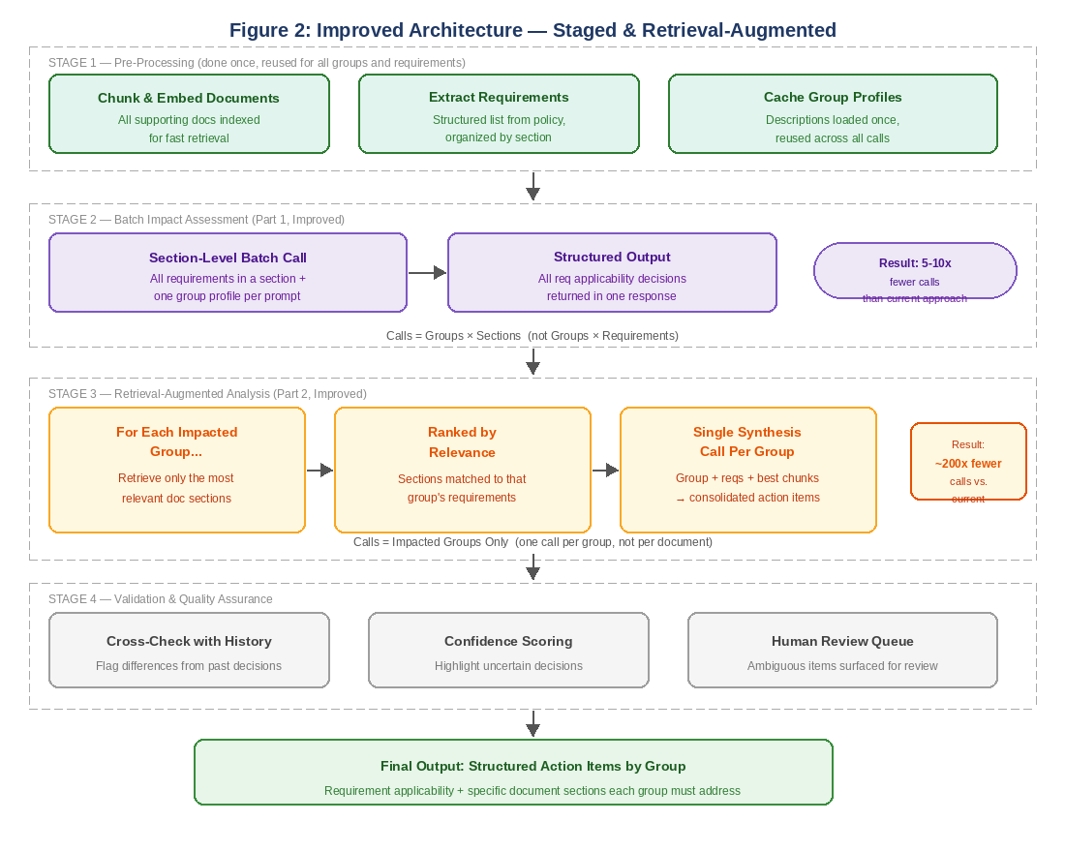
Figure 2: The improved architecture showing four stages: pre-processing (done once), batched impact assessment (Part 1), retrieval-augmented analysis (Part 2), and a validation and quality assurance layer. Call count reductions are shown for both Part 1 and Part 2.

4. Side-by-Side Comparison
The table below summarizes the key differences between the current and improved approaches across the dimensions that matter most for production readiness. Green cells highlight where the improved approach provides a clear advantage.

Dimension | Current Approach | Improved Approach | Why It Matters
Part 1 AI calls | Groups × Requirements | Groups × Sections | 5–10x reduction in cost and time
Part 2 AI calls | Groups × Reqs × Documents | One call per impacted group | ~200x reduction; viable at scale
Cross-requirement reasoning | No — each requirement isolated | Yes — section evaluated together | Better decisions on related requirements
Cross-document reasoning | No — one document per call | Yes — top relevant docs together | Eliminates duplicate or conflicting outputs
Use of historical data | In every prompt (risk of bias) | Post-processing signal only | Reduces bias; surfaces genuine change
Scale at 200 documents | Up to 6,000+ calls per run | Fewer than 30 calls per run | Makes the system viable for production

5. Why This Matters
The difference between the two approaches is not just a technical detail — it has direct and tangible business implications for anyone who relies on this system to manage policy compliance.

5.1 Speed and Responsiveness
When a policy changes, business groups need to know their obligations quickly. A system that requires thousands of AI calls to process a single policy change may take hours to deliver results, or may need to be batched across multiple overnight runs. The improved design enables same-day turnaround on most policy changes — making the system useful when it matters rather than delivering results after decisions have already been made without it.

5.2 Cost at Scale
Each AI call carries a financial cost. An approach that generates 6,000 calls per policy run is not economically sustainable if the organization manages dozens or hundreds of policies. The improved approach reduces call volume by two orders of magnitude, making the system cost-effective for ongoing operational use — not just periodic, high-value policy events.

5.3 Quality and Consistency
By allowing the AI to reason across related requirements and across multiple relevant documents at the same time, the improved approach produces more consistent and better-reasoned outputs. In the current approach, two requirements in the same section might produce conflicting applicability decisions for the same group simply because the AI never saw them together. Similarly, two supporting documents addressing the same obligation might generate duplicate action items. Neither of these problems can occur in the improved design.

5.4 Human Oversight and Trust
A system that produces thousands of outputs with no mechanism for human review creates a compliance risk of its own. The validation layer in Stage 4 ensures that the system surfaces its uncertainty rather than hiding it. Business owners and policy experts remain in the loop on the decisions that carry the most risk, while routine and high-confidence decisions flow through automatically. This makes the system both efficient and trustworthy.

6. Recommended Next Steps
Based on this analysis, the following actions are recommended to evolve the system from a working experiment into a production-ready capability:

- Validate the batching approach on real policy data by running section-level batch calls alongside the current individual calls and comparing the accuracy of results. This confirms the design holds before committing to a full rebuild.
- Select and configure a document embedding and indexing solution to power Stage 1. This is the foundation of the retrieval-augmented approach and the most important infrastructure investment.
- Determine the optimal retrieval depth — that is, how many document sections should be retrieved per group per run. This requires experimentation with representative supporting documents to find the right balance between completeness and focus.
- Design the confidence scoring thresholds in collaboration with policy owners and business group representatives, so the criteria for human review reflect actual organizational risk tolerance rather than arbitrary cutoffs.
- Pilot the validation queue with a small group of reviewers on a real policy change before wide deployment, to calibrate the experience and build familiarity with the workflow.

The current experiment has established that AI-driven policy impact assessment is both feasible and accurate. The improved architecture described in this document ensures that the system can scale to meet real operational demands — reliably, consistently, cost-effectively, and with the human oversight that responsible AI use requires.

