Policy Change System
Complete Design Reference
Architecture, Diagrams, Architect FAQ, and Agile Stories
March 2026

1. Executive Summary

This document is the complete design reference for the Policy Change System. It covers the end-to-end architecture, the data flows through each pipeline stage, the two-index Vector DB structure, the query flow that runs when a policy change is detected, and the Part 2 analysis that produces specific action items for each impacted line of business.

The system solves a specific organisational problem: when a policy changes, different lines of business (LOBs) are affected in different ways by different requirements, and each impacted LOB needs to know exactly which supporting documents and procedures they must review and update. Doing this manually across a large policy library and hundreds of supporting documents is slow, inconsistent, and error-prone. This system automates both the determination of who is affected and the identification of what they need to do.

What the system does
The system operates in two sequential parts triggered by a policy change notification containing a policy identifier and a plain-text description of what changed.

- Part 1 (Impact Assessment): determines which LOBs are affected by which specific requirements in the changed policy, and produces a traceable applicability matrix with a reason for every yes and no decision.
- Part 2 (Analysis Assessment): for each impacted LOB, identifies the specific sections of the supporting documents that the LOB must act on, and produces a structured action item list naming the document, the section, the required action, and the requirement it addresses.

How it works at a high level
Component | Purpose | Key output
Vector DB construction pipeline | Indexes all policy documents and LOB profiles before any change arrives | Policy index (3 chunk types) and LOB index
Query pipeline: relevance filter | Narrows the full requirement list to only those touched by the change | Relevant requirement list stored in MongoDB
Query pipeline: LOB candidate search | Finds LOBs semantically similar to each relevant requirement using vector search | Candidate LOB list per requirement
Part 1: impact assessment | LLM decides whether each candidate LOB is actually affected by each requirement | Applicability matrix: LOB x requirement with yes/no and reason
Part 2: analysis assessment | For each impacted LOB, retrieves relevant document sections and synthesises action items | Structured action item list per LOB stored in MongoDB

The system uses a Vector DB as a semantic search index rather than as a system of record. All source data remains in the Relational DB (policy and document content) and the external LOB system (LOB profiles). MongoDB serves as the operational working store during each pipeline run. The Vector DB holds two indexes: a policy index containing requirement chunks, section body chunks, and supporting document chunks, and a LOB index containing LOB profile chunks.

Key design principle: construction and querying are always sequential, never simultaneous. The Vector DB is built first across all policies, then the query pipeline runs when a change notification arrives. The content hash mechanism ensures re-runs only re-embed what has actually changed.

Why this approach
The critical architectural insight is that determining LOB applicability requires bridging two systems with no shared key: the policy database and the LOB system. Without a shared identifier, the connection must be established semantically. Embedding both requirement text and LOB profile descriptions in the same vector space allows the system to find LOBs whose responsibilities are semantically similar to each requirement, without any manual mapping between the two systems.

The reduction in LLM call volume compared to a naive approach is substantial. An approach that looped over every combination of LOB, requirement, and supporting document would require thousands of calls per policy run. The architecture described in this document reduces Part 2 to one LLM synthesis call per impacted LOB, with vector search doing the document narrowing work before the LLM is involved.

2. Vector DB Construction Pipeline

The construction pipeline is a batch process that runs once on initial setup across all policies in the system, and re-runs incrementally when a policy document changes or when LOB profiles are updated. It is not triggered by a policy change notification.

The pipeline produces two indexes. Index 1 (the policy index) contains three chunk types from the policy and supporting documents: requirement chunks (Type A), section body chunks (Type B), and supporting document section chunks (Type C). All three types coexist in the same physical index and are distinguished by the chunk_type metadata field. Index 2 (the LOB index) contains one chunk per LOB profile from the external system. These two indexes serve different search directions at query time and are kept physically separate for that reason.

The diagram below shows the complete construction pipeline including all ten steps, the role of MongoDB as the working store, and the two final indexes in the Vector DB.

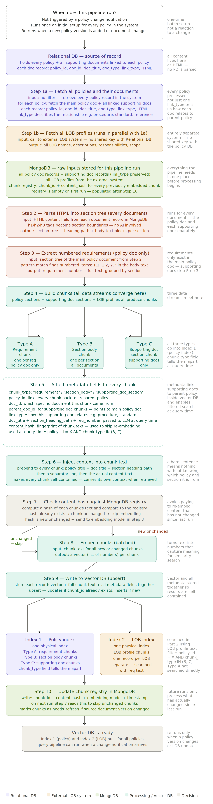
Figure 1: Vector DB construction pipeline. Runs as a batch process across all policies. Steps 7 and 8 use content hashing to skip unchanged chunks on re-runs.

The two-index structure
The diagram below clarifies exactly what lives in each index and how each is searched at query time. This is a common point of confusion: there are exactly two physical indexes, not one per chunk type.

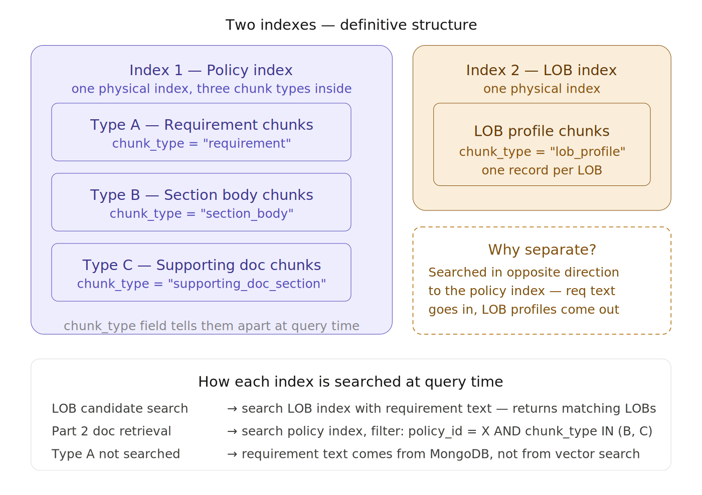
Figure 2: Two-index structure. Index 1 holds all document chunk types together, filtered by chunk_type metadata at query time. Index 2 holds only LOB profiles and is searched in the opposite direction.

3. Query Pipeline: From Notification to Applicability

The query pipeline runs when a policy change notification arrives. It receives a policy identifier and a plain-text description of what changed. Construction and querying are always sequential: the Vector DB must be built before the query pipeline runs, and after the query pipeline completes the construction pipeline re-runs to refresh the index for the changed policy.

The pipeline has five phases. The first three phases (fetching and parsing the HTML, extracting requirements, and running the LLM relevance filter) use no vector search at all. Vector search begins only at the LOB candidate search step. The LLM impact assessment in Part 1 uses no vector search either; it receives the candidate LOB profiles and requirement texts from MongoDB.

The diagram below shows the complete query flow from notification receipt through to the Part 1 applicability results stored in MongoDB, which then feed Part 2.

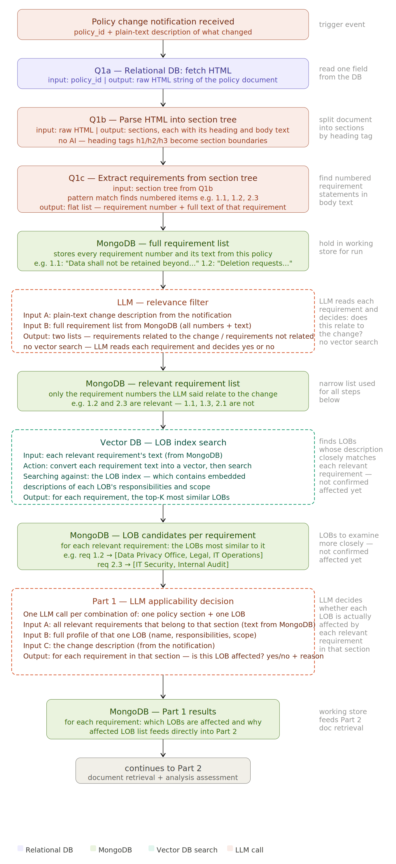
Figure 3: Query pipeline flow. Steps Q1a through the LLM relevance filter use no vector search. Vector search first appears at the LOB candidate search step. Part 1 results are stored in MongoDB and feed directly into Part 2.

4. Part 2: Analysis Assessment

Part 2 runs immediately after Part 1 completes. It takes the list of impacted LOBs and their applicable requirements from MongoDB and produces a specific, traceable set of action items for each LOB. The key design decision is that Part 2 makes exactly one LLM synthesis call per impacted LOB regardless of how many supporting documents exist. Vector search with metadata filtering narrows the document set before the LLM is involved.

For each impacted LOB, the pipeline embeds the LOB profile and searches Index 1 (the policy index) with two metadata filters applied before similarity search runs: policy_id must match the current policy, and chunk_type must be section_body or supporting_doc_section. Type A requirement chunks are excluded because the applicable requirements are already known from Part 1. The retrieved sections are then re-ranked against the specific applicable requirements for that LOB before being passed to the LLM.

The diagram below shows the complete Part 2 flow including the loop structure, the vector search with metadata filters, the re-ranking step, and the LLM synthesis call inputs.

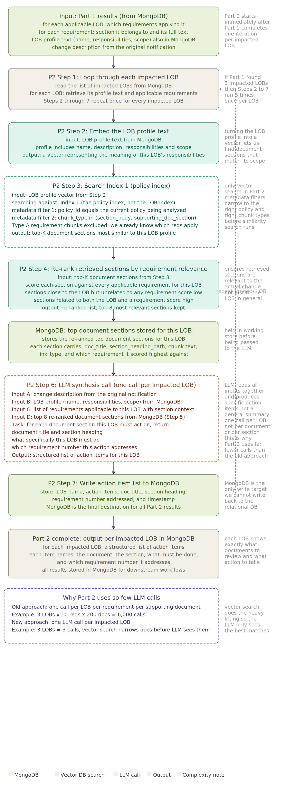
Figure 4: Part 2 analysis assessment flow. Steps 2 through 7 repeat once per impacted LOB. The only vector search in Part 2 is at Step 3. All results are written to MongoDB.

5. Architect FAQ

The following questions and answers address the technical design decisions an architect examining this system is most likely to raise. They cover the rationale for key choices, complexity analysis, optimization opportunities, and testing strategy.

5.1 Vector DB Construction

Q: Why batch process the entire policy database up front? Why not ingest per policy when a change occurs?

This question is really about two different architectural choices: ingesting the entire policy database up front versus ingesting only the policy that changed when a change notification arrives. Construction and querying never happen at the same time. When a change notification arrives, construction runs first for that policy, and only after all data is stored in the Vector DB does the query pipeline begin. The question is whether to pre-build the index for all policies or build it only for the one that triggered the notification.

Per-policy on-demand ingestion is a valid approach and is simpler to implement. However, pre-building the index for all policies offers four specific advantages.

Reduced wait time at notification time. The content hash check skips chunks whose text has not changed. If the index was never built, there is no prior state to compare against and the full construction cost is paid every time. If the index already exists, only the delta is re-embedded.

Cross-policy document deduplication. Supporting documents are often shared across multiple policies. If those documents are already indexed from a prior policy run, their chunks are not re-embedded when a different policy referencing the same documents is processed.

Consistent LOB index state. The LOB index is independent of any individual policy. It should exist before any query runs and be refreshed on its own schedule. Pre-building at startup establishes a clean baseline.

Operational simplicity. When the index covers all policies, the query pipeline always finds the policy already indexed with no conditional branching logic needed at query time.

Both approaches are valid. Pre-building is preferred when the policy database is large, when supporting documents are shared across policies, or when minimising time-to-result after a notification matters.

Q: How often does the construction pipeline re-run?

The construction pipeline re-runs for a specific policy when a new document version is loaded into the Relational DB, or when LOB profiles in the external system change. In both cases only affected chunks are re-embedded due to the hash check. The LOB index should be refreshed nightly at minimum since LOB profile changes do not produce a notification event.

Q: What happens if the Vector DB is stale when a change notification arrives?

The query pipeline will still function correctly. The relevance filter and impact assessment use requirement text extracted live from the HTML at query time, not from the Vector DB. The Vector DB is only used for LOB candidate search and document section retrieval in Part 2. If LOB profiles are slightly stale the LLM applicability call will correct for this using the full profile text from MongoDB. After the query pipeline completes, construction re-runs for the changed policy to bring the index fully current.

5.2 Complexity

Q: What is the call count complexity for each part?

The table below shows the number of calls at each stage and what drives it. Part 1 and Part 2 are both bounded by the number of impacted LOBs, not by the total number of requirements or supporting documents.

Stage | Call count | Example | What drives it
Vector DB construction | One embed per chunk | ~500 chunks per policy | Number of sections and docs
Relevance filter | 1 LLM call total | 1 call | Fixed regardless of policy size
LOB candidate search | 1 vector search per relevant req | ~10 searches | Number of relevant requirements
Impact assessment (Part 1) | LOBs x sections with relevant reqs | ~20 calls | Candidate LOBs and sections
Doc retrieval (Part 2) | 1 vector search per impacted LOB | 3 searches | Number of impacted LOBs only
Synthesis (Part 2) | 1 LLM call per impacted LOB | 3 calls | Number of impacted LOBs only

The old approach of looping over every (LOB, requirement, document) combination would produce up to 6,000 calls for a modest policy. The new approach reduces Part 2 to one LLM call per impacted LOB.

5.3 Prompt Caching Opportunities

Q: Are there opportunities to use prompt caching?

Four meaningful caching opportunities exist in this pipeline.

Relevance filter prefix caching. The full requirement list for a policy is a stable prefix that can be cached by the LLM provider if the policy is processed multiple times within a short window.

Impact assessment system prompt caching. The change description, policy title, and instruction content are identical across all Part 1 calls for the same policy run. Structuring the prompt so stable content appears first maximises provider-side prefix cache hits.

LOB profile TTL reuse. LOB profiles change infrequently. Profiles fetched at the start of one run can be reused for subsequent runs within a configurable time window without re-fetching from the external system.

Chunk embedding cache. The content hash check in Step 7 of the construction pipeline is itself the most impactful cache: any chunk whose text has not changed is never re-embedded.

Practical recommendation: structure all LLM prompts so stable context appears before variable content. This maximises provider-side prefix cache hit rates with no additional code changes.

Part 1 results can also be cached in MongoDB keyed on policy_id, policy version, and a hash of the change description. If the same combination is submitted again, the impact assessment LLM loop is skipped entirely.

5.4 Testing and Validation

Q: How do we test the results to make sure we get complete and accurate output?

The system has two failure modes: false exclusions (missing something that should be included) and false inclusions (including something irrelevant). False exclusions are the more serious failure because they are invisible to the downstream reviewer.

What to test | How to test | Pass criteria
Relevance filter completeness | Recall test against labelled dataset | No known-relevant requirement is excluded
LOB candidate recall | Compare results to historical records | Every known-affected LOB appears at the chosen top-K
Impact assessment accuracy | Human review of LLM decisions on a sample | Agreement rate above agreed threshold
Document retrieval relevance | Verify retrieved sections relate to applicable reqs | No LOB receives action items unrelated to its reqs
Action item completeness | Diff against manually produced lists for a sample | All material obligations identified by SMEs appear in output
Traceability | Verify every action item has doc section and req number | Zero action items without both a doc reference and req number

5.5 Additional Design Questions

Q: Why is there no shared key between the Relational DB and the external LOB system?

The absence of a shared key is a constraint of the current system landscape, not a design choice. Building a formal mapping table would be the ideal long-term solution. Until it exists, the LOB index serves as the semantic bridge. The risk is that LOBs with thin profiles match poorly against requirement text. If LOB profiles cannot be enriched in the external system, enriching them at index time using an LLM is a viable approach that does not require changes to the source system.

Q: Why are Type A requirement chunks excluded from the Part 2 document retrieval search?

By the time Part 2 runs, applicable requirements are already known from Part 1 and stored in MongoDB. Searching Type A chunks would return requirement statements that add no new information. Part 2 needs the procedural and narrative content of documents, which lives in Type B and Type C chunks. Including Type A would dilute results and waste retrieval budget.

Q: Is the system dependent on the quality of LOB profiles in the external system?

Yes, significantly. The quality of Part 1 LOB candidate retrieval is directly proportional to how descriptive and specific LOB profiles are. A LOB described only as "manages compliance activities" will match poorly against specific requirement text. Before deploying, audit the profiles against representative requirements. If profiles are thin, enriching them at index time using an LLM is a viable approach that does not require changes to the external system.

6. Agile User Stories

The stories below cover both system-level pipeline behaviour and the needs of LOB subject matter experts (SMEs) who need to understand whether a policy change affects their line of business and what specific actions they must take. Each story follows the standard format with acceptance criteria.

6.1 System Stories

System stories describe the pipeline infrastructure and data flows. They are owned by the engineering team.

SYS-001 | Vector DB initial construction
As a: system pipeline
I want: to parse the HTML of all policy documents and supporting documents, build context-enriched chunks, embed them, and store them in the policy index
So that: the index is ready before any change notifications are processed
Acceptance criteria:
- All policy and supporting documents are fetched and parsed using the HTML section parser
- Three chunk types are produced: requirement (Type A), section body (Type B), supporting doc section (Type C)
- All three types are written to Index 1 with chunk_type, policy_id, doc_id, parent_doc_id, link_type, and content_hash metadata fields
- LOB profiles are fetched from the external system and written to Index 2
- A chunk registry entry is created in MongoDB for every embedded chunk
- Construction completes without error for a policy database of at least 500 documents

SYS-002 | Incremental Vector DB refresh on policy change
As a: system pipeline
I want: to re-run construction for only the changed policy and its documents when a new document version is loaded
So that: the index reflects the latest content without re-embedding unchanged documents
Acceptance criteria:
- The pipeline fetches only documents associated with the changed policy_id
- Each chunk content_hash is compared to the MongoDB registry before embedding
- Chunks whose hash matches an existing registry entry are skipped
- Only new or changed chunks are embedded and upserted into the vector DB
- A policy with one changed section re-embeds only chunks from that section

SYS-003 | Relevance filter: identify requirements affected by a change
As a: system pipeline
I want: to send the full requirement list extracted from the changed policy HTML to the LLM alongside the change description, and receive back only the requirements that relate to the change
So that: downstream steps only process relevant requirements, reducing unnecessary LLM calls
Acceptance criteria:
- The HTML is fetched from the Relational DB and parsed into a section tree at notification time
- Requirements are extracted by numbered item pattern matching
- The LLM receives the change description and full requirement list and returns relevant and not-relevant lists
- The relevant list is stored in MongoDB for all downstream steps
- The excluded list is also stored with reasons for auditability

SYS-004 | Part 1 impact assessment: determine LOB applicability
As a: system pipeline
I want: to send each (policy section, candidate LOB) combination to the LLM with relevant requirements and the full LOB profile, and receive back a structured applicability decision
So that: the system produces a traceable applicability matrix before document analysis begins
Acceptance criteria:
- One LLM call is made per combination of policy section and candidate LOB
- Each call receives the change description, all relevant requirements in the section, and the full LOB profile
- The LLM returns applicable (yes or no), a plain-language reason, and a confidence level for each requirement
- Results are stored in MongoDB as the Part 1 applicability matrix
- LOW confidence decisions are flagged in a review queue before Part 2 begins

SYS-005 | Part 2 document retrieval and synthesis per impacted LOB
As a: system pipeline
I want: to embed each impacted LOB profile, search Index 1 filtered by policy_id and chunk_type, re-rank results against applicable requirements, and synthesise a structured action item list
So that: each impacted LOB receives a precise, traceable set of document sections to act on
Acceptance criteria:
- The LOB profile is embedded and used to query Index 1 with policy_id filter and chunk_type IN (section_body, supporting_doc_section)
- Type A requirement chunks are excluded from the search
- Retrieved sections are re-ranked weighting requirement relevance at 60 percent and LOB profile similarity at 40 percent
- The top 8 sections after re-ranking are passed to the LLM in a single call
- Output is a structured list naming document, section, specific action, and requirement number addressed
- All results are written to MongoDB

6.2 LOB SME User Stories

User stories describe the experience of an LOB subject matter expert navigating the system to understand their policy change obligations.

USR-001 | LOB SME: find out if my LOB is affected by a policy change
As a: LOB subject matter expert
I want: to be notified when a policy change assessment completes and to see immediately whether my LOB is applicable to any changed requirements
So that: I do not have to read the full policy or request an assessment manually
Acceptance criteria:
- I receive a notification when Part 1 completes that includes my LOB name and the number of applicable requirements
- The notification states clearly if my LOB has zero applicable requirements so I know no action is required
- I can access full results from the notification link without logging into a separate system
- The notification identifies the policy by name and version

USR-002 | LOB SME: understand which requirements apply to my LOB and why
As a: LOB subject matter expert
I want: to view a plain-language explanation for each requirement the system has determined applies to my LOB, including why
So that: I can make an informed judgement about whether the applicability decision is correct before I begin any work
Acceptance criteria:
- I can view all requirements applicable to my LOB grouped by policy section
- Each applicable requirement shows the full text and a plain-language reason for applicability
- I can also view not-applicable requirements with their reasons to verify nothing has been missed
- If I believe a not-applicable determination is wrong, I can flag it for review from this view
- The view is printable and exportable

USR-003 | LOB SME: see exactly which documents and sections I need to act on
As a: LOB subject matter expert
I want: to view a structured list of the specific document sections my LOB must review and update, with a plain-language description of the action required for each
So that: my team has a clear actionable work list without reading every supporting document
Acceptance criteria:
- For each applicable requirement I can see the supporting document sections my LOB must address
- Each item names the document, the section heading, what my LOB must specifically do, and which requirement it addresses
- Items covering multiple requirements in the same section are consolidated into a single item
- I can mark individual items as in progress or complete
- The action item list is exportable so I can assign tasks in my team's existing workflow tools

USR-004 | LOB SME: understand the scope of impact before committing my team
As a: LOB subject matter expert
I want: to see a summary of total impact including how many requirements apply, how many documents are involved, and how many action items were generated
So that: I can plan my team's capacity and escalate to management with accurate information
Acceptance criteria:
- A summary view shows the total count of applicable requirements, documents involved, and action items for my LOB
- The summary is available as soon as Part 2 completes before I open the detailed list
- I can see which policy sections are driving the most impact
- The summary is shareable as a standalone report for management

USR-005 | LOB SME: dispute an applicability or action item decision
As a: LOB subject matter expert
I want: to formally flag any determination I believe is incorrect, providing my reasoning
So that: errors can be corrected before my team acts on incorrect information and the correction is recorded for future runs
Acceptance criteria:
- I can raise a dispute on any applicable or not-applicable requirement determination for my LOB
- I can also dispute an individual action item if I believe it is incorrectly described
- The dispute form requires a plain-language reason
- Submitted disputes are routed to a reviewer and I am notified of the outcome
- Dispute outcomes are stored as labelled examples that inform future calibration

USR-006 | LOB SME: view the history of policy changes that affected my LOB
As a: LOB subject matter expert
I want: to see a chronological list of all policy changes where my LOB was applicable, with requirements and action items from each
So that: I have an ongoing compliance record I can present to auditors
Acceptance criteria:
- I can access a history view showing all completed assessments where my LOB was impacted
- Each entry shows the policy name, version, change description, applicable requirements, and action items generated
- I can see whether each historic action item was marked as complete
- The history is filterable by date range and policy name and is exportable

USR-007 | LOB SME: compare the current impact to a previous policy version
As a: LOB subject matter expert
I want: to see what has changed for my LOB between the current and previous policy version
So that: I can quickly understand the net change in my obligations rather than reviewing the full impact from scratch
Acceptance criteria:
- A comparison view shows requirements newly applicable in this version, requirements no longer applicable, and requirements whose action items changed
- Unchanged requirements and action items are clearly marked so I focus only on what is new or different
- I can export the comparison as a delta report for management

USR-008 | LOB SME: track the status of an assessment in progress
As a: LOB subject matter expert
I want: to check the current processing status of a policy change assessment so I know when my results will be available
So that: I am not waiting without visibility and can plan my team's schedule
Acceptance criteria:
- A status page shows the current pipeline stage: construction, relevance filter, candidate search, impact assessment, pending human review, document analysis, or complete
- If paused waiting for human review the status shows how many items are in the queue
- I receive a notification when the assessment reaches the complete state
- If the assessment fails the status page shows which stage failed and a plain-language description of the error

