Programming Principles and Practice

Assignment Report

Project: Grocery Store Inventory System

Author: Lin, Xiaofeng

ID: 1487467

**Introduction**

This Applet provides a simple way to track items of a grocery store.

The information of an item ready to be added to the warehouse is entered manually. When the Add to Stock button is clicked, the information is saved in a database, which is a group of text files. The user can browse the inventory in stock at any time by clicking the Show and Modify Items in Stock button.

When a user wants to move an item to the shelf from the warehouse, she can simple choose the item from a table of items in stock and by clicking the Move to Shelf. She can also check all the items off the shelf.

When a customer is ready to pay the items he has chosen, the cashier enter the barcode of each item. When all items have been added to the shopping cart table, the cashier can get the bill by simply clicking the checkout button. The store owner can check the statistics of the sold item record by clicking the statistics button, which pops up a new window that will show the comparison of generic and brand name items sold when the compare button is clicked.

The store worker can check all the items in stock, off the shelf or bought away by clicking the show and modify items button in a sub-window, i.e. Stock Window, Shelf Window or Sell Window, respectively.

**Results**

Some screenshots of windows of this system are shown below as the results of the program.

1. The Main Window (The Welcome Window)

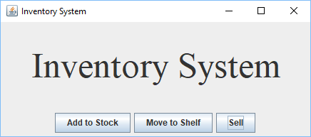

1. When the Add to Stock button is clicked, the Stock Window allowing item information input shows up.

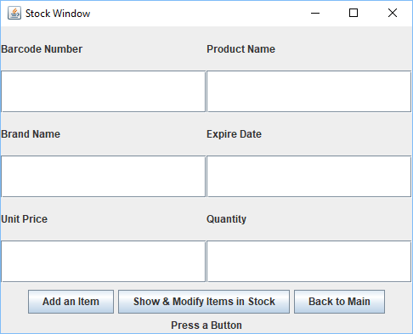

1. All items in stock are shown in the window below when the “Show & Modify Items in Stock” is clicked.

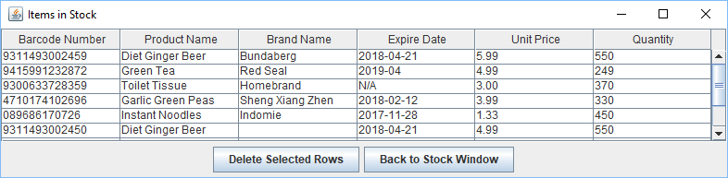

1. Back to the Main Window, click the “Move to Shelf” Button, the Shelf Window shows up. You can choose items from the table an move them to the shelf by clicking the “Move to Shelf” button.

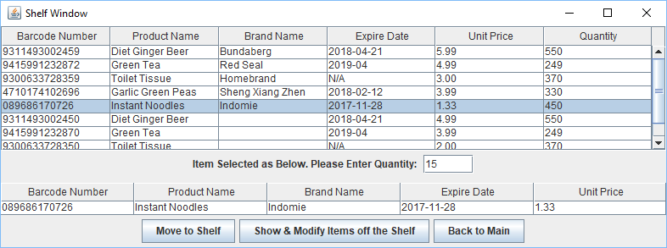

1. By clicking the middle button, you come to the table that shows all items off the shelf.

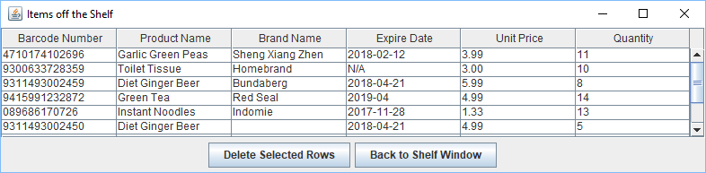

1. Back to the Main Window, open the sell window by clicking the sell button and now you can do the business. Enter the barcode of the item that a customer wants to buy and click the “Add to Cart” button. Items will be added to the shopping list one by one. You can specify the quantity by enter a number in the quantity text field. The default quantity is one.

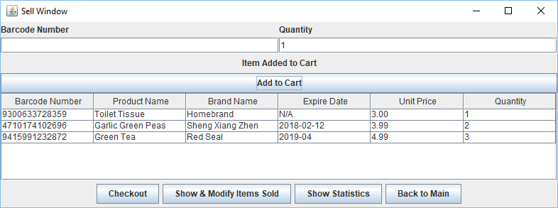

1. You can get the total by clicking the checkout button

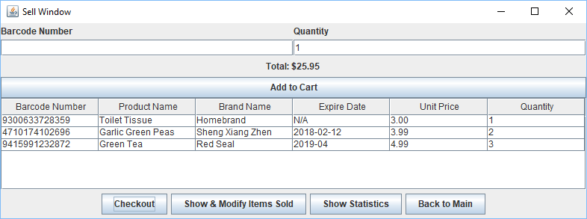

1. You can check the items that have been sold by clicking the second button.

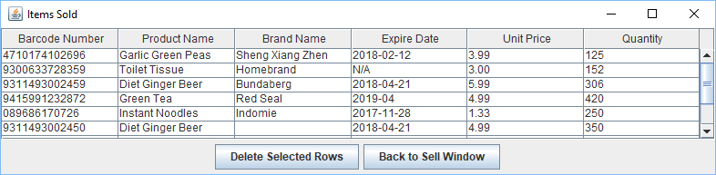

1. The system provides a comparison of generic and brand items. You can check it out by clicking the “Show Statistic” button and clicking the “Compare Generic & Brand” button in the window popped up.

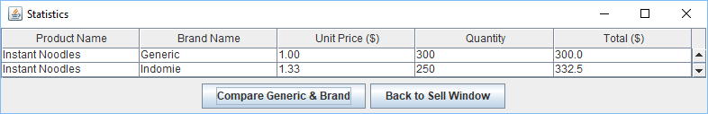

The relations of the classes that this project uses are shown below, which is a simplified UML diagram.

