How to assemble the fluorometer step by step

Materials

- Lasercut part set
- NodeMCU Amica V2
- Light sensor Adafruit TSL2591
- LED B-470-513/C
- Long pass filter, Acrylic 510nm
- 6x Jumper wires 6x
- Screws M2.5 x 8mm & nuts + washers(gasket)
- Black Edding, Tape

Overview

The device consists of two nested components, an big outer box and a small inner sampling assembly. The outer box only serves to further isolate the sampling assembly from ambient light. The sampling assembly holds the sensor, filter, and LED in place and features a hole to insert the 0.2ml PCR tube containing the sample into.

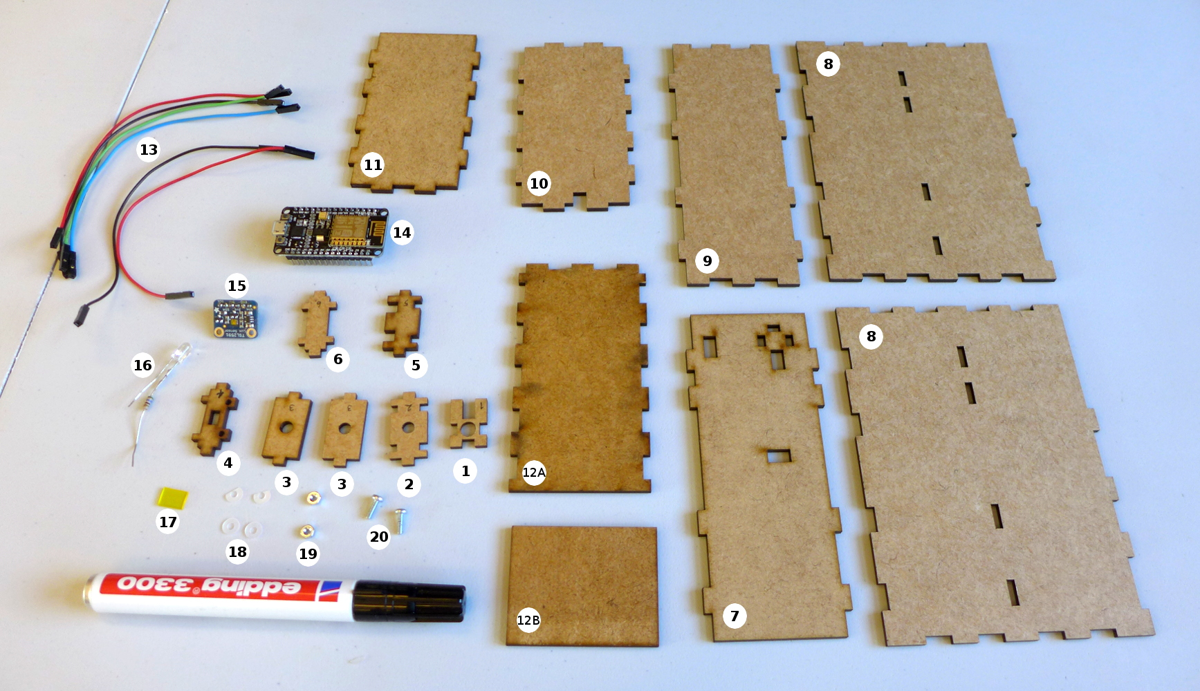
7, 8, 9, 10, 11, 12A, 12B: Outer box
1, 2, 2x3, 4, 5, 6: Sensor assembly
17: Filter
18, 19, 20: Washers, nuts, screws
16: LED (resistor not actually necessary)
15: Adafruit TSL2591 light sensor
14: NodeMCU Amica V2
13: Jumper wires
Step 1: Putting together the sampling assembly

1) Build the sensor holder
You will need a small piece of filter with the dimensions 5mm x 9 mm. The filter has to be big enough to cover the entire sensor window, but still small enough to fit on the sensor holder.

On piece 4, insert 2 screws in the round holes.
Flip piece 4 over and place two washers on each screw. You may have to cut off parts of the washers.
Place the sensor module on top of the washers. Check that the sensor on the sensor module is visible through the small hole in piece 4. Screw on the nuts and make sure that the sensor is held firmly in place by the screws and nuts.
To reduce the amount of reflected light inside the sampling assembly, we recommend you use a Black Edding to paint the side of piece 4 that is not covered by the sensor. (Not shown in the pictures).
Using small bits of black tape, fix the filter onto piece 4 in front of the small sensor hole. Make sure that the filter covers the entire hole.

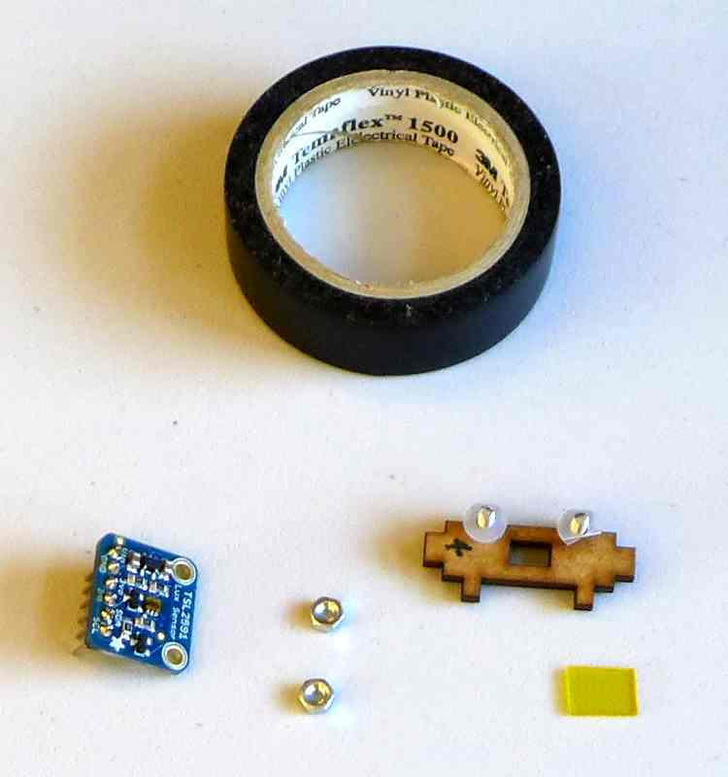
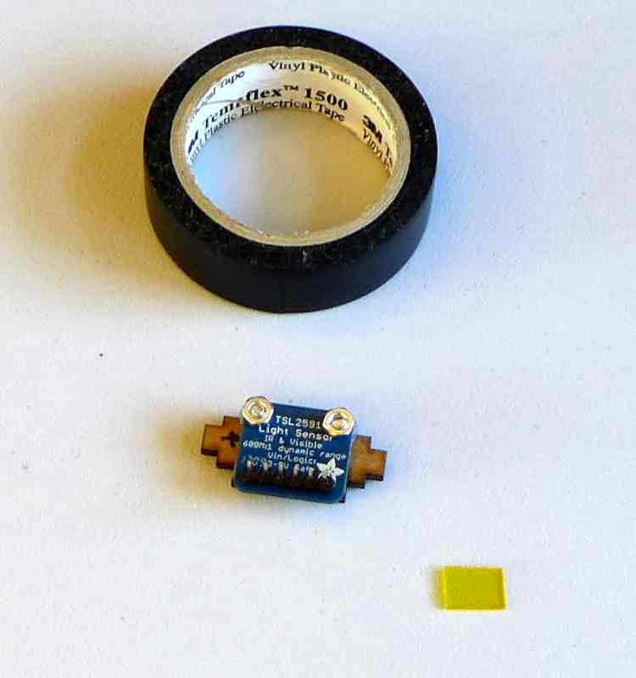
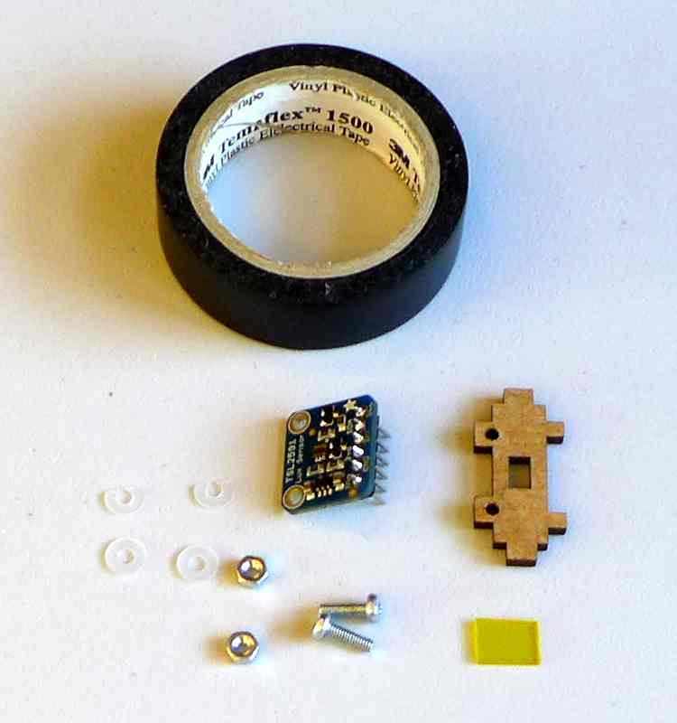
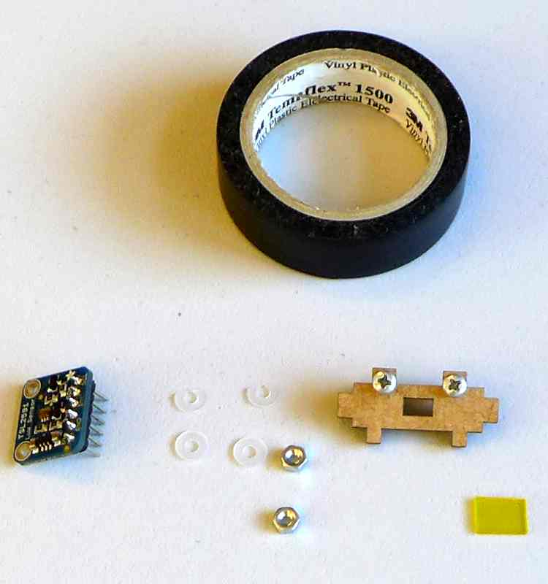

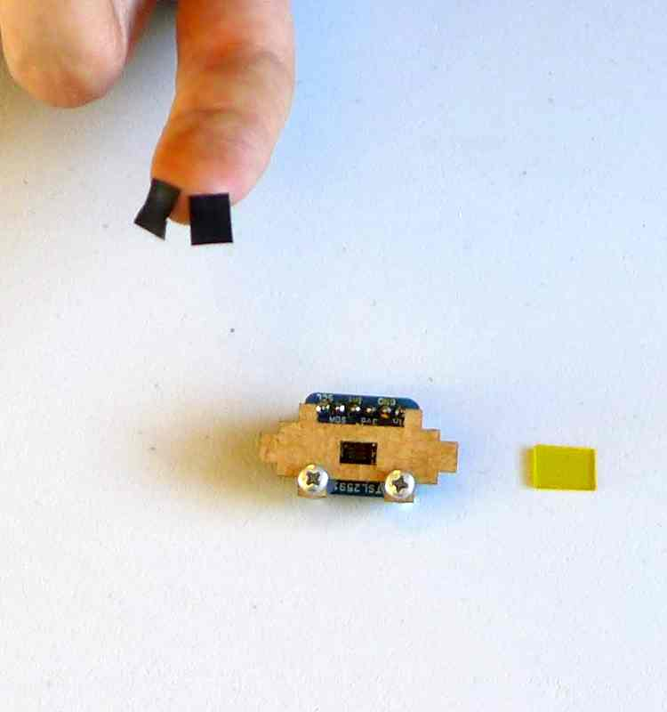
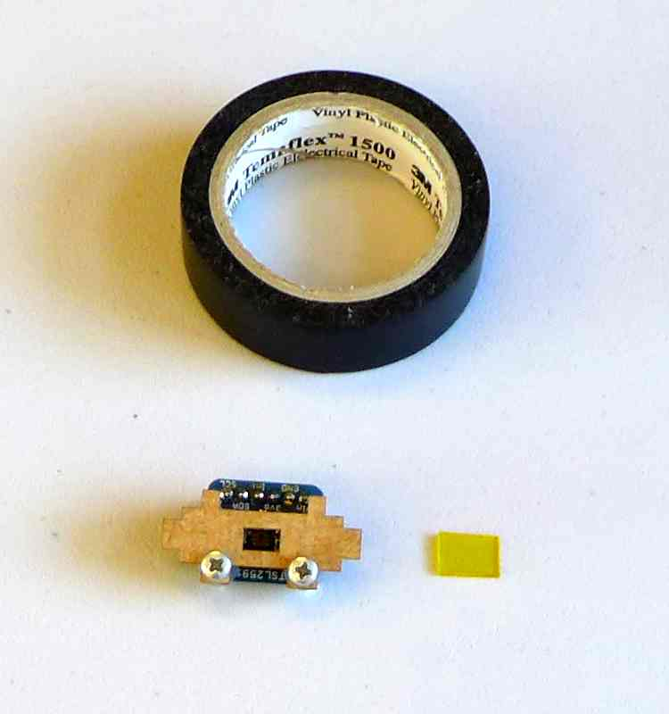
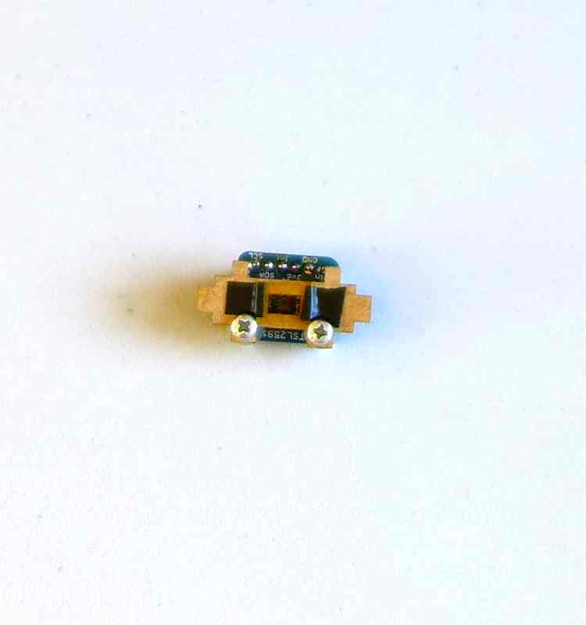

The finished sensor holder should look something like this:

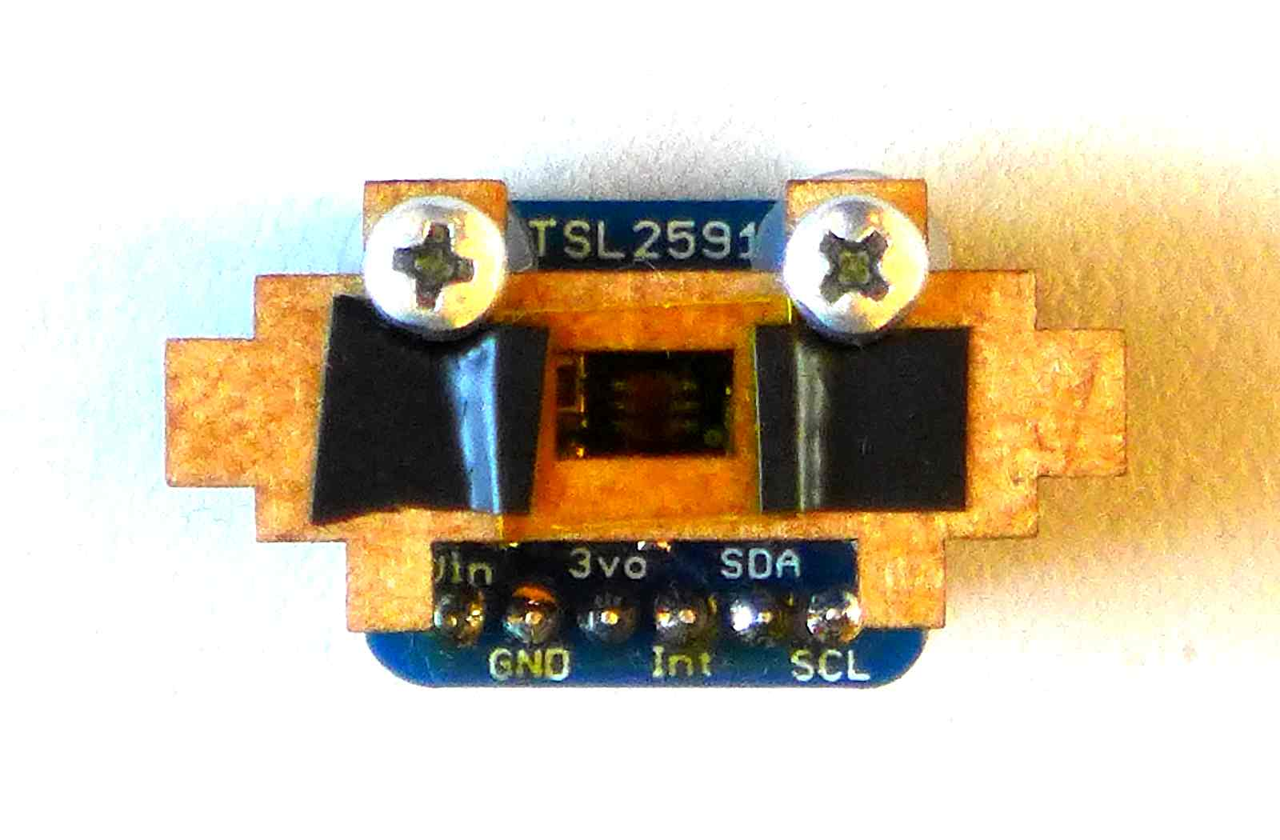

2) Build the LED holder

Note: The following images show a resistor, but when supplying the LED from the NodeMCU, this is not actually necessary.

Stack the two pieces 3 on top of each other. Insert the LED’s head into the hole. You might have to use a little bit of force; that’s OK, it ensures that the LED stays firmly in place.
Again, we recommend painting one side of piece 2 black. The black side will be the one facing the inside of the sampling assembly.

head into pieces
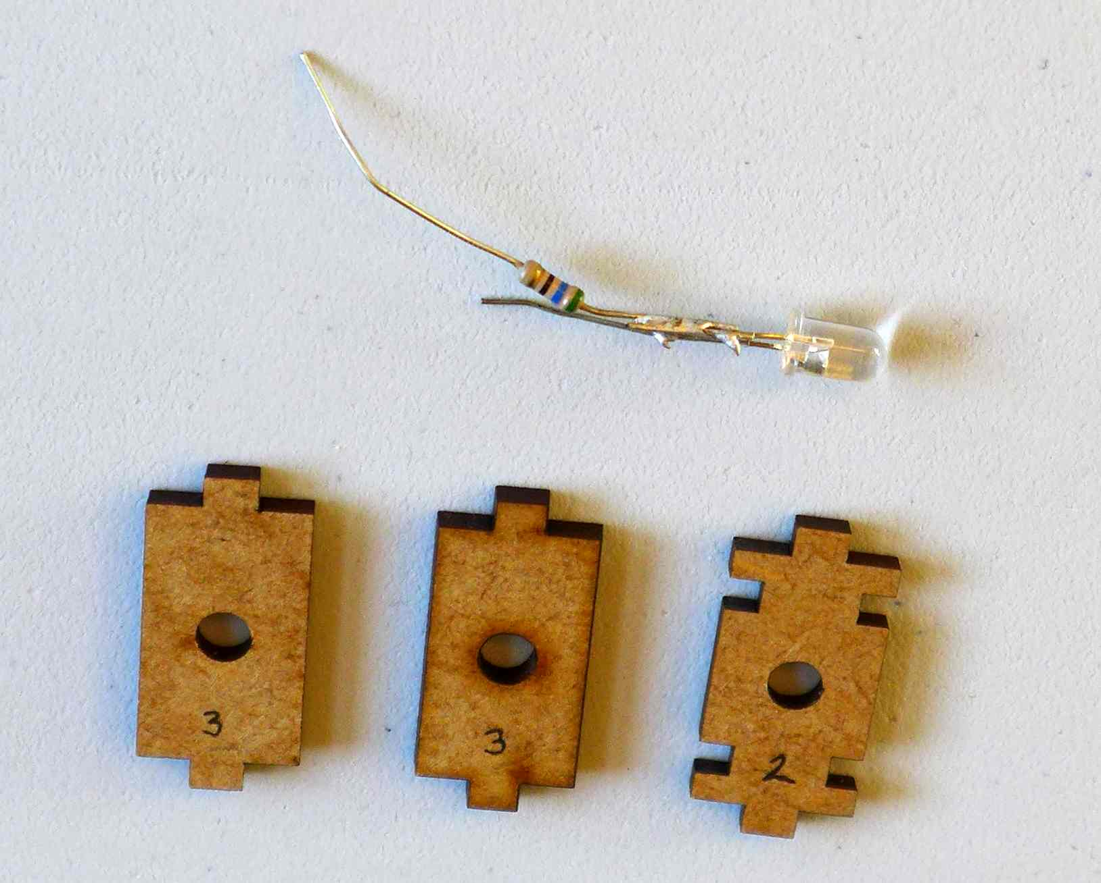
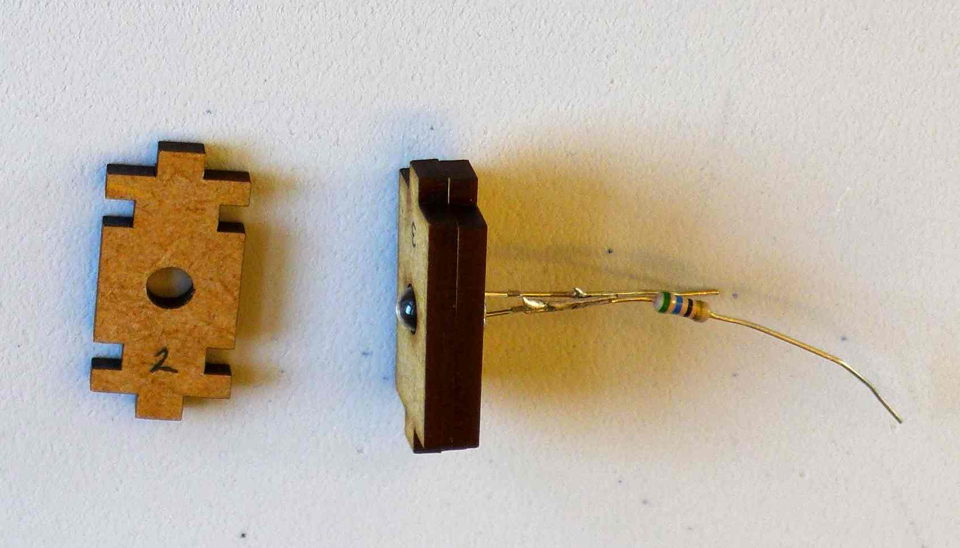
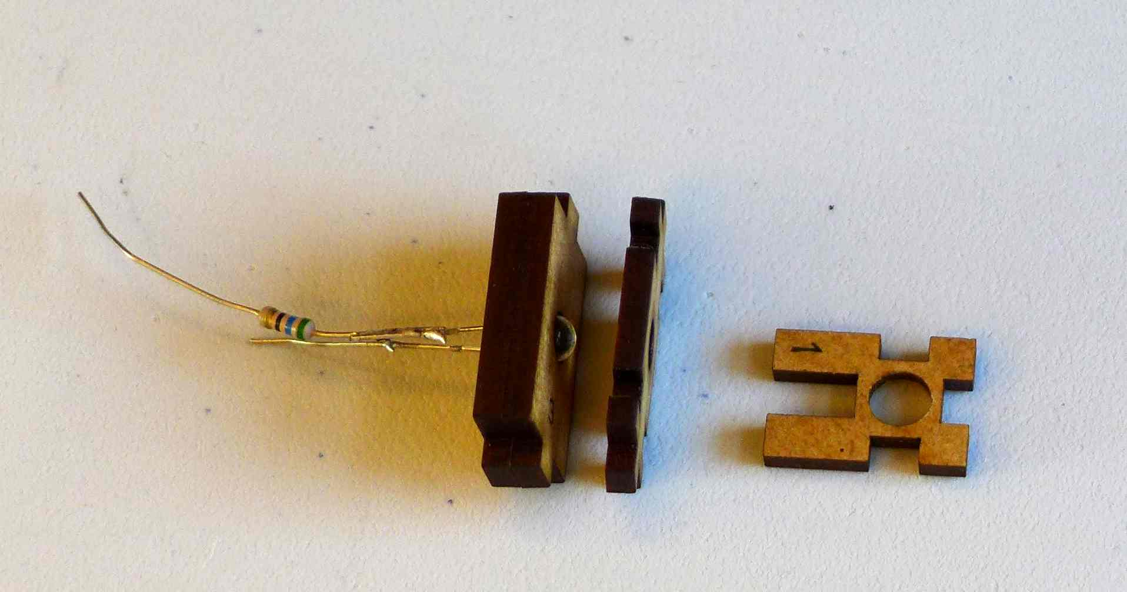

3) Put together the LED holder (2, 3, 3) and the top lid (1). Piece 1 should also be painted black on the side facing the inside of the sampling assembly (not shown here).
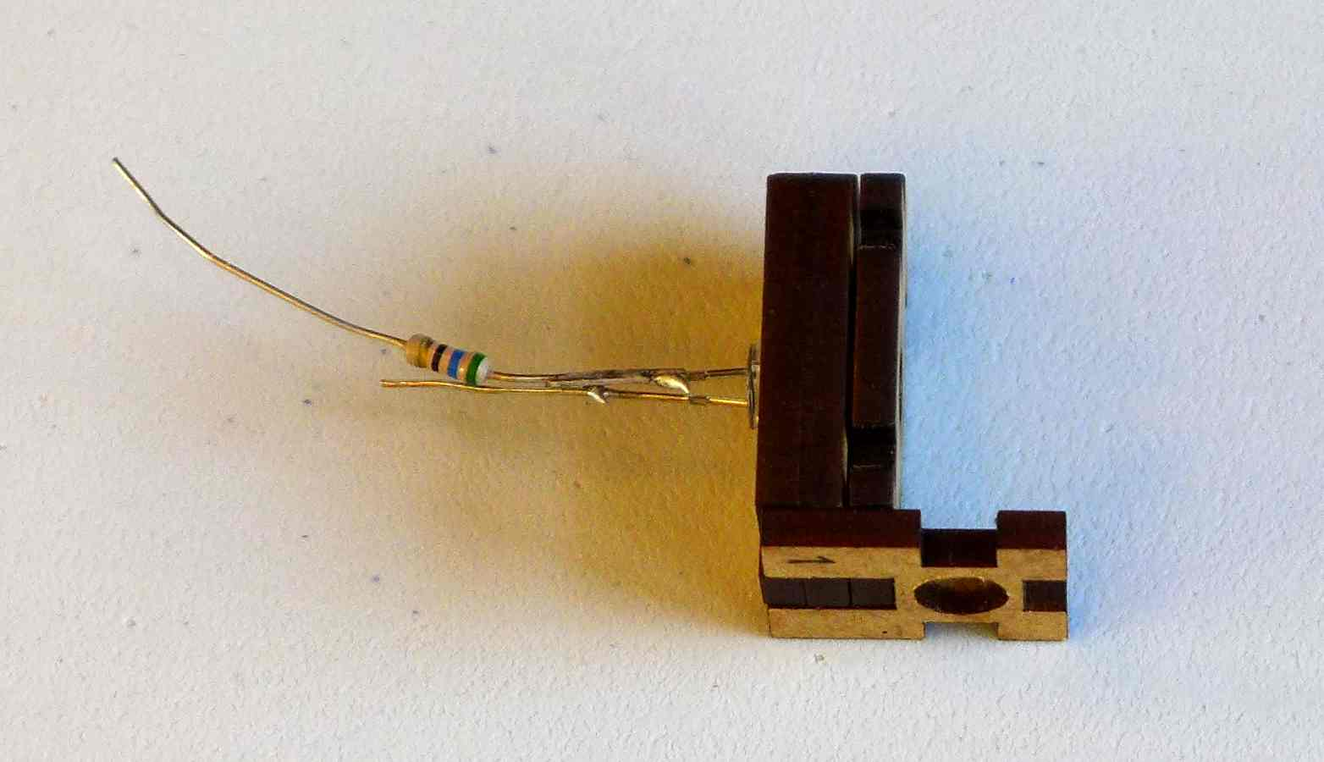

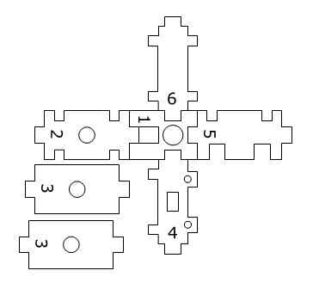
4) Add piece 6 as shown. Piece 6 should also be painted black on the side facing the inside of the sampling assembly (not shown here).
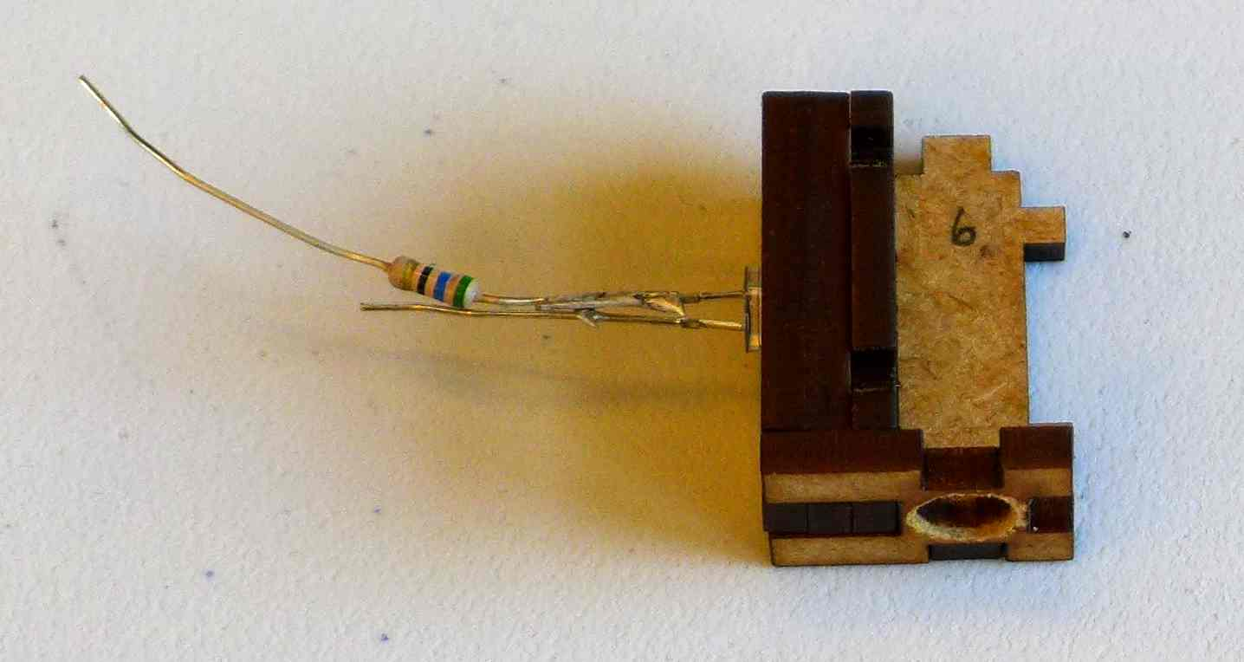

5) Add piece 5 as shown. Piece 5 should also be painted black on the side facing the inside of the sampling assembly (not shown here).

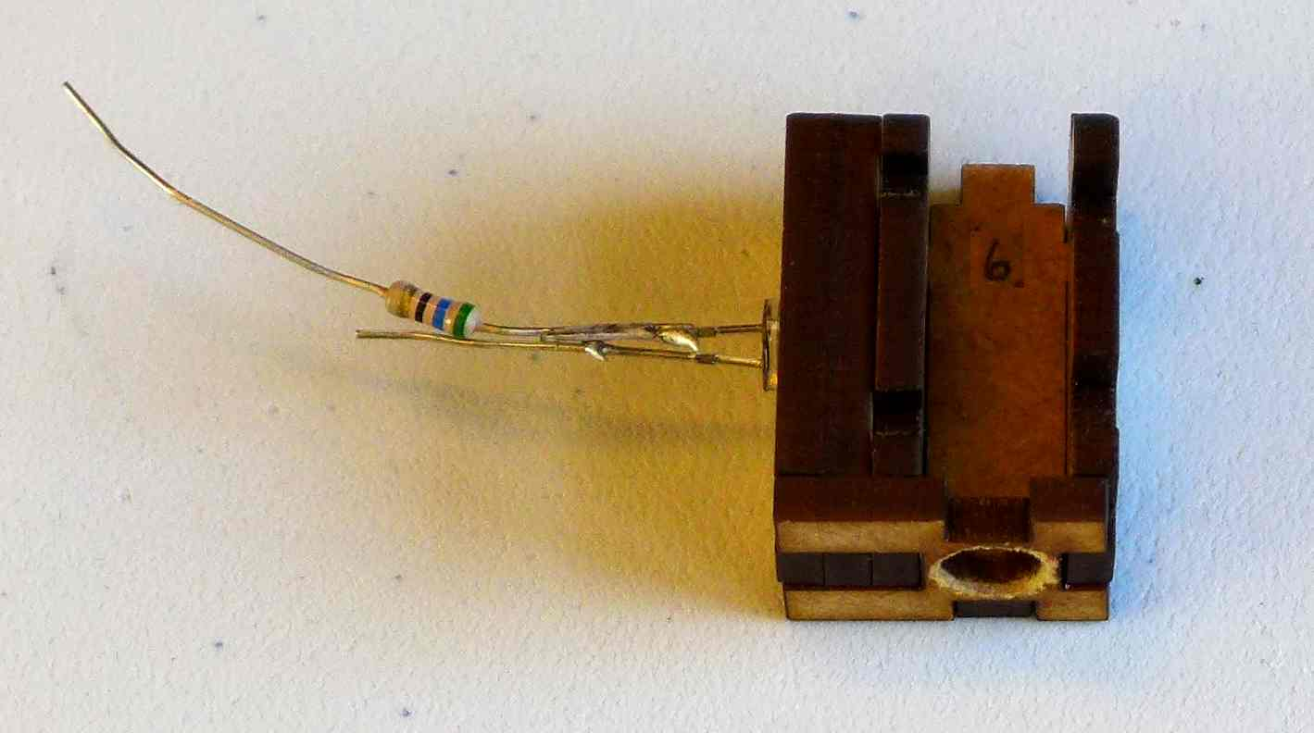

6) Add the sensor holder as shown. The sensor will be on the outside of the sampling assembly.
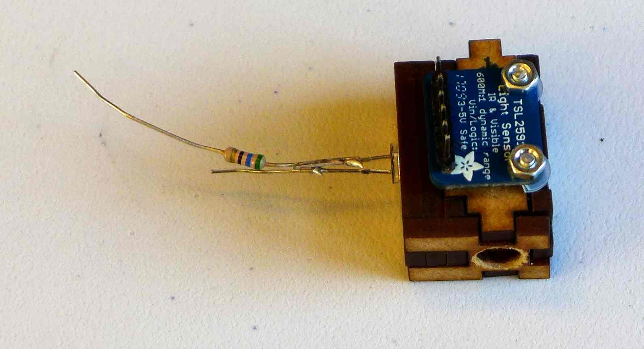

7) Insert the sampling assembly into piece 7. Make sure that the pins of the LED and sensor face their respective holes in piece 7, so that you can comfortably thread the cables from the LED and sensor to the NodeMCU that will sit underneath piece 7.
Then tape the sampling assembly to piece 7 tightly, so that it does not shift around when you are inserting sample tubes later.

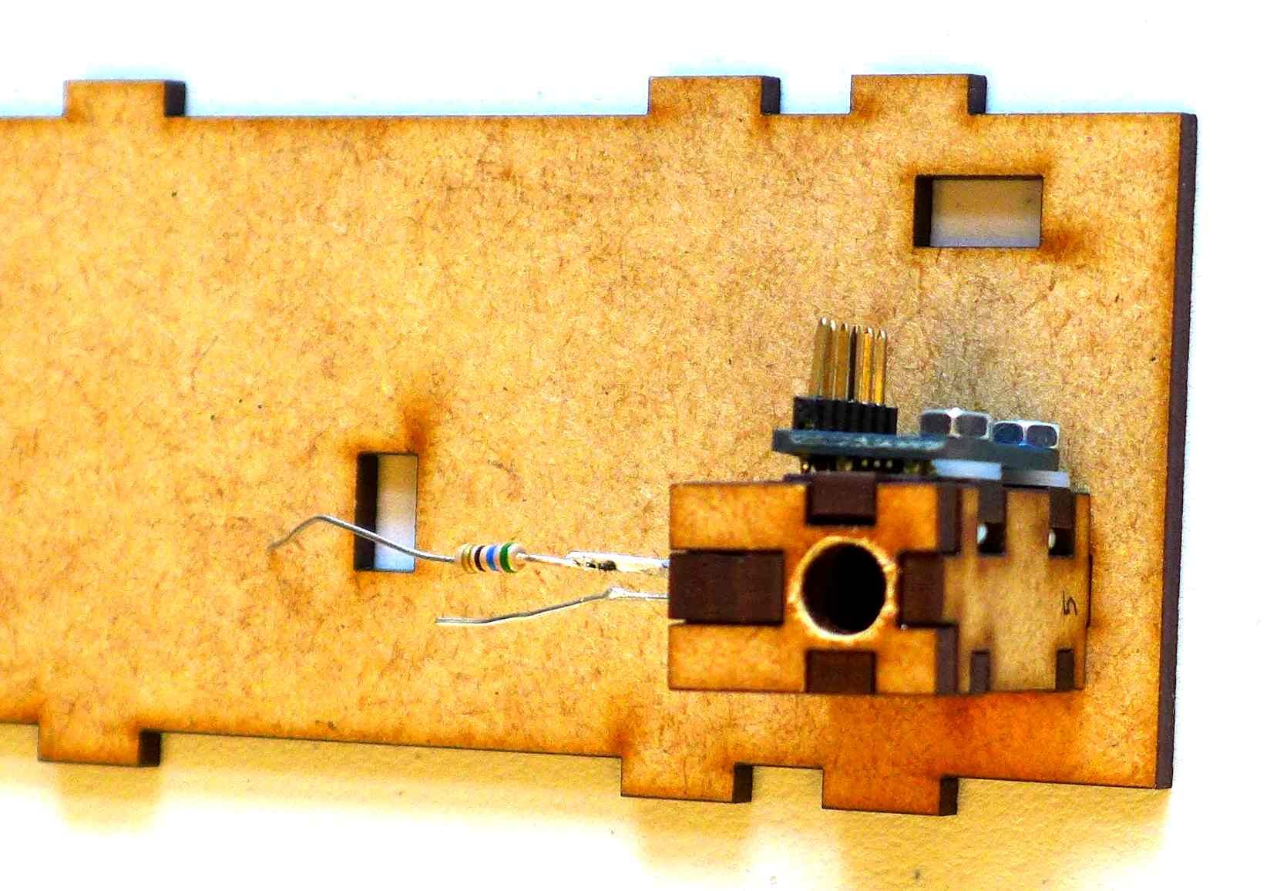

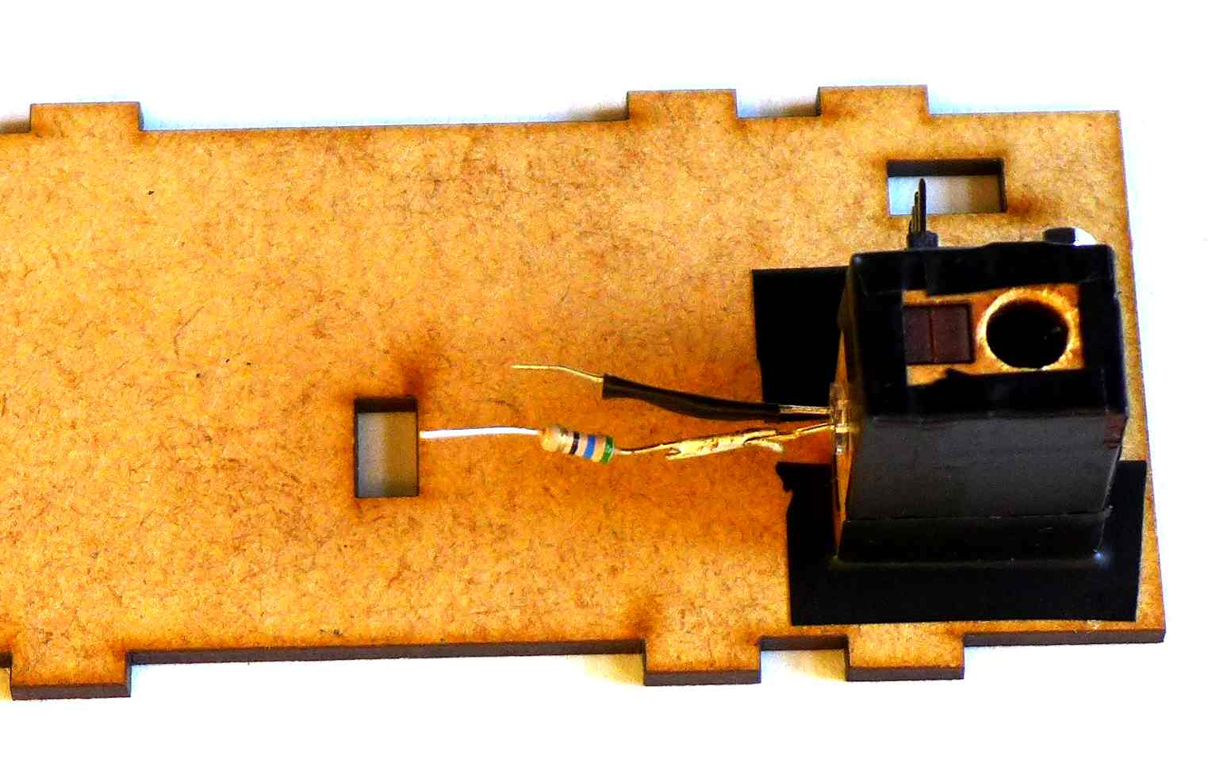

Step 2: Connecting the LED and the sensor to the NodeMCU
Connect the jumper wires to the LED and the sensor. Thread the wires through the holes in piece 7.

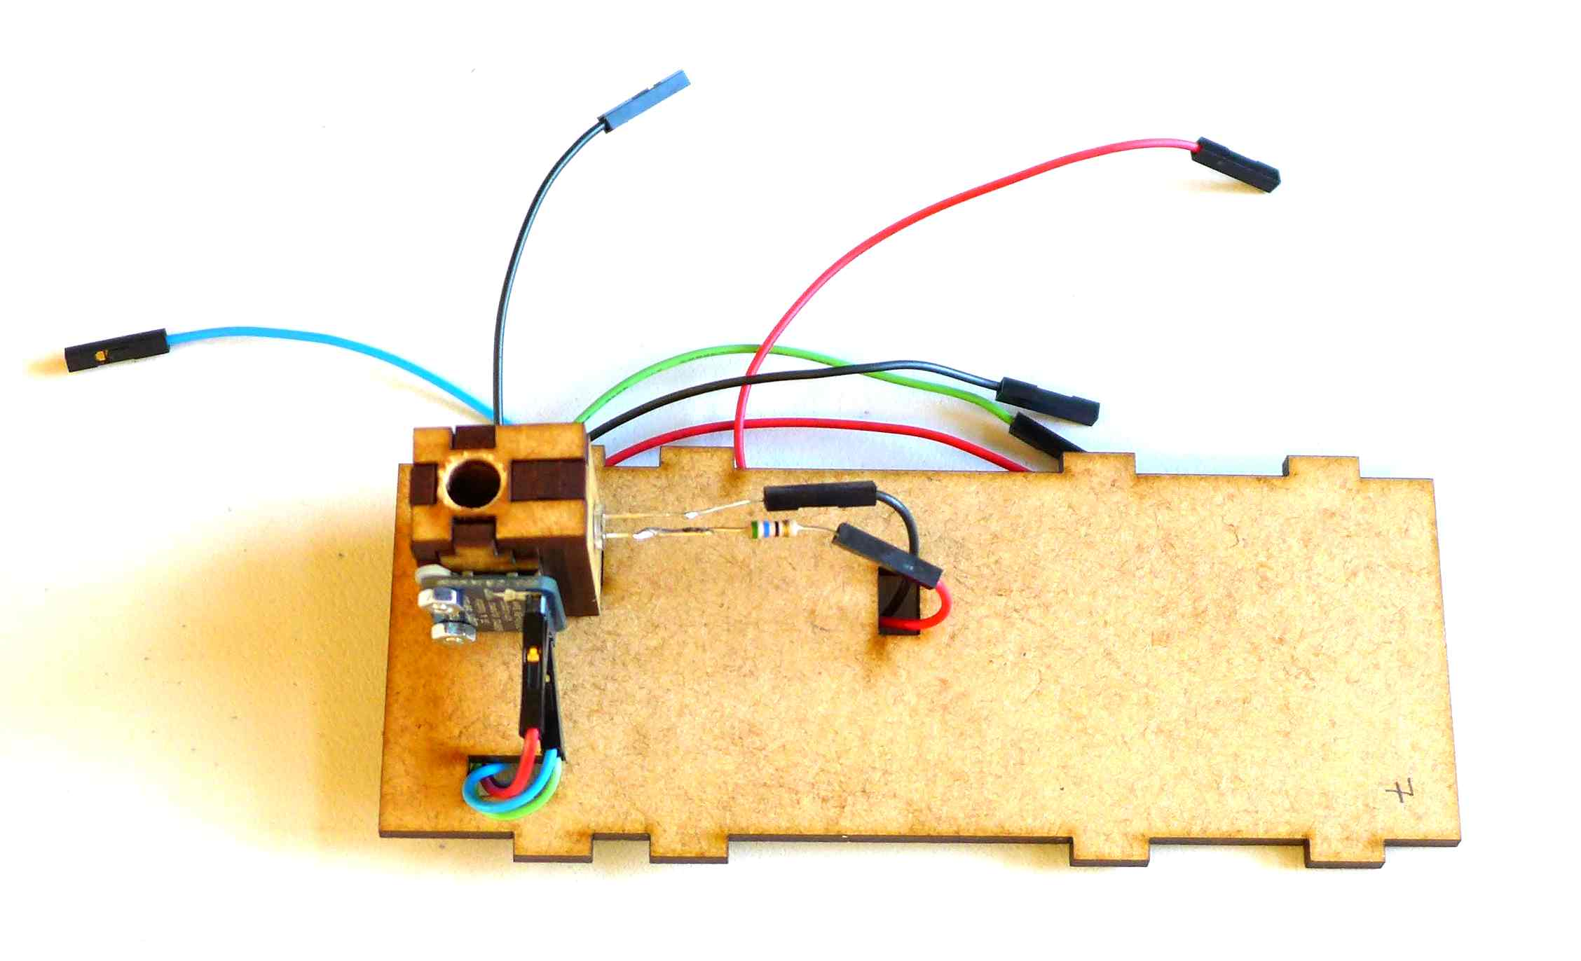
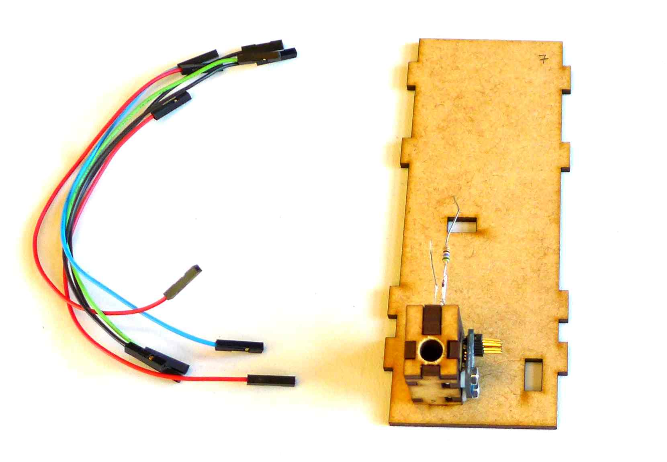

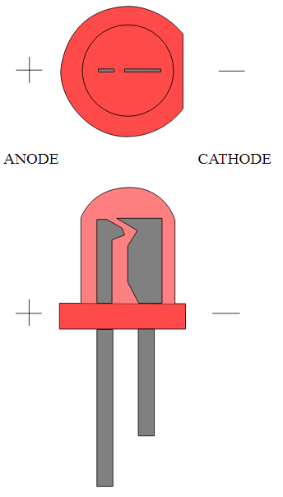
By w:en:user:Adam850 (w:en:Image:Led2.PNG) [Public domain], via Wikimedia Commons
Connect the jumper wires to the NodeMCU according to the table below:

NodeMCU | Sensor | LED
3.3v | VIN
GND | GND
Not connected | 3VO
Not connected | INT
D2 | SDA
D1 | SCL
D3 |  | +
GND |  | -

Step 3: Assembling the outer case around the sampling assembly and the NodeMCU

1) There are two identical pieces 8. They go on either side of piece 7. Piece 7 is fitted into the holes in the middle of the 8 pieces, so that when viewed from the front, the assembly looks like a letter H at this point.
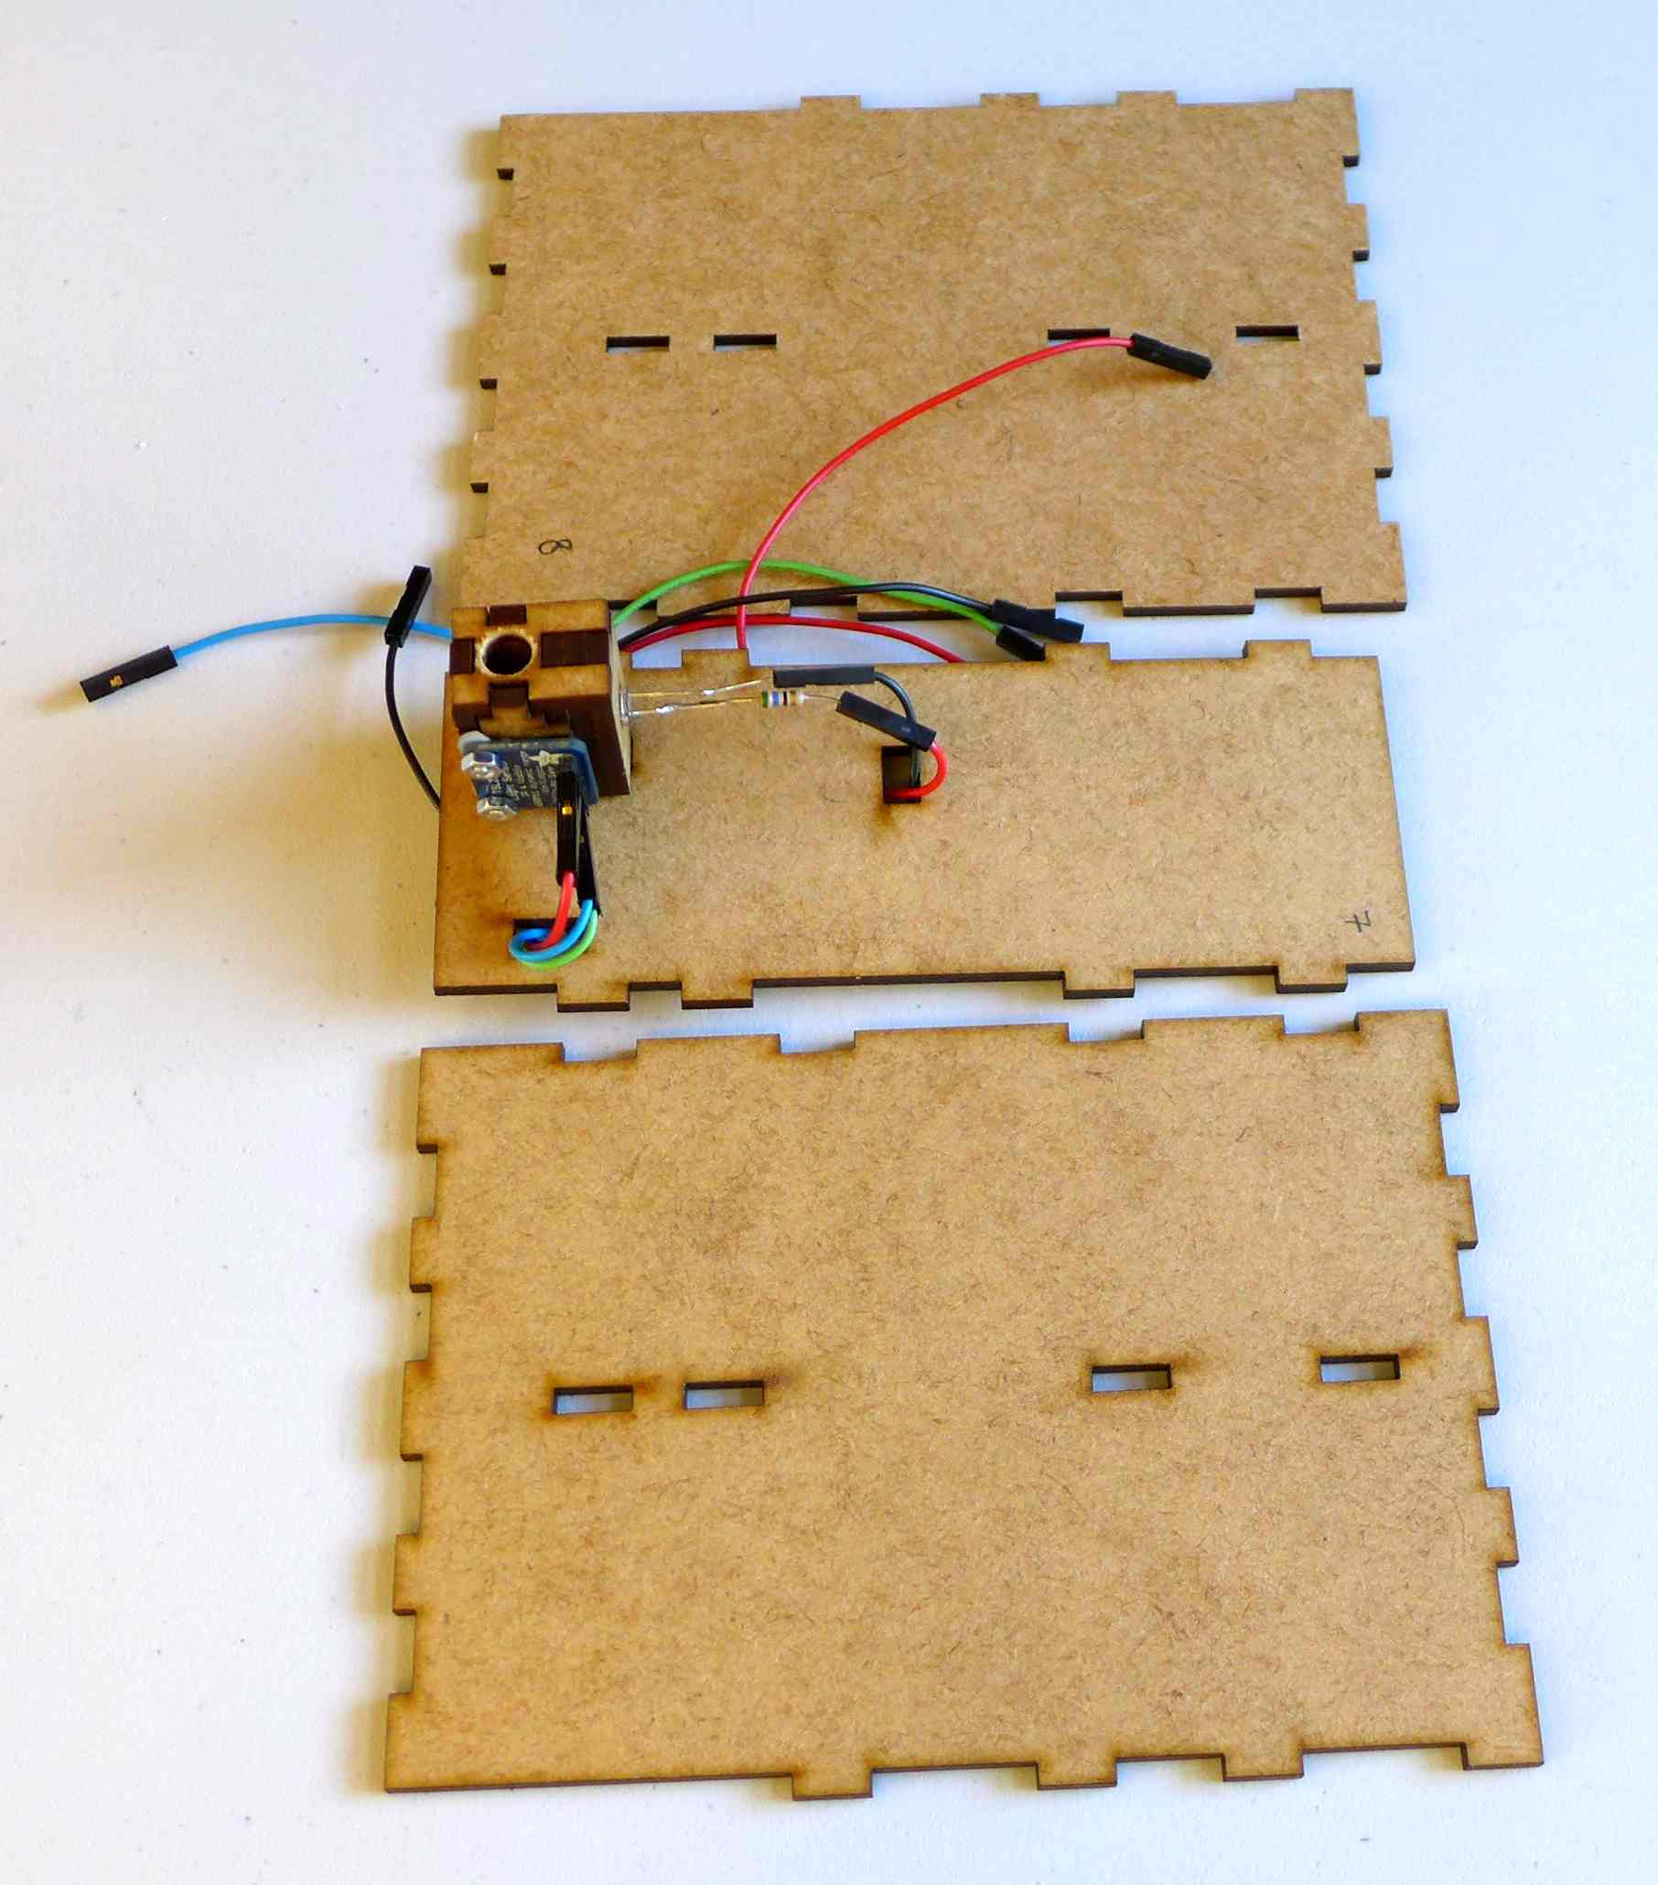
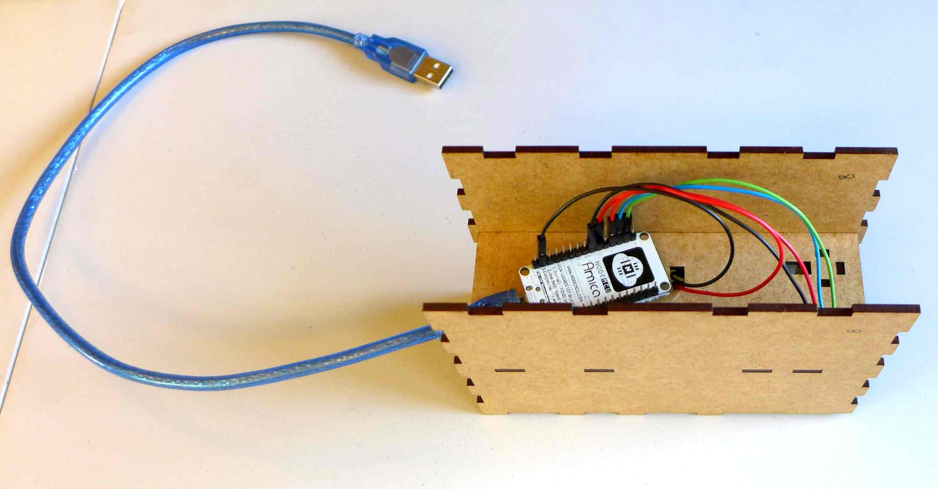

2) Fit piece 9 on the bottom of the case.

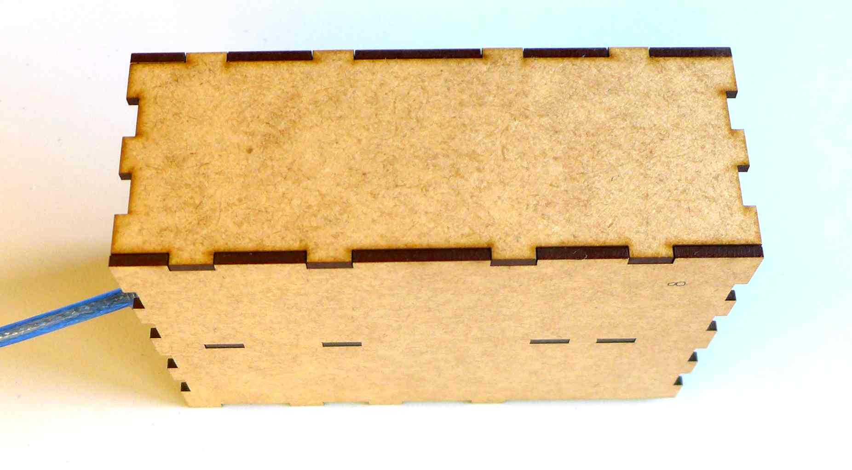

10) Close the sides with the pieces 10 and 11.
Piece 10 has to be assembled with the hole for the power supply cable on the lower side.
Piece 11 has one flat side, which is the top side.

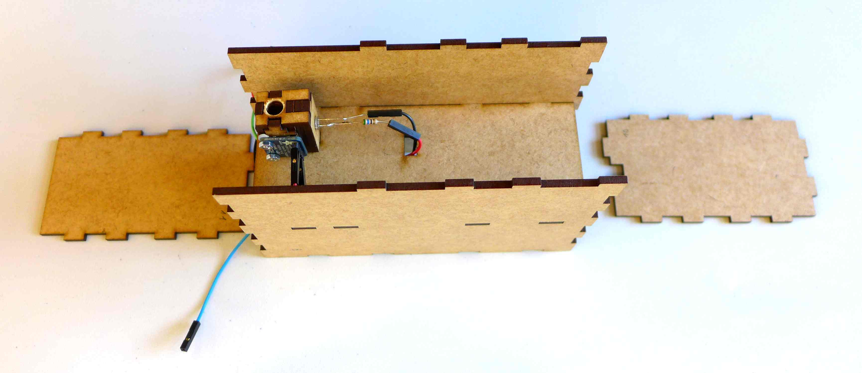

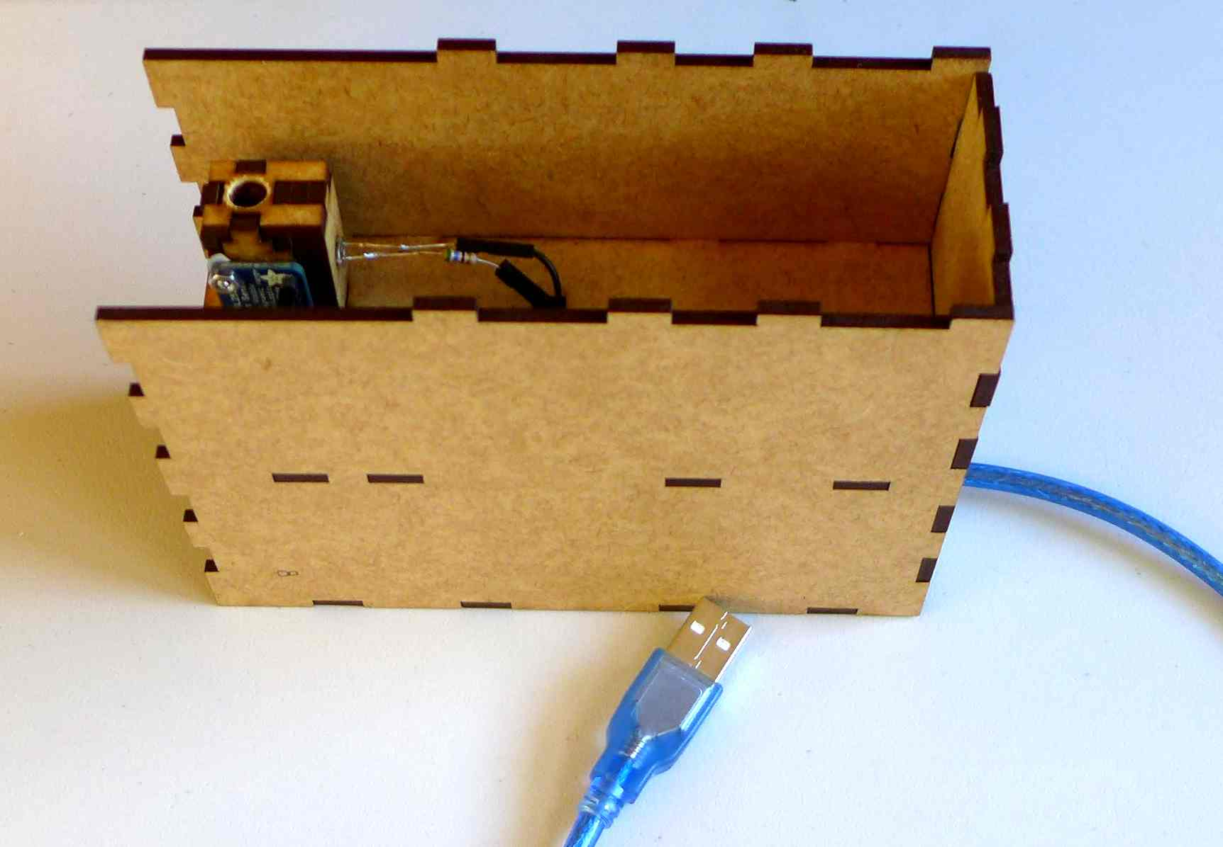
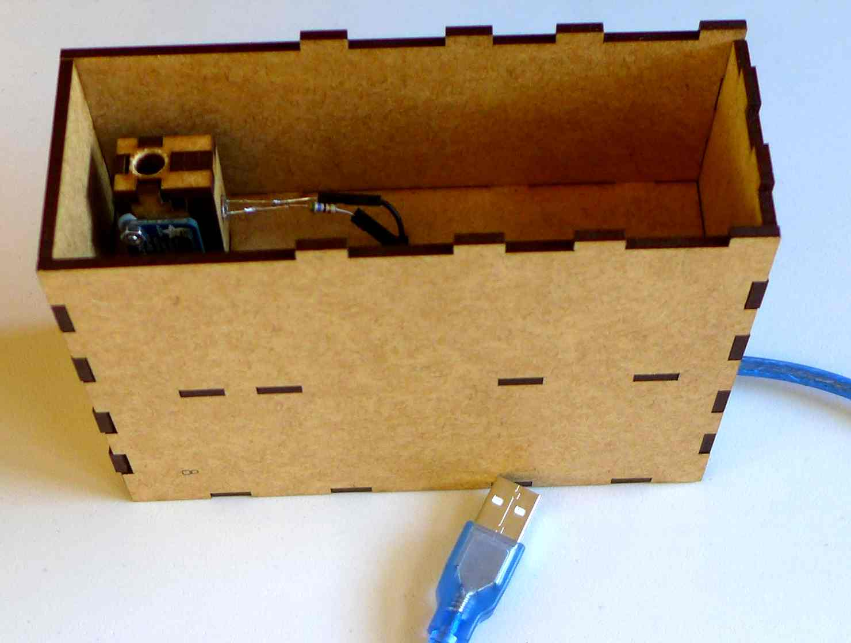

11) Use a black Edding to paint one side of piece 12b. That side will be the internal face of the lid. Align piece 12a and 12b on the flat side. Tape them together to make a lid that can be flipped open.
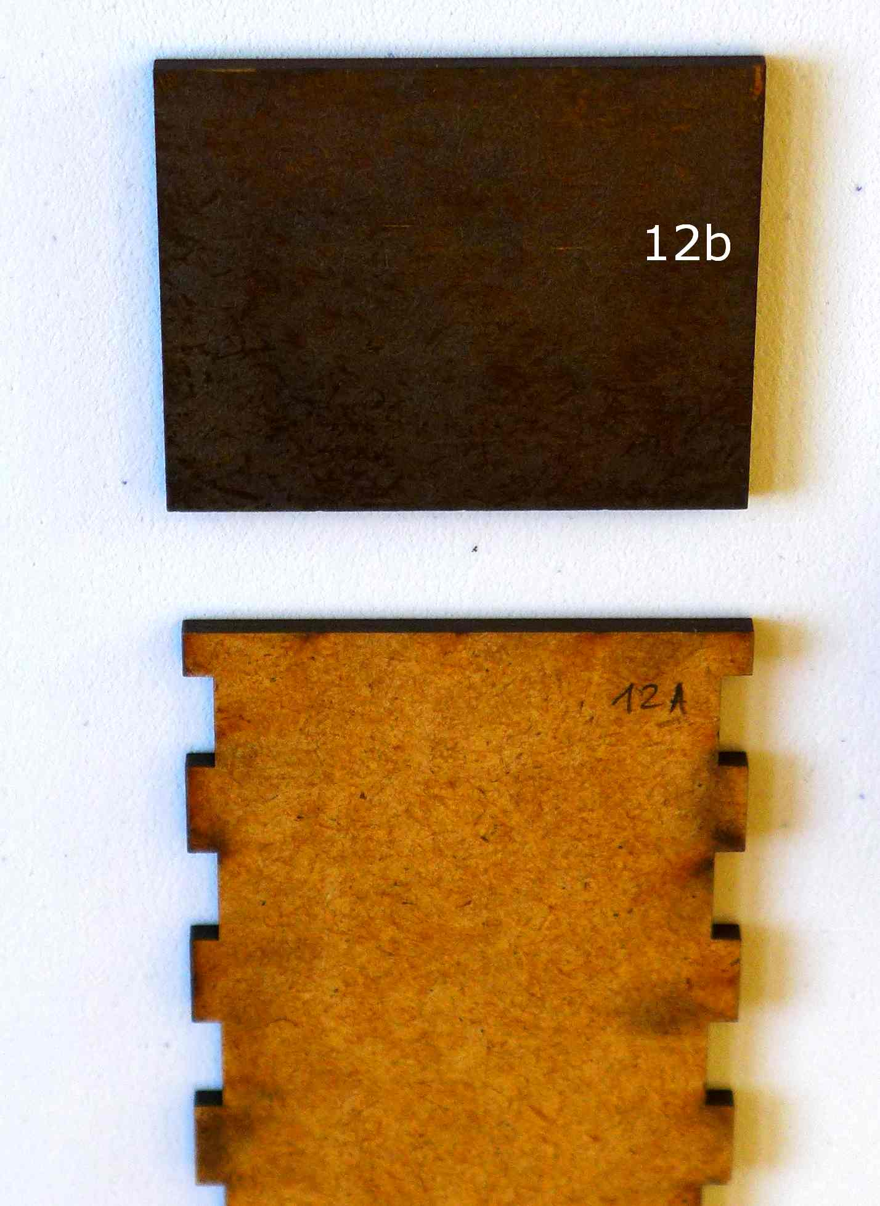
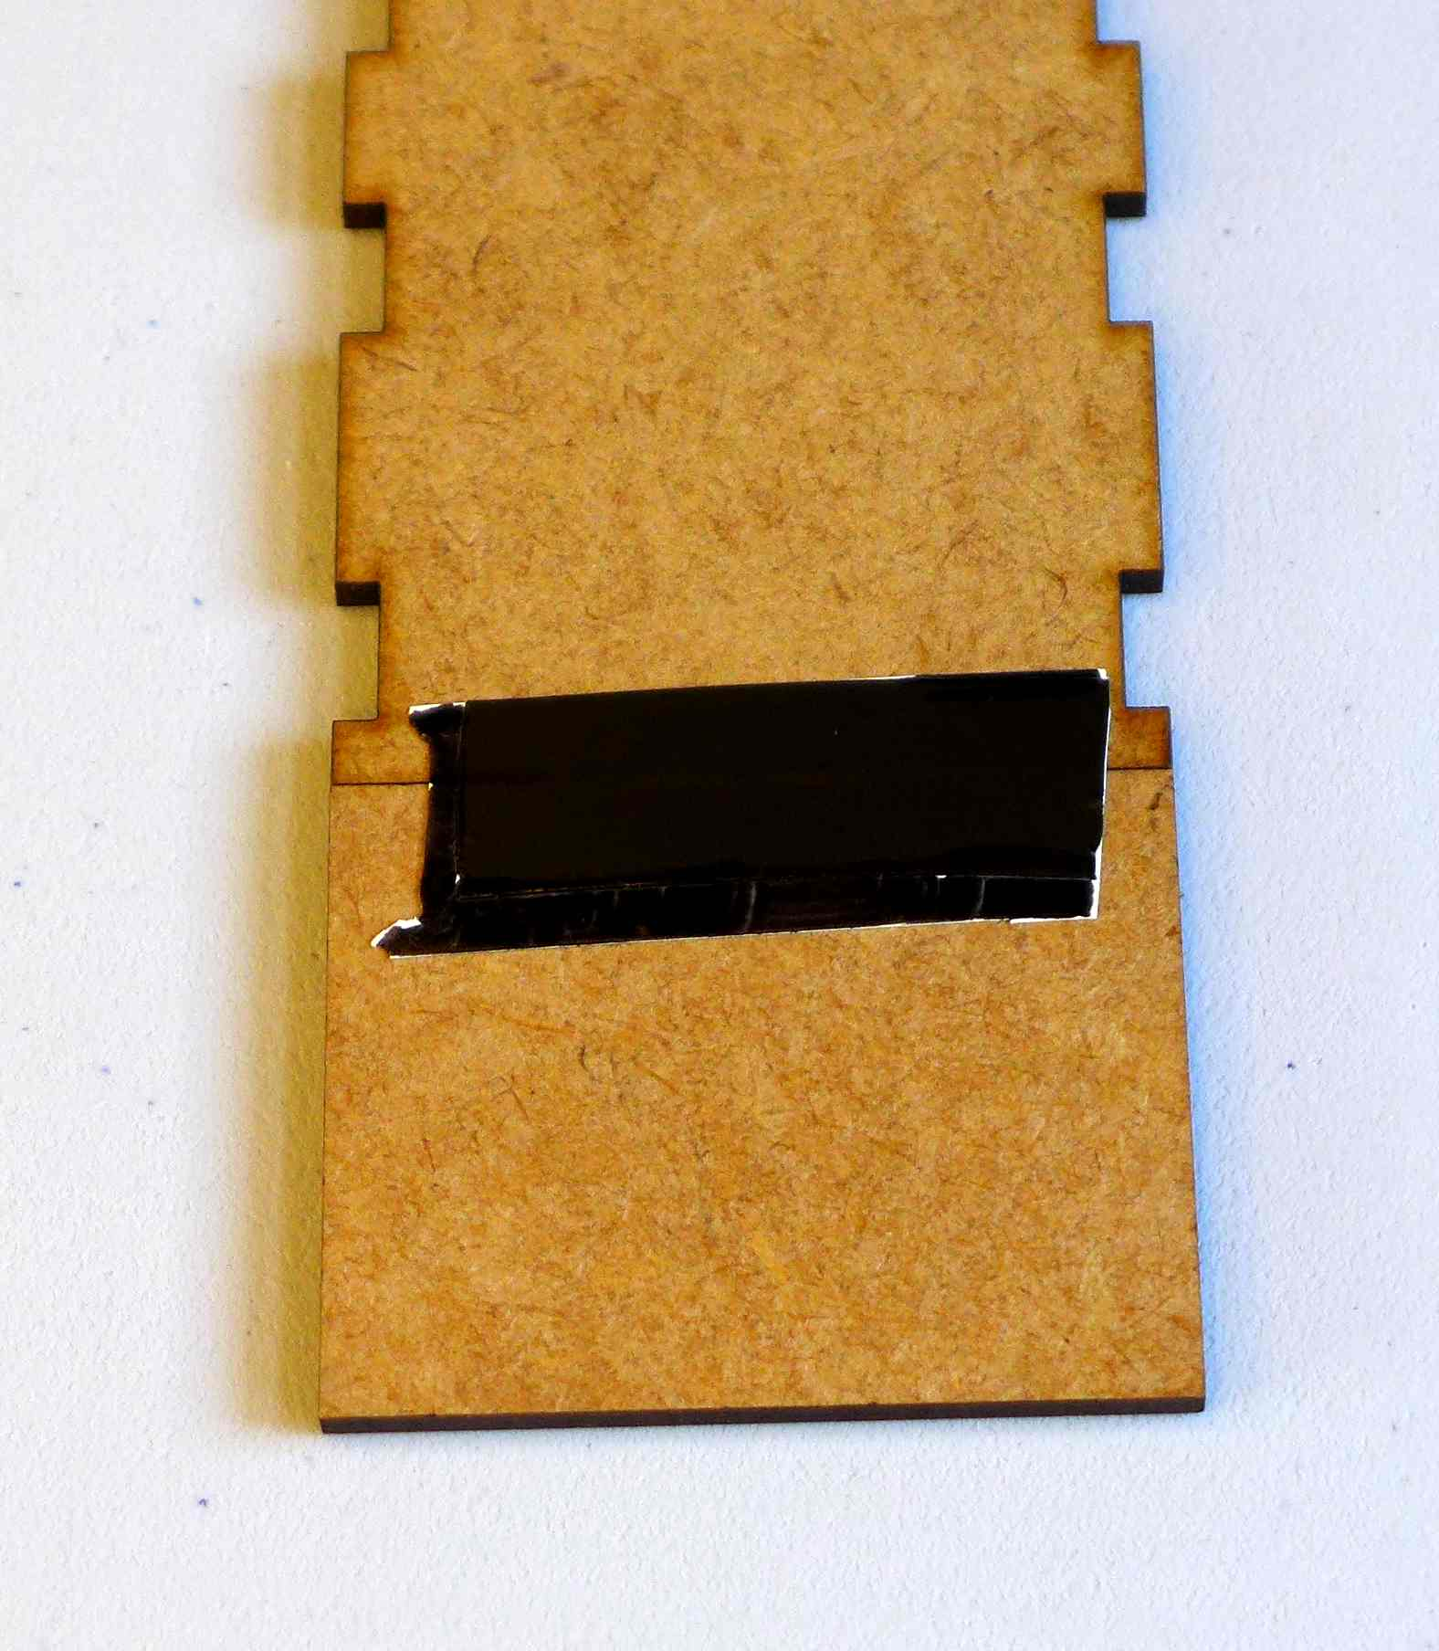
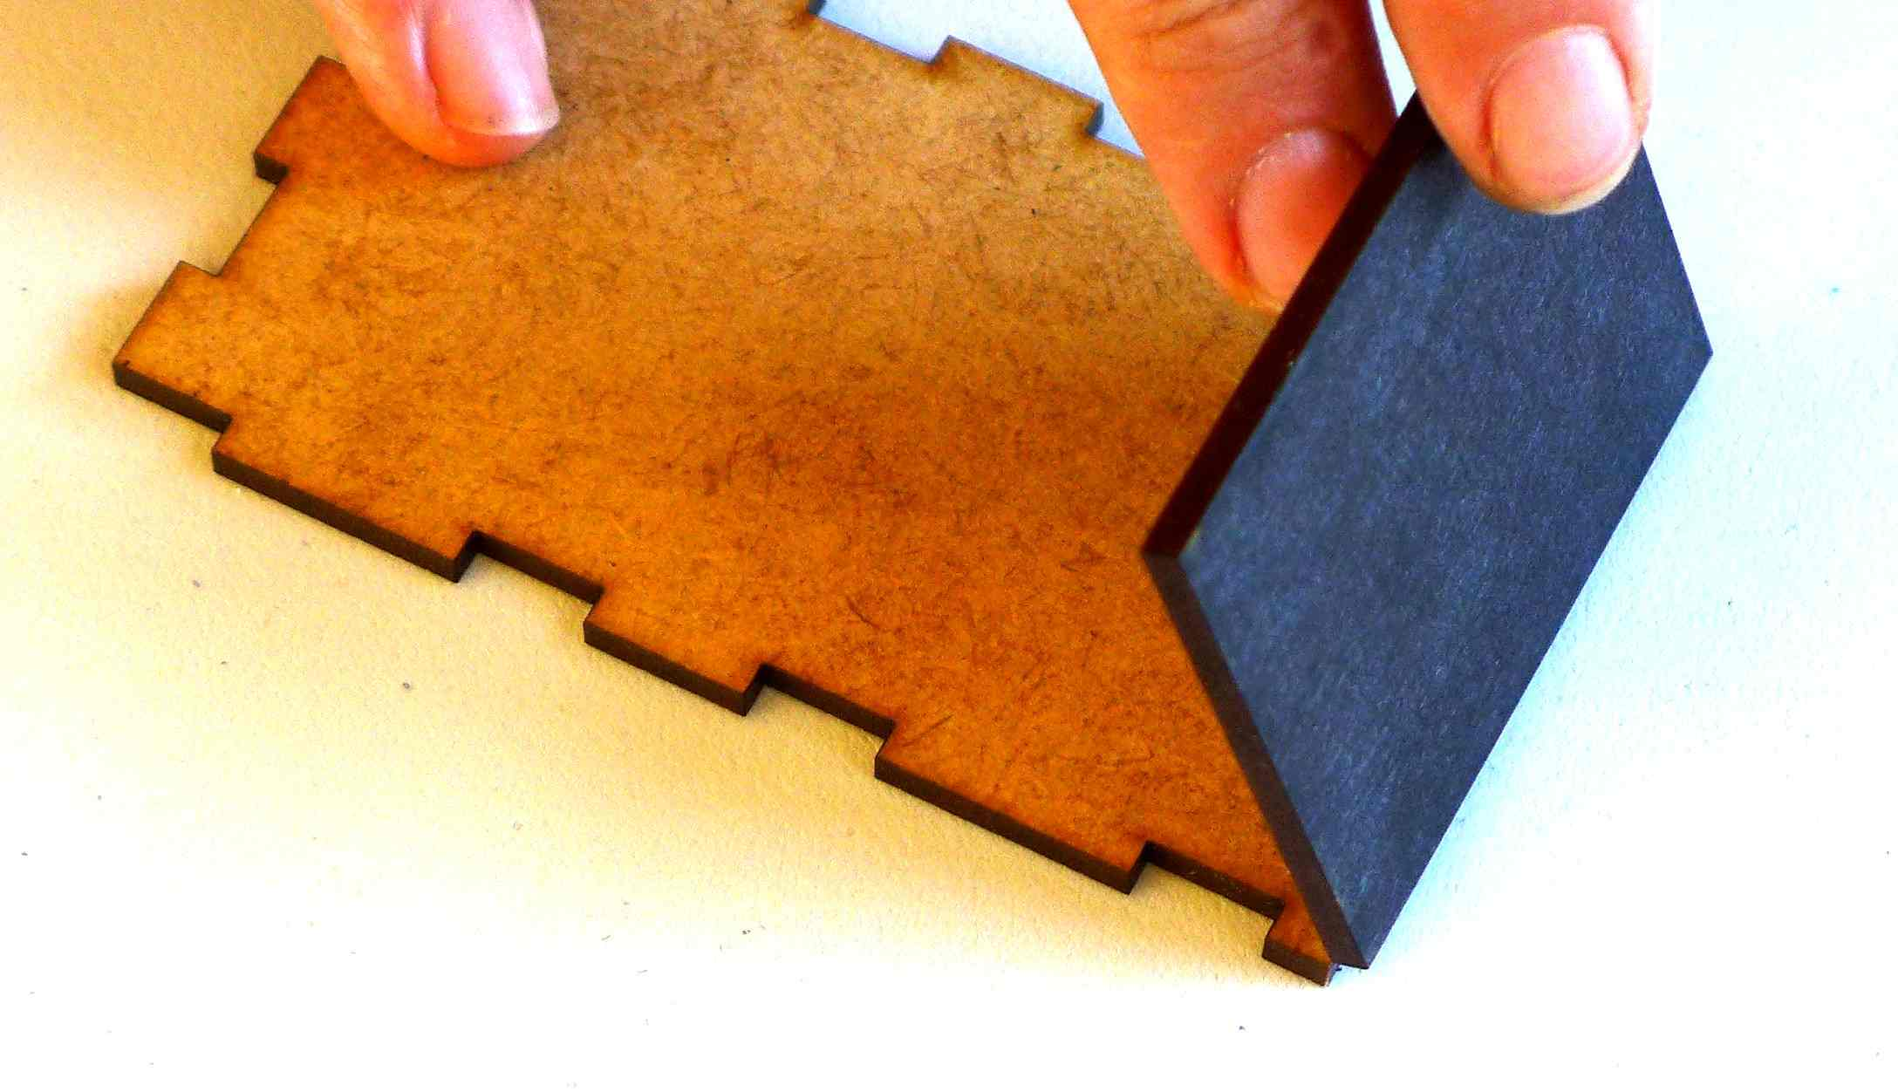

12) Put the lid consisting of piece 12A and 12B on top of the box and you are finished.
Now you are ready for testing.
