**Experimenting with a DIY spectrophotomoeter:**

With a DIY spectrophotometer we analysed the spectral proprieties of the filters, to have more insights about which filter was better to use.

Materials: LED 470-515 nm, dichroic filter 490 nm, acrylic filter 510 nm, glass filter 515 nm, water, gelgreen (DNA dye)



Fig. 1: Shows which portion of the spectrum of a 470-515 nm LED passes through the filters

This plot shows which wavelengths are being filtered. The dichroic filter ensures that just blue light hits the tube/solution. The acrylic and glass filters cut off the blue light before hitting the sensor. The combination of the two filters ensures that no green light enters the measurement spot, and all he green light produced, is produced by the fluorescent dye.

The next question was if the spectrophotometer was able to detect the fluorescent light.

So, the following setup was quickly built: LED, dichroic filter, tube, acrylic/glass filter, slit, diffraction grating, camera.



Fig. 2: Plot of spectra representing the amount of light coming through the spectrometer.

The spectrophotometer detected a lower amount of incoming light in presence of DNA while using the acrylic. With the glass filter, the spectrometer was not able to detect fluorescent light.

We attribute the bad quality of data to the poor construction.

The next question was if, by building a better setup, it was possible to still detect fluorescence.

All the parts were assembled in the spectrophotometer and the slit was made wider, to increase the amount of light entering the device.

The setup included the dichroic and the glass filter. The filters were kept to minimise the light that was not produced by fluorescence.

Having the glass filter pass at 515nm, it is expected that the blue part of the spectrum will not be shown.

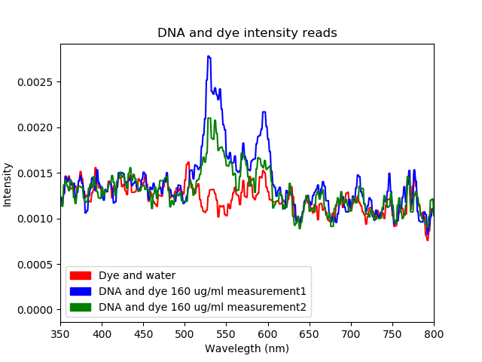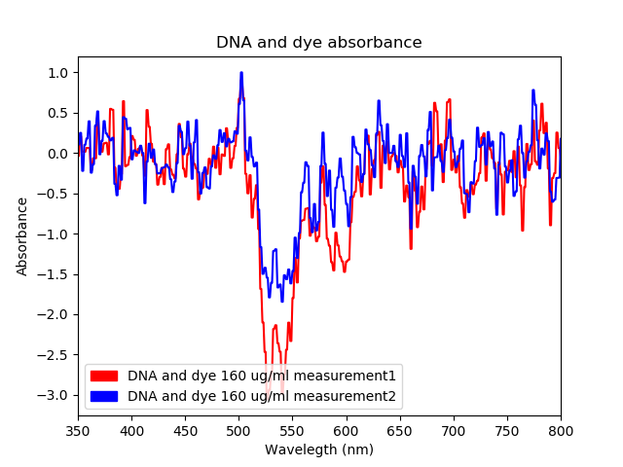

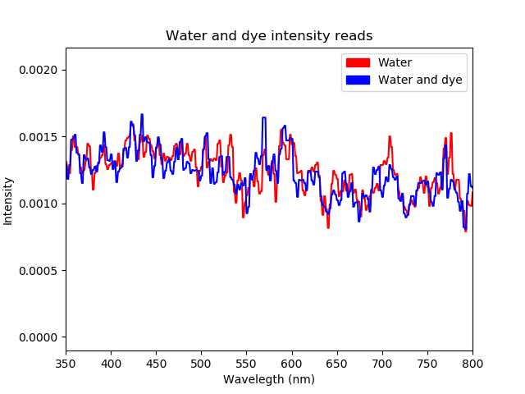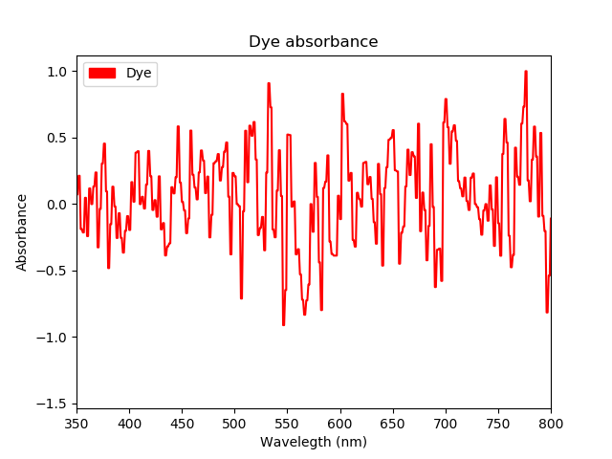

Goal of this experiment was to spot the fluorescent light. The experiment shows that it is possible with a DIY spectrophotometer to see minimal amount of fluorescent light. However, for purpose of DNA quantification, the device won't produce reliable data, because the measurement would be too close to the basal noise.