METAGENOMIC MOTIF COMPRESSOR

A Dictionary-Based Lossless Compression System
for Genomic Data Compression

Submitted By:
DIYA CHAKRABORTY

Department:
Computer Science Engineering(Cyber Security)

Date:
June 2026

ABSTRACT
Metagenomic Motif Compressor is a dictionary-based lossless genomic data compression system designed to reduce storage requirements of DNA sequences. The system identifies repeated DNA motifs, stores them in a dictionary, and replaces recurring patterns with compact reference identifiers. This approach preserves all original information while achieving efficient compression. The compressed data can be reconstructed accurately without any loss of sequence information. The project demonstrates how repeated biological patterns can be utilized to optimize genomic storage and facilitate efficient data management for bioinformatics applications.

INTRODUCTION
DNA sequences contain massive amounts of biological information represented by the nucleotides A, T, C, and G. Modern sequencing technologies generate large genomic datasets that require substantial storage space. Since DNA often contains repeated motifs and patterns, compression techniques can be applied to reduce storage requirements.

Metagenomic Motif Compressor is designed to identify recurring motifs in DNA sequences and replace them with compact reference identifiers. By using a dictionary-based lossless compression approach, the original DNA sequence can be reconstructed perfectly while reducing storage requirements.

PROBLEM STATEMENT
The rapid growth of genomic databases has created significant challenges in storing and managing DNA sequence data. Traditional storage methods require large amounts of memory and become inefficient as dataset sizes increase. A compression system is required to reduce storage requirements while preserving the complete biological information contained in genomic sequences.

OBJECTIVES
• Detect repeated DNA motifs.
• Create a motif dictionary.
• Assign reference identifiers.
• Replace repeated motifs.
• Generate compressed genomic data.
• Preserve original sequence information.
• Achieve lossless compression.

METHODOLOGY
1. Input DNA sequence.
2. Scan sequence for recurring motifs.
3. Detect repeated patterns.
4. Store motifs in a dictionary.
5. Assign unique reference IDs.
6. Replace motifs using references.
7. Generate compressed output.
8. Store compressed data.

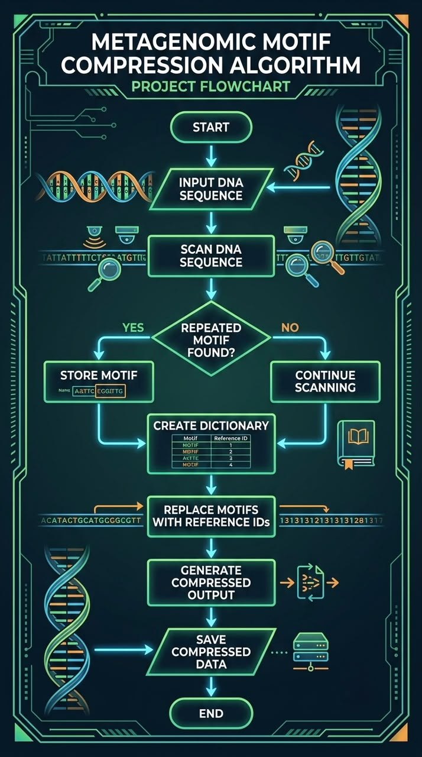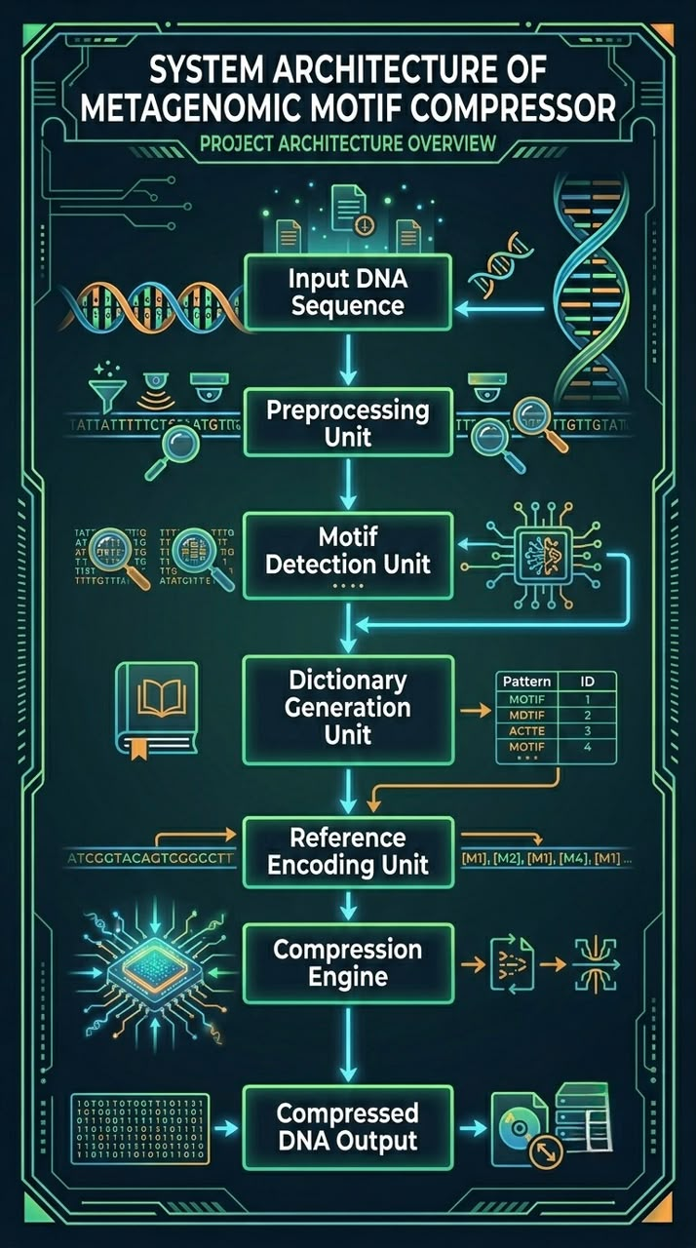
ADVANTAGES
• Reduces storage requirements.
• Preserves original DNA information.
• Easy motif identification.
• Supports accurate reconstruction.
• Suitable for genomic databases.

FUTURE IMPROVEMENTS
• Support larger genomic datasets.
• Apply machine learning for motif prediction.
• Improve compression efficiency.
• Develop graphical user interface.
• Enable real-time genomic processing.

CONCLUSION
The Metagenomic Motif Compressor demonstrates a lossless genomic data compression approach using motif detection and dictionary-based encoding. Repeated DNA motifs are identified and replaced with compact reference identifiers, reducing storage requirements while preserving the original sequence. The system provides an efficient and scalable solution for genomic data management and can serve as a foundation for future bioinformatics compression techniques.
REFERENCES
1. National Center for Biotechnology Information (NCBI)
2. Introduction to Bioinformatics – Pearson Publications
3. DNA Compression Techniques Research Papers
4. Genomic Data Storage and Analysis Resources
5. Python Documentation

