**CSE 3902**

**Sprint 2 Reflection**

**Group Loading…**

Group Members: Ben Roth, Sean Burns, Alex Quedens, Jiayi Pu, Diya Adengada

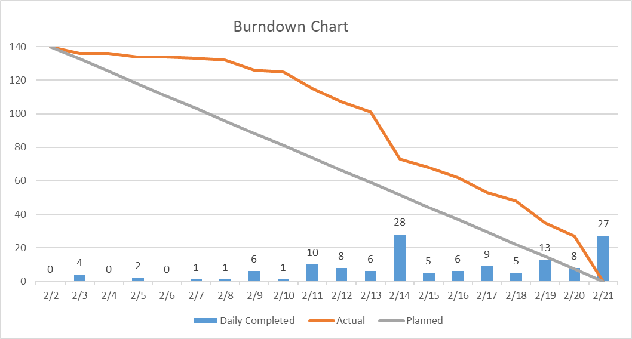

Overall, our team did pretty well on Sprint 2. We were able to get all of the required tasks completed by the deadline, although there was some functionality that we ended up finishing a little last minute. At the beginning of the sprint, we divided the tasks evenly and ensured that everyone knew which respective part they were working on, We also created a group chat for quicker communication, and used this to let eachother know when different parts were committed, if there were any pull requests opened, or if anyone needed help. We also met a couple of times over the course of the sprint, including a brief meeting on the day of the code functionality check in, and the submission deadline of the sprint, to ensure all the required parts were functional and included. Everyone in our team was very responsive and attended all meetings held.

For the next sprint, we will aim to complete all of our code by the first deadline (the functionality check in date), so we can have plenty of time to correct our code and make changes if needed, based on grader feedback.