1. List all customers in ascending order by their names.
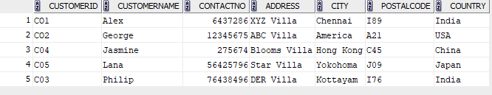
2. Retrieve a list of orders with the oldest ones appearing first, sorted by order date in ascending order.
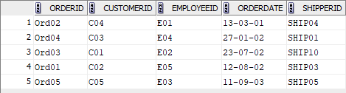
3. Find the employees who were born after 1980 and list them in descending order of their birthdates.
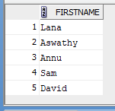
4. List orders placed by customers from 'USA' in descending order of the order date.

6. List the cities with the total number of customers.
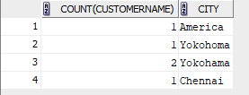
8. Display cities with more than 3 customers.
