DEPARTMENT
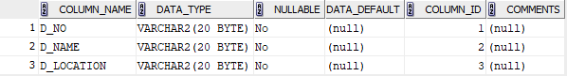

COURSE
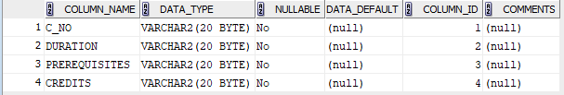

INSTRUCTOR 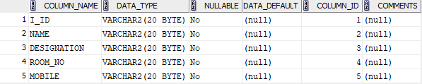

STUDENT
