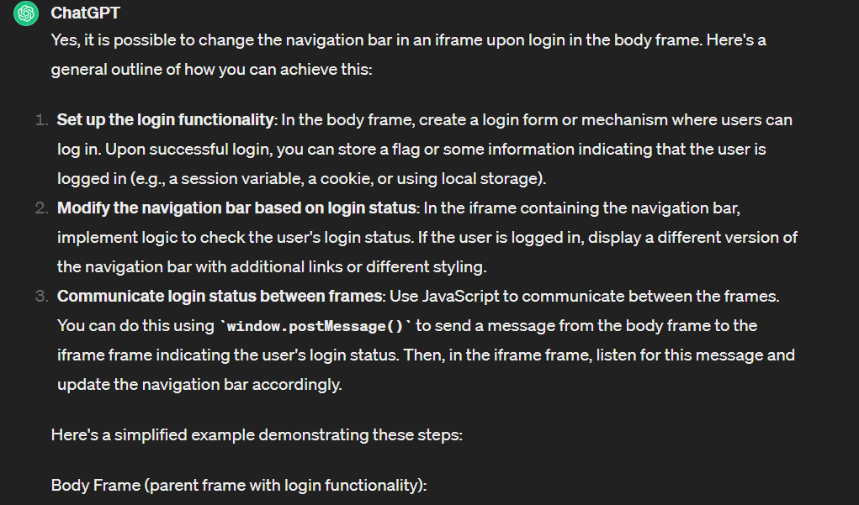

<!-- Login form -->

<form id="loginForm">

<!-- Login inputs -->

<input type="text" id="username" placeholder="Username">

<input type="password" id="password" placeholder="Password">

<button type="submit">Login</button>

</form>

<script>

document.getElementById("loginForm").addEventListener("submit", function(event) {

event.preventDefault(); // Prevent form submission

// Perform login validation

var username = document.getElementById("username").value;

var password = document.getElementById("password").value;

// Assuming login validation is successful, set login status

var isLoggedIn = true;

// Send message to iframe with login status

var iframe = document.getElementById("navbarFrame");

iframe.contentWindow.postMessage({ isLoggedIn: isLoggedIn }, "\*");

});

</script>

Navbar Frame (iframe containing the navigation bar):

<nav id="navbar">

<!-- Default navigation links -->

<a href="#">Home</a>

<a href="#">About</a>

<a href="#">Contact</a>

</nav>

<script>

// Listen for messages from the parent frame

window.addEventListener("message", function(event) {

if (event.data.isLoggedIn) {

// Modify the navigation bar for logged-in users

var navbar = document.getElementById("navbar");

navbar.innerHTML = `

<a href="#">Home</a>

<a href="#">Profile</a>

<a href="#">Messages</a>

<a href="#">Logout</a>

`;

}

});

</script>