GAS LEAKAGE DETECTOR SYSTEM

Submitted in partial fulfilment of the requirements for the award of the certificate of
IoT internship Program
By

Ricky Thoudam (Reg.no: - 2101CS0203)
Naorem Diyabarta Singh (Reg.no: - 2101CS0216)
Naoroibam Lanngamba Luwang (Reg.no: - 2101CS0209)



INNOVATION HUB MANNIPUR,
CUBETEN TECHNOLOGIES
MSIT Park, Mantripukhri, Imphal West, Manipur – 795002
MARCH-2024

DECLARATION

We Ricky Thoudam(Reg.no: - 2101CS0203), Naorem Diyabarta Singh (Reg.no: - 2101CS0216) and Naoroibam Lanngamba Luwang(Reg.no:- 2101CS0209) hereby declare that the Project Report entitled “GAS LEAKAGE DETECTOR SYSTEM” done by us under the guidance Romila Thiyam, Khangembam Badan Kumar and Puneshwar Laishram is submitted in partial fulfillment of the requirements for the award of the certificate of IoT internship Program.

NAME AND SIGNATURE OF THE CANDIDATES

 |  | Ricky Thoudam
 |  | Naorem Diyabarta Singh
 |  | Naoroibam Lanngamba Luwang

Date: 26-03-2024
Place: Imphal

ACKNOWLEDGEMENT

We are pleased to acknowledge our sincere thanks to Innovation Hub Manipur of CubeTen Technologies for their kind encouragement in doing this project and for completing it successfully. We are grateful to them.

We convey our thanks to Romila Thiyam, Khangembam Badan Kumar and Puneshwar Laishram of Innovation Hub Manipur, CubeTen Technologies for providing us necessary support and details at the right time during the progressive reviews.

We would like to express our sincere and deep sense of gratitude to our Project Guide Romila Thiyam for her valuable guidance, suggestions and constant encouragement paved way for the successful completion of our project work.

We wish to express our thanks to all the staff and non-staff members of the Innovation Hub Manipur and CubeTen Technologies who were helpful in many ways for the completion of the project.

ABSTRACT

Liquefied Petroleum Gas (LPG) is a main source of fuel, especially in urban areas because it is clean compared to firewood and charcoal. Gas leakage is a major problem in the industrial sector, residential premises, etc. Nowadays, home security has become a major issue because of increasing gas leakage. Gas leakage is a source of great anxiety with ateliers, residential areas and vehicles like Compressed Natural Gas (CNG), buses, and cars which are run on gas power. One of the preventive methods to stop accidents associated with the gas leakage is to install a gas leakage detection kit at vulnerable places. The aim of this paper is to propose and discuss a design of a gas leakage detection system that can automatically detect, alert and control gas leakage. This proposed system also includes an alerting system for the users. The system is based on a sensor that easily detects a gas leakage.

TABLE OF CONTENTS

CHAPTER | TITLE | PAGE NO.
 | ABSTRACT | iv
 | LIST OF FIGURES | vi
1 | INTRODUCTION | 7
1.1 | SCOPE OF THE PROJECT | 8
1.2 | ADVANTAGES OF GAS DETECTION SYSTEM | 9
1.3 | APPLICATIONS OF USING GAS SENSOR | 9
2 | PROPOSED SYSTEM | 11
2.1 | BLOCK DIAGRAM | 11
2.2 | COMPONENTS REQUIRED | 12
2.3 | SIMULATION DIAGRAM | 16
2.4 | HARDWARE CONNECTION | 16
3 | CONCLUSION | 18
3.1 | RESULT | 19
3.2 | FUTURE SCOPE | 20
 | APPENDIX SOURCE CODE | 21

LIST OF FIGURES

FIGURE NO. | TITLE | PAGE NO.
2.1 | Block Diagram | 11
2.2 | Wi-Fi Module (ESP8266) | 13
2.3 | MQ6 Gas Sensor | 13
2.4 | Buzzer | 13
2.5 | DC Fan | 14
2.6 | Single Channel Relay | 14
2.7 | 12V Battery | 14
2.8 | Jumper Wires | 15
2.9 | Gas Lighter | 15
2.10 | Breadboard | 16
2.11 | Simulation Diagram | 16
2.12 | Hardware Connection | 17
3.1 | Final Product of our smart LPG gas detector | 19

CHAPTER 1

INTRODUCTION

Gas leakage is a serious problem and nowadays it is observed in many places like residences, industries, and vehicles like Compressed Natural Gas (CNG), buses, cars, etc. It is noticed that due to gas leakage, dangerous accidents occur. The Liquefied petroleum gas (LPG), or propane, is a flammable mixture of hydrocarbon gases used as fuel in many applications like homes, hostels, industries, automobiles, and vehicles because of its desirable properties which include high calorific value, less smoke, less soot, and meager harm to the environment. Liquid petroleum gas (LPG) is highly inflammable and can burn even at some distance from the source of leakage. This energy source is primarily composed of propane and butane which are highly flammable chemical compounds. These gases can catch fire easily. In homes, LPG is used mainly for cooking purposes. When a leak occurs, the leaked gases may lead to an explosion. Gas leakage leads to various accidents resulting in both material loss and human injuries. Home fires have been occurring frequently and the threat to human lives and properties has been growing in recent years. The risks of explosion, fire, suffocation are based on their physical properties such toxicity, flammability, etc.
The number of deaths due to the explosion of gas cylinders has been increasing in recent years. The Bhopal gas tragedy is an example of accidents due to gas leakage. The reason for such explosions is due to substandard cylinders, old valves, no regular checking of gas cylinders, worn out regulators and a lack of awareness of handling gas cylinders.
Therefore, the gas leakage should be detected and controlled to protect people from danger. An odorant such as ethane thiol is added to LPG, so that leaks can be detected easily by most people. However, some people who have a reduced sense of smell may not be able to rely upon this inherent safety mechanism. A gas leakage detector becomes vital and helps to protect people from the dangers of gas leakage There are different gas detection techniques used. In this paper a low-cost advanced sensor-based gas leakage detector, alert and control system is proposed and discussed. The system is very efficient, user friendly, portable, small in size and cost effective.

SCOPE OF THE PROJECT

A gas detector is a device that detects the presence of gases in an area, often as part of a safety system. A gas detector can sound an alarm to operators in the area where the leak is occurring, giving them the opportunity to leave. This type of device is important because there are many gases that can be harmful to organic life, such as humans or animals.
Gas detectors can be used to detect combustible, flammable and toxic gases, and oxygen depletion. This type of device is used widely in industry and can be found in locations, such as on oil rigs, to monitor manufacturing processes and emerging technologies such as photovoltaic. They may be used in firefighting.
In this work whenever the gas is leaked it is sensed by the sensor and it sends signal through the processor to buzzer. The ppm can be seen in mobile display. Whenever the gas leakage reaches the ppm of 400 it will send signal to the buzzer and the buzzer will ring alerting the people around that the gas is leaking and the fan will be switched on automatically, it will also notify immediately to any internet connected device through notifications or email once the gas leakage is detected. By combining gas detection, alerting mechanisms, and remote monitoring/notification capabilities, our system offers a comprehensive solution for gas leak detection and safety. Whether at home or away, users can rest assured knowing they will be promptly alerted to any potential hazards.

ADVANTAGES OF GAS DETECTION SYSTEM

- You can monitor the number of gases in your environment.
- Can escape from higher chance of poisoning, explosion, fire or asphyxiation.
- Get real time alerts about the gaseous presence in the atmosphere
- Prevent the fire hazards and explosion
- Supervise gas concentration levels
- Ensure workers health
- Real-time update about leakage
- Cost-effective installation
- Data analytics for improved decision
- Measure oxygen level accuracy
- Get immediate gas leak alerts

APPLICATIONS OF GAS SENSORS

LPG (liquefied petroleum gas) gas sensors are utilized in various applications where detection and monitoring of LPG leaks are crucial for safety and efficiency.

- Residential and Commercial Buildings
LPG gas sensors are often installed in homes, apartments, hotels, and other buildings where LPG is used for cooking, heating, or other purposes. These sensors detect leaks promptly, alerting occupants and authorities to prevent potential hazards such as fire or explosions.
- Industrial Facilities
Industries that utilize LPG for manufacturing processes or as a fuel source implement gas sensors to ensure safety standards are met. Continuous monitoring helps prevent accidents and ensures compliance with regulations.
- Laboratories
Laboratories that use LPG for various applications employ gas sensors to ensure safety and prevent accidents due to leaks.
- Transportation
LPG is also used as a fuel in buses, trucks, and forklifts. Gas sensors are employed to monitor LPG tanks and detect leaks during transportation, reducing the risk of accidents.
- Automobiles
LPG is used as an alternative fuel in some vehicles. Gas sensors are installed to monitor LPG levels in tanks and detect leaks to prevent accidents and ensure efficient fuel usage.

CHAPTER 2

PROPOSED SYSTEM

BLOCKED DIAGRAM

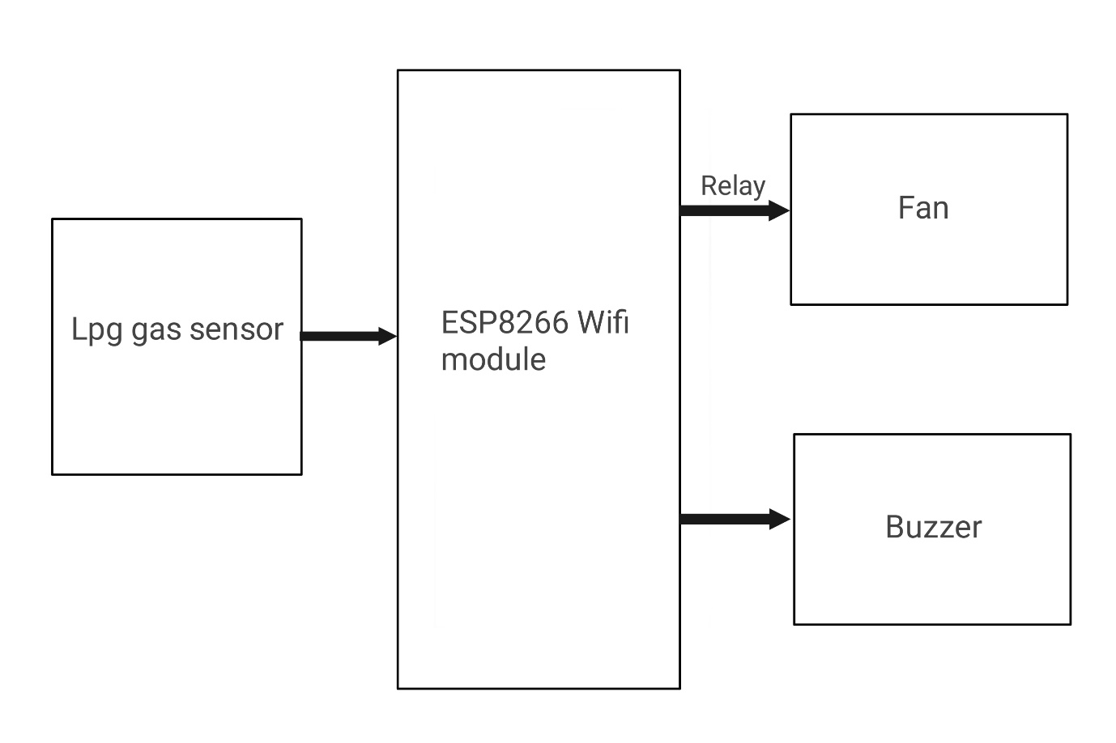
Fig 2.1 - Block Diagram

The MQ6 semiconductor sensor is utilized for LPG gas detection. It operates by detecting changes in conductivity, with higher levels indicating the presence of LPG. This sensor is particularly sensitive to gases like Propane and Butane and is cost-effective for various applications. When connected to an ESP8266, the sensor provides digital output upon gas detection. If gas is detected, a buzzer activates. The buzzer alerts users with beeping sounds and also the fan will be activated automatically. In addition to local alerts, our system ensures users stay informed about gas levels regardless of their location. Through Blynk integration, users can access a dedicated app interface or receive notifications via email.

COMPONENTS REQUIRED

SL NO. | EQUIPMENT | QUANTITY
1. | Wi-Fi Module – ESP8266 | 1
2. | MQ6 Gas Sensor | 1
3. | Buzzer | 1
4. | DC Fan | 1
5. | Single channel relay | 1
6. | 12V Battery | 1
7. | Jumper Wires (male to male / female) | 20
8. | Gas Lighter | 1
9. | Breadboard | 1

Table 2.1 - Components Required

- Wi-Fi Module – ESP8266
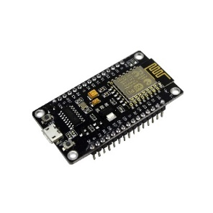
Fig 2.2 - Wi-Fi Module (ESP8266)
Wireless communication module widely used for IoT projects. Offers Wi-Fi connectivity, enabling devices to connect to the internet and exchange data.
- MQ6 Gas Sensor

Fig 2.3 - MQ6 Gas Sensor
Gas sensor capable of detecting multiple gases such as LPG, butane, propane, methane, alcohol, and smoke. Utilized in gas leakage detection systems and air quality monitoring devices.
- Buzzer

Fig 2.4 - Buzzer
An electronic signaling device that produces sound. Commonly used in alarms, timers, and notifications in electronic circuits.
- DC Fan
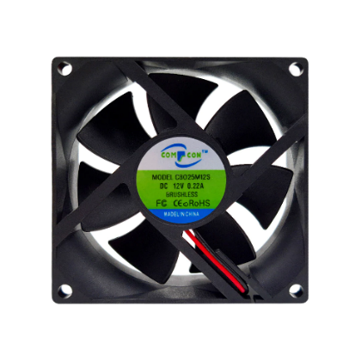
Fig 2.5 - DC Fan
Widely used for cooling electronic components, such as computer systems, amplifiers, and power supplies.
- Single Channel Relay
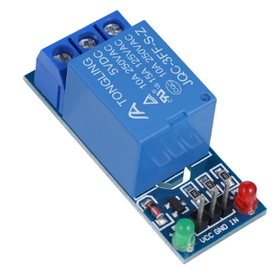
Fig 2.6 Single Channel Relay
Electromechanical switch used to control high-power devices with low-power signals. Enables the isolation between low-voltage circuits and high-voltage circuits, ensuring safety in control systems.
- 12V Battery

Fig 2.7 – 12V Battery
A power source commonly used in various electronic devices systems, providing a stable voltage output of 12 volts.
- Jumper Wires (male to male / female)
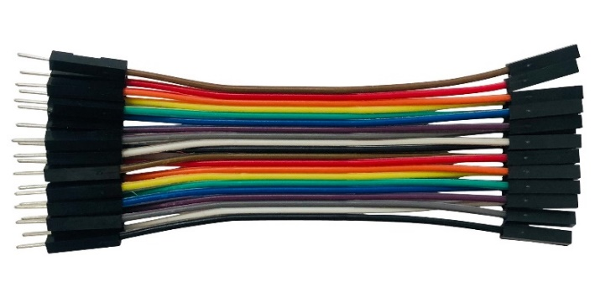
Fig 2.8 – Jumper Wires
Short wires with connectors at each end, used to create temporary electrical connections on breadboards or between components. Facilitates quick and flexible connections in prototyping and troubleshooting electronic circuits.
- Gas Lighter

Fig 2.9 – Gas Lighter
Handheld device used for igniting flames, commonly fueled by butane or similar flammable gases. Features a piezoelectric ignition mechanism that creates sparks to ignite the gas when the button is pressed.
- Breadboard
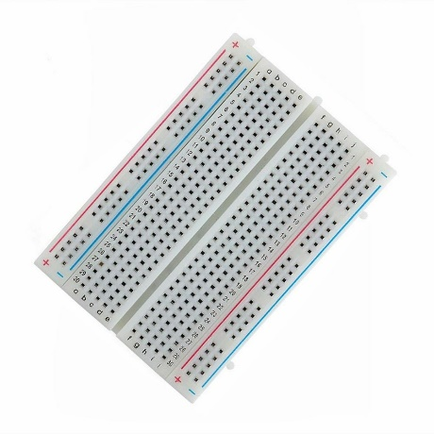
Fig 2.10 – Breadboard
Prototyping tool for electronics projects, allowing components to be easily connected and tested without soldering. Ideal for rapid prototyping and experimenting with circuit designs.

SIMULATION DIAGRAM

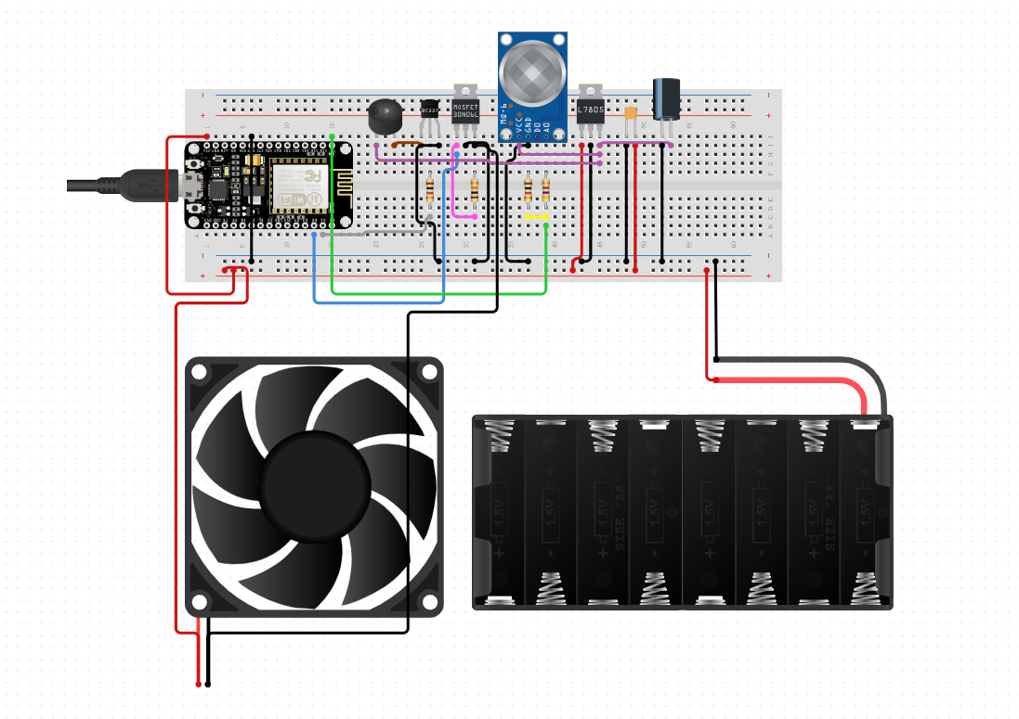
Fig 2.11 – Simulation Diagram

HARDWARE CONNECTION

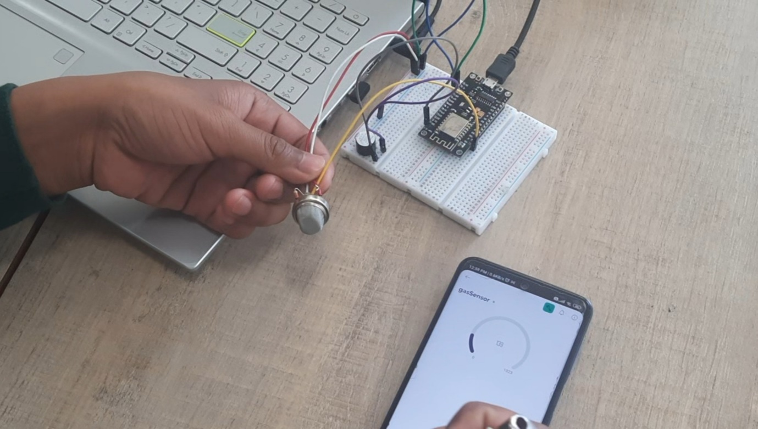
Fig 2.12 – Hardware Connection

The above fig shows the hardware connection of sensor-based gas detection system.
In practical whenever the supply is in on condition and the MQ-6 sensor if detects the gas it shows the ppm value in the mobile/pc (IoT) device. When the ppm value reaches the value of 400 ppm the controller gives the signal to the buzz and activates the fan.

CHAPTER 3

CONCLUSION

The design of a sensor-based automatic gas leakage detector with an alert and control system has been proposed and discussed in this paper. This is a low-cost, low power, lightweight, portable, safe, user friendly, efficient, multi featured and simple system device for detecting gas. Gas leakage detection will not only provide us with significance in the health department but it will also lead to raise our economy, because when gas leaks it not only contaminates the atmosphere but also wastage of gases will hurt our economy. The proposed system will cost only USD 10 which is easily affordable even for poor people. In the open literatures it is noticed that much work has not been done for a smart gas detection system. In future, more advanced features will be integrated with this system which will provide users with more safety and relaxation. The proliferation of handheld devices has led to developments in the field of smart gas sensors, which has considerably widened their scope of application. The need for ensuring safety in workplaces is expected to be the key driving force for the market over the coming years.

3.1 RESULT

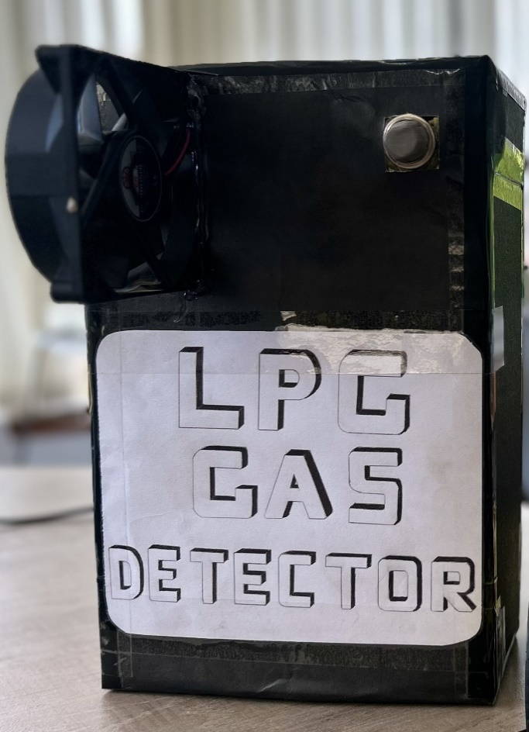
Fig 3.1 – Final Product of our smart LPG gas detector

This is the final product of our Smart LPG Gas Detector System.
Our creation is a Wi-Fi-connected gas detector using the ESP8266 module. It uses sensors to spot gas leaks and sends instant alerts to your phone. It's easy to set up, super accurate, and keeps you safe while saving money.

3.2 FUTURE SCOPE

The future of our smart LPG gas detector system looks promising. We plan to enhance its capabilities by adding features like monitoring gas usage, integrating with emergency services for accident notifications, and developing user-friendly mobile and web apps for real-time monitoring. With these improvements, our system will become even safer and more versatile for use in various environments.

APPENDIX SOURCE CODE

#define BLYNK_TEMPLATE_ID "TMPL3InVDC1kk"
#define BLYNK_TEMPLATE_NAME "gasSensor"
#define BLYNK_AUTH_TOKEN "lVtOBwim3176gm9TdRucnP5yeZpXWj3P"

//Include the library files
#define BLYNK_PRINT Serial
#include <ESP8266WiFi.h>
#include <BlynkSimpleEsp8266.h>

int buzzer = D0;
int sensor = A0;
int relay = D3;
int sensorData;
int sensorThres = 1500;

BlynkTimer timer;
char auth[] = BLYNK_AUTH_TOKEN;
char ssid[] = "Test1";//Enter your WIFI name
char pass[] = "123456789";//Enter your WIFI password

// //Get the button value
BLYNK_WRITE(V0) {
digitalWrite(A0, param.asInt());
int sensorValue= param.asInt();
}
BLYNK_WRITE(V1) {
digitalWrite(D3, param.asInt());
}

void setup() {
//Set the LED pin as an output pin
pinMode(buzzer, OUTPUT);
pinMode(sensor, INPUT);
pinMode(relay, OUTPUT);
Serial.begin(9600);

//Initialize the Blynk library
Blynk.begin(auth, ssid, pass, "blynk.cloud", 80);
}

void loop()
{
Blynk.run();
timer.run();

sensorData = analogRead(sensor);
Blynk.virtualWrite(V0, sensorData);
Serial.print("Sensor Data:");
Serial.println(sensorData);
delay(1000);

if(sensorData >= 400){
digitalWrite(buzzer, HIGH);
// Blynk.email("naoremdiyabarta@gmail.com", "Alert", "Gas Leakage Detected!");
Blynk.logEvent("gas_alert","Gas Leakage Detected");
digitalWrite(relay, HIGH);
delay(5000);

} else {
digitalWrite(buzzer, LOW);
digitalWrite(relay, LOW);

}
}

