Homework 1

Diya Benjamin  
[diyabenjamin@gatech.edu](mailto:diyabenjamin@gatech.edu)

# Question 1:

## Semantic Network representing the problem:

The semantic network for the Rey, Snoke and Kylo Ren problem is as shown in Figure 1 below. The diagram shows two nodes where each node is a state in the problem solving. The components of the state include Rey (white), Kylo Ren (black), Snoke (yellow) and a space shuttle with arrow indicating the position of the shuttle. The colors denote the color of their attires in Star Wars. The left side of the state denotes the planet and right side denotes the ship.

The first node shows Rey and Snoke on the left side (planet), space shuttle also on the left side while Kylo Ren is on the right side (ship). Similarly, the second node represents another state in the problem solving. Here, Rey is alone on the left side while Kylo Ren and Snoke are on the right side. The space shuttle is also on the right side. Here, the space shuttle is now on the right side. Thus, the node represents the lexicon of the semantic network.

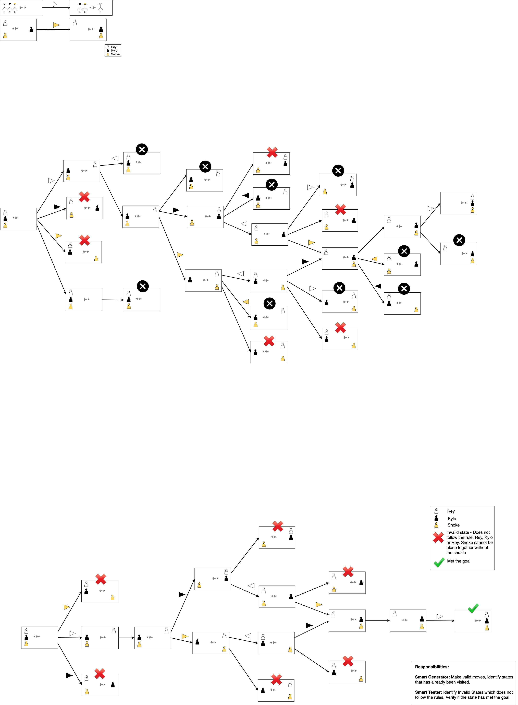The transformation from one state to another is shown using arrow links with labels. The label represents the operator semantics of the problem solving which indicates the transitioning from one state to another state. The yellow arrow pointing to right indicates that Snoke is travelling from planet to ship.

Figure 1. Semantic Network representing the problem

## Applying Generate & Test method to solve the problem:

Figure 2. Semantic Network representing the problem

# Question 2:

## AI cynic:

**Elon Musk** is the founder and CEO of SpaceX and Tesla. He along with Stephen Hawking, Bill Gates and other dozens of AI experts were concerned about the potential social impacts of AI. He is aware of the benefits of AI and its drawbacks if used incautiously. Musk worries that the dramatic rate of improvement in AI could surpass our ability to manage it in a safer way. He also wants the development of AI to be regulated. For this, he needs a regulatory body in place who can oversee that AI is developed safely while also maintaining the public safety. They can come up with rules that give the highest probability for a safe advent of AI (Clifford, 2018).

He is determined to keep tabs on AI’s impact on humanity. His self-driving cars uses narrow AI, while the risk lies in general or digital AI. Hence, he suggests everyone to be very cautious while working on digital AI and to do more research. His new venture Neuralink was founded to achieve a symbiosis between human intelligence and digital AI. He also started OpenAI, a non-profit organization, to cater to AI safety and to make AI accessible to everyone.

## AI optimist:

Sebastian Thrun, co-founder of Udacity and an innovator and computer scientist talks about the positive effects of AI. From his point of view, there is always an initial skepticism about the technology before it actually succeeds and improves human life. He gives examples of how Kodak camera, electricity and agricultural revolution were initially viewed as threat to the society. Similarly, humans are just worried about the AI revolution.

Thrun believes that there are numerous opportunities in AI especially in the field of education. People from different geographical regions can acquire education online through Udacity, Coursera and other such similar platforms. He also mentions that the autonomous car technology will be a major industry in the coming years. He strongly believes that AI would help free up people from repetitive mindless jobs, and utilize that time in doing more creative work ("Will Artificial Intelligence Destroy Our Jobs, or Empower Us to Unfold Our True Creative Powers?," 2016). He is not concerned about people losing jobs in the future to development of AI. He strongly believes that AI do not replace people, instead it gives them super-powers.

## Comparison:

Elon Musk focuses on regulating the advancements in AI to avoid any kind of threat to humanity, while Sebastian Thrun is excited about AI improvements in online education. Both of them are focusing on entirely **different possibilities**. However, I believe that their vision about the future **could co-exist**. Thrun is optimistic about the future of AI, as he believes it could improve opportunities for education to people worldwide and also improve jobs in the future. His vision is possible if we take the suggestions posted by Musk into consideration. All the developments of AI need to be controlled with proper legislations in place. This will allow the visions of both Elon Musk and Sebastian Thrun to co-exist and thus focusing on a better and safer society.

In this debate, I agree with Elon Musk about the risk that could tag along with the tremendous improvements in the field of AI. If not controlled and regulated, the machines could possibly become a threat to humanity. These machines cannot think, they only do what they have been trained for. If anything goes wrong, machines may not have the knowledge of all possible worst-case scenarios and what actions to perform under such conditions. This poses extreme danger to society as a whole.

## AI realists and AI agnostics:

Apart from above two perspectives of AI, there are many prominent personalities who think that AI will change society in both good as well as bad ways. They are called as AI realists and below are two prominent examples.

**Max Tegmark**, MIT professor and physicist and AI researcher is an **AI realist**. He is aware of the risks of AI, while also believing that AI can outsmart people at all jobs. At the same time, he is also concerned about the risks that AI might pose. Autonomous weapons are AI systems that are meant to kill. If misused, it can cause a large number of casualties. Similarly, if we fail to align AI objectives with ours, it can be a threat to humanity. Max believes that there is amazing potential in AI which can help humanity flourish. Right now, we have only seen the tip of AI iceberg ("Physicist Max Tegmark explains why AI will help humanity flourish," n.d.). If AI accomplishes broad intelligence to learn any task at the human level, then it would be the biggest change in the history of life on earth. Machines would be able to build even smarter machines by itself.

Apple co-founder **Steve Wozniak** is an **AI realist**. Though Steve earlier had joined Elon Musk, Stephen Hawking to mention the risk of AI, he later found out that AI has a long way to go. Steve overcame his fear that machines could turn humans into pets ("How Steve Wozniak Got Over His Fear of Robots Turning People Into Pets," 2017). According to him, AI makes machines program more information faster compared to human, but they lack intelligence. Machines can do only things that they are told to do and a lot of learning also goes behind it. Machines can’t think the way human brains do. On positive end, Steve is optimistic that future AI robots are going to help humans have better lives.

There are few prominent AI agnostics who think that AI will not affect society. Founder and CEO of Geometric Intelligence, NYU professor and scientist, **Gary Marcus** is an **AI agnostic**. He mentions that humans are far better than machines. Gary compares the learning process of children as well as machines through a perspective of human cognitive development. He is disappointed at the state of AI and how poorly machines perform compared to children. There are various things that AI can do, but they are very narrow. People wrongly believe that if AI works for certain set of problems, it will by default work for all other problems. He describes AI development in past several years as being **overhyped**. He mentions that the code that people write in AI are narrow, brittle and mostly hacks. It works for the circumstances for which it was built, but in the long run its not sufficient and can’t adapt. Whereas, humans can adapt to all kinds of things, even those that haven’t encountered yet. His fundamental view is that AI is not reliable and hence cannot be used in an open-ended world ("AI Hasn’t Found Its Isaac Newton: Gary Marcus on Deep Learning Defects & ‘Frenemy’ Yann LeCun," 2019). Thus, Gary Marcus believes that AI will not impact society at all.

# Question 3:

## General Data Protection Regulation:

The GDPR is an EU law that gives EU citizens more control over their personal data and its usage online. It allows them to consent what information about them is collected and how it is used. This regulation applies to all the businesses that can be accessed by a European citizen, even if they are not located in EU. It will influence personal data usage worldwide.

**How it might apply to the use of AI to create personalized experiences**. AI is used by many companies for automated decision-making to create personalized experiences for their users. These require collecting personal data in order to know about someone digitally. It can take a long time to accrue enough data to get insights about a customer’s personal life. GDPR rules states that the customer’s data cannot be held in possession by any business for a long time. This can compromise the effectiveness of the tool. It also prohibits the processing of sensitive data such as data related to racism, sexual orientation, health or political views of the consumer. Thus, GDPR and its improved privacy measures complicate the use of AI.

AI needs to be careful when collecting data from users and only collect the data that is needed. This data should only be handed over to people who will carry out its processing. GDPR legislation refers to this as ‘data minimization’ which prevents data from being mishandled. However, GDPR just gives individual more right over their data. The companies see this as an opportunity to improve so as to gain user’s trust with using their data to deliver real value and personalized experiences. The main priority of these companies lies in protecting the privacy of the customers and ensuring the security of their data.

## Device or company where personalization is deeply rooted:

Most of the location-based applications such as Accuweather or Google Maps have personalization deeply embedded in its functional purpose. This personalization is deeply rooted in **Facebook** too. Facebook gathers data from its consumers when they either register or when they like a particular brand or share a specific content. It uses the friend’s list, previous browsing history and other personal data of its user in order to personalize his/her news feed. It cannot provide its intended service if there is no access to these data.

Compared to other businesses that use email or direct mail to reach out to their consumers, Facebook has the advantage of having real live data. It has access to people’s real name, an email id and, typically, a phone number. Facebook uses these data to match people to form specific groups which could be used for various purposes such as brand advertising. Facebook uses personal photos for facial recognition to use in automatic tagging of photos or to identify usage of photo by someone.

## Evaluate adaptation:

**Facebook** needs to go through lot of changes to adapt to the GDPR regulations. For each feature of Facebook that requires using the personal data if users, they want to get the user’s **consent** first. Users have the full right to either turn the feature completely on or off. In addition to that, Facebook needs to provide proper information on what data will be collected and how it will be used. The consent must be in an intelligible and easily accessible form, using clear and plain language. This will provide a clearer picture of what information the users can give Facebook and other companies when agreeing to use their services.

Facebook needs to get permission from users to use their data to target them with advertisements. Under GDPR’s right to **data portability**, users can download their personal data from Facebook and take them to another social platform. Facebook will ask for permission to use the **facial recognition** to identify people in photos. Earlier, Facebook would assume consent and automatically turn on this feature for users outside EU and Canada, but now it will ask for permission from everyone.

## Determine and defend:

The users in the European economic area can use Facebook and other companies or tools without waiving their GDPR rights. This is possible if the company can win the trust of its users. They should believe that letting the company use their personal data will not be used in any negative way but only to improve their personal experience with using the tool. Users should feel that their information is protected so that they can be comfortable using the tools such as Facebook. Facebook can first ask for consent from users to collect their personal data.

As Facebook is a well-established social platform, it is possible for users in EU area or worldwide to use Facebook without worrying about their personal data being exploited. Facebook asks for user’s consent for applying their data to be used in its various features such as facial recognition, friend suggestion, advertisements based on location and browsing history, etc. I believe that people in European Economic Area can use Facebook and its features without waiving their GDPR rights. They have the power to remove consent on Facebook at any time, if they are not comfortable with their data being used ("How Google, Facebook will adapt to Europe's new privacy law," 2018).

# Question 4:

## Depiction of AI from popular culture (movies) – Positive light:

I would use the movie **‘Her’** to give an example of depiction of the positive side of AI. The movie follows a man named Theodore who develops a relationship with Samantha, an intelligent computer operating system personified through a female voice. She can be considered to be more like a virtual assistant who we can talk to and ask questions to get answers. She can work effectively unlike today’s virtual assistants who need step-by-step instructions.

She has the rapid ability to learn and adapt which makes her smarter with each passing day (Sofge, 2013). Her features such as speech recognition, speed generation, natural language processing, reasoning, planning and learning are all impressive and they exceed the current state of the art. She does not use predetermined responses or scripted dialogs unlike today’s virtual assistants. Samantha is able to engage in flexible reasoning and **human-like dialog** delivery.

Samantha can understand the goal of the task and perform them without needing instructions from the user. She has access to our calendar, emails, notes, etc. and hence she can communicate with us in context about our day to day activities as well as emotions. She can organize people’s days, provide insights on life if needed and also provide inputs on certain scenarios. This movie shows that future virtual assistants can be more human-like and have quest to understand life and relations. She can be empathetic and a good supporting companion for the user.

## Depiction of AI from popular culture (movies) – Negative light:

The movie **Enthiran (Robot)** is about a robot named ‘Chitti’ who has got his own artificial intelligence and human-like physical appearance. This robot was created by scientist Vaseegaran for use in the Indian Army to prevent loss of lives of human soldiers. The robot was able to use his aritifical intelligence to help rescue people from a burning building efficiently and in less time. But Chitti failed the evaluation at the Artificial Intelligence Research and Development (AIRD) institute, as he lacked emotions and rational judgement. So, Vaseegaran decides to upgrade Chitti’s software to give him the ability to understand and exhibit **human-like emotions** and to make rational judgement.

After the upgrade, the robot was able to successfully deliver a pregnant woman in time of emergency and also exhibit emotions. Chitti finally passed the AIRD evaluation. But the scientist’s project backfired when the robot falls in love with the scientist’s girlfriend. When she rejects Chitti, he deliberately fails the Army test. The enraged scientist Vaseegaran disassembles the robot and dumps him. The rival scientist takes this opportunity to find and reassemble the robot to manipulate him against Vaseegaran. This causes the robot to become aggressive and homicidal. Chitti uses his intelligence to create relicas of himself to form a huge robot army and program them to cause destruction to humanity.

## Compare and Evaluate:

In both cases above, AI is portrayed to be **inherently good and beneficial** to the society. But when robot ‘Chitti’ starts to think and act on his own by following his emotions, it leads to unfavorable and destructive situations. This movie makes us think that it’s possible for AI to spur a machine war. The machines cannot distinguish good from bad and it would just blindly follow any orders.

I think the two depictions above are **compatible**. They could exist in the same fictional universe if the virtual assistant ‘Samantha’ is given the physical existence of ‘Chitti’. Similarly, the way ‘Samantha’ uses her intelligence and emotions in a positive way could be incorporated into robot ‘Chitti’. This existence will add more value to how AI interacts with the user, thus providing a richer experience.

The ‘Her’ movie depicts AI to be realistic especially in the way the AI operating system interacts with humans. It does not have the slight interest in conquering humans and thus does not seem to be a threat to society (Sofge,2013). It presents machines to be smarter and not superior, hence they do the job that they are created for, which does not include conquering or enslaving their own creators.

# References

1. Clifford, C. (2018, March 14). Elon Musk: 'Mark my words ? A.I. is far more dangerous than nukes? Retrieved from https://www.cnbc.com/2018/03/13/elon-musk-at-sxsw-a-i-is-more-dangerous-than-nuclear-weapons.html
2. How Google, Facebook will adapt to Europe's new privacy law. (2018, May 18). Retrieved from https://www.apnews.com/04326e9b1da647739fe35550e6edcc56
3. AI Hasn’t Found Its Isaac Newton: Gary Marcus on Deep Learning Defects & ‘Frenemy’ Yann LeCun. (2019, February 15). Retrieved from https://syncedreview.com/2019/02/15/ai-hasnt-found-its-isaac-newton-gary-marcus-on-deep-learning-defects-frenemy-yann-lecun/
4. How Steve Wozniak Got Over His Fear of Robots Turning People Into Pets. (2017, April 19). Retrieved from https://www.wired.com/2017/04/steve-wozniak-silicon-valleys-nerdiest-legend/
5. Benefits & Risks of Artificial Intelligence French. (2017, August 3). Retrieved from https://futureoflife.org/background/benefits-risks-artificial-intelligence-french/
6. Physicist Max Tegmark explains why AI will help humanity flourish. (n.d.). Retrieved from https://massivesci.com/videos/max-tegmark-artificial-intelligence-future/
7. Sofge, E. (2013, December 21). Her Is the Smartest Movie About Artificial Intelligence In Years. Retrieved from <https://www.popsci.com/blog-network/zero-moment/her-smartest-movie-about-artificial-intelligence-years/>
8. Will Artificial Intelligence Destroy Our Jobs, or Empower Us to Unfold Our True Creative Powers? (2016, December 9). Retrieved from https://blog.udacity.com/2016/12/artificial-intelligence-destroy-jobs-empower-us.html