**ASSIGNMENT 2- DECISION TREE (dxc190009)**

1. Autograder - Your code will be auto-graded and cross-checked with other submissions. The auto-grader will evaluate your code on several different data sets to perform a sanity check. In order to ensure that your code passes the auto-grader, ensure that you do not modify the function headers. In addition, do not hard code any values (such as y = 0 and 1) and make your code as general as possible.

1. For depth = 1, ..., 10, learn decision trees and compute the average training and test errors on each of the three MONK’s problems. Make three plots, one for each of the MONK’s problem sets, plotting training and testing error curves together for each problem, with tree depth on the x-axis and error on the y-axis

Monk 1 Plot

Monk 2 Plot

Monk 3 Plot

1. For monks-1, report the visualized learned decision tree and the confusion matrix on the test set for depth = 1, 3, 5. You may use scikit-learns’s confusion matrix() function

For Monk 1

Decision tree with depth 1:

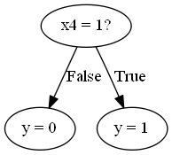

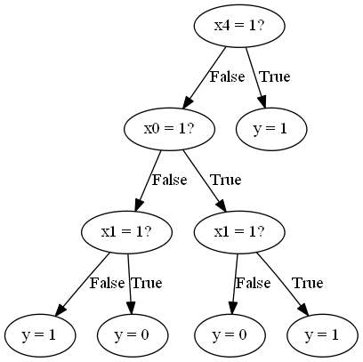Decision tree with depth 3:

Decision Tree with depth 5:

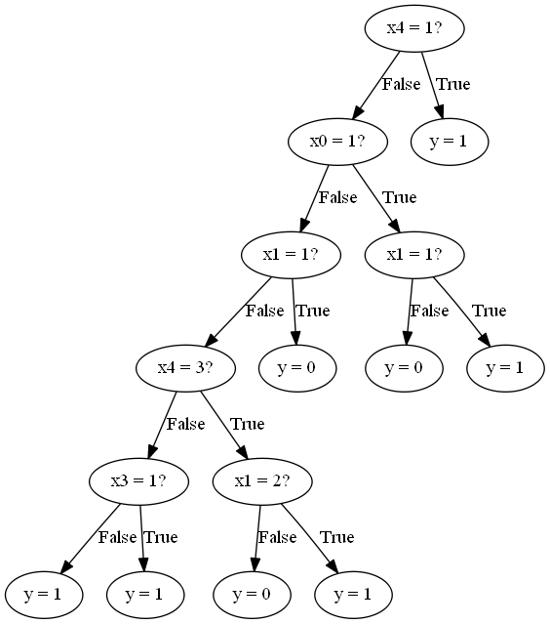

1. For monks-1, use scikit-learn’s DecisionTreeClassifier [3] to learn a decision tree using criterion=’entropy’ for depth = 1, 3, 5. You may use scikit-learn’s confusion matrix()

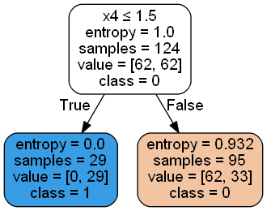Decision Tree at depth1:

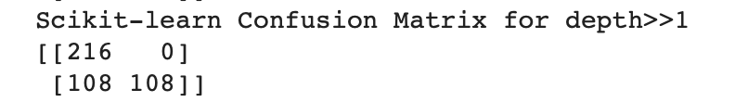

Decision Tree with depth 3:

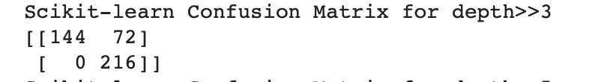

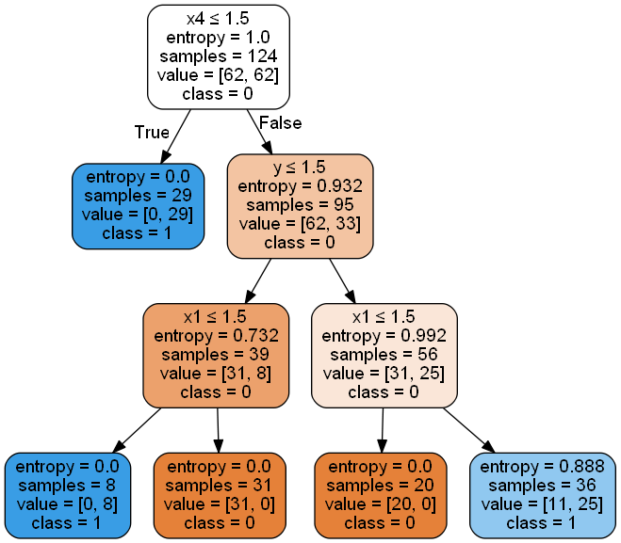

Decision Tree with Depth 5: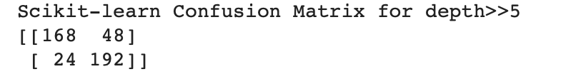

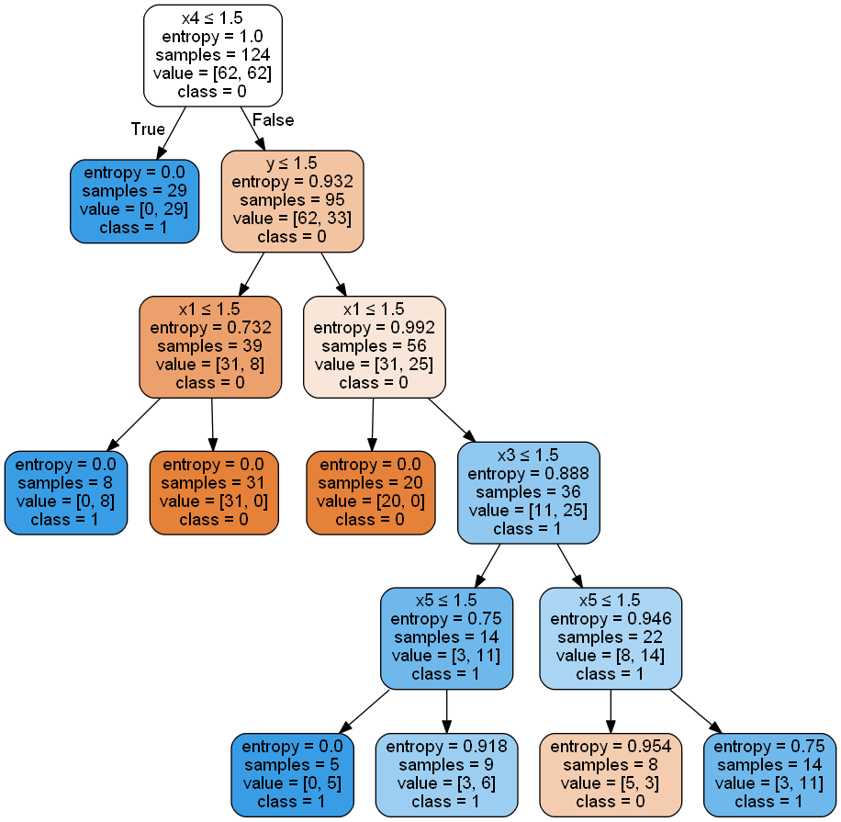

1. Repeat steps (c) and (d) with your “own” data set and report the confusion matrices. You can use other data sets in the UCI repository. If you encounter continuous features, consider a simple discretization strategy to pre-process them into binary features using the mean

sampledataset (sample.train, sample.test)

Depth 1

Depth 3

Depth 5



