**Diya Goyal 102215255 2NC11**

**Lab Assignment 3**

**UCS 406 Data Structures and Algorithms**

Note: Use C/C++ or JAVA programming language.

Q1. Write a function to perform following operations on string.

1. Find the length of string.

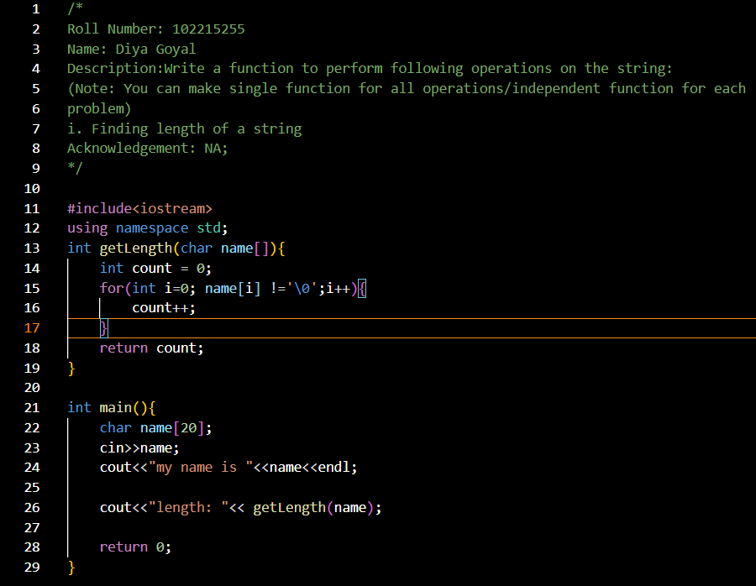

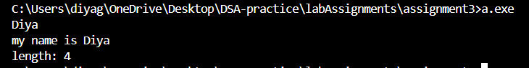

1. Converting a string to lower case.

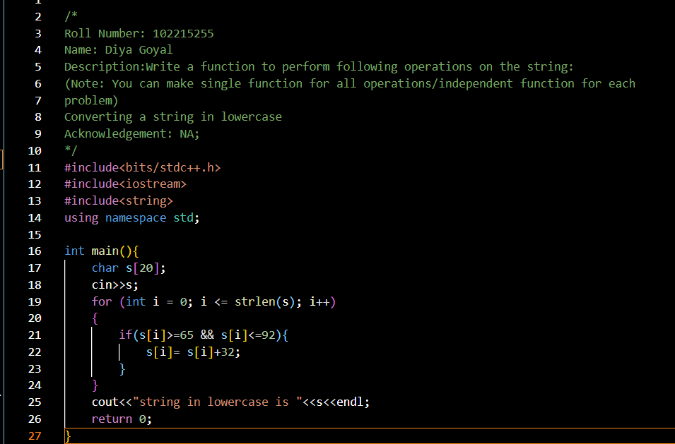

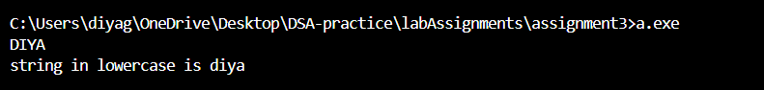

1. Counting number of words and vowels in a string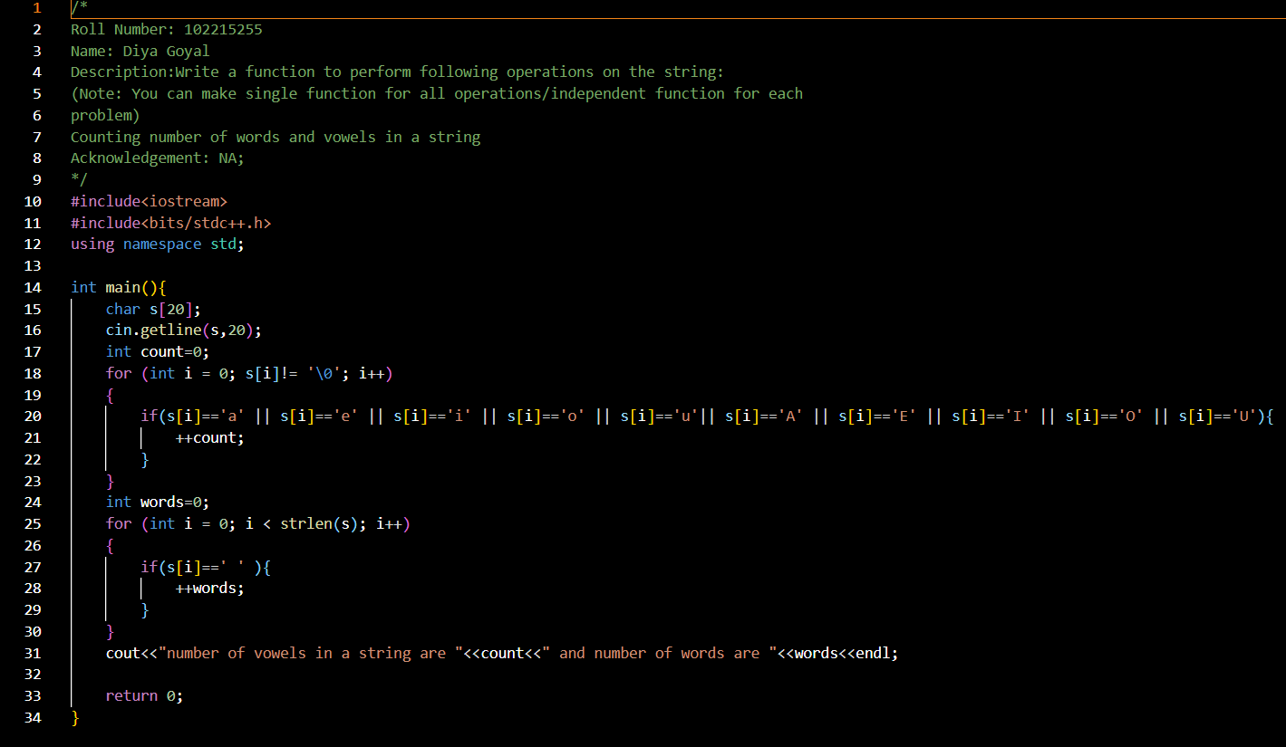

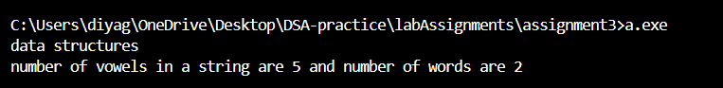

1. Validating a string

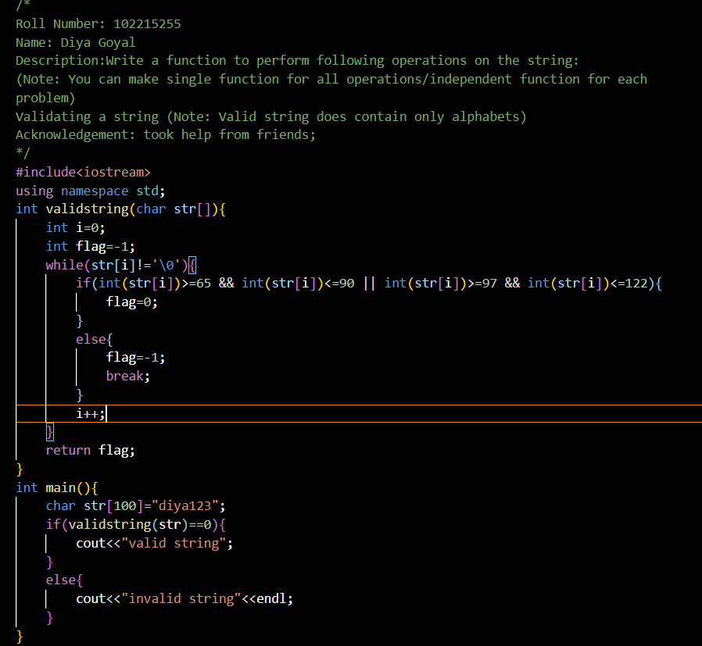



1. Reversing a string (Eg. Code → edoC)

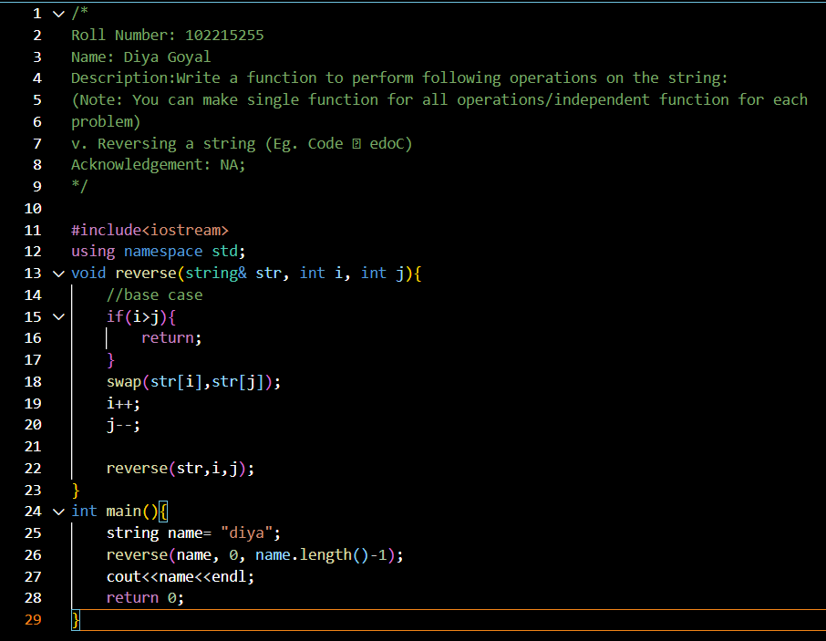

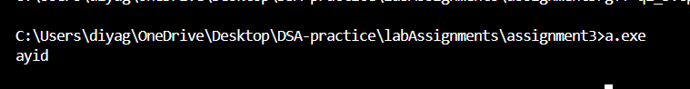

1. Checking if a string is palindrome.

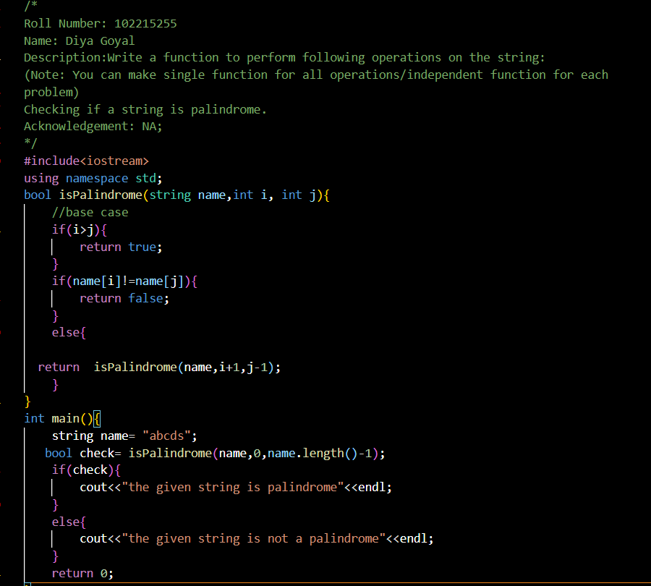

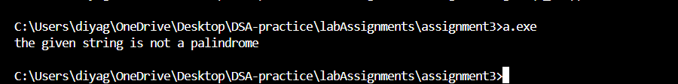

1. Finding duplicate characters in a string (Note: print the duplicate characters only once,

irrespective of the number of times it occurred)

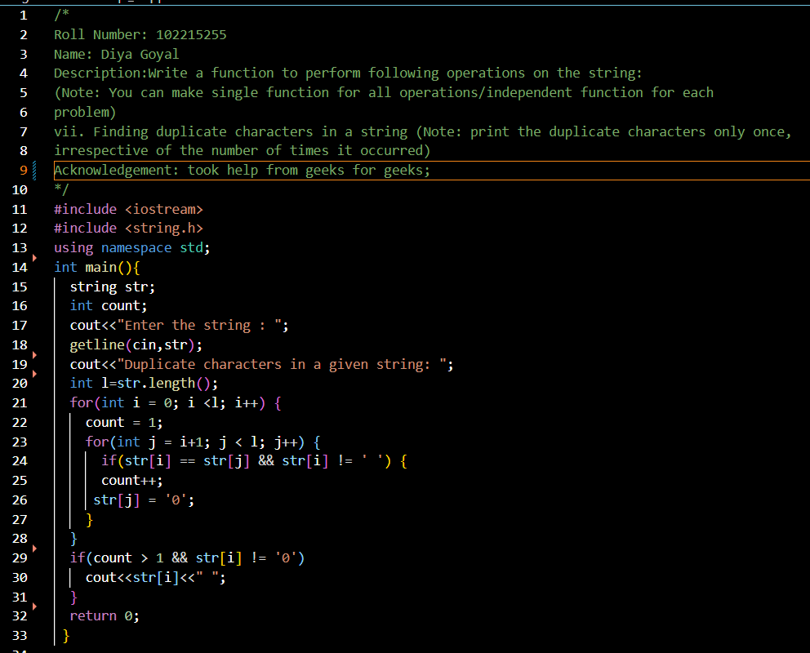

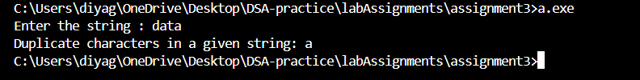

Q2. Write a program to find factorial of a program recursively.

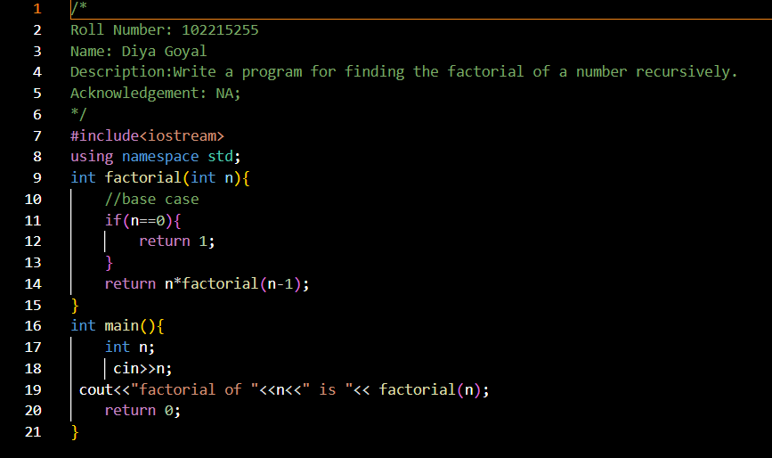

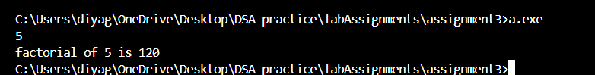

Q3. Implement combination formula n C r using recursion and code it in C/C++/JAVA/Python language.

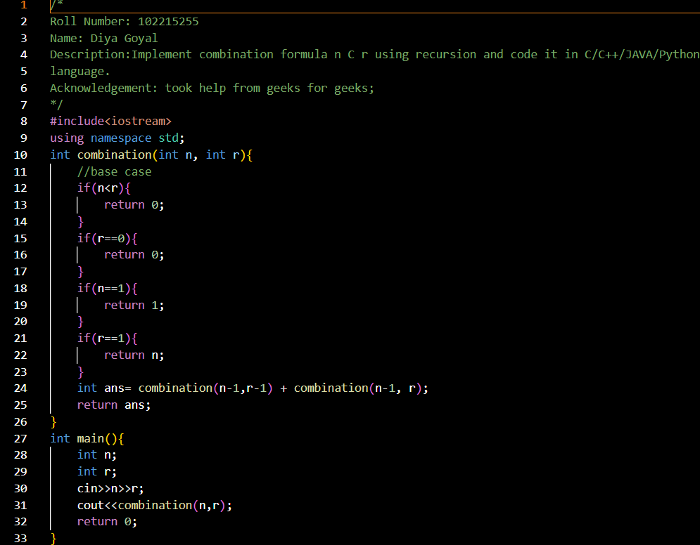

Q4. Implement the Tower of Hanoi Problem using recursion and code it in C/C++/JAVA/Python language.

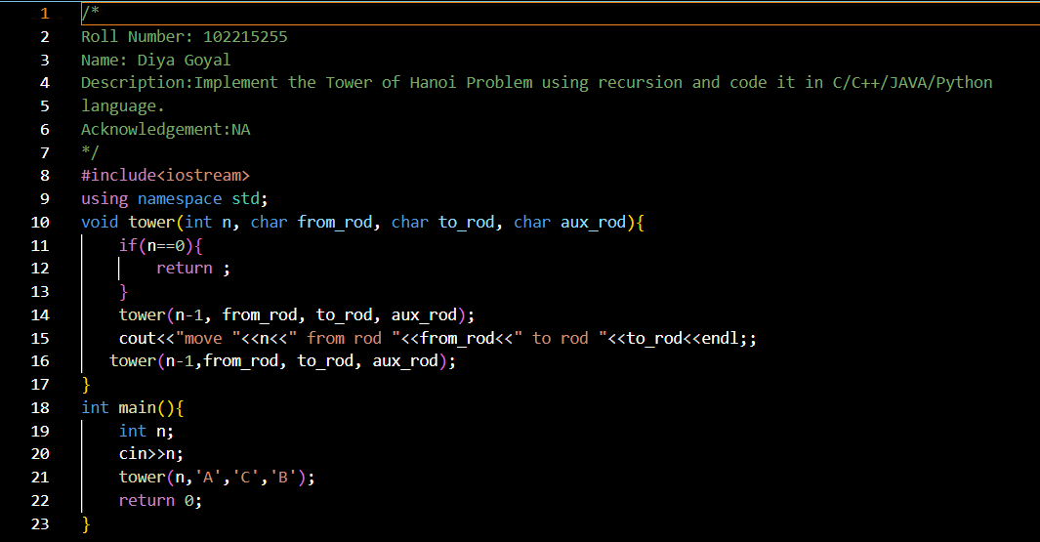

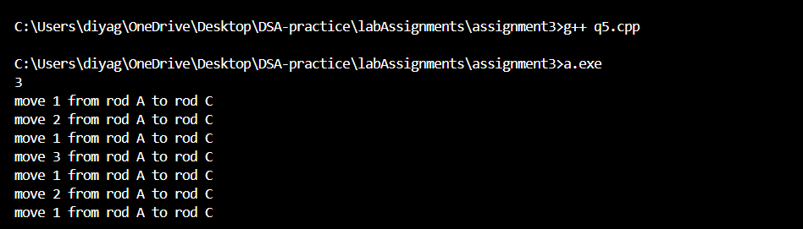

Q5. Implement the Fibonacci series using recursion and code it in C/C++/JAVA/Python language.

