**Diya Goyal 102215255 2NC11**

**Lab Assignment 4**

**UCS 406 Data Structures and Algorithms**

Note: Use C/C++ or JAVA programming language.

Q1. Implement the following stack operations using arrays:

* Push
* Pop
* IsFull
* isEmpty
* Peek
* stackTopCreate a stack structure and stack class for the above said implementation.

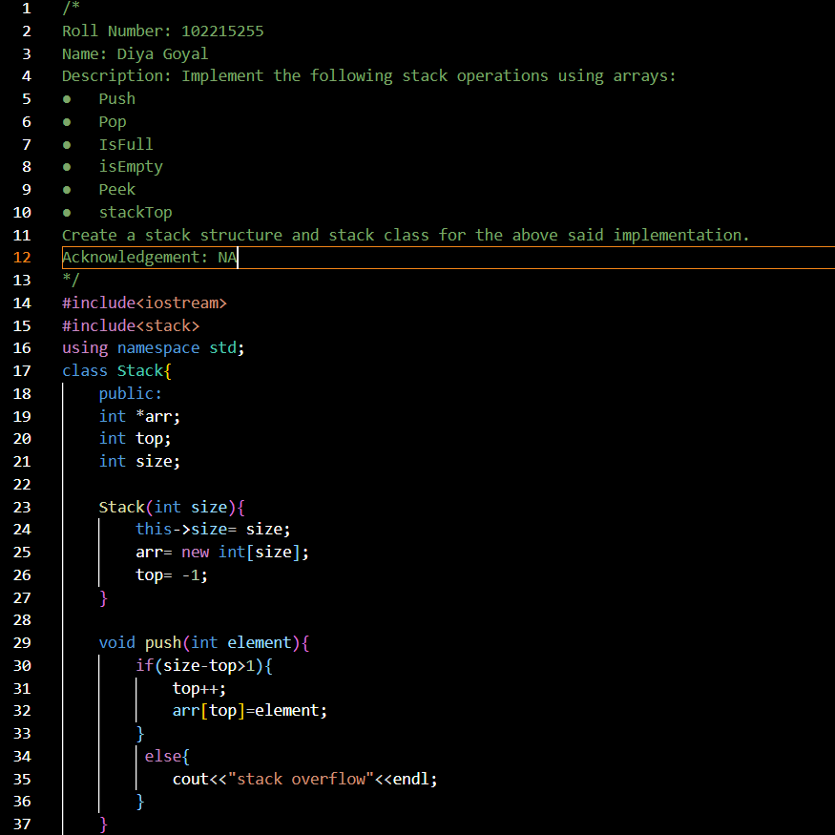

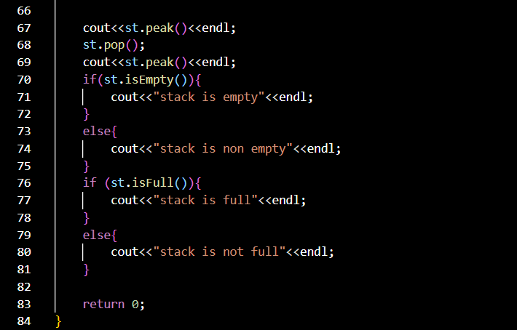 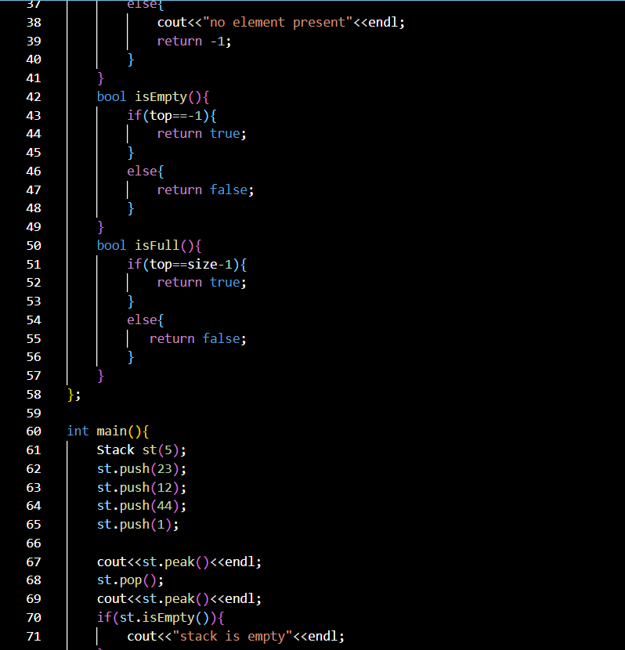

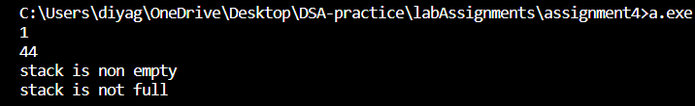

Q2. Implement the following stack operations using linked List:

* Push
* Pop
* IsFull
* isEmpty
* Peek

Create a stack structure and stack class for the above said implementation.

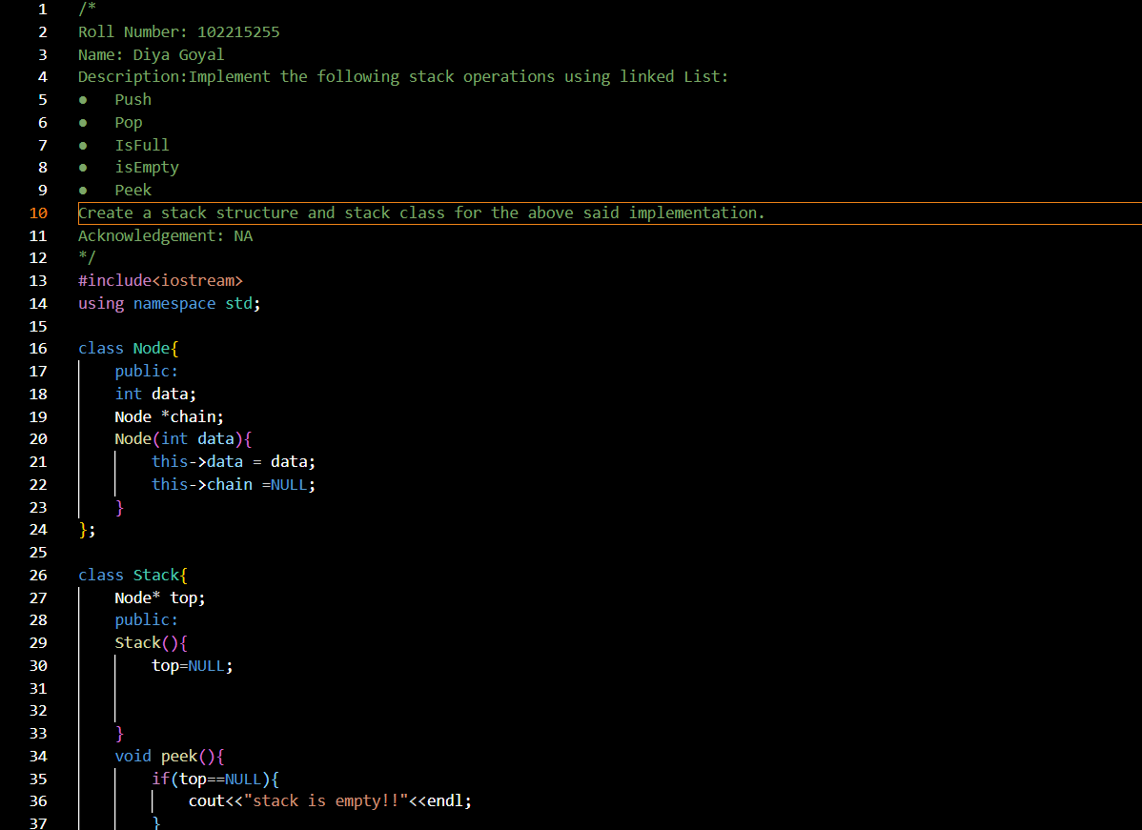

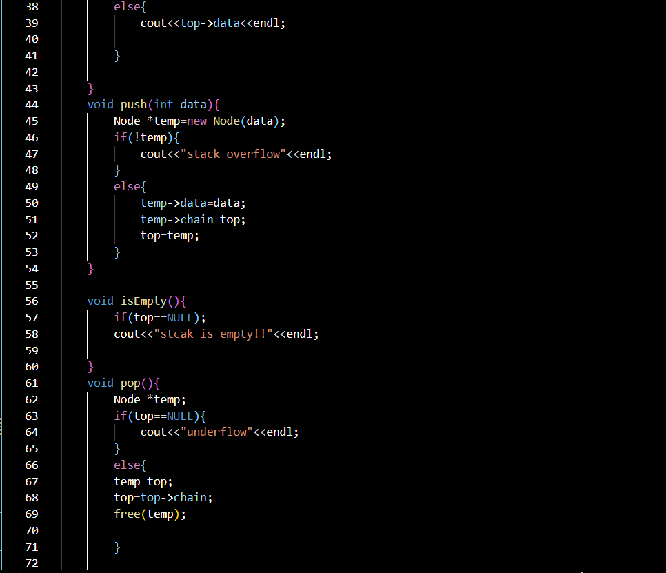

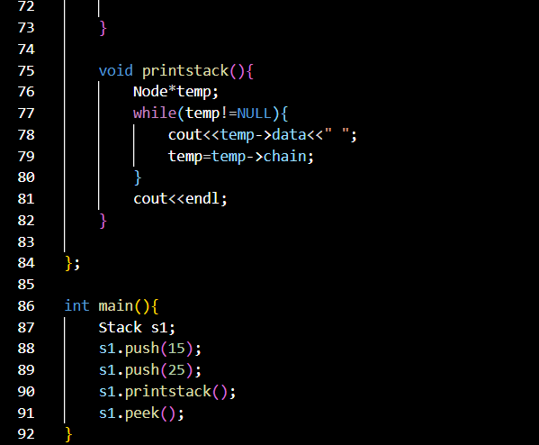



Q3. Implement linear queue by writing a class and also implement the following fumctions:

* Insert or enqueue
* Remove or dequeue
* Isfull
* IsemptyWrite main function to exemplify the results. Also write a main function to make the implementation a “Menu-Driven”.

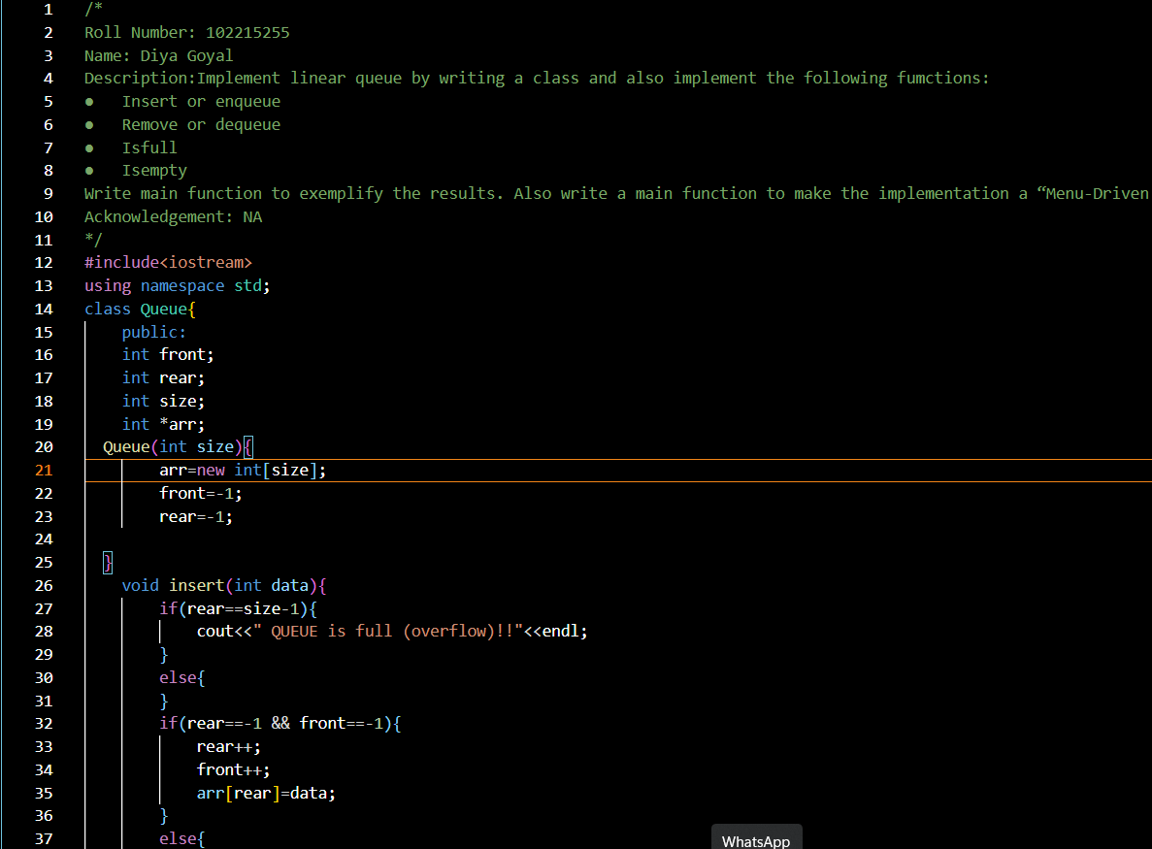

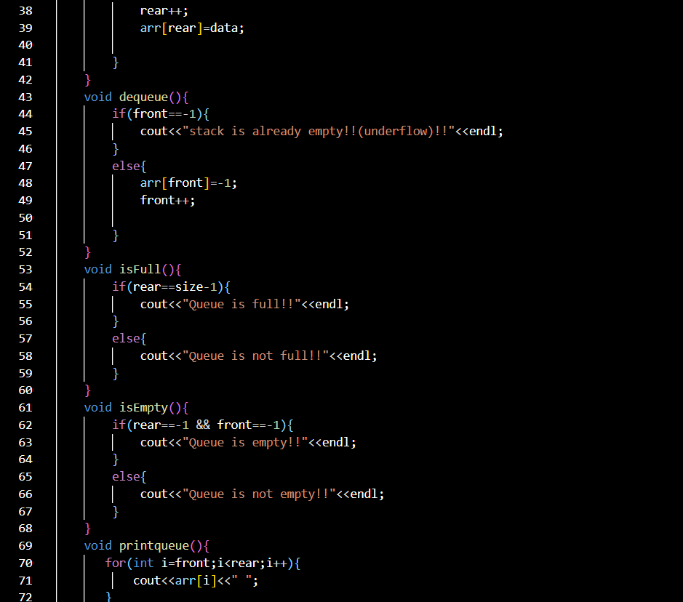

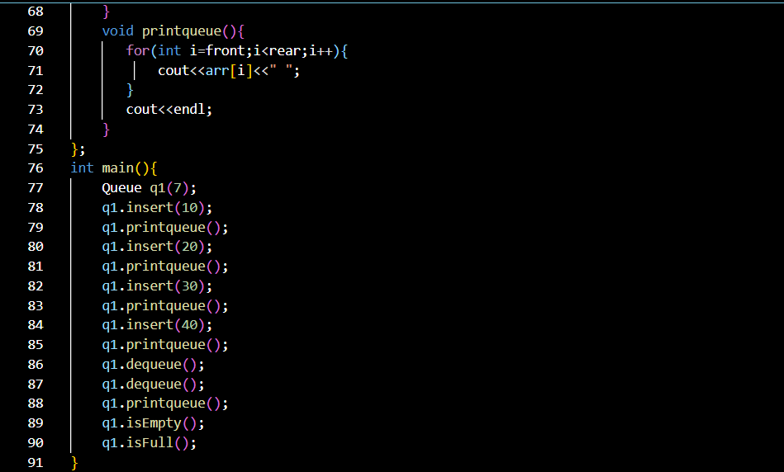

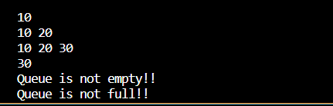

Q4. Implement a queue using two stacks only. Name the two as forward and reverse stacks. The resultant queue (comprised of two stacks) should perform the following functions with minimum time complexity:

1. Enqueue()
2. Dequeue()
3. isFull()
4. isEmpty()

Also incorporate the code for exception handling.

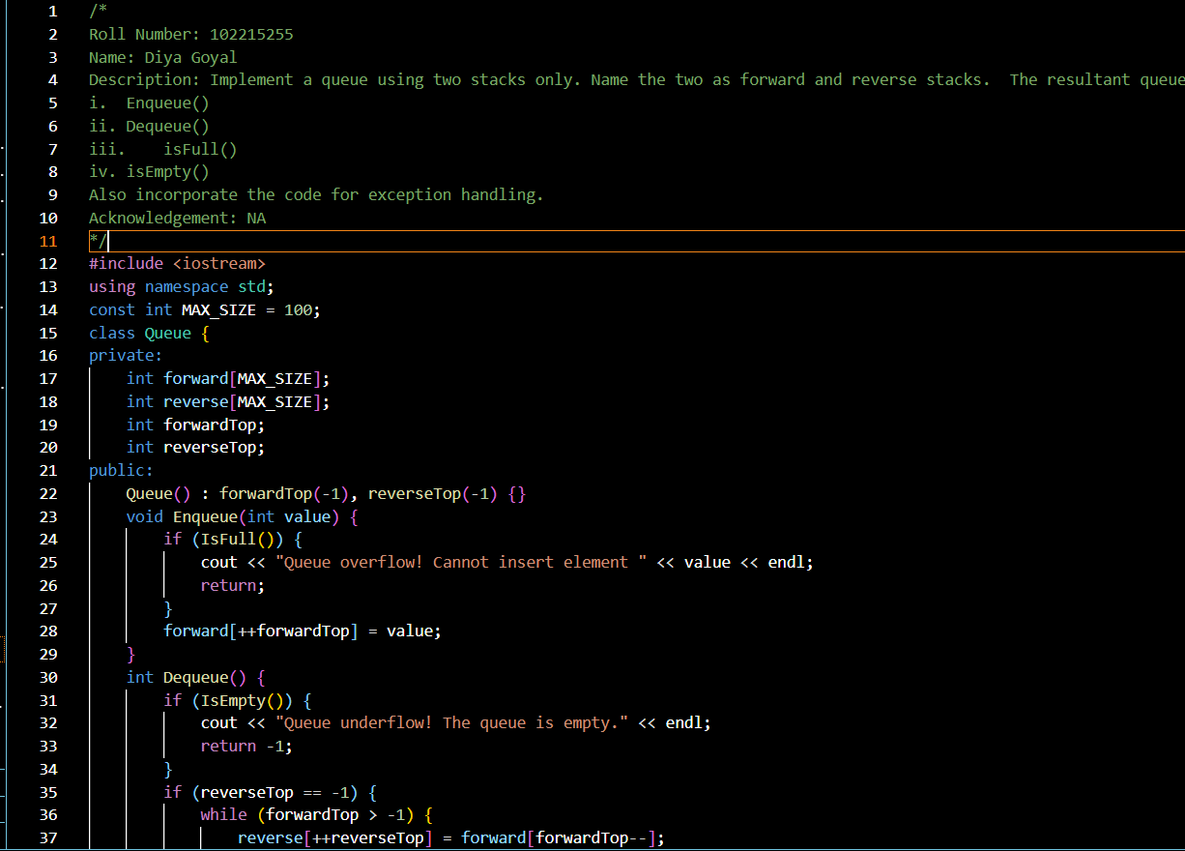

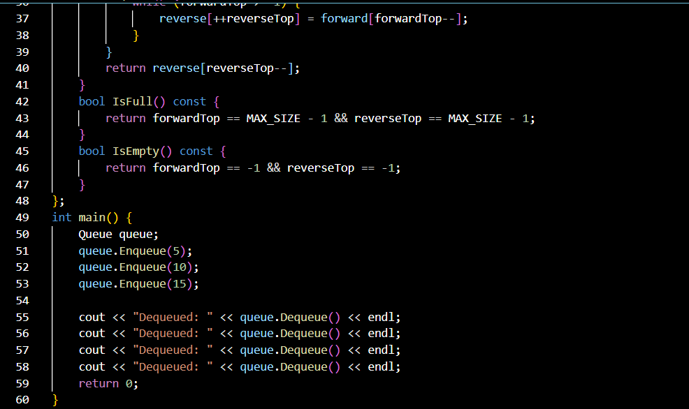

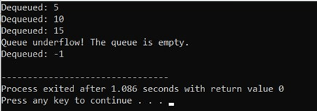

Q5. Implement priority queue by writing a class and also implement the following fumctions:

* Insert or enqueue
* Remove or dequeue
* Isfull
* Isempty

Write main function to exemplify the results. Also write a main function to make the implementation a “Menu-Driven”.

