A Convolutional Neural Network based Approach for Recognizing Malayalam Handwritten Characters

Jabir Ali V

**Abstract**— Optical character recognition has leveraged its capabilities to reduce tedious manual work of converting images containing charcters to texts for recent decades, recognition of handwritten texts is harder than recognizing printed texts as different handwritten script may have different style of writings, slants etc, The Convolutional Neural Network(CNN) has been successfully used to recognize charcters in many languages. This paper proposes a CNN architecture for classification of handwritten characters in Malayalam language. Malayalam is a south Indian language which is used by 33.3 million people in the state of Kerala. This CNN Model has shown a tesing accuracy of 97.26% for the classification of 44 handwritten Malayalam characters by using a dataset having seventy three thousand training images and eighteen thousand testing images. In addition, this paper put forward an algorithm to process an image containig handwritten Malayalam characters and output the corresponding Malayalam characters.

**Index Terms**— Classification, Convolutional Neural Network, Dataset Augmentation OCR, Optimizer, Segmentation

——————————  ——————————

# 1 Introduction

OPTICAL character recognition is the process of converting images containing printed, typewritten or handwritten characters into machine encoded format. OCR has leveraged its capabilities to reduce the tedious manual work work of converting images of printed or handwritten texts to digital form for the recent decades. Different methods have been used in OCR such as Bayesian theory, Hidden Markov Model, Template Matching and Neural Networks. The recognition task of handwritten characters is rather complex and is a great challenge to researchers as the solution should be able to cope with the challenges in identifying the characters from a variety of writing styles, slants of personal intrest. Especially in a language like Malayalam which is having a complex structure and very identical nature of character set.

Convlolutional Neural Network (CNN) is a popular deep learning method which has successfully used in many classification problems, It has a great capability to find patters in two dimensional data and were applied in the area of natural language processing, image classification, face recognition, autonomous driving etc. The proposed method uses a new CNN architecture to do the classification task. Unlike other classical machine learning such as SVM and Random Forest, the feature extraction task is implicitely done in CNN by using the gradient descent algorithm proposed by Yann LeCunn.This paper also propose method to do the task of segmentation of words and characters from a document image and to make character prediction from the CNN Model created.

# 2 Malayalam Language

Malayalam is the main language of kerala, a south Indian state. Malayalam is spoken by around 33 million people in kerala and it is one among the twenty two scheduled languages in India. Like other south Indian languages such as Tamil, Kannada and Telugu, Malayalam language has a complex structure. It contains core characters and vowel diacritics. In addition to this, the script is formed mostly by curves and holes. There are characters which looks very similar and having only small distinguishable difference. The modern Malayalam script contains 13 vowel letters and 36 consonants. Apart from this basic characters there are characters which are formed by the combination of other consonants called conjunct consonants. Here a dataset of 44 basic Malayalam characters shown in Fig 1.

————————————————

* Jabir Ali is currently pursuing masters degree program in computer applications in College of Engineering Trivandrum,Kerala University ,India , E-mail: jabir366@gmail.com

# 3 Literature Review

Shailesh Acharya et al proposed a Large Scale Handwritten Devanagari Character Recognition that used The Deep learning technique convolutional neural network for classifying Devanagari handwritten characters. The employed increment of dataset and added a dropout layer in order to reduce over fitting. They used two models of the network. First model consisted of three convolution layers and one fully connected layer and the second model was a shallow network. The highest testing accuracy for first model was 0.982681 and for the second model was 0.98471.

G Raju et al. put forwarded a Malayalam character recognition system which uses gradient based features and Run Length count. The authors also have proposed another character recognition scheme using the fusion of local and global

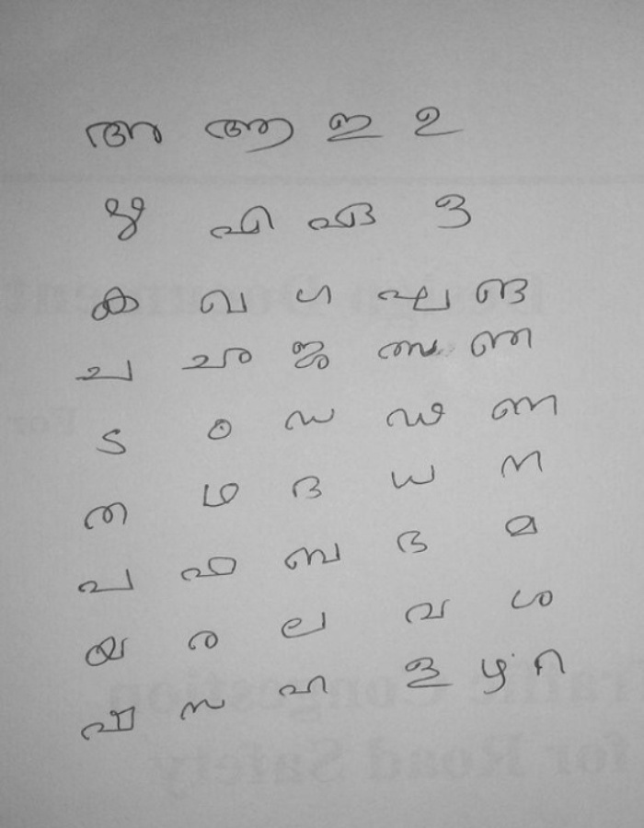

Fig.1

features for the recognition of isolated Malayalam characters.

. Arora et al. proposed a multiple classifier system using chain code histogram and moment invariants for the recognition of Devanagari character recognition.

# 4 Citations

IJSER style is to not citations in individual brackets, followed by a comma, e.g. “[1], [5]” (as opposed to the more common “[1, 5]” form.) Citation ranges should be formatted as follows: [1], [2], [3], [4] (as opposed to [1]-[4], which is not IJSER style). When citing a section in a book, please give the relevant page numbers [2]. In sentences, refer simply to the reference number, as in [3]. Do not use “Ref. [3]” or “reference [3]” At the beginning of a sentence use the author names instead of “Reference [3],” e.g., “Smith and Smith [3] show ... .” Please note that references will be formatted by IJSER production staff in the same order provided by the author.

# 5 Equations

If you are using Word, use either the Microsoft Equation Editor or the MathType add-on (http://www.mathtype.com) for equations in your paper (Insert | Object | Create New | Microsoft Equation or MathType Equation). “Float over text” should not be selected.

Number equations consecutively with equation numbers in parentheses flush with the right margin, as in (1). First, use the equation editor to create the equation. Then, select the “Equation” markup style. Press the tab key and write the equation number in parentheses. To make your equations more compact, you may use the solidus ( / ), the exp function, or appropriate exponents. Use parentheses to avoid ambiguities in denominators. Punctuate equations when they are part of a sentence, as in

 (1)

Be sure that the symbols in your equation have been defined before the equation appears or immediately following. Italicize symbols (*T* might refer to temperature, but T is the unit tesla). Per IJSER, please refer to “(1),” not “Eq. (1)” or “equation (1),” except at the beginning of a sentence: “Equation (1) shows ... .” Also see *The Handbook of Writing for the Mathematical Sciences*, 1993. Published by the Society for Industrial and Applied Mathematics, this handbook provides some helpful information about math typography and other stylistic matters. For further information about typesetting mathematical equations, please visit the IJSER styel guide: [http://www.ijser.org](http://www.ijser.org/).

Please note that math equations might need to be reformatted from the original submission for page layout reasons. This includes the possibility that some in-line equations will be made display equations to create better flow in a paragraph. If display equations do not fit in the two-column format, they will also be reformatted. Authors are strongly encouraged to ensure that equations fit in the given column width.

# 6 Helpful Hints

## 6.1 Figures and Tables

Because IJSER staff will do the final formatting of your paper, some figures may have to be moved from where they appeared in the original submission. Figures and tables should be sized as they are to appear in print. Figures or tables not correctly sized will be returned to the author for reformatting.

Detailed information about the creation and submission of images for articles can be found at: [http://www.ijser.org](http://www.ijser.org/). We strongly encourage authors to carefully review the material posted here to avoid problems with incorrect files or poorly formatted graphics.

Place figure captions below the figures; place table titles above the tables. If your figure has two parts, include the labels “(a)” and “(b)” as part of the artwork. Please verify that the figures and tables you mention in the text actually exist. Figures and tables should be called out in the order they are to appear in the paper. For example, avoid referring to figure “8” in the first paragraph of the article unless figure 8 will again be referred to after the reference to figure 7. **Please do not include figure captions as part of the figure. Do not put captions in “text boxes” linked to the figures. Do not put borders around the outside of your figures.** Per IJSER, please use the abbreviation “Fig.” even at the beginning of a sentence. Do not abbreviate “Table.” Tables are numbered numerically.

Figures may only appear in color for certain journals. Please verify with IJSER that the journal you are submitting to does indeed accept color before submitting final materials. **Do not use color unless it is necessary for the proper interpretation of your figures.**

Figures (graphs, charts, drawing or tables) should be named fig1.eps, fig2.ps, etc. If your figure has multiple parts, please submit as a single figure. Please do not give them descriptive names. Author photograph files should be named after the author’s LAST name. Please avoid naming files with the author’s first name or an abbreviated version of either name to avoid confusion. If a graphic is to appear in print as black and white, it should be saved and submitted as a black and white file (grayscale or bitmap.) If a graphic is to appear in color, it should be submitted as an RGB color file.

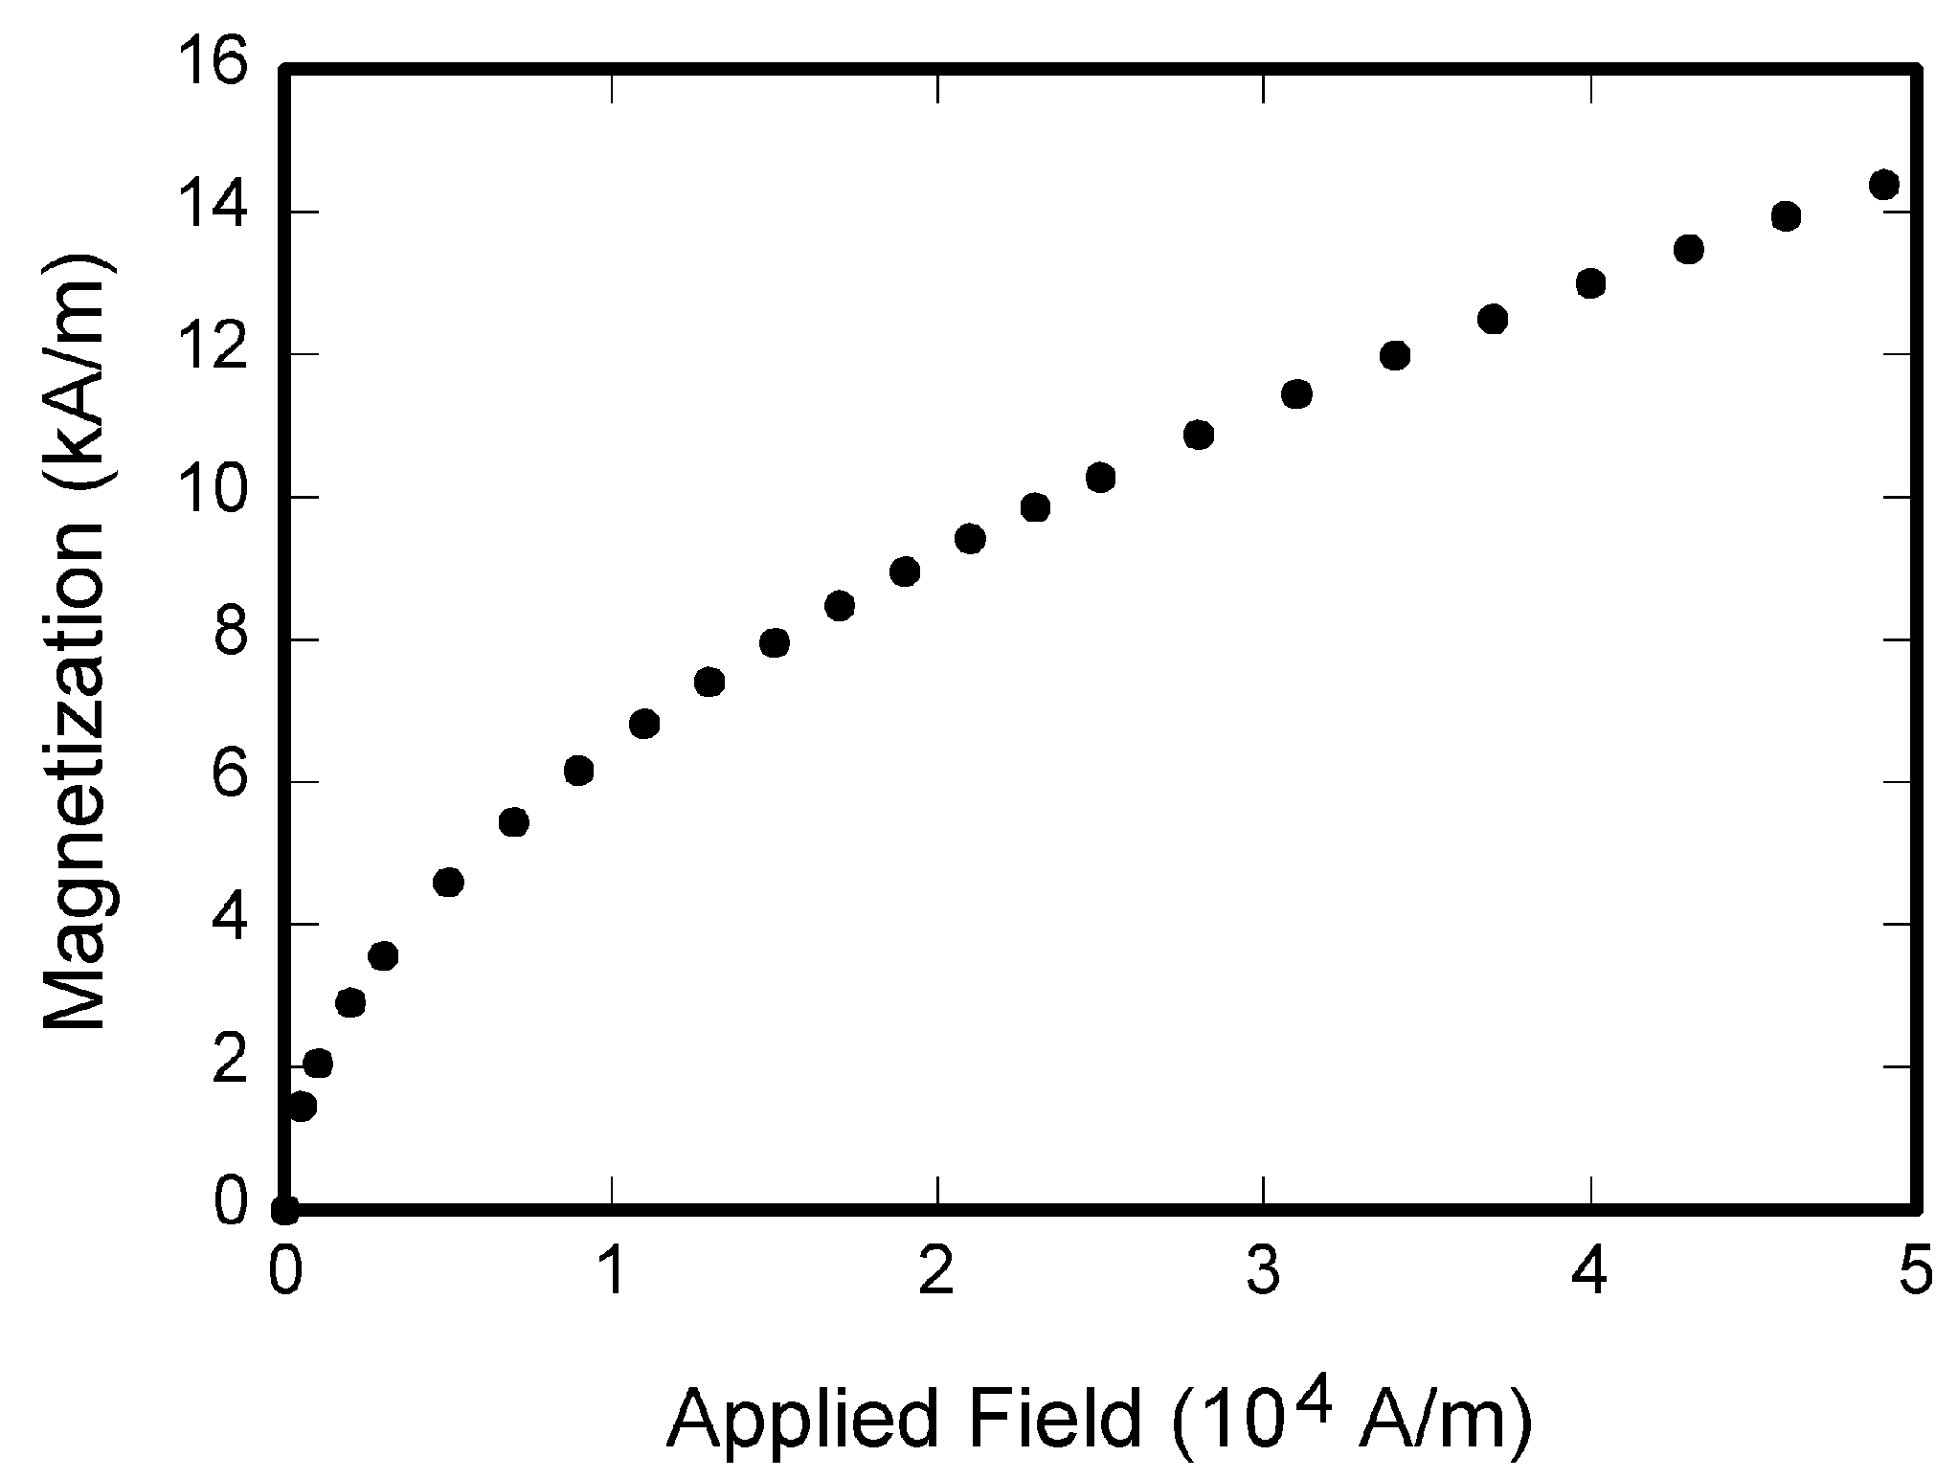

Fig. 1. Magnetization as a function of applied field. Note that “Fig.” is abbreviated. There is a period after the figure number, followed by one space. It is good practice to briefly explain the significance of the figure in the caption.

Figure axis labels are often a source of confusion. Use words rather than symbols. As an example, write the quantity “Magnetization,” or “Magnetization *M*,” not just “*M*.” Put units in parentheses. Do not label axes only with units. As in Fig. 1, for example, write “Magnetization (A/m)” or “Magnetization (Am1),” not just “A/m.” Do not label axes with a ratio of quantities and units. For example, write “Temperature (K),” not “Temperature/K.” Table 1 shows some examples of units of measure.

Multipliers can be especially confusing. Write “Magnetization (kA/m)” or “Magnetization (103 A/m).” Do not write “Magnetization (A/m)  1,000” because the reader would not know whether the top axis label in Fig. 1 meant 16,000 A/m or 0.016 A/m. Figure labels should be legible, approximately 8 to 12 point type. When creating your graphics, especially in complex graphs and charts, please ensure that line weights are thick enough that when reproduced at print size, they will still be legible. We suggest at least 1 point.

## 6.3 Footnotes

Number footnotes separately in superscripts (Insert | Footnote)[1]. Place the actual footnote at the bottom of the column in which it is cited; do not put footnotes in the reference list (endnotes). Use letters for table footnotes (see Table 1). Please do not include footnotes in the abstract and avoid using a footnote in the first column of the article. This will cause it to appear of the affiliation box, making the layout look confusing.

## 6.4 Lists

TABLE 1  
Units for Magentic Properties

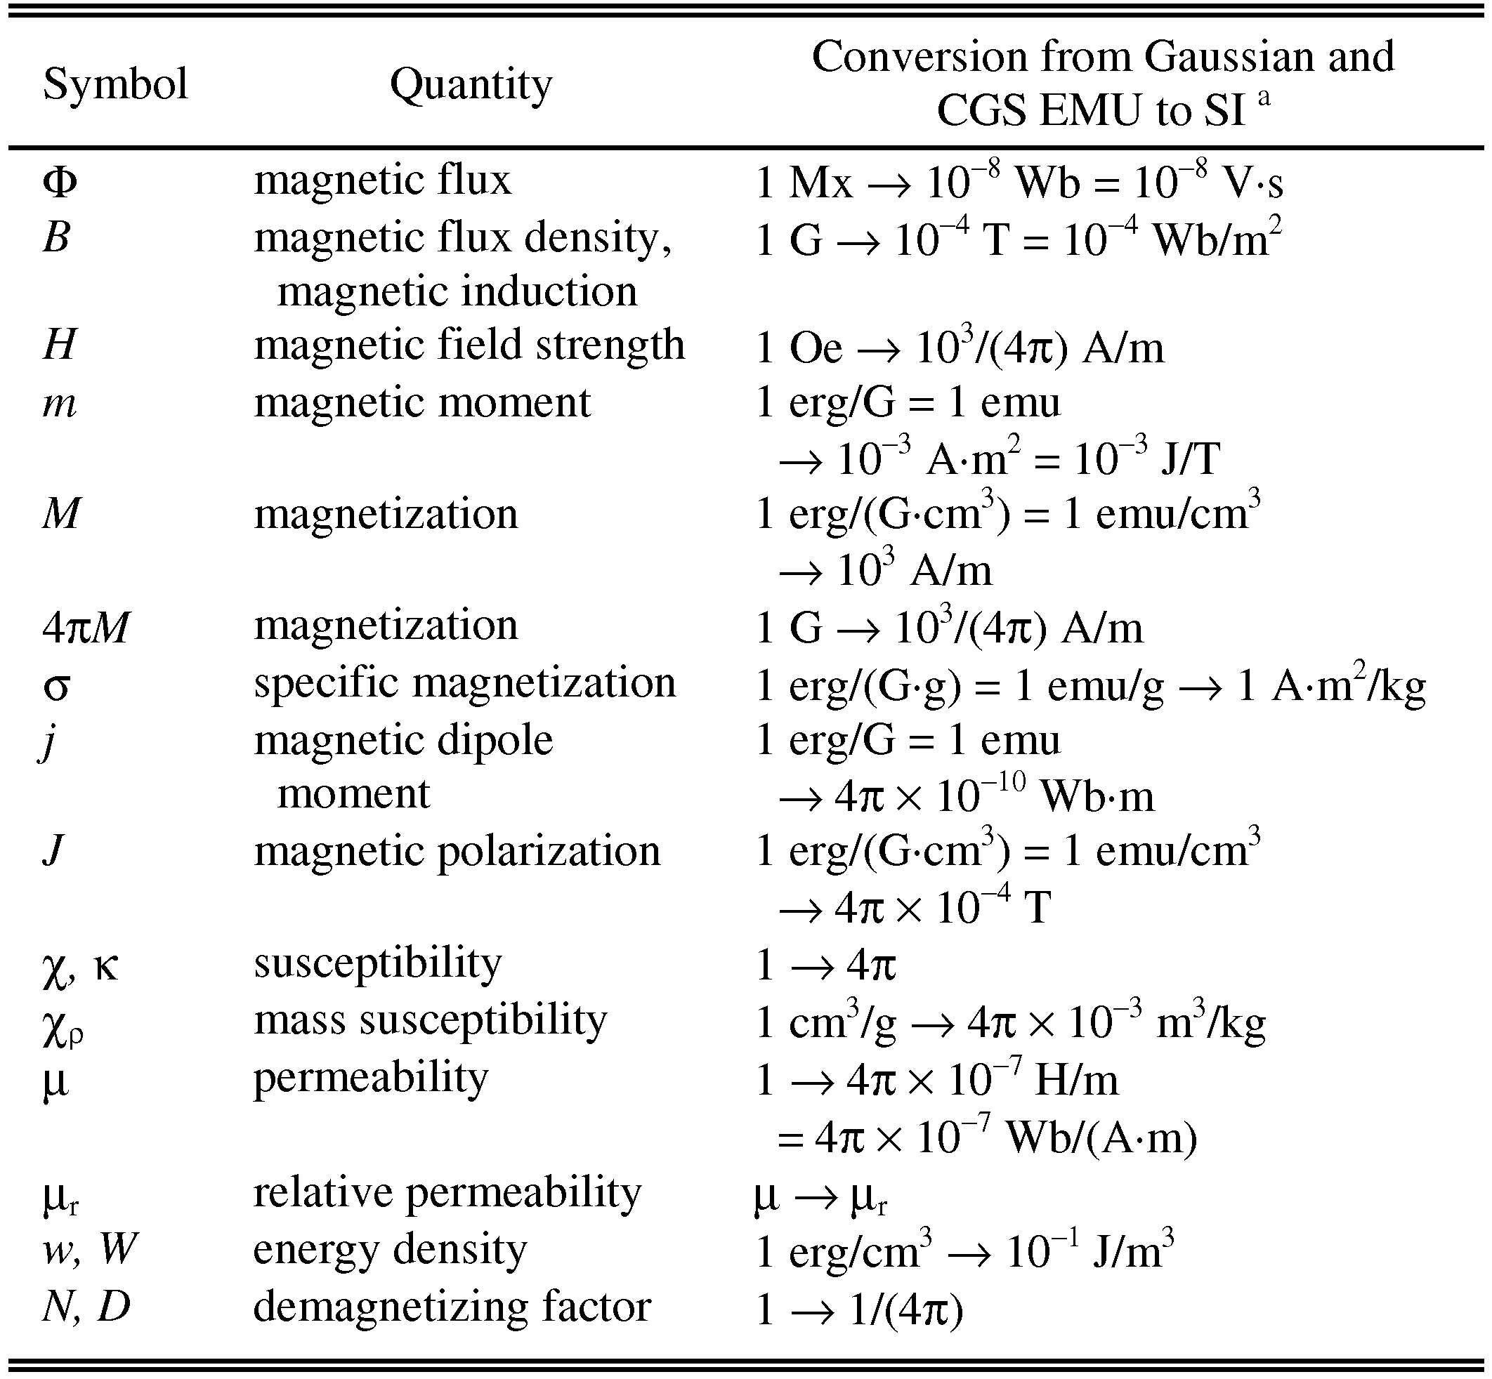

Statements that serve as captions for the entire table do not need footnote letters.

aGaussian units are the same as cgs emu for magnetostatics; Mx = maxwell, G = gauss, Oe = oersted; Wb = weber, V = volt, s = second, T = tesla, m = meter, A = ampere, J = joule, kg = kilogram, H = henry.

The IJSER style is to create displayed lists if the number of items in the list is longer than three. For example, within the text lists would appear 1) using a number, 2) followed by a close parenthesis. However, longer lists will be formatted so that:

1. Items will be set outside of the paragraphs.
2. Items will be punctuated as sentences where it is appropriate.
3. Items will be numbered, followed by a period.

## 6.5 Theorems and Proofs

Theorems and related structures, such as axioms corollaries, and lemmas, are formatted using a hanging indent paragraph. They begin with a title and are followed by the text, in italics.

**Theorem 1.** *Theorems, corollaries, lemmas, and related structures follow this format. They do not need to be numbered, but are generally numbered sequentially.*

Proofs are formatted using the same hanging indent format. However, they are not italicized.

**Proof.** The same format should be used for structures such as remarks, examples, and solutions (though these would not have a Q.E.D. box at the end as a proof does).

# 7 End Sections

## Appendices

Appendixes, if needed, appear before the acknowledgment. In the event multiple appendices are required, they will be labeled “Appendix A,” “Appendix B, “ etc. If an article does not meet submission length requirements, authors are strongly encouraged to make their appendices supplemental material.

## IJSER Transactions accepts supplemental materials for review with regular paper submissions. These materials may be published on our Digital Library with the electronic version of the paper and are available for free to Digital Library visitors. Please see our guidelines below for file specifications and information. Any submitted materials that do not follow these specifications will not be accepted. All materials must follow US copyright guidelines and may not include material previously copyrighted by another author, organization or company. More information can be found at http://www.ijser.org.

## 7.2 Acknowledgments

The preferred spelling of the word “acknowledgment” in American English is without an “e” after the “g.” Use the singular heading even if you have many acknowledgments. Avoid expressions such as “One of us (S.B.A.) would like to thank ... .” Instead, write “F. A. Author thanks ... .” Sponsor and financial support acknowledgments are included in the acknowledgment section. For example: This work was supported in part by the US Department of Commerce under Grant BS123456 (sponsor and financial support acknowledgment goes here). Researchers that contributed information or assistance to the article should also be acknowledged in this section.

## 7.3 References

Unfortunately, the Computer Society document translator cannot handle automatic endnotes in Word; therefore, type the reference list at the end of the paper using the “References” style. See the IJSER’s style for reference formatting at: http://www.ijser.org  
transref.htm. The order in which the references are submitted in the manuscript is the order they will appear in the final paper, i.e., references submitted nonalphabetized will remain that way.

Please note that the references at the end of this document are in the preferred referencing style. Within the text, use “et al.” when referencing a source with more than three authors. In the reference section, give all authors’ names; do not use “et al.” Do not place a space between an authors' initials. Papers that have not been published should be cited as “unpublished” [4]. Papers that have been submitted or accepted for publication should be cited as “submitted for publication” [5]. Please give affiliations and addresses for personal communications [6].

Capitalize all the words in a paper title. For papers published in translation journals, please give the English citation first, followed by the original foreign-language citation [7].

## 7.3 Additional Formatting and Style Resources

Additional information on formatting and style issues can be obtained in the IJSER Style Guide, which is posted online at: http://www.ijser.org/. Click on the appropriate topic under the Special Sections link.

# Conclusion

Although a conclusion may review the main points of the paper, do not replicate the abstract as the conclusion. A conclusion might elaborate on the importance of the work or suggest applications and extensions. Authors are strongly encouraged not to call out multiple figures or tables in the conclusion—these should be referenced in the body of the paper.

**Acknowledgment**

The authors wish to thank A, B, C. This work was supported in part by a grant from XYZ.

**References**

1. J.S. Bridle, “Probabilistic Interpretation of Feedforward Classification Network Outputs, with Relationships to Statistical Pattern Recognition,” *Neurocomputing—Algorithms, Architectures and Applications,* F. Fogelman-Soulie and J. Herault, eds., NATO ASI Series F68, Berlin: Springer-Verlag, pp. 227-236, 1989. (Book style with paper title and editor)
2. W.-K. Chen, *Linear Networks and Systems.* Belmont, Calif.: Wadsworth, pp. 123-135, 1993. (Book style)
3. H. Poor, “A Hypertext History of Multiuser Dimensions,” *MUD History,* http://www.ccs.neu.edu/home/pb/mud-history.html. 1986. (URL link *include year)
4. K. Elissa, “An Overview of Decision Theory,"unpublished. (Unplublished manuscript)
5. R. Nicole, "The Last Word on Decision Theory," *J. Computer Vision,* submitted for publication. (Pending publication)
6. C. J. Kaufman, Rocky Mountain Research Laboratories, Boulder, Colo., personal communication, 1992. (Personal communication)
7. D.S. Coming and O.G. Staadt, "Velocity-Aligned Discrete Oriented Polytopes for Dynamic Collision Detection," *IEEE Trans. Visualization and Computer Graphics*, vol. 14,  no. 1,  pp. 1-12,  Jan/Feb  2008, doi:10.1109/TVCG.2007.70405. (IEEE Transactions )
8. S.P. Bingulac, “On the Compatibility of Adaptive Controllers,” *Proc. Fourth Ann. Allerton Conf. Circuits and Systems Theory*, pp. 8-16, 1994. (Conference proceedings)
9. H. Goto, Y. Hasegawa, and M. Tanaka, “Efficient Scheduling Focusing on the Duality of MPL Representation,” *Proc. IEEE Symp. Computational Intelligence in Scheduling* *(SCIS ’07)*, pp. 57-64, Apr. 2007, doi:10.1109/SCIS.2007.367670. (Conference proceedings)
10. J. Williams, “Narrow-Band Analyzer,” PhD dissertation, Dept. of Electrical Eng., Harvard Univ., Cambridge, Mass., 1993. (Thesis or dissertation)
11. E.E. Reber, R.L. Michell, and C.J. Carter, “Oxygen Absorption in the Earth’s Atmosphere,” Technical Report TR-0200 (420-46)-3, Aerospace Corp., Los Angeles, Calif., Nov. 1988. (Technical report with report number)
12. L. Hubert and P. Arabie, “Comparing Partitions,” *J. Classification,* vol. 2, no. 4, pp. 193-218, Apr. 1985. (Journal or magazine citation)
13. R.J. Vidmar, “On the Use of Atmospheric Plasmas as Electromagnetic Reflectors,” *IEEE Trans. Plasma Science*, vol. 21, no. 3, pp. 876-880, available at http://www.halcyon.com/pub/journals/21ps03-vidmar, Aug. 1992. (URL for Transaction, journal, or magzine)
14. J.M.P. Martinez, R.B. Llavori, M.J.A. Cabo, and T.B. Pedersen, "Integrating Data Warehouses with Web Data: A Survey," *IEEE Trans. Knowledge and Data Eng.*, preprint, 21 Dec. 2007, doi:10.1109/TKDE.2007.190746.(PrePrint)

1. It is recommended that footnotes be avoided (except for the unnumbered footnote with the receipt date on the first page). Instead, try to integrate the footnote information into the text.