**APPENDIX**

**Prediction Of Real Time Input**

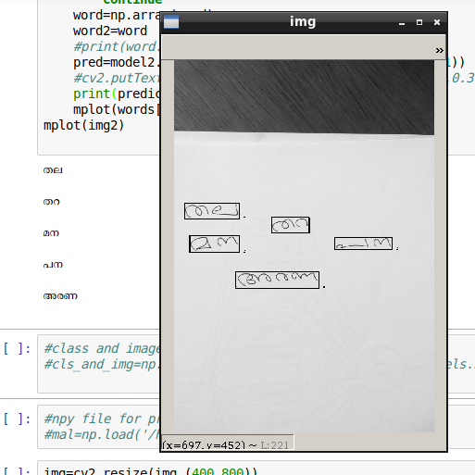

**The CNN Architecture**

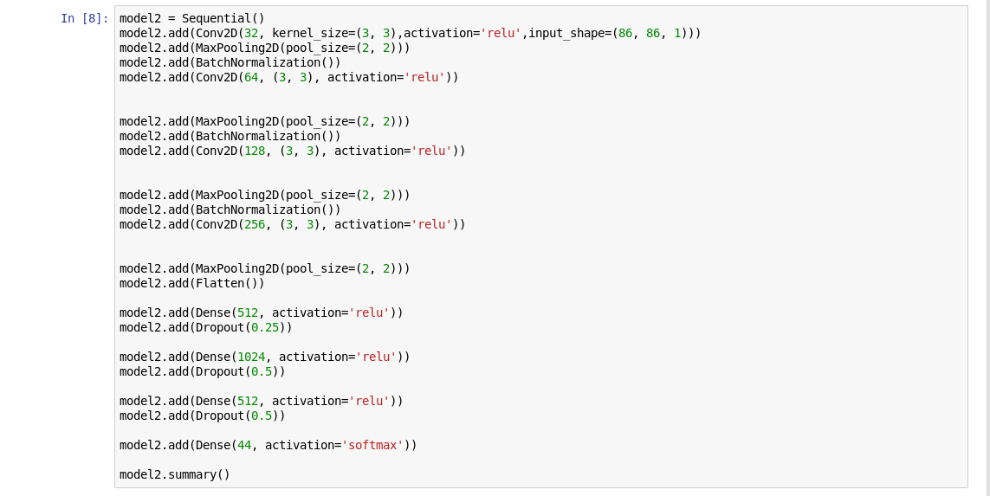

**Training The CNN Model**

