**Step 1: Create an GitHub account.**

* First open GIthub website.
* Create an account on Github.



* Enter your email id and sign up.
* After entering your email id set password and select any username for your account.
* After all this you ill get this page that is below.

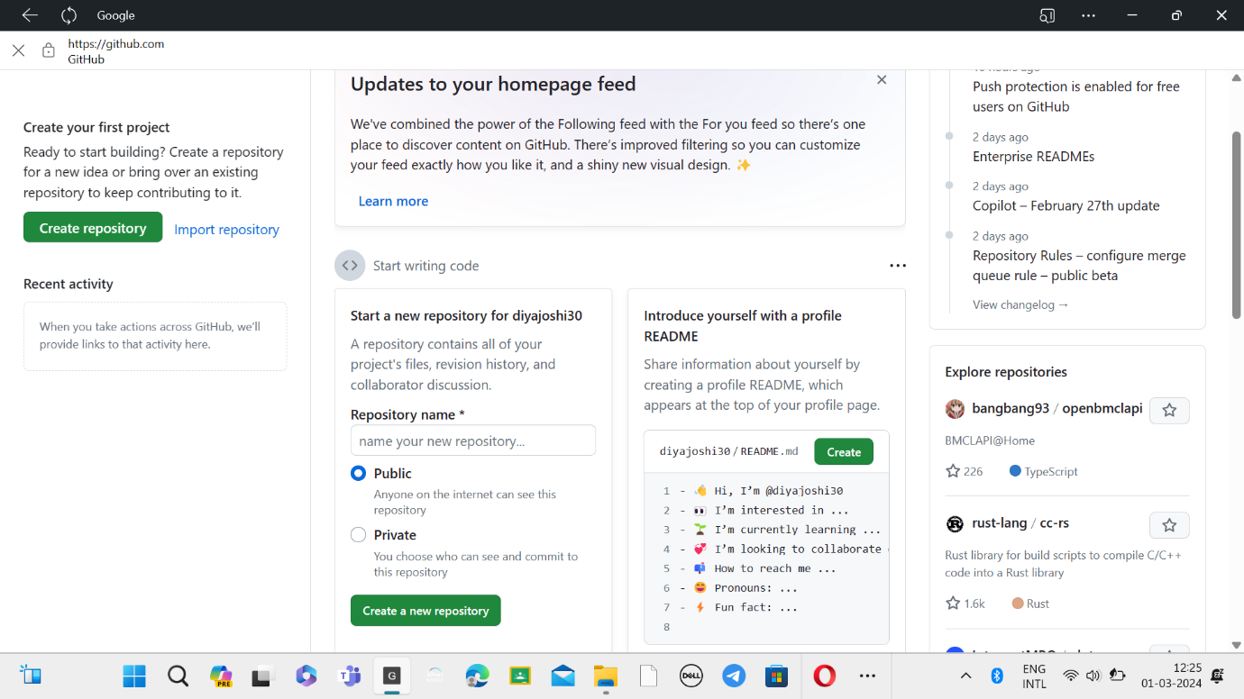

**Step 2: Create a Repository in Github.**

* A repository is like a place or a container where something is stored, in this case we are creating a Git repository to store code.

* To create a new repository, select **Create** **New Repository**.

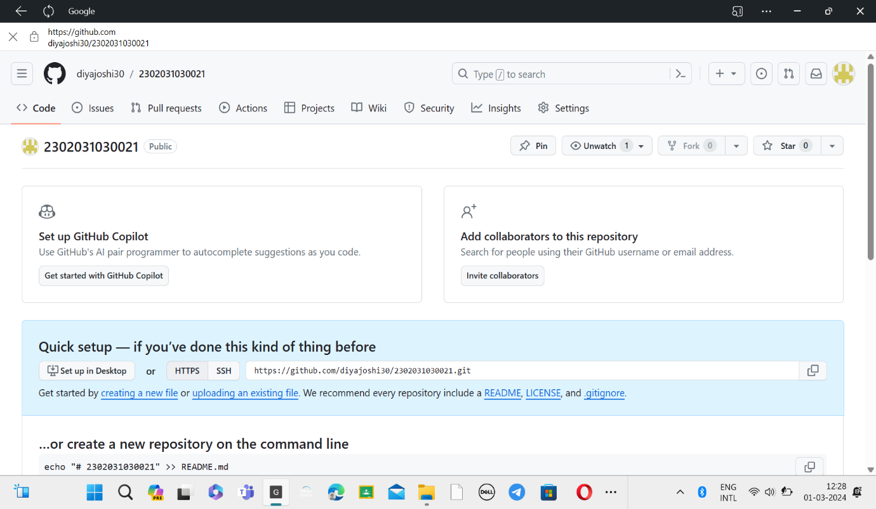

* Here is the has been repository is created.

**Step 3: Create new folder in repository.**

* Click on creating new file.

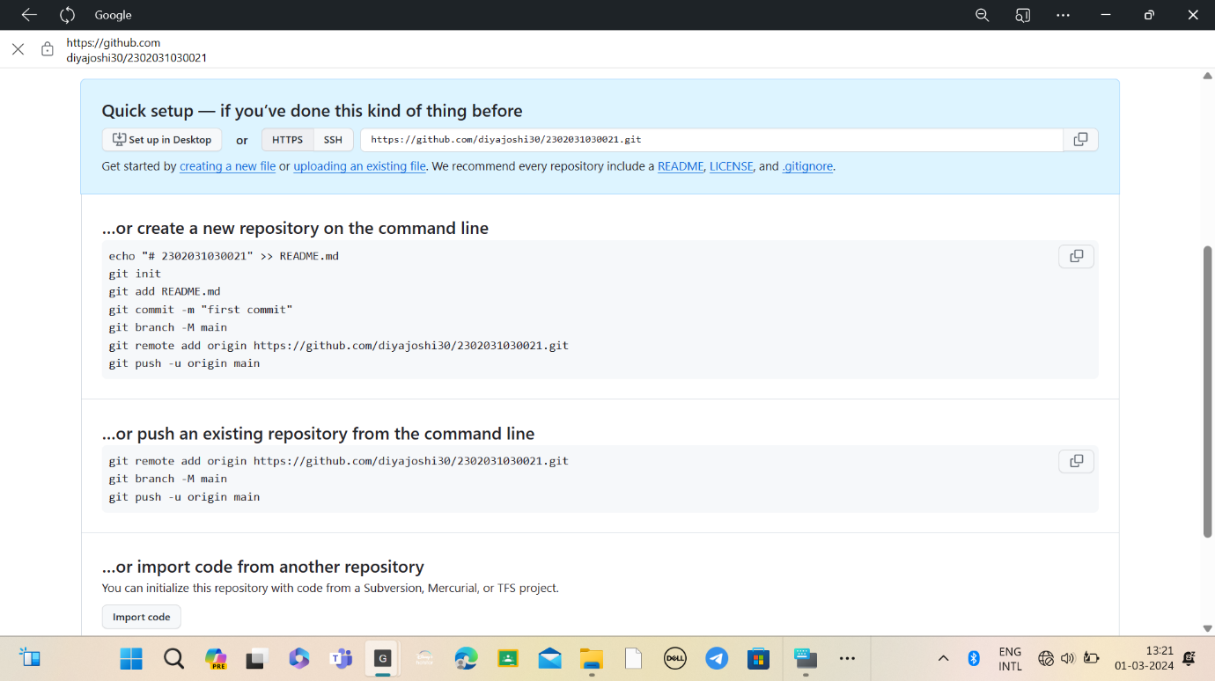

* From the folder we can create new file

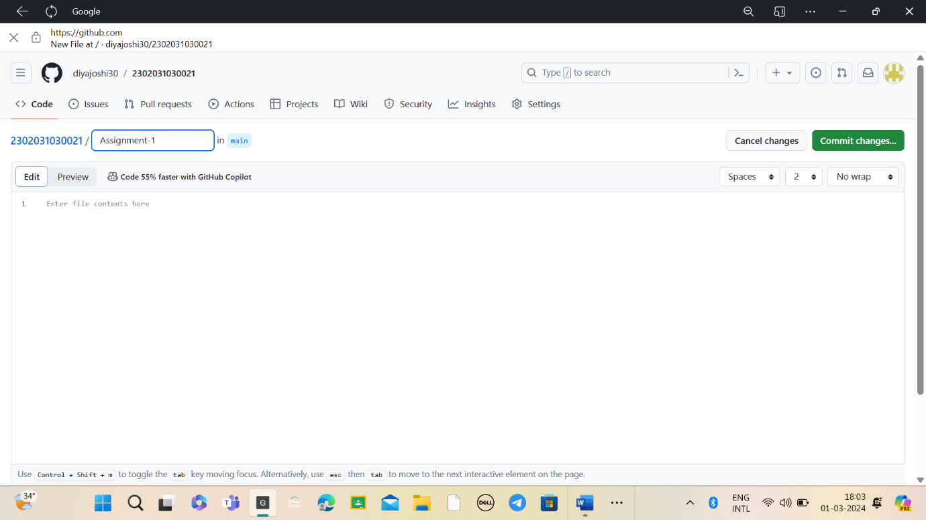

* By entering “/” function we can create new file.

So, these all are the steps to make a repository, folder and file.

Thank You