Module 2 Assignment: JavaScript language

Diya Liza Varghese

Information Technology, Polytechnic School, Arizona State University

IFT 544: Middleware Prog & Database Sec (2023 Fall)

Dr. Dinesh Sthapit

September 03, 2023

Introduction to JavaScript -1

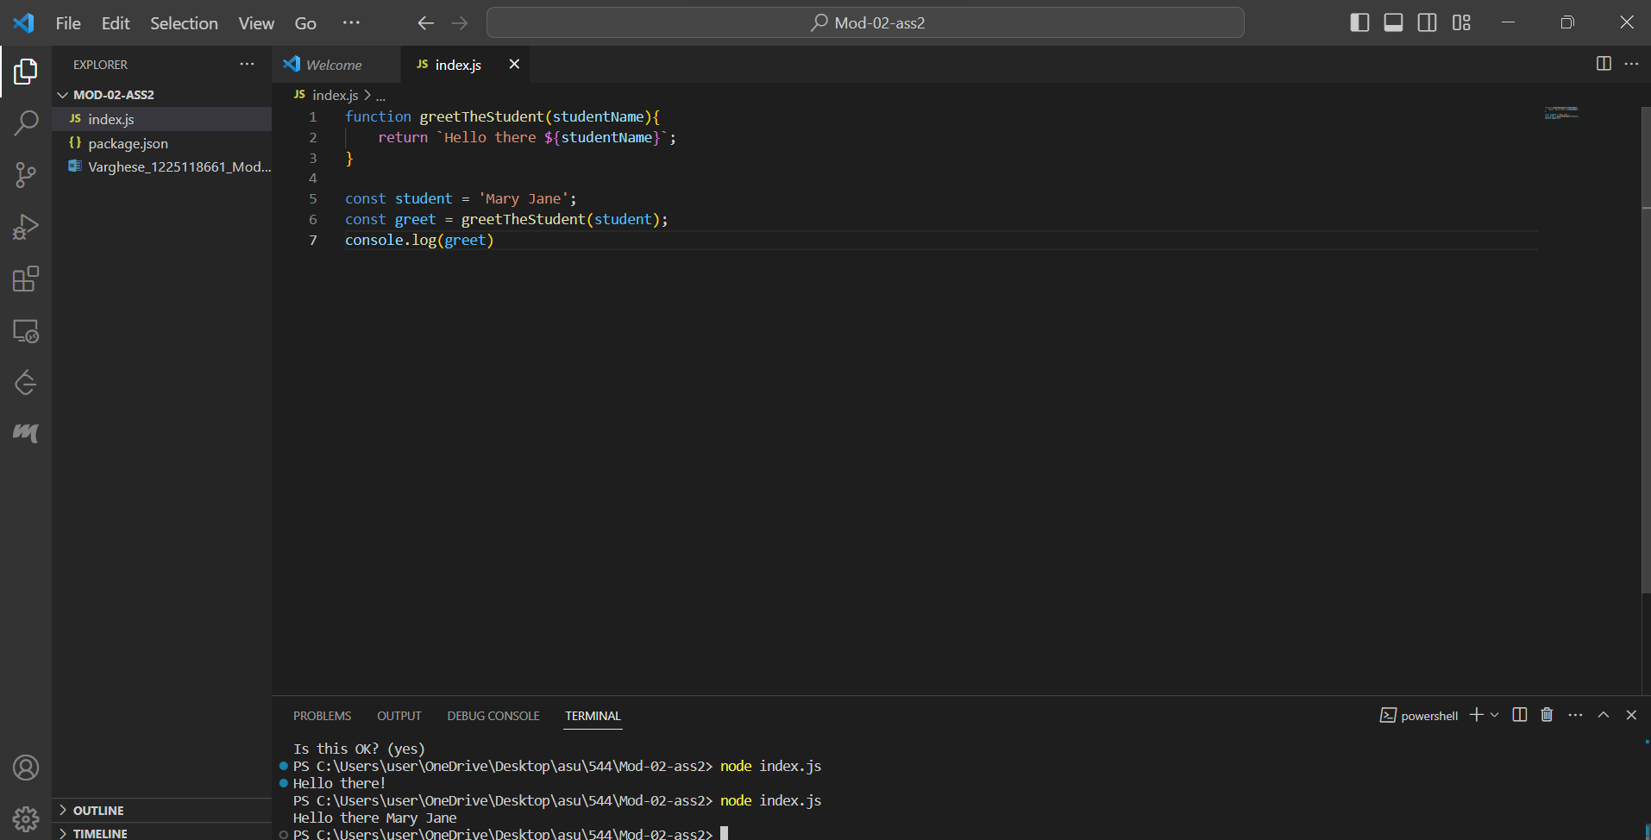

function greetTheStudent(studentName){

    return `Hello there ${studentName}`;

}

const student = 'Mary Jane';

const greet = greetTheStudent(student);

console.log(greet)

JavaScript Function Refactoring 2

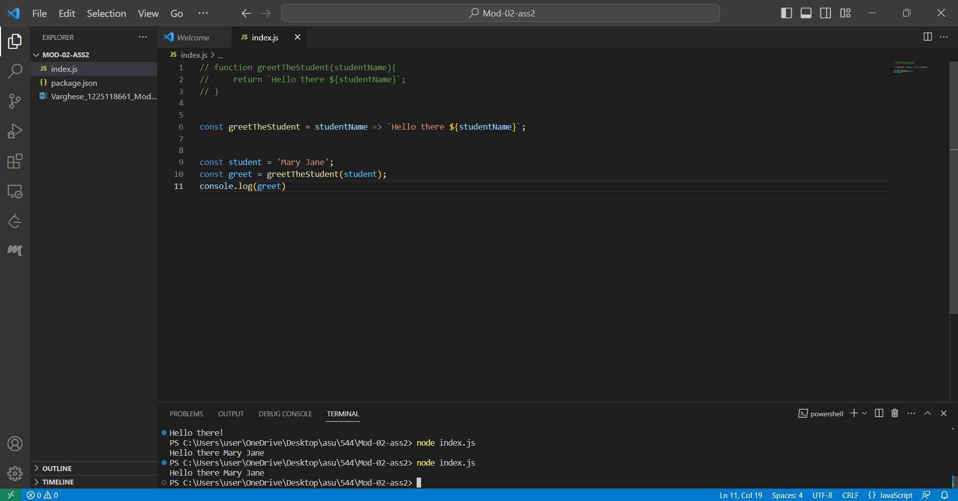

const greetTheStudent = studentName => `Hello there ${studentName}`;

const student = 'Mary Jane';

const greet = greetTheStudent(student);

console.log(greet)

JavaScript Refactoring 3

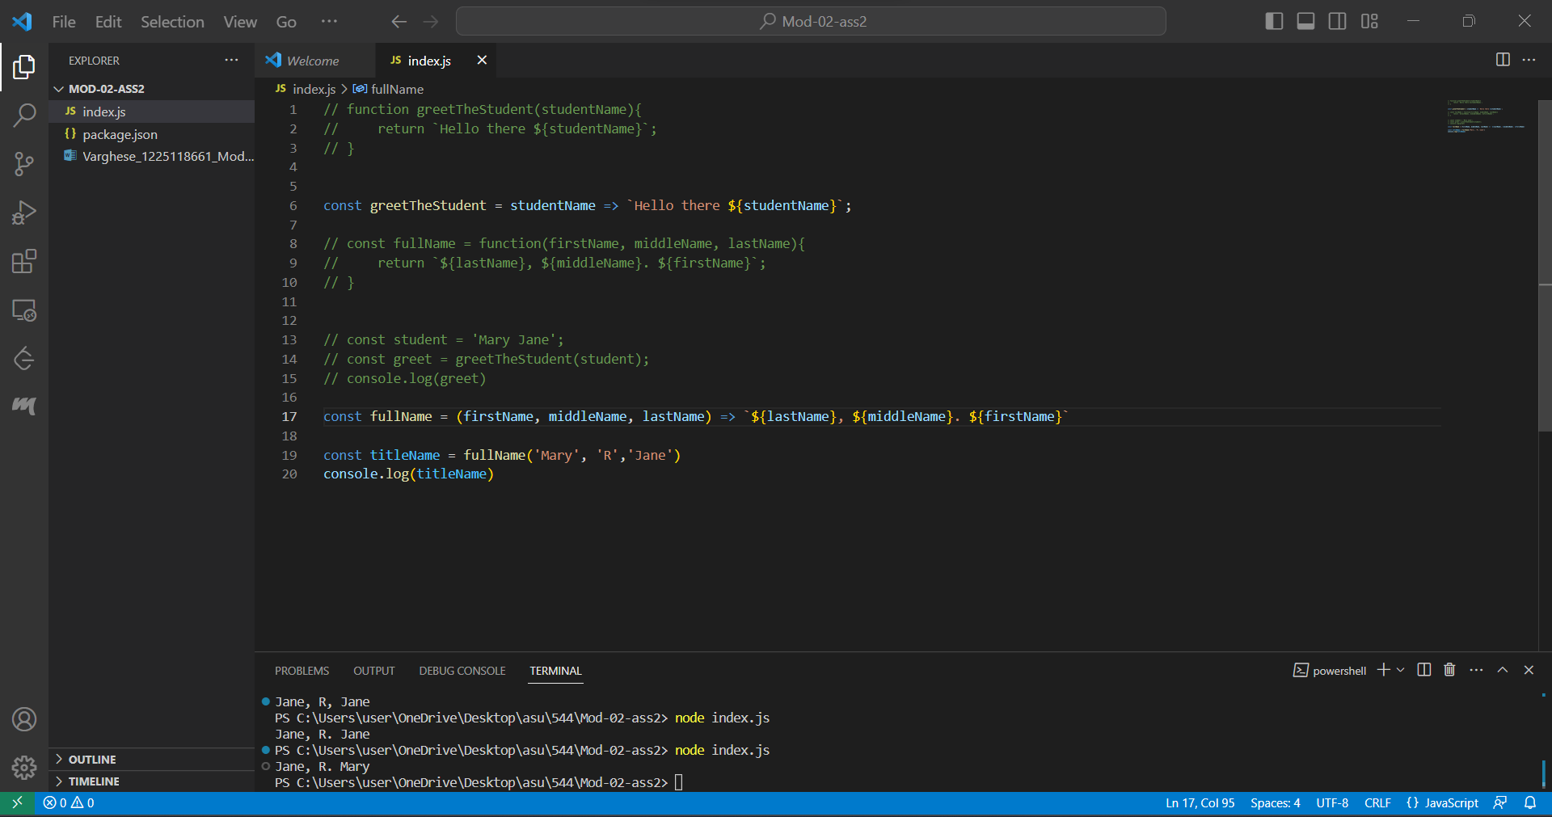

const fullName = (firstName, middleName, lastName) => `${lastName}, ${middleName}. ${firstName}`

const titleName = fullName('Mary', 'R','Jane')

console.log(titleName)

JavaScript Variables 4

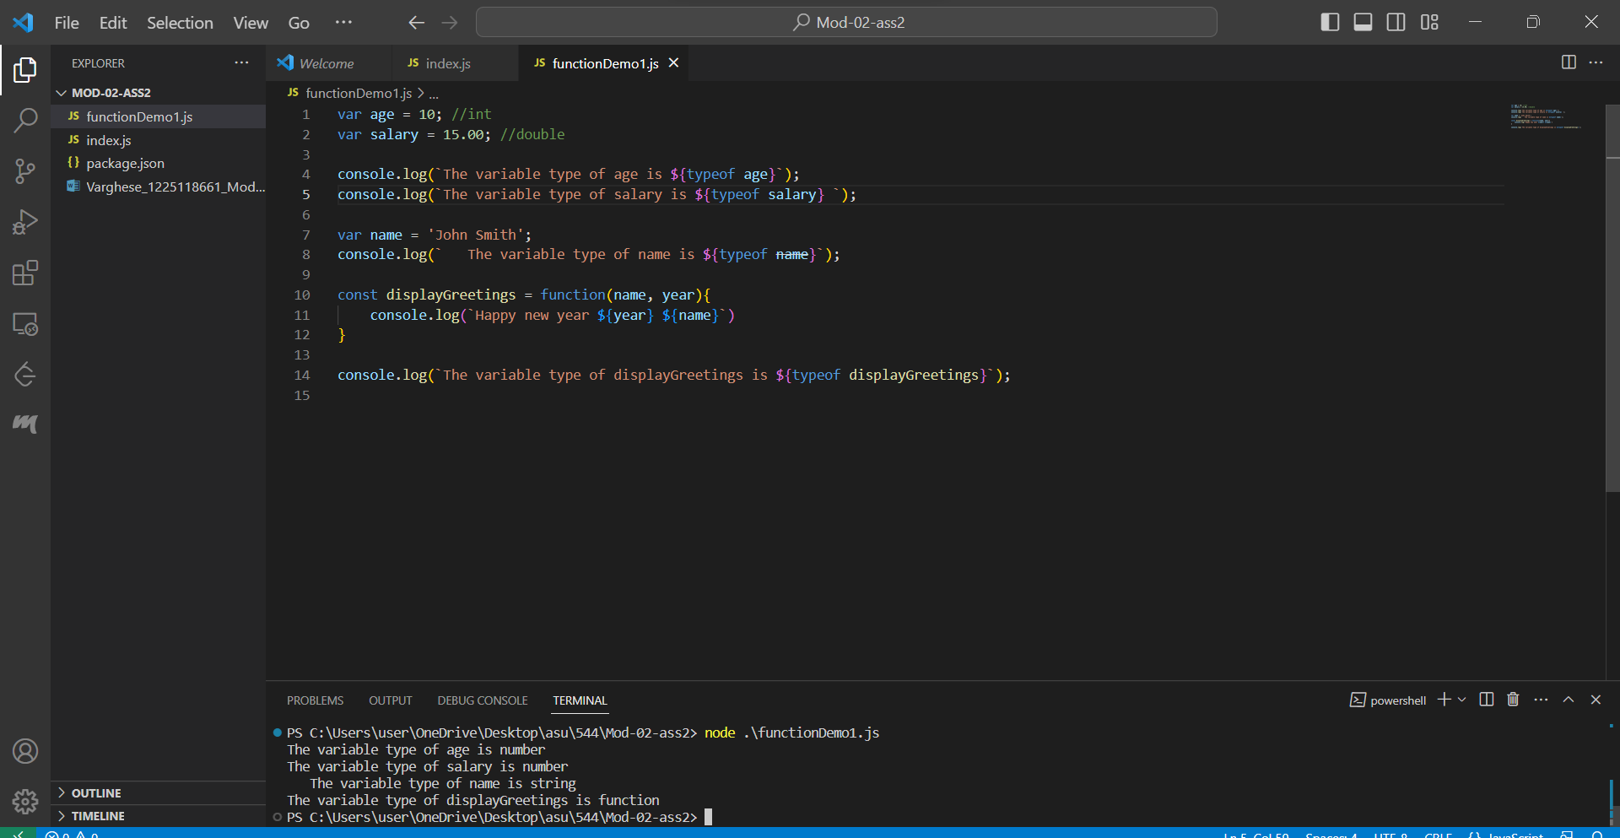

var age = 10; //int

var salary = 15.00; //double

console.log(`The variable type of age is ${typeof age}`);

console.log(`The variable type of salary is ${typeof salary} `);

var name = 'John Smith';

console.log(`   The variable type of name is ${typeof name}`);

const displayGreetings = function(name, year){

    console.log(`Happy new year ${year} ${name}`)

}

console.log(`The variable type of displayGreetings is ${typeof displayGreetings}`);

JavaScript Objects 5

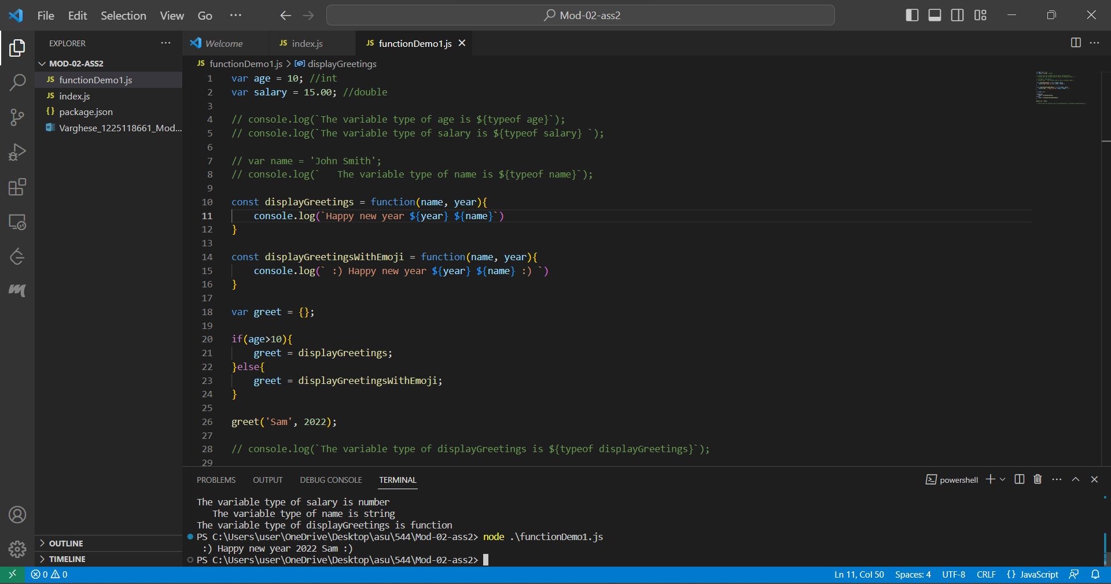

const displayGreetings = function(name, year){

    console.log(`Happy new year ${year} ${name}`)

}

const displayGreetingsWithEmoji = function(name, year){

    console.log(` :) Happy new year ${year} ${name} :) `)

}

var greet = {};

if(age>10){

    greet = displayGreetings;

}else{

    greet = displayGreetingsWithEmoji;

}

greet('Sam', 2022);

JavaScript Parameter (Function as a parameter) 6

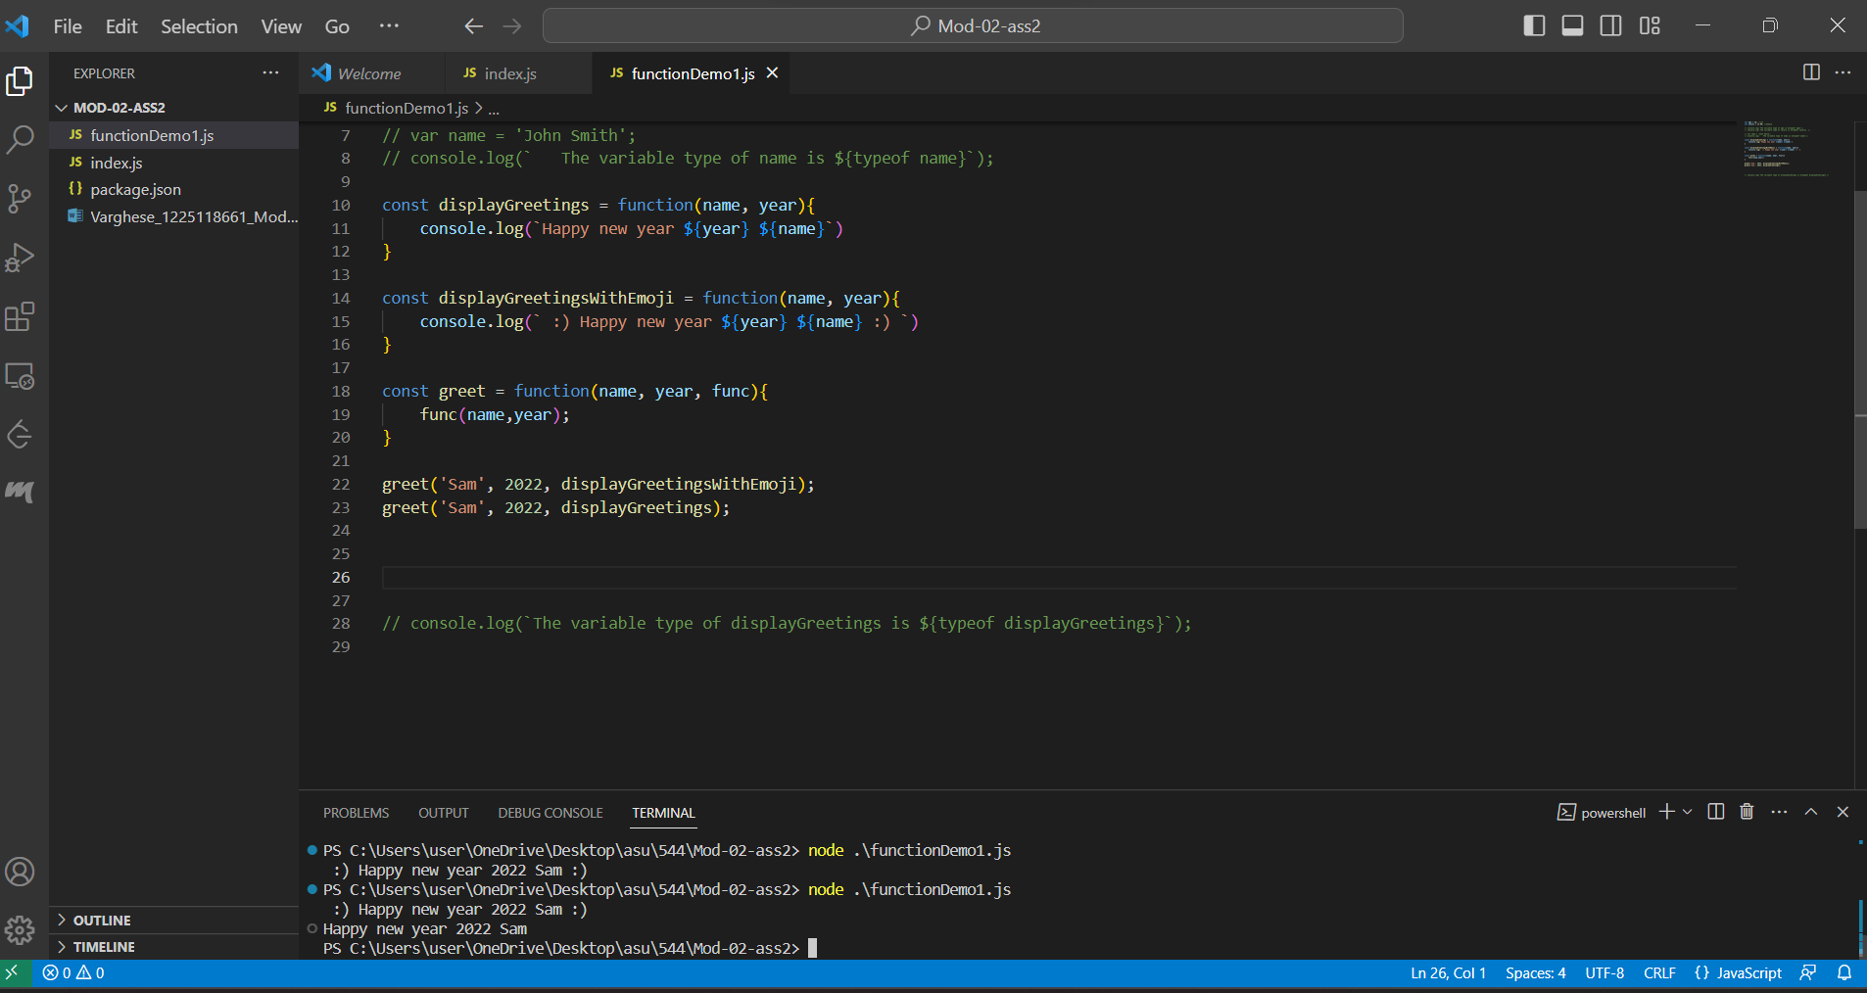

const displayGreetings = function(name, year){

    console.log(`Happy new year ${year} ${name}`)

}

const displayGreetingsWithEmoji = function(name, year){

    console.log(` :) Happy new year ${year} ${name} :) `)

}

const greet = function(name, year, func){

    func(name,year);

}

greet('Sam', 2022, displayGreetingsWithEmoji);

greet('Sam', 2022, displayGreetings);

JavaScript Objects II 8

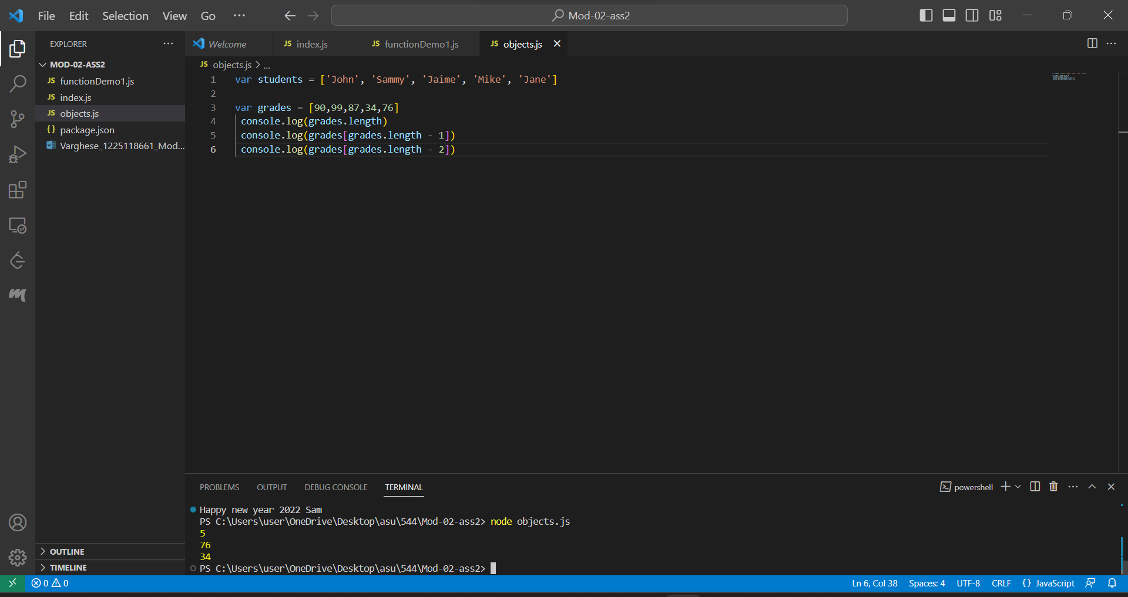

var students = ['John', 'Sammy', 'Jaime', 'Mike', 'Jane']

var grades = [90,99,87,34,76]

 console.log(grades.length)

 console.log(grades[grades.length - 1])

 console.log(grades[grades.length - 2])

JavaScripts Arrays 9

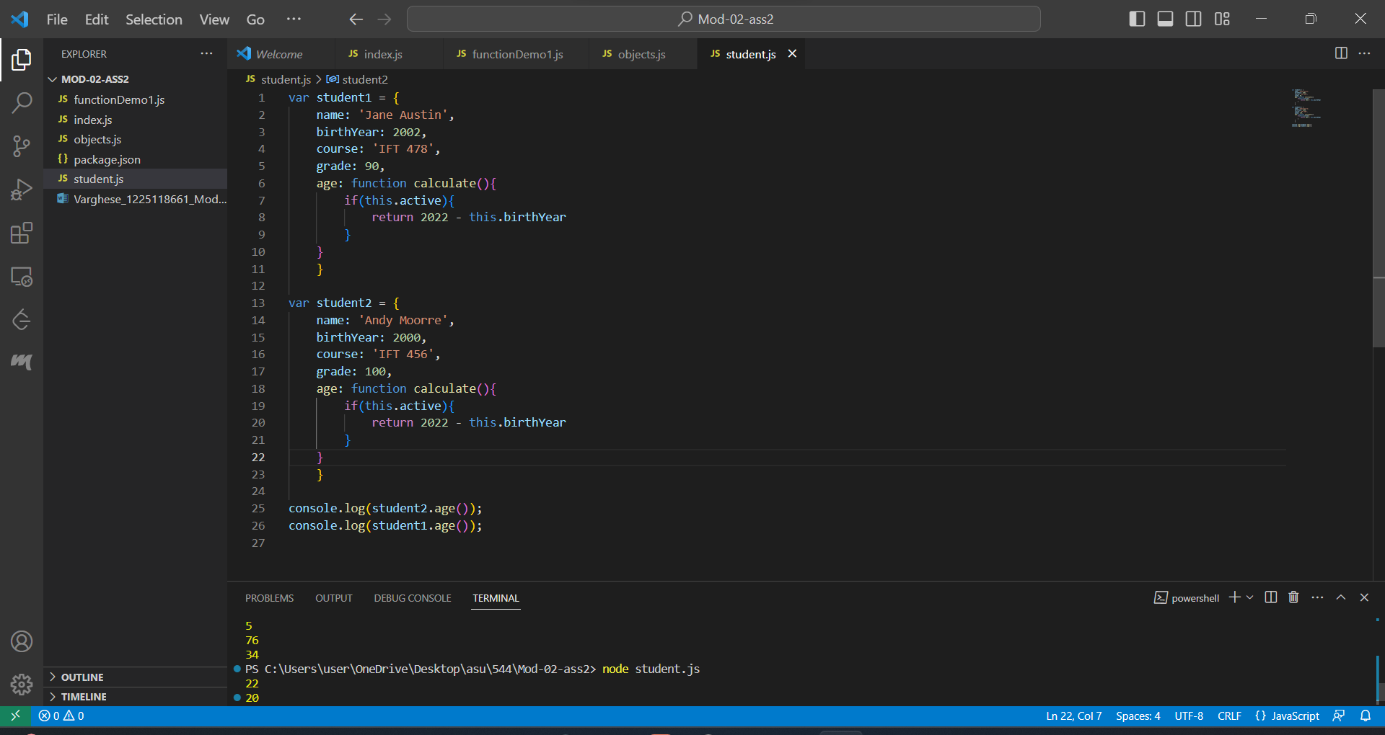

var student1 = {

    name: 'Jane Austin',

    birthYear: 2002,

    course: 'IFT 478',

    grade: 90,

    age: function calculate(){

        if(this.active){

            return 2022 - this.birthYear

        }

    }

    }

var student2 = {

    name: 'Andy Moorre',

    birthYear: 2000,

    course: 'IFT 456',

    grade: 100,

    age: function calculate(){

        if(this.active){

            return 2022 - this.birthYear

        }

    }

    }

Accessing Elements of JavaScript Object Arrays 10

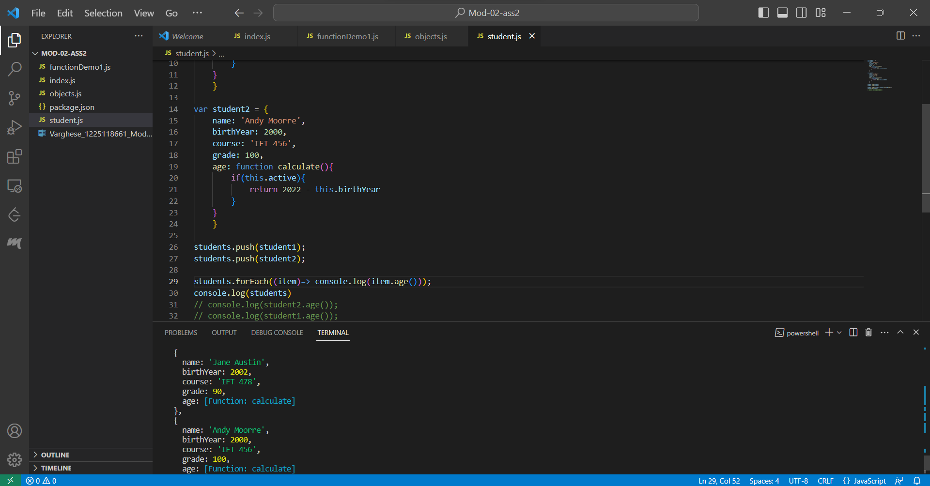

tudents.push(student1);

students.push(student2);

students.forEach((ite