Rutgers University

[Industrial Mathematics](http://www.baidu.com/link?url=kedZJCIxeGp32inLkb4wlJwx5M_jHq_NHbMZ4xUFOzeGohW8jit2K9GQKOBiY7tEjxRKyhHCJS0jDIJ9mDYky_EaNAQnv5YFEVJxCu-L0XS" \t "https://www.baidu.com/_blank)

Shen Hanwen

**AnalyzeFalcon9Model**

**1 [Comparison](http://www.baidu.com/link?url=TOZ6xr6Wae4cREKy20Qf97qAZt3v97gfPuNqlGu4eOUAU1pHd5xMp2itykCFnAfm1XidegVszBaYqpOQp0oSNUe99Eat3ZQG9zRewe2rniW" \t "https://www.baidu.com/_blank) and Conclusion**

In fact,there is no difference between the model of Matlab and C++ at a large scale T(time),as the data shown in Figure 4.

Therefore the conclusion is that the C++ code converted form Matlab code is fit with the model .

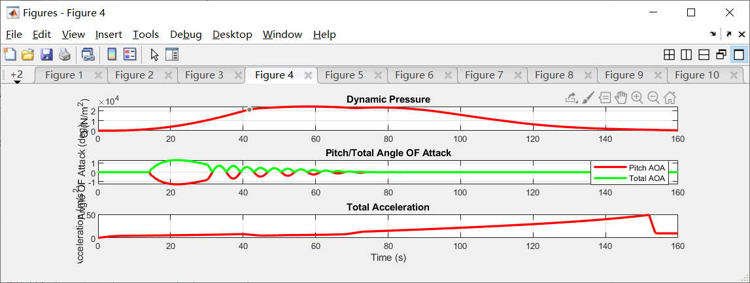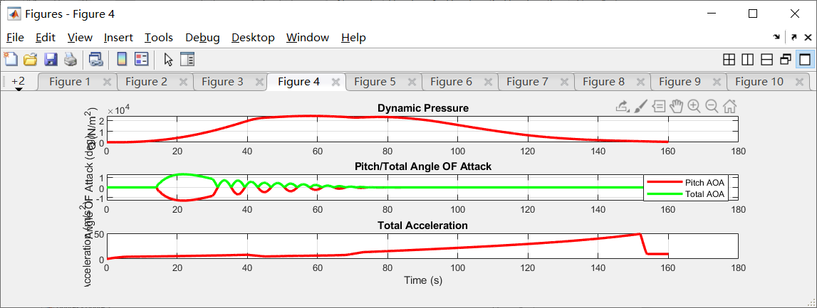

**2 MATLAB**

Here are detailed Figure 1 - Figure 12 showing the result of ‘Falcon9ModelMATLAB.dat’ analyzing by ‘AnalyzeFalcon9Model.m’from ‘TestFullFalcon9Model.m’.

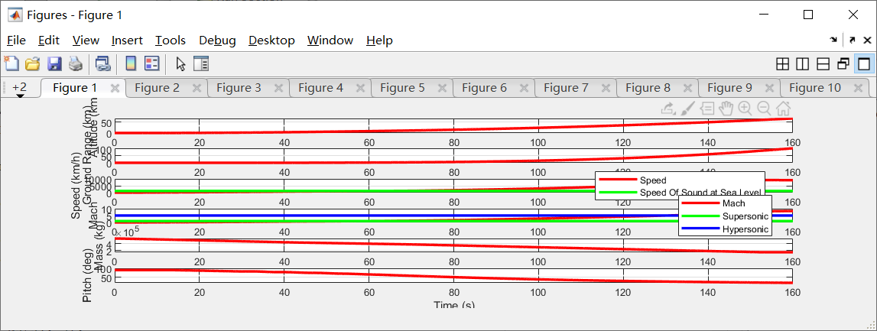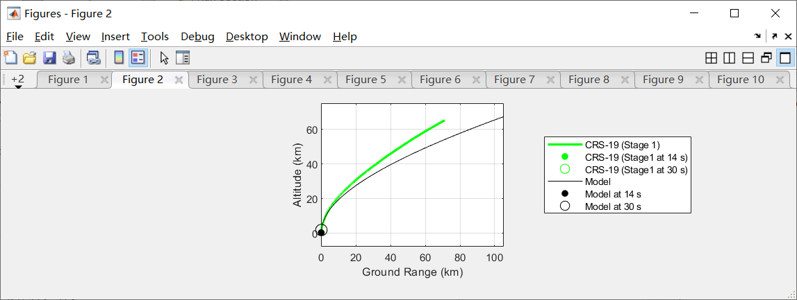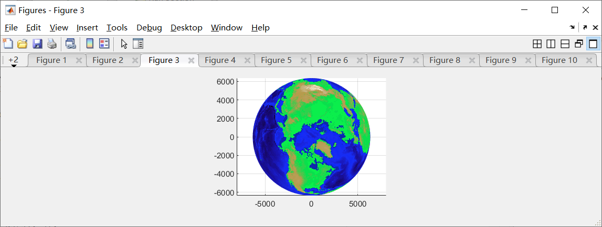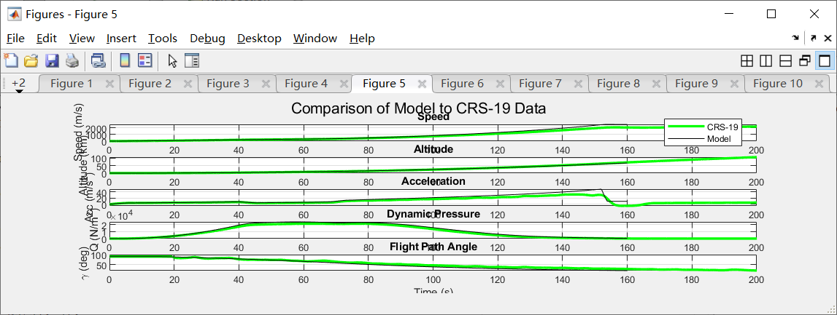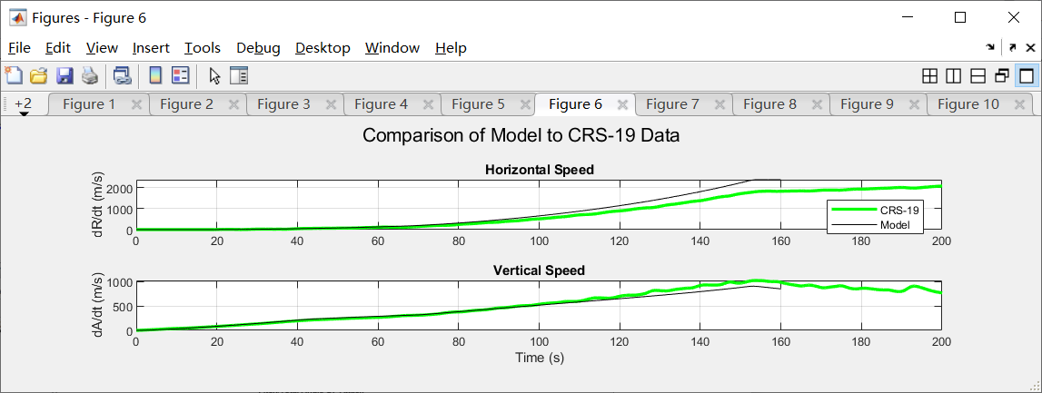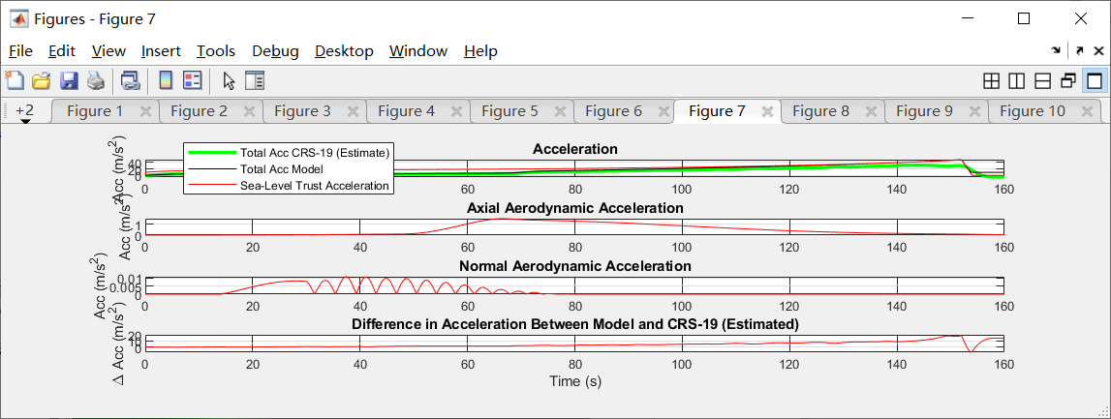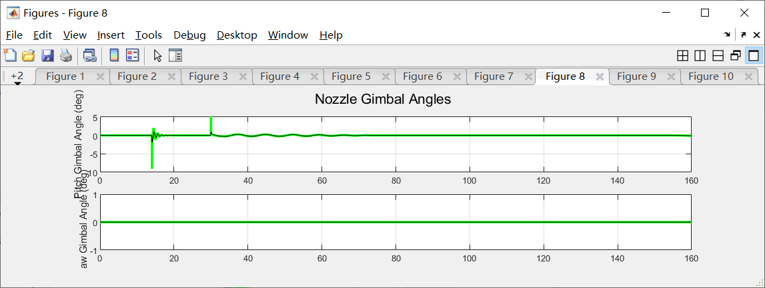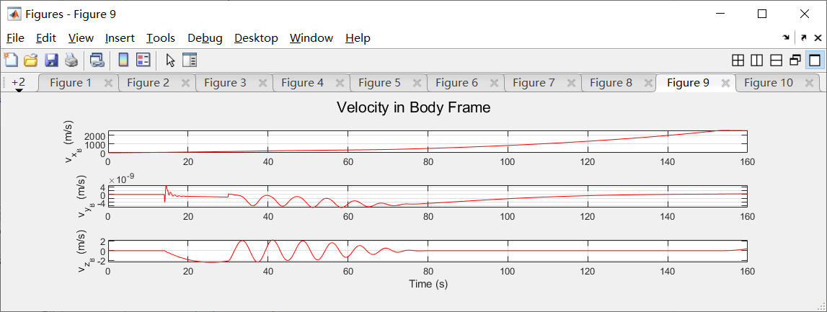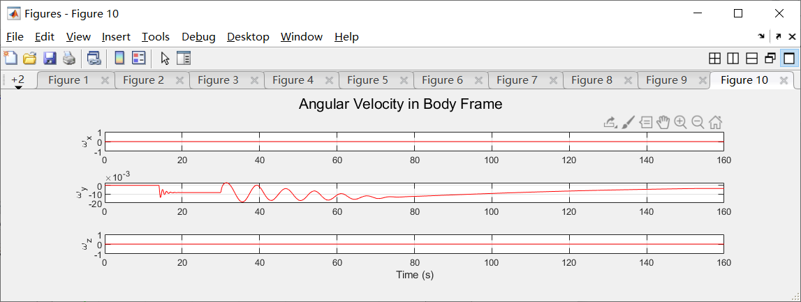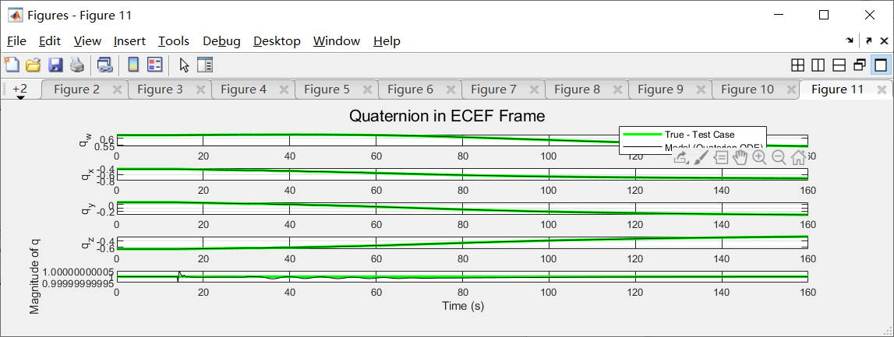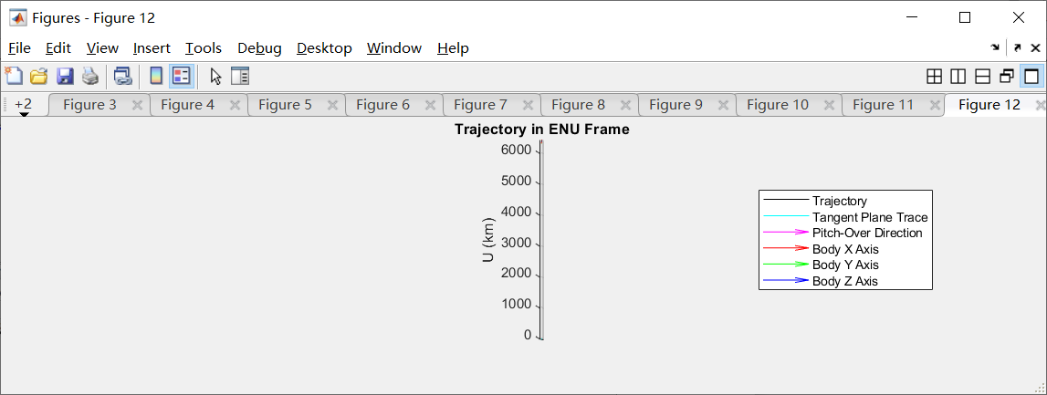

**3 C++**

